

Report Title

REPORT SUBTITLE

Name | Course Title | Date

Evidence of Learning

1. Import the CSV API to read the file from Dataset

import csv

1. Declare class and its constructor

class pipelineIncident :

def __init__(self, Incident_Number, Incident_Types, Reported_Date, Nearest_Populated_Centre, Province, Company, Substance, Significant, What_happened_category):

self.Incident_Number = Incident_Number

self.Incident_Types = Incident_Types

self.Reported_Date = Reported_Date

self.Nearest_Populated_Centre = Nearest_Populated_Centre

self.Province = Province

self.Company = Company

self.Substance = Substance

self.Significant = Significant

self.What_happened_category = What_happened_category

1. Declare class setters and getters

def get_Incident_Number(self):

"""Return Incident Number."""

return self.Incident_Number

def set_Incident_Number(self, a):

"""Set Incident Number."""

self.Incident_Number = a

def get_Incident_Types(self):

"""Set Incident Types."""

return self.Incident_Types

def set_Incident_Types(self, a):

"""Set Incident Types."""

self.Incident_Types = a

def get_Reported_Date(self):

"""Get Reported Date."""

return self.Reported_Date

def set_Reported_Date(self, a):

"""Set Reported Date."""

self.Reported_Date = a

def get_Nearest_Populated_Centre(self):

"""get _Nearest_Populated_Centre."""

return self.Nearest_Populated_Centre

def set_Nearest_Populated_Centre(self, a):

"""set _Nearest_Populated_Centre."""

self.Incident_Number = a

def get_Province(self):

"""to get_Province."""

return self.Province

def set_Province(self, a):

"""to set_Province."""

self.Province = a

def get_Company(self):

"""to get_Company."""

return self.Company

def set_Company(self, a):

"""to set_Company."""

self.Company = a

def get_Substance(self):

"""to get_Substance ."""

return self.Substance

def set_Substance(self, a):

"""to set_Substance."""

self.Substance = a

def get_Significant(self):

"""to get_Significant ."""

return self.Significant

def set_Significant(self, a):

"""to set_Significant ."""

self.Significant = a

def get_What_happened_category(self):

"""to get_What_happened_category ."""

return self.Significant

def set_What_happened_category(self, a):

"""to set_What_happened_category ."""

self.What_happened_category = a

1. Declare a list and initialize empty

pipelineIncidentList = []

1. Read file properly and handle the exception

try:

# handle exception

with open('pipeline-incidents-comprehensive-data.csv', 'rt') as f: #read file from dataset

csv_reader = csv.reader(f)

next(csv_reader) # skip the heading

for line in csv_reader: # save data into List

pipelineIncidentList.append( pipelineIncident(line[0], line[1], line[2], line[3], line[4], line[5], line[10], line[12], line[17]) )

except FileNotFoundError:

print('File not found!!', file_name)

# If any other error occurs, print the file name

except Exception:

print('Another Error!!', file_name)

1. Calculate the records using for loop

# calculate count of the records using for loops

totalRecords = 0

for incident in pipelineIncidentList:

totalRecords = totalRecords + 1

print(incident.get_Incident_Number() + " " + incident.get_Incident_Types() + " " + incident.get_Reported_Date() + " " +incident.get_Nearest_Populated_Centre()+ " "+ incident.get_Province()+ " "+incident.get_Company()+ " "+ incident.get_Substance()+ " "+incident.get_Significant()+ " "+ incident.get_What_happened_category())

print ('\n\n\n Total Records in this dataset is ' + str(totalRecords)+ '\n')

1. Count the incident records according to province using for loop

dictionaryProvince = {}

for incident in pipelineIncidentList: # for loop to calculate the count of incidents against each province

province = incident.get_Province()

if province not in dictionaryProvince:

dictionaryProvince[province] = 0

dictionaryProvince[province] += 1

for key, value in dictionaryProvince.items(): # print the province and its count

print(key, ' : ', value)

Program Demonstration via Screen Shots

Display data using for loop

Display count of incident in each province

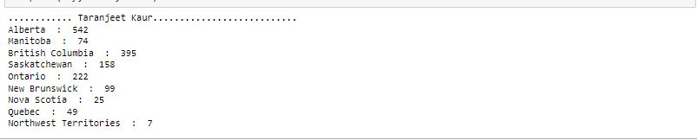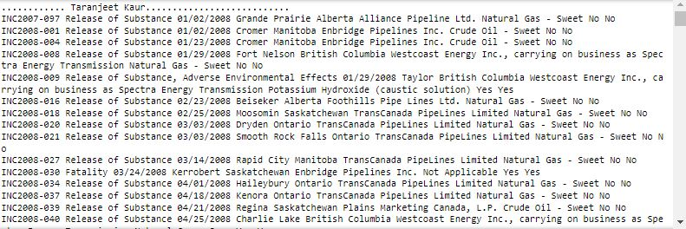

Source Code Commenting Example

import csv

class pipelineIncident :

"""Declaration of pipelineIncident class."""

def __init__(self, Incident_Number, Incident_Types, Reported_Date, Nearest_Populated_Centre, Province, Company, Substance, Significant, What_happened_category):

self.Incident_Number = Incident_Number

self.Incident_Types = Incident_Types

self.Reported_Date = Reported_Date

self.Nearest_Populated_Centre = Nearest_Populated_Centre

self.Province = Province

self.Company = Company

self.Substance = Substance

self.Significant = Significant

self.What_happened_category = What_happened_category

def get_Incident_Number(self):

"""Return Incident Number."""

return self.Incident_Number

def set_Incident_Number(self, a):

"""Set Incident Number."""

self.Incident_Number = a

def get_Incident_Types(self):

"""Set Incident Types."""

return self.Incident_Types

def set_Incident_Types(self, a):

"""Set Incident Types."""

self.Incident_Types = a

def get_Reported_Date(self):

"""Get Reported Date."""

return self.Reported_Date

def set_Reported_Date(self, a):

"""Set Reported Date."""

self.Reported_Date = a

def get_Nearest_Populated_Centre(self):

"""get _Nearest_Populated_Centre."""

return self.Nearest_Populated_Centre

def set_Nearest_Populated_Centre(self, a):

"""set _Nearest_Populated_Centre."""

self.Incident_Number = a

def get_Province(self):

"""to get_Province."""

return self.Province

def set_Province(self, a):

"""to set_Province."""

self.Province = a

def get_Company(self):

"""to get_Company."""

return self.Company

def set_Company(self, a):

"""to set_Company."""

self.Company = a

def get_Substance(self):

"""to get_Substance ."""

return self.Substance

def set_Substance(self, a):

"""to set_Substance."""

self.Substance = a

def get_Significant(self):

"""to get_Significant ."""

return self.Significant

def set_Significant(self, a):

"""to set_Significant ."""

self.Significant = a

def get_What_happened_category(self):

"""to get_What_happened_category ."""

return self.Significant

def set_What_happened_category(self, a):

"""to set_What_happened_category ."""

self.What_happened_category = a

pipelineIncidentList = []

try: # handle exception

with open('pipeline-incidents-comprehensive-data.csv', 'rt') as f: #read file from dataset

csv_reader = csv.reader(f)

next(csv_reader) # skip the heading

for line in csv_reader: # save data into List

pipelineIncidentList.append( pipelineIncident(line[0], line[1], line[2], line[3], line[4], line[5], line[10], line[12], line[17]) )

except FileNotFoundError:

print('File not found!!', file_name)

# If any other error occurs, print the file name

except Exception:

print('Another Error!!', file_name)

print('............ Taranjeet Kaur...........................')

# calculate count of the records using for loops

totalRecords = 0

for incident in pipelineIncidentList:

totalRecords = totalRecords + 1

print(incident.get_Incident_Number() + " " + incident.get_Incident_Types() + " " + incident.get_Reported_Date() + " " +incident.get_Nearest_Populated_Centre()+ " "+ incident.get_Province()+ " "+incident.get_Company()+ " "+ incident.get_Substance()+ " "+incident.get_Significant()+ " "+ incident.get_What_happened_category())

print ('\n\n\n Total Records in this dataset is ' + str(totalRecords)+ '\n')

print('............ Taranjeet Kaur...........................')

#Count of Incident according to province

dictionaryProvince = {}

for incident in pipelineIncidentList: # for loop to calculate the count of incidents against each province

province = incident.get_Province()

if province not in dictionaryProvince:

dictionaryProvince[province] = 0

dictionaryProvince[province] += 1

for key, value in dictionaryProvince.items(): # print the province and its count

print(key, ' : ', value)