[Twitter Bad Actor Detection] Use Case

Document Information

|  |  |
| --- | --- |
| **Document Title** | Title of use case – Verb Noun phrasing is almost always the most appropriate! |
| **Document Owner** |  |
| **Version** |  |
| **Status** |  |
| **Date** |  |

1. Brief Description

The application uses features like sentiment analysis to predict the chances of an account being a bad actor. It also highlights specific tweets that are the most significant in the said analysis.

1. Actors

* System of Twitter
* Follower / Author

1. Pre-Conditions

* The user of the twitter must have an ID through which the twitter account can be accessed.
* Publishing the tweet, before it will be analyzed through the tweet score generator using the constraints (Text, Time, Length)

1. Basic Flow
2. Having the user ID to access it, if not then create an ID.
3. Then the access will be granted on the basis of verification from the database.
4. If the tweet should be published it will redirect to the tweet analyzer to check the score of originality of the tweet to be published.
5. Tweet collector uses the analyzer from the database to use the technique of sentiment analysis to check whether it is positive, negative or neutral tweet.
6. Then the extracted data from the database is used as the account metdata to ensure the user description, Score evaluation and the generation of bad actor report.
7. Alternate/Exception Flows

1a - If the tweet accessed is denied upon the request from the server/ database then it will not allow to publish until and unless it generates a score.

1. Post Conditions

* The Search Bar shall accept as input any alphanumeric character (a-z,A-Z,0-9) as well as underscores.
* The Search Bar shall display an error message when an invalid character is input when searching for an account.
* The Search Bar shall display the message “No Account Found” dialogue when no user is found that matches the input characters
* The system shall permit the user to enter the name of any valid twitter account.
* The search bar shall display a dropdown list of users which start with the characters typed in the search bar.
* There shall be a webpage titled ‘Score and Highlights’.

1. Supplemental Requirements

This is a special section I use to hold miscellaneous requirements related to the use case. Often you’ll find BAs including a Business Rules section or other collection of information related to the use case. These may or may not be actual requirements – you’ll want to establish a clear pattern and communicate that clearly and ensure it’s consistent with how your organization documents this type of requirement. I’ve also used this section to capture the most salient decisions and notes so they are stored right with the use case for future consideration.

1. Visual Model

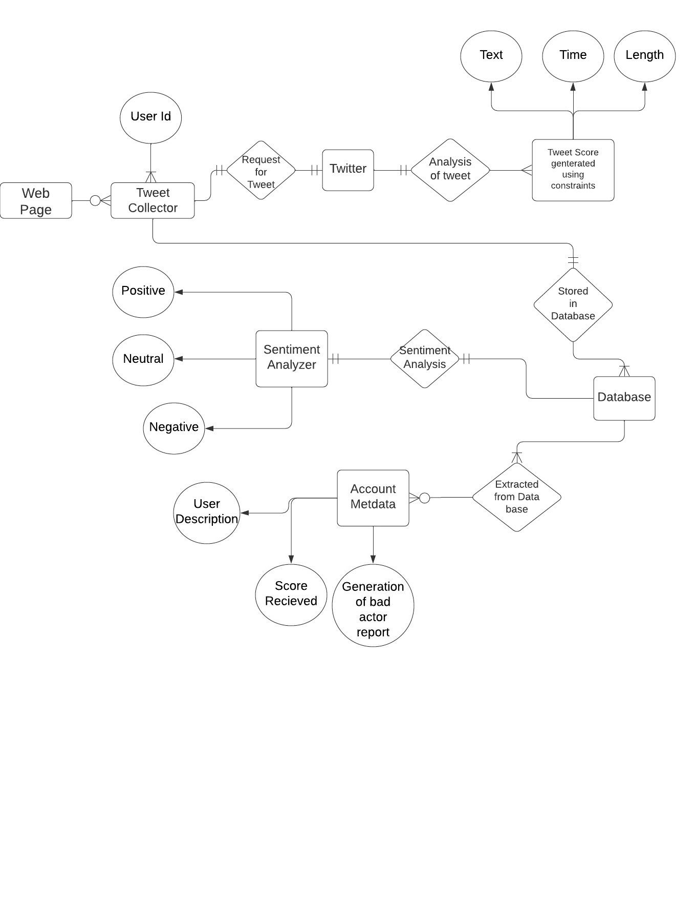

Revision History

|  |  |  |  |  |
| --- | --- | --- | --- | --- |
| V. | Date | Author | Description | Status |
|  |  |  |  |  |
|  |  |  |  |  |