**Introduction:**

Price-cut.co.uk is an international electronics store that provides electronics all over the world in less price than the market. The company have different offices in UK, as well in different parts of the world also. The main office is in London that consists of four departments.

1. **Finance**
2. **HR**
3. **Sales**
4. **Admin**

As the company’s mostly business is online based so it has lots of servers but four of them are situated at the London branch. Servers include DNS Server, Wb-server, email server and File server. The File server have the logs of the IOT sensors like temperate, humidity, fire, door etc.

The company’s major servers are DNS and Web server. Purpose of the report is to provide all the technical information including IP addressing, routing technologies and all the other necessary information that is implemented in this network so that it would be easy to understand the topology.

Computer networks consists of different networks including LAN, WAN, WLAN, PAN, HAN, MAN etc. Most common and most widely used are **Local Area Network (LAN)**, **Wide area Network (WAN), Wireless Local Area Network (WLAN).**

1. **Local Area Network (LAN)**

Local Area Network consist of a network that connects computers and other network devices within a limited or small area. It could be home, office or even a school. Other networking devices can include printer, IP phones etc.

1. **Wide Area Network (WAN)**

Wide area network connects different LANS together that are far apart usually spread in kilometers. WAN covers large geographical area.

1. **Wireless LAN (WLAN)**

Its is very much similar to the LAN. In a Local area network or LAN devices are connected using Ethernet cables while in WLAN devices communicate wirelessly. Devices on a WLAN communicate via Wi-Fi.

Now to support any network topology following equipment is used

1. **Media**

There are different media types used in a computer network. Media is used to transfer packets from one device to another. It could be fiber, coaxial, twisted pair, or serial.

Different media type cables are used at different devices. For example, Serial cables are used to connect routers, twisted cables are used to connect workstations to routers or switches or switches to router and vice versa. In this topology all the devices will be connected using the appropriate media for every device.



1. **Switch**

Switch is a networking device used to connect different workstations or networking devices with the help of ethernet cable. Switch basically works at layer 2 of OSI model. Switches have ports at which mainly workstations are connected. It’s used to connect workstations at the same network. It sends packets with the help of MAC addresses. Switch checks destination MAC address of the packet and send the packet to the corresponding workstation. Some switches also so routing and work at layer 3. They are called multi-layer switches. Switches are used mostly after a router or immediately after the core network in distribution and access network. In this topology switches will be placed at the distribution layer just after the router and at access layer in every department.

1. **Router**

It’s very similar like the switch but it works on layer 3. It uses IP addresses instead of the MAC addresses used in the switches. Router is used to route packets and connect LANs situated in different areas. Different routers connect to make a Wide Area Network (WAN).

Routers are purely used in Core network and their function is to just route the packets as fast as they can. Core is situated in the top hierarchy of the three-tire network. Router is the first device where a packet is received first. Similarly in this topology it will be placed at the top layer that is the core where it will be connected to the WAN.

1. **Client**

Client is the end user that is connected to the network device. It is mostly a workstation or a laptop using by a person. In this topology Client is the user that is requesting or sending information.

1. **DNS Server:**

DNS is abbreviation of Domain Name Server. As the name suggest Server of the Domain Name. In simple words DNS server maps the name of the website that is price-cut.co.uk. The users don’t have to write the web-server IP address that is 10.10.10.106. IP address is very difficult for people to memorize so whenever a user types the domain name the system sends a query to DNS server, and it checks which IP address is associated with the domain name.

1. **Web Server:**

Web server is a server that contains all the information that is displayed on the website. It uses HTTP (Hyper Text transfer protocol)

1. **DHCP server**

DHCP server is responsible for assigning IP addresses to workstations or end users. Without a DHCP server its very difficult to assign every workstation IP address individually. It can be done in a small network, but it would be very difficult to manage it in a larger network

All other terminologies and technologies will be explained further in the report.

**Topologies**

1. **Bus**

Bus topology is a topology in networking in which every networking device or workstation is connected to single cable. Transmission of the data from one end to the other end is performed in single direction. Bi-directional features are not permissible in bus technology. It is a non-robust and multi point topology. If one PC or point fails, the whole topology crashes. If the traffic is heavy on the network increased collusions will occur on the network. The advantage of this topology is that its cost efficient. A number of devices can be connected using one wire

1. **Star**

All devices are connected to hub/switch or any networking device node in star topology. Hub/ switch acts as the central node where all the other devices and computers are connected. Each device needs 1 port to connect to the hub. Its setup is costly but is easy to configure. If the hub fails, the whole network clasps. Network performance is based on the hub connector. Star topology is easy to troubleshoot, modify and set up. Failure occurs on only those nodes that are affected other works totally fine. Network performs fast with few nodes.

1. **Mesh**

In mesh topology every network device is connected with the other network device using dedicated channels known as links. These links can be twisted pair cable of seral or fibre. Mesh develops a P2P point to point connection between all the devices in the network. So, this causes a high-level redundancy so if one cable fails, still the data can be transmitted though the alternative path provided by the mesh topology. It is a robust design and provides security and privacy also. Disadvantages include installation and configuration that is a bit complicated than other topologies. Cost of cables and devices as cables are in bulk quantity. Also, maintenance cost is high. Mesh topology is further classified into two topologies. Partial Mesh and Full mesh.

In partial mesh topology most of the devices are connected normally like in a mesh but few are connected to only one or two devices

**Cisco 3 tire Topology**

According to cisco, the best way to design any topology is to design it according to the cisco 3 tier topology that consists of

1. **Core Layer**
2. **Distribution Layer**
3. **Access Layer**

**Core layer**

Core layer contains the router whose work is just to route packets as fast as it can. It can be a network of routers but in our case, there is only 1 router that connects to other site routers.

**Distribution layer**

Distribution layer in which multilayer switch is placed which work is to assign VLANs to departments, routing as well as switching. Access control List are also implemented here.

**Access Layer**

Access layer is the last layer of 3 tire architecture and here the end devices are connected. Switches are configured with their respected VLANs.

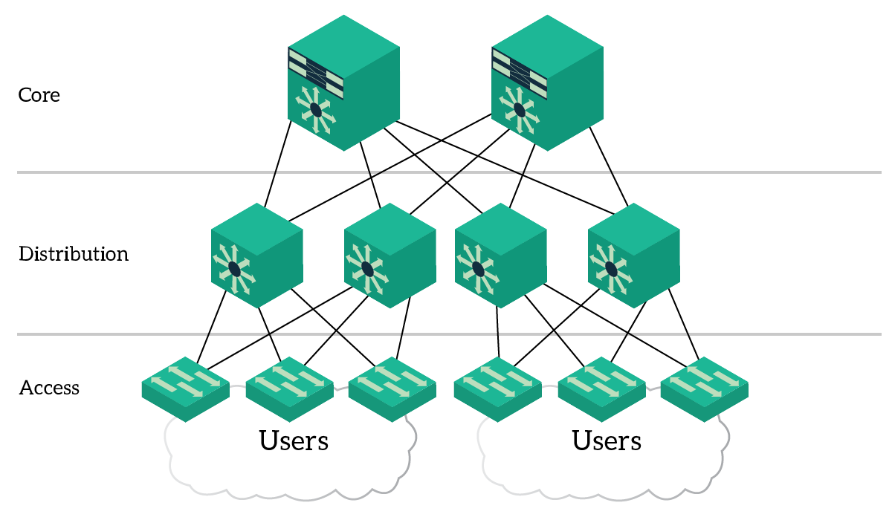

**Design and Implementation**

After all the research, it was clear that cisco 3 tire architecture is to be used here. As the network is not that big so we are using minimum equipment for testing. It can be made fault tolerant and redundant by adding more routers and switches to the network. A picture containing text, map, sky

After designing the topology, the next big thing is IP addressing. To Design start with big chunk first then end to the smallest chunk.

|  |  |  |  |  |  |  |
| --- | --- | --- | --- | --- | --- | --- |
| Department | Devices | Network | VLAN | IP range | Users | Subnet Mask |
| Finance | 8 Computer & Printer | 10.10.10.64/28 | 10 | 10.10.10.65 – 10.10.10.78 | 16 | 255.255.255.240 |
| HR | 7 Computers & Printer | 10.10.10.80/28 | 20 | 10.10.10.81 – 10.10.10.94 | 16 | 255.255.255.240 |
| Sales | 52 Computers & printer | 10.10.10.0/26 | 30 | 10.10.10.1 – 10.10.10.62 | 62 | 255.255.255.192 |
| Admin | 5 computers | 10.10.10.96/29 | 40 | 10.10.10.97 – 10.10.10.102 | 6 | 255.255.255.248 |
| Wireless Devices | Should be sufficient for a college students and staff | 192.168.221.0/24 |  | 192.168.221.1-192.168.221.254 | 254 | 255.255.255.0 |
| dns/web/email & File server | 4 Servers | 10.10.10.104/29 |  | 10.10.10.105 - 10.10.10.110 | 6 | 255.255.255.248 |

|  |  |
| --- | --- |
| Server | IP Address |
| DNS | 10.10.10.106 |
| Webserver | 10.10.10.107 |
| FTP | 10.10.10.108 |
| Email Server | 10.10.10.109 |

While all the departments will get IP address with the help of DHCP Server

|  |  |  |  |
| --- | --- | --- | --- |
| **Device** | **Description** | **Price** | **Image** |
| **Cisco 2911 router** | **Router** | **$1,879.00** |  |
| **Cisco Catayst 3650** | **Multilayer switch** | **$2,139.0** |  |
| **Cisco 2950** | **Layer 2 switch**  **WS-C2950-24 24 port, 10/100 Catalyst Switch** | **$329.99** |  |
| **Workstation** | **Computer** | **500$** |  |

**Cisco 2911**

|  |  |
| --- | --- |
| **Product Code** | Cisco 2911-V/K9 |
| **Voice Bundle** | · High-density-packet voice DSP module, optimized for voice and video support  · Standards-certified VoiceXML browser services  · Cisco Unified Border Element capabilities  · Cisco Unity Express voicemail support  · Support for Cisco Communications Manager Express and Survivable  · Remote Site Telephony |
| **Rack Units** | 2RU |
| **Interfaces** | 3 integrated 10/100/1000 Ethernet ports (RJ-45 only) |
| **Expansion Slot(s)** | 1 service module slot  1 Internal Service Module slot  2 onboard digital signal processor (DSP) slots  4 enhanced high-speed WAN interface card slots |
| **RAM** | 512 MB (installed) / 2 GB (max) |
| **Flash Memory** | 256 MB (installed) / 8 GB (max) |
| **Dimensions** | 43.8 cm x 30.5 cm x 8.9 cm |

**Cisco 3650**

|  |  |
| --- | --- |
| **Product Code** | WS-C3650-48PS-L |
| **Enclosure Type** | Rack-mountable - 1U |
| **Feature Set** | LAN Base |
| **Available PoE Power** | 390W |
| **Uplink Interfaces** | 4 x 1G SFP |
| **Ports** | 48 x 10/100/1000 Ethernet ports |
| **Maximum stacking number** | 9 |
| **Stack bandwidth** | 160 Gpbs |
| **Forwarding Performance** | 77.37Mpps |
| **Switching Capacity** | 176Gbps |
| **RAM** | 4 G |
| **Flash Memory** | 2G |
| **Number of AP per switch/stack** | 50 |
| **Number of wireless clients per switch/stack** | 1000 |
| **Dimensions** | 44.5 cm x 44.5 cm x 4.4 cm |
| **Package Weight** | 17.49 Kg |

**Dell WorkStation**

|  |  |
| --- | --- |
| **RAM** | 8Gb |
| **Storage** | 1Tb+256SSD |
| **Processor** | Intel i7 10th gen |
| **GPU** | 2GB |
| **Power Supply** | 660Watts |

**Trunk and access ports:**

G1/0/2/6 all ports are trunk ports While all the ports of access switches are access ports.

**Access – Control List:**

Access List is implemented according to the given conditions. All the 4 departments cannot access each other but can access the servers and similarly the servers can access all the computers.

**Finance Department:**

PC0 is of VLAN10 Finance department, and we can clearly see that Finance cannot access other 3 departments but can access the Server0

**HR Department:**

PC1 is of VLAN20 HR department, and we can clearly see that HR cannot access other 3 departments but can access the Server0

**Sales Department:**

PC2 is of VLAN30 Sales department, and we can clearly see that Sales cannot access other 3 departments but can access the Server1

**Admin Department:**

PC3 is of VLAN40 HR department, and we can clearly see that Admin cannot access other 3 departments but can access the Server0

**DNS and Webserver**

Webserver 10.10.10.107 is mapped to DNS server 10.10.10.106 where [www.price-cut.co.uk](http://www.price-cut.co.uk) is mapped back to the webserver that is 10.10.10.107

**DHCP configuration a Layer 3 switch**

**Finance Department DHCP at end Device**

**VLANS**

**Trunk Ports**

**Access-List:**

**OSPF**

**IP route Layer 3 switch**

**IP Interface Layer 3 Switch**

**References:**

1. <https://www.networkworld.com/article/3584876/what-is-a-network-switch-and-how-does-it-work.html>
2. <https://www.techwalla.com/articles/types-of-media-used-in-computer-networking>
3. <https://www.cloudflare.com/learning/dns/what-is-dns/>
4. <https://www.efficientip.com/what-is-dhcp-and-why-is-it-important/>
5. <https://www.ictshore.com/free-ccna-course/three-tier-architecture/>