**Minesweeper design document**

by Aleksejs Loginovs

Requirements:

* Main menu with following buttons:
  + Start game
  + Highscores
  + About
  + Exit
* Difficulty slider in menu
* 3 different difficulties with grid sizes of:
  + Beginner – 9x9 and 10 mines
  + Advanced – 16x16 and 40 mines
  + Hard – 24x24 and 99 mines
* Timer that calculates the time passed since game started
* Score calculation (mines / time passed * 100)
* Have a randomly generated grid
* Be able to place flags by rightclicking tiles
* Be able to open tiles by leftclicking them
* Be able to win the game by opening all tiles that aren’t mines
* Be able to lose game by opening a mine
* A reset button that will reset the game field

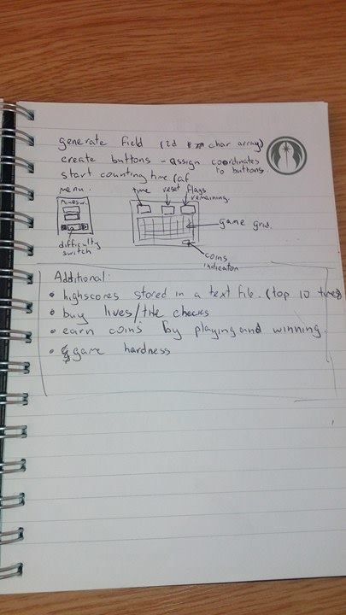design 1

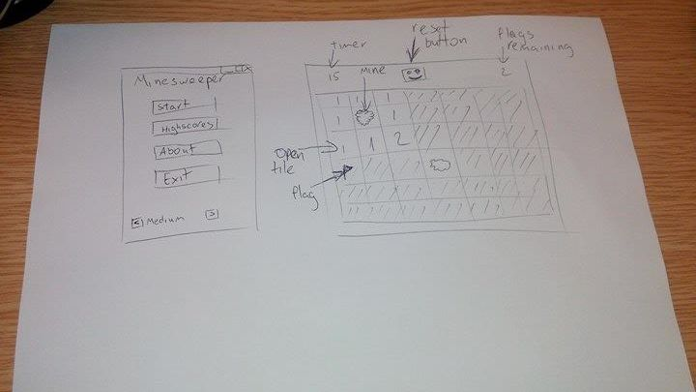

design 2