Question: What If we replaced global maximum with 1D-peak In Attempt #2? Would That work?

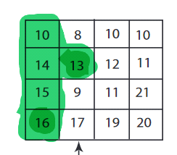

Assumption: Indexing starts with 1, not 0.

Let the matrix be 'a'

j = 4/2 = 2

1. Pick column j = 2.

2. find a peak, 13 is one such peak located at i = 2 and j = 2.

3. Compare it with adjuscent element, a[2][3] < a[2,2] but a[2] [1] > a[2,2]. So, we choose all those columns left to j = 2 for further analysis.

4. Fortunetly, it has only a single column, Finding the peak of this column gives a[4][1] = 16.

5. It can be observed that, a[4][1] is not a 2-D peak.

Hence, replacing max with 1-D peak will not give the same result.