Lundervold-AI Pre-Examination Screening
An AI-Initiated, Rule-Based Pipeline for Pre-Examination Screening in Clinical Neuropsychology
Astri J. Lundervold^{a,b}, Birgitte Berentsen^{c}, Arvid Lundervold^{d,e}
ª Department of Clinical and Biological Psychology, University of Bergen, Bergen, Norway
^{b} Department of Geriatric Medicine, Haraldsplass Deaconess Hospital AS Surgical Clinic, Bergen, Norway
^{c} National Centre for Functional Gastrointestinal Disorders, Department of Medicine, Haukeland University Hospital, Bergen, Norway
^{d} Department of Biomedicine, University of Bergen, Bergen, Norway
^{e} Mohn Medical Imaging and Visualization Centre (MMIV), Department of Radiology, Haukeland University Hospital, Bergen, Norway

Corresponding author:
Astri J. Lundervold
Department of Clinical and Biological Psychology, University of Bergen, Christiesgate 12, 5015 Bergen, Norway
Email: Astri.Lundervold@uib.no
ORCID iDs:
Astri J. Lundervold: https://orcid.org/0000-0002-6819-6164
Birgitte Berentsen: https://orcid.org/0000-0003-3574-7078
Arvid Lundervold: https://orcid.org/0000-0002-0032-4182

Abstract word count: 224
Manuscript word count (excluding title page, abstract, references, tables, and figures): 4961

Abstract
Objective. We present a proof-of-concept framework for automated pre-examination screening in clinical neuropsychology. Because fully digital cognitive instruments are not yet universally available, the framework is demonstrated on existing data from a study of irritable bowel syndrome (IBS). A deterministic pipeline transforms multi-domain scores into a structured clinical analysis with cross-domain reasoning and audience-tailored reports.
Method. The pipeline processes five instruments (Bergen Insomnia Scale [BIS], Conners' CPT-3, Chalder Fatigue Scale, Hospital Anxiety and Depression Scale [HADS], and the Repeatable Battery for the Assessment of Neuropsychological Status [RBANS]), applying published cutoffs and cohort-relative summaries. For each patient it generates an eight-step rule-based reasoning chain, cohort-contextualized visualizations, and PDF reports in three variants for clinical peers, referring physicians, and patients. Analyses were performed on an analysis-ready cohort dataset comprising 105 adults (65 IBS, 40 healthy controls) from the Bergen Brain–Gut–Microbiota study. The pipeline was co-developed with an AI coding assistant; no AI is used at runtime.
Results. The pipeline identified flagged findings in sleep (50%), fatigue (40%), anxiety (35%), and attention (30%), with multi-domain flags in 60%. Cross-domain reasoning chains linked co-occurring findings to plausible mechanisms (e.g., insomnia–fatigue–attention cascades). Two case illustrations demonstrated differentiated clinical formulations across diverse profiles.
Conclusions. The framework augments rather than replaces clinical judgment, and its transparent, reproducible architecture supports professional oversight. Full realization depends on the ongoing digitalization of cognitive assessment instruments for remote administration.

Keywords: Decision Support Systems, Clinical; Neuropsychological Tests; Artificial Intelligence; Irritable Bowel Syndrome; Cognitive Dysfunction; Electronic Health Records

Statement of Research Significance
Research Question(s) or Topic(s): Can a transparent, rule-based system that combines questionnaire and cognitive screening data into an integrated clinical summary support neuropsychologists during the planning phase of an outpatient examination?
Main Findings: Applied to one hundred and five adults with and without irritable bowel syndrome, the system produced patient-level summaries that highlighted clinically meaningful patterns across sleep, fatigue, mood, attention, and broader thinking ability, and generated readable summaries tailored separately for clinical colleagues, referring doctors, and patients and their families.
Study Contributions: The work shows that a deterministic, rule-based system can deliver structured pre-examination summaries without using artificial intelligence at the moment the patient is processed. Because every step traces back to an explicit rule, the approach offers a transparent and traceable model for using artificial intelligence safely during the design phase while keeping clinical decisions firmly with the neuropsychologist.

Introduction
In outpatient neuropsychological practice, clinicians often begin their pre-examination preparation with a referral letter and a set of intake questionnaires that must be synthesized into a clinically meaningful picture of the patient's difficulties and likely needs. This synthesis requires forming preliminary hypotheses about which cognitive, emotional, and functional domains are most relevant, whether interactions across domains are likely to affect test performance, and which aspects of the examination should be prioritized. This work is often done under time pressure and with limited opportunity for systematic review. As a result, clinically relevant patterns may be overlooked, and the examination may default to a standard battery rather than being tailored to the individual patient. More broadly, neuropsychologists must balance clinical productivity with precision in patient care while integrating complex multi-domain information, tailoring assessments to the individual patient, and preparing reports that are both clinically accurate and understandable to others. Report writing itself remains a major workload burden, often requiring two to ten hours per patient depending on report length and patient complexity (Postal et al., 2018). In this setting, tools that can support efficiency while preserving clinical precision are naturally of interest.
This helps explain why artificial intelligence has become increasingly relevant to neuropsychology. In a recent perspective article, Lundervold (2025) proposed the framework of precision neuropsychology, within which incorporating AI into practice presents both opportunities and risks. Used carefully and ethically, AI may help reduce clinician workload, improve access to services, and extend aspects of neuropsychological care to underserved populations (Kronenberger et al., 2025). At the same time, such use must remain transparent, clinically grounded, and subject to professional oversight so that computational support strengthens rather than displaces clinical judgment (DeRight & Puente, 2026; Lundervold, 2025).
Despite broader advances in medical AI (Meskó & Topol, 2023; Thirunavukarasu et al., 2023), relatively few concrete changes in everyday neuropsychological practice can be attributed directly to AI adoption (DeRight & Puente, 2026). Existing applications have mainly focused on computerized testing, automated scoring, and diagnostic classification (Andersen et al., 2026; Parsons et al., 2018). These developments are useful for organizing scores and findings, but they do not address the interpretive task at the center of neuropsychological work: bringing cognitive, emotional, and genetic and environmental factors together into a coherent clinical formulation. In addition, neuropsychological reports must be tailored to the differing needs of patients and referral sources (Postal et al., 2018).
This leaves an important gap between what automated systems can calculate and what clinicians need before meeting the patient. In practice, the neuropsychologist must consider not only whether a domain is elevated, but also how findings relate to one another and which aspects of the examination deserve particular attention. Support at this stage therefore requires more than score reporting. It requires a structured way of relating findings across domains so that screening data can inform examination planning in a clinically meaningful way.
IBS provides a useful context for examining this challenge. It is a common functional gastrointestinal disorder affecting approximately 14% of the global population and associated with chronic abdominal pain, altered bowel habits, and reduced quality of life (Arif et al., 2025). Through the gut–brain axis (Cryan et al., 2019; Mayer et al., 2015), IBS may also be linked to sleep disturbance (Tu et al., 2017), fatigue (Han & Yang, 2016), emotional symptoms such as anxiety and depression (Staudacher et al., 2023), and more subtle cognitive difficulties (Billing et al., 2024; Lam et al., 2019). Because these difficulties often co-occur and may influence one another, IBS offers a clinically relevant context for examining how multi-domain screening data may be integrated before formal assessment. In the present study, this question is examined using data from the Bergen Brain–Gut–Microbiota study (Berentsen et al., 2020), and the data set presented in the present study overlaps with data analyzed in prior work on psychological distress subgroups in this cohort (Lundervold et al., 2024). Both that study and a subsequent analysis (Lundervold et al., 2026) have shown considerable overlap in neuropsychological profiles between IBS patients and healthy controls, making the full cohort a useful testbed across a broad range of symptom profiles.
In this study, we present a fully automated, deterministic pipeline as a proof-of-concept framework for pre-examination screening in outpatient neuropsychological practice. Using five established instruments covering sleep, fatigue, emotional distress, sustained attention, and neurocognitive function, the pipeline applies published cutoffs together with cohort-based interpretive rules to generate a structured clinical overview, visual summaries, and report-ready outputs. It is intended as decision support for the pre-examination phase rather than as an autonomous diagnostic system, and the clinician retains full responsibility for diagnostic and therapeutic conclusions.
Method
Participants
The cohort comprises N = 105 adults: 65 patients meeting Rome IV criteria for IBS and 40 age- and gender-matched healthy controls (HC). Participants were recruited through the National Centre for Functional Gastrointestinal Disorders at Haukeland University Hospital, Bergen, Norway, as part of the Bergen Brain–Gut–Microbiota (B-BGM) study (Berentsen et al., 2020). Inclusion criteria for IBS patients required an Irritable Bowel Syndrome Severity Scoring System (IBS-SSS) score ≥ 175, corresponding to at least moderate symptom severity (Francis et al., 1997).
The study was conducted in accordance with the Declaration of Helsinki and was approved by the Regional Committee for Medical and Health Research Ethics, South East Norway (REK2015-01621). All participants provided written informed consent.
All analyses were performed on an analysis-ready cohort file derived from the source dataset after documented data cleaning, while the raw source file was preserved unchanged. The cleaning decisions are documented in the project repository.
Demographic characteristics are summarized in Table 1. The IBS group included three subtypes: IBS-D (diarrhea-predominant, n = 24), IBS-C (constipation-predominant, n = 9), and IBS-M (mixed, n = 32). IBS symptom severity was assessed using the Irritable Bowel Syndrome Severity Scoring System, IBS-SSS (range 0–500; available for n = 56 IBS patients), with a mean of M = 273.8 (SD = 71.3).
[INSERT TABLE 1 HERE]
Neuropsychological Instruments
Five assessment domains were evaluated using established instruments with known psychometric properties. The instruments differ in their administration requirements, which has direct implications for how much of the screening profile can be collected before the patient's first clinic visit. Three self-report questionnaires, the Bergen Insomnia Scale (BIS), Chalder Fatigue Scale (Chalder), and Hospital Anxiety and Depression Scale (HADS), can be administered digitally and completed by patients remotely. The Conners' Continuous Performance Test, Third Edition (CPT-3), is self-administered but currently requires proprietary software on a clinic computer, restricting it to in-clinic use. The Repeatable Battery for the Assessment of Neuropsychological Status (RBANS) requires administration by a trained psychometrician. Thus, in the current landscape, the questionnaire data can arrive before the consultation, while the cognitive test data require an initial clinic-based session:
1. Sleep/Insomnia – Bergen Insomnia Scale (BIS) [self-report]: Six items scored 0–7 (days/week), total 0–42 (Pallesen et al., 2008). Pipeline cutoffs: Minimal (≤ 6), Mild (7–14), Moderate (15–24), Severe (≥ 25); clinical flags at total ≥ 19 or ≥ 3 items at ≥ 3 days/week.
2. Sustained attention – Conners' CPT-3 [self-administered, clinic-based]: A 14-minute continuous performance test yielding T-scored metrics (M = 50, SD = 10) including Detectability (d′), Omissions, Commissions, and Hit Reaction Time (Conners, 2014). Pipeline thresholds: T ≥ 60 (mildly elevated), T ≥ 65 (clinically significant).
3. Fatigue – Chalder Fatigue Scale [self-report]: Eleven items with bimodal scoring (0–11) covering physical and mental fatigue (Chalder et al., 1993). Pipeline caseness threshold: ≥ 4.
4. Emotional distress – HADS [self-report]: Anxiety (HADS-A) and Depression (HADS-D) subscales, each 0–21 (Zigmond & Snaith, 1983). Pipeline cutoffs: Normal (≤ 7), Borderline (8–10), Clinical (≥ 11) (Bjelland et al., 2002).
5. Neurocognition – RBANS [clinician-administered]: Ten subtests assessing the five cognitive domains (Immediate Memory, Visuospatial/Constructional, Language, Attention, Delayed Memory) were administered by a trained psychometrician in approximately 30 minutes using the Norwegian version (Randolph, 2013). In the pipeline, raw RBANS subtests are standardized within the cohort and averaged into domain summary composites aligned with these five domains, while recognition scores are retained as an auxiliary summary and RBANS_Sum_Raw is used as a broad total-score indicator. Cognitive flags are raised for marked cohort-relative weakness (domain-summary or total-score percentile < 16).
The CPT-3 and RBANS are retained as separate domains because they assess complementary aspects of cognition: the CPT-3 targets sustained attention and response inhibition, while the RBANS covers broad cognitive function. Their separation also enables the reasoning engine to distinguish differential patterns (e.g., isolated sustained attention deficits driven by fatigue vs. broader cognitive involvement).
The Deterministic Pipeline
Architecture overview
The deterministic pipeline is implemented as a standalone Python program that combines a quantitative analysis layer with structured clinical reasoning. The pipeline was applied to the analysis-ready cohort file described above. Cleaning decisions that required source verification were not overwritten at runtime. Instead, the upstream files preserved the recorded values together with explicit flags, allowing downstream interpretation to remain conservative and auditable.
Clarification on the role of AI. During development, the pipeline was co-authored with an AI coding assistant (Cursor IDE with Claude Opus 4.6 and GPT-5.4); all AI-generated content was reviewed, verified, and edited by the authors. At runtime, however, no AI is involved: the deployed pipeline contains no large language model API calls, no AI client libraries, and no network dependencies. All clinical classifications, reasoning chains, and recommendations are produced by deterministic, rule-based logic operating on published cutoffs and pre-authored text templates (Supplementary Material S1). In short, AI was used to author the rules; the rules themselves execute deterministically without AI.
The pipeline processes each patient through five sequential stages:
(i). Data ingestion and preprocessing: Loading the analysis-ready cohort file, computing derived scores (BIS total, Chalder bimodal total, HADS total), and validating score ranges. Upstream cleaning standardizes datatypes, missing-value encoding, and selected metadata labels while preserving unresolved discrepancies as flagged values rather than silently correcting them.
(ii). Per-domain analysis: For each of the five domains, the pipeline applies established clinical cutoffs to generate severity classifications and identify clinically significant findings. For the self-report instruments (BIS, Chalder, HADS), cutoffs are applied directly to raw or derived sum scores. For CPT-3, the pipeline uses software-generated T-scores and interprets higher values as less favorable across the selected metrics; Detectability, Omissions, Commissions, HRT, HRT SD, Perseverations, and Variability are flagged at T ≥ 60/T ≥ 65. For RBANS, the pipeline uses cohort-standardized raw subtests rather than age-corrected index columns, with a total raw-score composite retained as a broad overall indicator. Cognitive flags are raised for marked cohort-relative weakness (domain-summary or total-score percentile < 16). Because missingness is handled on a domain-specific basis, the effective denominator varies across measures.
(iii). Cross-domain pattern analysis: A rule-based engine identifies co-occurring elevations across domains and generates mechanistic hypotheses. For example, elevated BIS combined with low cohort-relative RBANS memory summaries triggers hypotheses about impaired sleep-dependent memory consolidation, whereas co-occurring HADS anxiety elevation with CPT decrements triggers hypotheses about anxiety-related attentional interference. The full set of cross-domain rules is documented in Supplementary Material S1.
(iv). Eight-step clinical reasoning chain: A structured protocol designed to mirror the integrative reasoning used in clinical neuropsychological interpretation (Figure 1; example content in Table 2). Step 1 establishes demographic and clinical context. Steps 2–6 assess each domain independently: sleep (BIS), fatigue (Chalder), emotional distress (HADS), sustained attention (CPT), and neurocognition (RBANS). Step 7 integrates findings across domains, identifying co-occurring patterns and formulating mechanistic hypotheses. Step 8 synthesizes the integrated profile into a prognostic formulation. The full reasoning-chain specification is provided in Supplementary Material S1.
(v). Output generation: Three output streams are produced: (a) a structured JSON file containing quantitative results, interpretations, flags, reasoning steps, and recommendations; (b) two visualization types, a multi-panel domain profile and a radar plot, each produced in three audience-tailored variants; and (c) a compiled PDF report integrating text, tables, and figures.
[INSERT FIGURE 1 HERE]
Audience-tailored output design
A distinctive feature of the pipeline is the generation of outputs tailored to three audiences (Table 3):
• Clinical peers: Full statistical detail including z-scores, percentile ranks, and effect sizes, with technical labels and expanded radar plots.
• Referring physicians: Simplified summaries with traffic-light color coding, brief clinical annotations, and compact radar plots designed for rapid triage and referral decisions.
• Patients and families: Accessible infographic-style outputs with plain-language labels, qualitative anchors, and non-alarming visual design.
All visualizations use a color-blind-friendly palette (Wong, 2011) and normalize scores to a common percentile-of-wellness scale (0–100, higher = better functioning) with inverted polarity for scales where high raw scores indicate worse outcomes.
Recommendation engine
The pipeline generates two categories of recommendations relevant to neuropsychological decision-making: therapeutic interventions and further examinations. Each recommendation is explicitly linked to the domain findings that justify it and uses conditional logic intended to reflect clinical reasoning (e.g., “If memory weaknesses persist after sleep intervention, consider expanded memory testing”). Recommendations reference established treatment guidelines where applicable (e.g., cognitive behavioral therapy for insomnia [CBT-I]: Grade A recommendation; Riemann et al., 2017). They are intended as a starting point for clinician review rather than as stand-alone clinical advice.
Computational reproducibility
The pipeline source code and anonymised example outputs are available in a public GitHub repository (https://github.com/arvidl/AI-driven-neuropsych-screening), together with an environment specification file (environment.yml) for dependency replication. The cohort dataset is not publicly available due to ethics approval conditions; reproducibility at the dataset level is supported by documentation of cleaning decisions in the repository. The complete audience-tailored reports generated for the two case illustrations are provided as supplementary files.
Statistical Analysis
Cohort-level group comparisons
IBS–HC group differences across all five domains were reassessed on the analysis-ready cohort file and are treated here as secondary, context-setting analyses rather than as the paper's primary empirical contribution. Comparisons used two-tailed independent-samples Welch's t-tests with effect sizes reported as Cohen's d (pooled SD). Significance was set at α = .05 with no correction for multiple comparisons, consistent with the exploratory proof-of-concept nature of the study. Domain-specific complete-case samples were used for each comparison.
Pipeline output evaluation
Pipeline outputs were re-evaluated on the analysis-ready cohort file along three dimensions: (a) quantitative accuracy, that is, whether computed scores, percentiles, cutoff classifications, and flags matched the cleaned input data and documented scoring rules; (b) clinical coherence, that is, whether the generated reasoning chains remained clinically plausible after data cleaning and score verification; and (c) output completeness, that is, whether analyzable patient-level outputs could be generated across the full cohort.
Results
Cohort Characteristics
Demographic and clinical characteristics from the analysis-ready cohort file are presented in Table 1. The IBS and HC groups did not differ significantly in age (t(77) = 0.90, p = .37) or education (t(68) = −1.54, p = .13; HC n = 28 because of missing data). The cohort was predominantly female (74.3%), consistent with the known sex distribution of IBS (Sperber et al., 2021). The two groups were well matched on sample-level characteristics. Domain-specific denominators vary across instruments because of blockwise missingness in a subset of participants. For clarity, the RBANS rows in Table 1 report conventional index scores for cohort-level group comparison, whereas the patient-level pipeline uses raw RBANS subtests and cohort-standardized summary composites.
Group Differences Across Domains
Table 1 summarizes IBS–HC comparisons. Particularly pronounced differences emerged for fatigue (Chalder total, p < .001), anxiety (HADS-A, p < .001), insomnia (BIS total, p < .001), and depression (HADS-D, p < .001). CPT Detectability also differed significantly between groups (p < .01), and CPT Omissions reached significance as well (p < .01). RBANS index scores revealed significant IBS–HC differences for Total Scale (p < .01), Immediate Memory (p < .01), Attention (p < .05), and Delayed Memory (p < .05), with non-significant differences for Visuospatial and Language.
These findings remain consistent with the gut-brain axis literature (Cryan et al., 2019; Mayer et al., 2015): IBS patients showed elevated insomnia, fatigue, and emotional distress relative to controls. At the same time, these group comparisons are secondary to the main purpose of the paper, which is to demonstrate a transparent deterministic screening pipeline.
Pipeline Output Summary
The analysis-ready cohort file was processed successfully for all 105 participants. For each participant, the pipeline generates a structured clinical analysis, a report-ready LaTeX source file, a compiled PDF report, and two visualization families (multi-panel profiles and radar plots) in three audience-tailored variants. Thus, when full report generation is invoked, the pipeline yields 15 output files per participant. The pipeline preserved the overall distributional pattern while domain-flag counts reflect the scoring and classification rules described above.
Distribution of clinical findings
The distribution of domain-specific flags across the 105 pipeline summaries was as follows:
• Sleep (BIS): 53 participants (50%) triggered a sleep-domain flag through moderate/severe insomnia classification, total score ≥ 19, and/or ≥ 3 BIS items endorsed at ≥ 3 days/week; 40 of these were IBS patients.
• Fatigue (Chalder): 42 participants (40%) met the fatigue caseness threshold (≥ 4); 36 were IBS patients.
• Emotional distress (HADS): 37 participants (35%) reached borderline or clinical caseness on the Anxiety subscale (≥ 8); 31 were IBS patients. For Depression, 8 participants (8%) reached borderline or clinical caseness; 7 were IBS patients.
• Attention (CPT-3): 32 participants (30%) had at least one flagged CPT metric (Detectability, Omissions, Commissions, HRT, HRT SD, Perseverations, or Variability at T ≥ 60); 24 of these were IBS patients.
• Neurocognition (RBANS): 48 participants (46%) met the pipeline's cognition-flag criterion, defined as at least one RBANS domain-summary percentile < 16 or a total raw-score percentile < 16; 36 of these were IBS patients.
The pipeline identified multi-domain elevations (flags in ≥ 2 domains) in 63 participants (60%), predominantly within the IBS group (n = 51).
Case Illustrations
We present two illustrative cases demonstrating the pipeline's clinical reasoning and audience-tailored output. Table 2 summarizes the eight-step reasoning chain across both cases and highlights the contrast between a circumscribed sleep-centered profile and a broader multi-domain profile.
[INSERT TABLE 2 HERE]
Case 1: IBS patient with circumscribed sleep disturbance
The patient is a 38-year-old male with IBS-D (moderate severity, IBS-SSS = 195).
Pipeline output. As summarized in Table 2, the pipeline produced a relatively focal profile centered on clinically elevated sleep disturbance, with Detectability at the CPT flag threshold and otherwise preserved fatigue, mood, and cohort-relative cognition. The reasoning chain therefore characterized the case as an interacting sleep–attention pattern and recommended prioritising CBT-I and structured sleep-hygiene measures, with re-evaluation of sustained attention if difficulties persist after sleep treatment.
The corresponding clinical multi-panel profile and audience-tailored radar plots are shown in Figures 2 and 3. The complete audience-tailored report for this case is provided as Supplementary Material S2 (case_1_report.pdf).
[INSERT FIGURE 2 HERE]
[INSERT FIGURE 3 HERE]
Clinical interpretation Case 1 after reading the rule-based report. Prior to examination, these data warrant careful consideration in planning the assessment. The convergence of moderate insomnia, borderline attentional inefficiency, and verbal-learning weakness could suggest sleep disturbance as a principal upstream contributor, but this interpretation should be held tentatively. Detectability (d’), a core index of the capacity to discriminate target from non-target stimuli, is of particular concern. In IBS, hypervigilance toward somatic and threat-related stimuli may lower the response criterion independently of sleep quality, reducing detectability even without a primary attentional capacity deficit (Akbari et al., 2025). The upcoming examination should therefore disentangle the relative contributions of sleep disruption and hypervigilance-driven arousal, and determine whether the verbal memory difficulties reflect sleep-mediated consolidation impairment or a more specific learning vulnerability. Sleep-focused intervention remains indicated, but the full examination should precede any decision to defer broader neuropsychological follow-up.
Case 2: IBS patient with multi-domain involvement
A second IBS patient (IBS-M subtype, female, age 31, IBS-SSS = 305) provides a contrasting example of multi-domain involvement.
Pipeline output. As summarized in Table 2, the second case showed a broader profile with severe insomnia, maximum fatigue caseness, clinical anxiety, and cohort-relative RBANS weakness, while sustained attention remained within expected range and depression remained unflagged. The pipeline's cross-domain reasoning linked insomnia and fatigue, noted the bidirectional mood–sleep relationship, and supported a coordinated multi-component intervention strategy before reassessing the cognitive weaknesses, with close gastroenterology follow-up given the high IBS symptom burden.
The corresponding clinical multi-panel and radar visualizations for this case are shown in Figures 4 and 5. The complete audience-tailored report for this case is provided as Supplementary Material S3 (case_2_report.pdf).
[INSERT FIGURE 4 HERE]
[INSERT FIGURE 5 HERE]
[INSERT TABLE 3 HERE]
Clinical interpretation Case 2 after reading the rule-based report. While the AI-generated report appropriately identifies sleep disturbance, fatigue, and anxiety as primary intervention targets, the figures reveal several features that warrant clinical attention beyond what the rule-based output captures. Most notably, the RBANS subtest profile shows a degree of specificity that is difficult to attribute to insomnia or anxiety alone. The Naming subtest falls severely below the cohort mean, a pattern more consistent with a language network vulnerability than with the diffuse processing inefficiency typically associated with sleep disruption or elevated arousal. Fatigue and insomnia tend to impair processing speed, working memory, and retrieval, but not confrontation naming, and this dissociation should prompt careful observation during the examination itself. Equally important is the stark contrast visible in the radar plots between preserved attentional performance, with concentration near the 50th percentile, and severely compromised memory and thinking at approximately the 3rd percentile. This degree of dissociation argues against a unitary sleep-fatigue explanation and raises the possibility of a primary cognitive vulnerability operating independently of the functional factors identified by the pipeline. Taken together, these observations suggest that comprehensive neuropsychological follow-up should proceed concurrently. The severity and specificity of the cognitive profile visible here justifies prioritizing clarification of the memory and language weaknesses as an immediate clinical step rather than a deferred one.
Discussion
Summary of findings
We developed and demonstrated a deterministic, rule-based pipeline for automated pre-examination screening in outpatient neuropsychological practice. Applied to a cohort of 105 participants (65 IBS, 40 HC), the pipeline identified clinically significant findings across five assessment domains, generated structured cross-domain reasoning chains, and produced audience-tailored outputs for clinical peers, referring physicians, and patients.
Its primary purpose is to provide the neuropsychologist with a structured synthesis of available screening data before the clinical encounter. In this way, it may reduce the time needed for pre-examination preparation and enable a more targeted clinical interview and test selection.
The main contribution of the framework is not automated diagnosis, but automated integration. Rather than merely organizing scores, the pipeline combines domain-specific findings into a preliminary clinical formulation and expresses that formulation in formats adapted to different end users. The case illustrations suggest that this approach can differentiate between relatively circumscribed and broader multi-domain profiles while also making explicit where subsequent clinician review remains essential.
Relation to prior work
Traditional template-based systems can present summaries with scores but typically provide more limited support for cross-domain reasoning.
A central feature of the pipeline is the eight-step reasoning chain, which mirrors the sequence of integrative judgments clinicians make when reviewing screening data. Rather than listing isolated elevations, it links findings across domains and generates clinically plausible hypotheses about how sleep, fatigue, emotional distress, sustained attention, and broader cognition may interact. In this sense, the framework aims to support both interpretation and communication.
The deterministic architecture is important in this context. Clinicians need to understand why a tool generated a particular interpretation, and to be able to challenge it when the clinical picture calls for it. Because every classification, flag, reasoning step, and recommendation traces back to an explicit rule, the pipeline offers transparency, reproducibility, and traceability. This is a practical advantage in clinical neuropsychology, where interpretive judgment is itself a core professional competency and where opaque generative output would be difficult to justify clinically.
Clinical implications
From a workflow perspective, the pipeline is best understood as a structured briefing tool for the pre-examination phase. In many outpatient services, patients or families already provide questionnaires or background information before the appointment (e.g., King's College Hospital NHS Foundation Trust, 2026; Stanford Health Care, 2026). The present framework extends that workflow by automatically integrating the available screening data into a cross-domain summary before the first face-to-face encounter. Instead of reviewing separate forms manually at the start of the consultation, the clinician receives a synthesized overview of flagged areas, possible cross-domain interactions, and preliminary next-step suggestions.
This may have several practical benefits. The screening summary may help clinicians prioritise patients with multi-domain elevations, guide the selection of follow-up instruments, and serve as a discussion aid during the clinical interview. Because the pipeline applies the same cutoffs and rules across patients, it may also reduce inconsistency that can arise when intake material is reviewed using memory or idiosyncratic judgment alone, and the standardized output may serve as a starting point for later documentation (Postal et al., 2018).
The cross-domain component is particularly relevant to neuropsychological practice. Its purpose is not to infer causality autonomously, but to highlight clinically meaningful constellations of findings that might otherwise remain fragmented across separate instruments. Such outputs are best understood as hypothesis-generating rather than definitive and require clinical verification during the subsequent assessment.
The audience-tailored outputs address a related practical problem. Referring physicians often prefer brief, targeted summaries, whereas patients and family members benefit from accessible language and visual presentation (Gruters et al., 2022; Postal & Armstrong, 2024; Postal et al., 2018). By producing distinct but data-equivalent outputs for clinical peers, physicians, and patients, the framework supports communication without requiring the clinician to create multiple reports from scratch.
The case illustrations clarify an important boundary condition: the pipeline produces a structured preliminary formulation, not a complete clinical interpretation. In both cases, the rule-based report identified the major domain findings, but clinician interpretation added inferences the rules alone did not capture. In Case 1, this concerned the mechanistic significance of reduced detectability, where hypervigilance-driven criterion shift may operate independently of sleep quality. In Case 2, it concerned the subtest-level specificity of the RBANS profile, where the naming deficit and the dissociation between preserved attention and compromised memory and language raised the possibility of a primary cognitive vulnerability. Together, these cases illustrate that rule-based reasoning performs well in integrating domain-level findings, but that clinician interpretation remains essential for recognizing mechanistic dissociations and determining the sequencing of intervention and further assessment.
The framework is therefore best understood as clinician-supervised decision support. Rules encode population-level evidence and predefined thresholds, whereas a skilled neuropsychologist integrates contextual factors, domain knowledge, clinical experience, and the patient's own account of difficulties. The pipeline does not diagnose and does not interact with patients; all outputs require professional review and may need to be modified when factors such as language, education, culture, sensory limitations, genetics, or referral context alter the meaning of the data. In this respect, the framework may extend efficiency and consistency while preserving the neuropsychologist's interpretive authority (Lundervold, 2025).
Limitations
Several limitations should be acknowledged. The present study is a single-cohort, cross-sectional proof of concept based on a specific instrument battery (BIS, CPT-3, Chalder, HADS, RBANS), and extension of the framework to other batteries or clinical populations would require reconfiguration of cutoffs, variable mappings, and domain-specific logic. In addition, the validation reported here concerns computational accuracy and output completeness rather than formal clinical validity. Further work comparing pipeline-generated reports with clinician-written reports, using blinded expert ratings, is needed before broader implementation can be considered.
The interpretive scope is also bounded by the structure of the reasoning rules. The cross-domain engine generates plausible hypotheses but does not establish causal relationships, and its outputs require clinical evaluation. Cohort-relative percentiles are based on N = 105, and the RBANS summaries are cohort-standardized rather than norm-corrected, which limits interpretive precision. Finally, the full pre-examination workflow envisioned by the framework was not achievable within the present design. Although remotely administered cognitive tools are already available in some settings, the present dataset required clinic-based collection of CPT-3 and RBANS data. The study did not examine usability, accessibility, or equity, and it is unknown how the pipeline's outputs would perform for patients with limited digital access, language barriers, low health literacy, or disability-related access needs.
Future directions
Future work should address both clinical translation and further development of the framework. One important direction is to examine how the pipeline performs when paired with cognitive assessment tools that allow a larger proportion of the screening profile to be collected before the first clinic visit. Another is longitudinal application, as repeated processing of patient data could support structured monitoring of symptom change and treatment response over time. Because the pipeline is modular, it may also be extended to additional neuropsychological instruments and clinical populations, allowing evaluation of how well the present reasoning logic generalizes across assessment contexts.
Equally important will be studies of usability and implementation in routine care. Evaluation involving neuropsychologists, referring physicians, and patients is needed to determine whether the audience-tailored outputs improve examination planning, clinical communication, and workflow efficiency. Such work should test performance across patients with differing language backgrounds, digital access, health literacy, and disability-related needs. In the longer term, integration with electronic health record systems may support use within ordinary clinical workflows, provided that transparency, governance, and professional accountability remain central.
This work also aligns with recent proposals for characterizing AI systems by their cognitive capabilities and benchmarking them against meaningful human baselines (Burnell et al., 2026).
Conclusions
The present study introduces a proof-of-concept framework for automated pre-examination screening in outpatient neuropsychological practice. Within the limits of the present dataset and rule set, the deterministic pipeline identified clinically relevant findings, generated structured cross-domain hypotheses, and produced audience-tailored outputs for different stakeholders. The framework is intended to support, rather than replace, neuropsychological judgment, and its deterministic architecture offers transparency, traceability, and reproducibility. At the same time, it should be regarded as an initial demonstration rather than as a fully validated model for routine clinical use. Its clinical value will depend on formal validation, usability testing, and careful integration with assessment workflows.
Acknowledgements
The authors thank the participants in the Bergen Brain–Gut–Microbiota study for their contributions. The pipeline was developed using open-source Python tools and LaTeX, and was co-authored with AI assistance (Claude Opus 4.7, Anthropic, accessed via the Cursor IDE [https://cursor.com], April 2026). The AI coding assistant contributed to writing the Python code, designing the clinical decision rules, authoring the narrative text templates, implementing the visualizations, and drafting portions of the manuscript text for language, clarity, and consistency. All AI-generated content was reviewed, verified, and edited by the authors. The deployed deterministic pipeline uses no AI models at runtime.
Competing Interests
The authors declare none.
Sources of Support
This work was supported by the University of Bergen. The original data collection (Bergen Brain–Gut–Microbiota project) was funded by the Research Council of Norway (grant ID FRIMED-BIO276010 and project number 294594), Helse Vest's Research Funding (grant ID HV912243), and the Trond Mohn Research Foundation (grant number BFS2018TMT0).
Data Availability Statement
The cohort dataset contains clinical neuropsychological data collected under ethics approval and is not publicly available due to participant confidentiality and ethics approval conditions. Data may be made available upon reasonable request to the corresponding author, subject to institutional data sharing agreements. The pipeline source code and anonymised example outputs are openly available at https://github.com/arvidl/AI-driven-neuropsych-screening. The complete audience-tailored reports for the two case illustrations are provided as Supplementary Material S2 and S3.
Supplementary Material
The supplementary material for this article can be found at [update to provide the DOI here]. Supplementary Material S1 (supplementary_methods.pdf) contains the prompt-development and rule-specification materials, including the complete system prompt specification, the five assessment domains, visualization designs, audience-tailored output variants, and the structured JSON output format. S1 also provides a transparent account of AI's role in the project (development time vs. runtime), followed by the complete set of explicit decision rules. Supplementary Material S2 (case_1_report.pdf) provides the complete audience-tailored pipeline report for Case 1. Supplementary Material S3 (case_2_report.pdf) provides the corresponding report for Case 2.
References
Akbari, R., Salimi, Y., Dehghani-Aarani, F., & Rezayat, E. (2025). Attention in irritable bowel syndrome: A systematic review of affected domains and brain-gut axis interactions. Journal of Psychosomatic Research, 191, 112067. https://doi.org/10.1016/j.jpsychores.2025.112067
Andersen, S. L., Lundervold, A. J., & Ronold, E. H. (2026). Automated versus human scoring of the Rey–Osterrieth Complex Figure Test: A rapid review. Frontiers in Psychiatry, 16, 1746720. https://doi.org/10.3389/fpsyt.2025.1746720
Arif, T. B., Ali, S. H., Bhojwani, K. D., Sadiq, M., Siddiqui, A. A., Ur-Rahman, A., Khan, M. Z., Hasan, F., & Shahzil, M. (2025). Global prevalence and risk factors of irritable bowel syndrome from 2006 to 2024 using the Rome III and IV criteria: A meta-analysis. European Journal of Gastroenterology & Hepatology, 37(12), 1314–1325. https://doi.org/10.1097/MEG.0000000000002994
Berentsen, B., Nagaraja, B. H., Teige, E. P., Lied, G. A., Lundervold, A. J., Lundervold, K., Steinsvik, E. K., Hillestad, E. R., Valeur, J., Brønstad, I., Gilja, O. H., Osnes, B., Hatlebakk, J. G., Haász, J., Labus, J., Gupta, A., Mayer, E. A., Benitez-Páez, A., Sanz, Y., … Hausken, T. (2020). Study protocol of the Bergen brain–gut–microbiota-axis study. Medicine, 99(37), e21950. https://doi.org/10.1097/MD.0000000000021950
Billing, J., Berentsen, B., Lundervold, A., Hillestad, E. M. R., Lied, G. A., Hausken, T., & Lundervold, A. J. (2024). Cognitive function in patients with irritable bowel syndrome: Impairment is common and only weakly correlated with depression/anxiety and severity of gastrointestinal symptoms. Scandinavian Journal of Gastroenterology, 59(1), 25–33. https://doi.org/10.1080/00365521.2023.2256916
Bjelland, I., Dahl, A. A., Haug, T. T., & Neckelmann, D. (2002). The validity of the Hospital Anxiety and Depression Scale: An updated literature review. Journal of Psychosomatic Research, 52(2), 69–77. https://doi.org/10.1016/S0022-3999(01)00296-3
Burnell, R., Yamamori, Y., Firat, O., Olszewska, K., Hughes-Fitt, S., Kelly, O., Galatzer-Levy, I. R., Morris, M. R., Dafoe, A., Snyder, A. M., Goodman, N. D., Botvinick, M., & Legg, S. (2026). Measuring progress toward AGI: A cognitive framework (Technical report). Google DeepMind. https://storage.googleapis.com/deepmind-media/DeepMind.com/Blog/measuring-progress-toward-agi/measuring-progress-toward-agi-a-cognitive-framework.pdf
Chalder, T., Berelowitz, G., Pawlikowska, T., Watts, L., Wessely, S., Wright, D., & Wallace, E. P. (1993). Development of a fatigue scale. Journal of Psychosomatic Research, 37(2), 147–153. https://doi.org/10.1016/0022-3999(93)90081-P
Conners, C. K. (2014). Conners' Continuous Performance Test 3rd edition (CPT-3): Technical manual. Multi-Health Systems Inc.
Cryan, J. F., O'Riordan, K. J., Cowan, C. S. M., Sandhu, K. V., Bastiaanssen, T. F. S., Boehme, M., Codagnone, M. G., Cussotto, S., Fulling, C., Golubeva, A. V., Guzzetta, K. E., Jaggar, M., Long-Smith, C. M., Lyte, J. M., Martin, J. A., Molinero-Perez, A., Moloney, G., Morelli, E., Morillas, E., … Dinan, T. G. (2019). The microbiota–gut–brain axis. Physiological Reviews, 99(4), 1877–2013. https://doi.org/10.1152/physrev.00018.2018
DeRight, J., & Puente, A. N. (2026). Artificial intelligence in neuropsychological practice: Tool selection, privacy, and billing guidance. The Clinical Neuropsychologist, 1–19. https://doi.org/10.1080/13854046.2026.2635117
Francis, C. Y., Morris, J., & Whorwell, P. J. (1997). The irritable bowel severity scoring system: A simple method of monitoring irritable bowel syndrome and its progress. Alimentary Pharmacology & Therapeutics, 11(2), 395–402. https://doi.org/10.1046/j.1365-2036.1997.142318000.x
Gruters, A. A. A., Ramakers, I. H. G. B., Verhey, F. R. J., Kessels, R. P. C., & de Vugt, M. E. (2022). A scoping review of communicating neuropsychological test results to patients and family members. Neuropsychology Review, 32(2), 294–315. https://doi.org/10.1007/s11065-021-09507-2
Han, C. J., & Yang, G. S. (2016). Fatigue in irritable bowel syndrome: A systematic review and meta-analysis of pooled frequency and severity of fatigue. Asian Nursing Research, 10(1), 1–10. https://doi.org/10.1016/j.anr.2016.01.003
King's College Hospital NHS Foundation Trust. (2026). Neuropsychology. Retrieved March 18, 2026, from https://www.kch.nhs.uk/services/services-a-to-z/neuropsychology/
Kronenberger, O. R., Gottlieb, M. C., & Cullum, C. M. (2025). Large language models in neuropsychology: Emerging applications and ethical considerations [Advance online publication]. The Clinical Neuropsychologist. https://doi.org/10.1080/13854046.2025.2604094
Lam, N. C.-Y., Yeung, H.-Y., Li, W.-K., Lo, H.-Y., Yuen, C.-F., Chang, R. C.-C., & Ho, Y.-S. (2019). Cognitive impairment in irritable bowel syndrome (IBS): A systematic review. Brain Research, 1719, 274–284. https://doi.org/10.1016/j.brainres.2019.05.036
Lundervold, A., Billing, J., Berentsen, B., & Lundervold, A. J. (2026). Patient similarity networks for irritable bowel syndrome: Revisiting brain morphometry and cognitive features. Diagnostics, 16(2), 357. https://doi.org/10.3390/diagnostics16020357
Lundervold, A. J. (2025). Precision neuropsychology in the era of AI. Frontiers in Psychology, 16, 1537368. https://doi.org/10.3389/fpsyg.2025.1537368
Lundervold, A. J., Billing, J. E., Berentsen, B., Lied, G. A., Steinsvik, E. K., Hausken, T., & Lundervold, A. (2024). Decoding IBS: A machine learning approach to psychological distress and gut–brain interaction. BMC Gastroenterology, 24, 267. https://doi.org/10.1186/s12876-024-03355-z
Mayer, E. A., Tillisch, K., & Gupta, A. (2015). Gut/brain axis and the microbiota. The Journal of Clinical Investigation, 125(3), 926–938. https://doi.org/10.1172/JCI76304
Meskó, B., & Topol, E. J. (2023). The imperative for regulatory oversight of large language models (or generative AI) in healthcare. npj Digital Medicine, 6(1), 120. https://doi.org/10.1038/s41746-023-00873-0
Pallesen, S., Bjorvatn, B., Nordhus, I. H., Sivertsen, B., Hjornevik, M., & Morin, C. M. (2008). A new scale for measuring insomnia: The Bergen Insomnia Scale. Perceptual and Motor Skills, 107(3), 691–706. https://doi.org/10.2466/pms.107.3.691-706
Parsons, T. D., McMahan, T., & Kane, R. (2018). Practice parameters facilitating adoption of advanced technologies for enhancing neuropsychological assessment paradigms. The Clinical Neuropsychologist, 32(1), 16–41. https://doi.org/10.1080/13854046.2017.1337932
Postal, K. S., & Armstrong, K. (2024). Feedback that sticks: The art of effectively communicating neuropsychological assessment results (2nd ed.). Oxford University Press.
Postal, K. S., Chow, C., Jung, S., Erickson-Moreo, K., Geier, F., Lanca, M., & Adams, R. L. (2018). The stakeholders' project in neuropsychological report writing: A survey of neuropsychologists' and referral sources' views of neuropsychological reports. The Clinical Neuropsychologist, 32(3), 326–344. https://doi.org/10.1080/13854046.2017.1373859
Randolph, C. (2013). RBANS: Repeatable battery for the assessment of neuropsychological status, Norwegian manual. NCS Pearson, Inc.
Riemann, D., Baglioni, C., Bassetti, C., Bjorvatn, B., Dolenc Grošelj, L., Ellis, J. G., Espie, C. A., Garcia-Borreguero, D., Gjerstad, M., Gonçalves, M., Hertenstein, E., Jansson-Fröjmark, M., Jennum, P. J., Leger, D., Nissen, C., Parrino, L., Paunio, T., Pevernagie, D., Verbraecken, J., … Spiegelhalder, K. (2017). European guideline for the diagnosis and treatment of insomnia. Journal of Sleep Research, 26(6), 675–700. https://doi.org/10.1111/jsr.12594
Sperber, A. D., Bangdiwala, S. I., Drossman, D. A., Ghoshal, U. C., Simren, M., Tack, J., Whitehead, W. E., Dumitrascu, D. L., Fang, X., Fukudo, S., Kellow, J., Okeke, E., Quigley, E. M. M., Schmulson, M., Whorwell, P., Archampong, T., Adibi, P., Andresen, V., Benninga, M. A., … Palsson, O. S. (2021). Worldwide prevalence and burden of functional gastrointestinal disorders, results of Rome Foundation Global Study. Gastroenterology, 160(1), 99–114.e3. https://doi.org/10.1053/j.gastro.2020.04.014
Stanford Health Care. (2026). Patient forms – Neuropsychology Clinic. Retrieved March 18, 2026, from https://stanfordhealthcare.org/medical-clinics/neuropsychology-clinic/what-to-expect/patient-forms.html
Staudacher, H. M., Black, C. J., Teasdale, S. B., Mikocka-Walus, A., & Keefer, L. (2023). Irritable bowel syndrome and mental health comorbidity—Approach to multidisciplinary management. Nature Reviews Gastroenterology & Hepatology, 20(9), 582–596. https://doi.org/10.1038/s41575-023-00794-z
Thirunavukarasu, A. J., Ting, D. S. J., Elangovan, K., Gutierrez, L., Tan, T. F., & Ting, D. S. W. (2023). Large language models in medicine. Nature Medicine, 29(8), 1930–1940. https://doi.org/10.1038/s41591-023-02448-8
Tu, Q., Heitkemper, M. M., Jarrett, M. E., & Buchanan, D. T. (2017). Sleep disturbances in irritable bowel syndrome: A systematic review. Neurogastroenterology & Motility, 29(3), e12946. https://doi.org/10.1111/nmo.12946
Wong, B. (2011). Points of view: Color blindness. Nature Methods, 8(6), 441. https://doi.org/10.1038/nmeth.1618
Zigmond, A. S., & Snaith, R. P. (1983). The Hospital Anxiety and Depression Scale. Acta Psychiatrica Scandinavica, 67(6), 361–370. https://doi.org/10.1111/j.1600-0447.1983.tb09716.x

Table 1.
Cohort demographics and neuropsychological domain scores by group.
Measure | IBS (n = 65) | HC (n = 40) | t / χ² | Cohen's d
 | M (SD) | M (SD)
Demographics
Age (years) | 37.8 (11.4) | 35.6 (12.5) | 0.90 | 0.19
Education (years)ᵃ | 15.8 (1.9) | 16.4 (1.4) | −1.54 | −0.31
Female (%) | 78.5 | 67.5 | 1.04† | —
Sleepᵇ
BIS total (0–42) | 17.6 (7.6) | 10.3 (6.9) | 4.89*** | 0.99
Attention (CPT-3 T-scores)ᶜ
Detectability (d′) | 48.9 (7.8) | 44.3 (7.1) | 3.00** | 0.60
Omissions | 47.4 (6.4) | 45.0 (1.6) | 2.79** | 0.45
Commissions | 51.0 (9.1) | 48.0 (8.1) | 1.70 | 0.34
HRT | 48.4 (8.0) | 48.7 (8.8) | −0.18 | −0.04
Fatigueᵈ
Chalder total (0–11) | 6.4 (3.4) | 1.6 (2.5) | 7.37*** | 1.55
Emotional distress (HADS)ᵉ
Anxiety (0–21) | 8.1 (4.2) | 4.2 (3.3) | 4.97*** | 1.00
Depression (0–21) | 4.7 (3.1) | 2.1 (2.3) | 4.52*** | 0.90
Neurocognition (RBANS index scores)ᶜ
Immediate Memory | 89.6 (16.1) | 98.3 (15.7) | −2.65** | −0.54
Visuospatial | 94.0 (11.7) | 94.6 (12.4) | −0.24 | −0.05
Language | 98.2 (14.1) | 100.9 (13.9) | −0.97 | −0.20
Attention | 92.5 (12.2) | 100.0 (18.3) | −2.22* | −0.51
Delayed Memory | 93.2 (15.0) | 101.8 (19.8) | −2.30* | −0.51
Total Scale | 90.5 (13.2) | 99.2 (12.9) | −3.25** | −0.67
Note. †χ² test for gender; all others are independent-samples Welch's t-tests. *p < .05; **p < .01; ***p < .001. Sample sizes vary by measure due to missing data: ᵃHC n = 28; ᵇIBS n = 58, HC n = 39; ᶜHC n = 37; ᵈIBS n = 49, HC n = 35; ᵉIBS n = 57, HC n = 36. Negative d values indicate IBS < HC. BIS = Bergen Insomnia Scale; CPT-3 = Conners' Continuous Performance Test, 3rd edition; HRT = Hit Reaction Time; HADS = Hospital Anxiety and Depression Scale; RBANS = Repeatable Battery for the Assessment of Neuropsychological Status.

Table 2.
Comparative summary of the pipeline's eight-step clinical reasoning across the two illustrative cases.
Step | Case 1: Focal sleep problems | Case 2: Multi-domain involvement
1. Context | Male, 38 yrs, 12 yrs education, IBS-D, moderate IBS severity. | Female, 31 yrs, 16 yrs education, IBS-M, high IBS severity.
2. Sleep | BIS = 16 (Moderate; 59th cohort percentile). Clinically elevated, with four items endorsed at ≥ 3 days/week. | BIS = 32 (98th cohort percentile). Severe insomnia and highly elevated sleep-domain burden.
3. Fatigue | Chalder = 3 (below caseness threshold). No fatigue flag. | Chalder = 11 (97th cohort percentile). Maximum fatigue caseness.
4. Mood | HADS-A = 2 and HADS-D = 2 (both Normal). Emotional distress not flagged. | HADS-A = 12 (clinical range), HADS-D = 6 (Normal). Anxiety flagged without depressive caseness.
5. Attention | CPT-3 Detectability T = 60 (mildly elevated), with remaining CPT metrics within normal limits. | CPT-3 profile within expected range; sustained attention remained comparatively preserved.
6. Cognition | RBANS Sum Raw = 233 (57th cohort percentile). Broadly mid-range profile; Word List approached the lower boundary of normal range.ᵃ | RBANS Sum Raw = 213 (15th cohort percentile). Marked relative weakness in Language, with additional weakness in Immediate Memory, Delayed Memory, and Recognition.ᵃ
7. Integration | Flags span sleep and attention, supporting an interacting symptom pattern with potential sleep-related attentional inefficiency. | Sleep, fatigue, anxiety, and cognition form a multi-domain pattern. The pipeline links insomnia and fatigue, notes the bidirectional mood-sleep relationship, and identifies anxiety as a contributor to cognitive inefficiency.
8. Prognosis | Prognosis depends mainly on whether the flagged domains respond to targeted follow-up. | Mood and cognitive inefficiency co-occur, so emotional stabilization may improve concentration and reduce apparent cognitive burden.
Note. ᵃRBANS scores are cohort-relative rather than population-normed. BIS = Bergen Insomnia Scale; CPT-3 = Conners' Continuous Performance Test, 3rd edition; HADS = Hospital Anxiety and Depression Scale; HADS-A = HADS Anxiety subscale; HADS-D = HADS Depression subscale; IBS = irritable bowel syndrome; IBS-D = diarrhea-predominant IBS; IBS-M = mixed IBS; RBANS = Repeatable Battery for the Assessment of Neuropsychological Status.

Table 3.
Audience-tailored output design: content and visualization specifications.
Audience | Multi-panel figure | Radar plot
Clinical peers | Full statistical detail: z-scores, percentiles, effect sizes, confidence intervals. Technical labels. | Expanded 10-spoke version with Cohen's d inset.
Referring physicians | Traffic-light color coding (OK/Monitor/Action). Brief annotations for clinical triage. | Compact 5-spoke version. Traffic-light vertex coloring.
Patients & families | Accessible infographic. Plain-language labels, qualitative anchors, warm palette, no raw scores. | Compact 5 spokes with qualitative anchors and interpretation sentence.
Note. All variants display the same underlying data.

Figure Legends
Figure 1. Eight-step clinical reasoning chain. Step 1 provides demographic and clinical context. Steps 2–6 assess five domains independently (parallel). Step 7 integrates findings across domains, identifying co-occurring patterns. Step 8 produces the prognostic formulation.
Figure 2. Multi-panel domain profile (clinical version) for Case 1. Each panel shows the cohort distribution (violin plots split by IBS/HC group) with the patient's score marked as a blue diamond. Panel 1 (BIS): Insomnia total with clinical threshold. Panel 2 (CPT): Attention metrics with software-generated T-scores. Panel 3 (Chalder): Fatigue with caseness threshold. Panel 4 (HADS): Anxiety and Depression with classification zones. Panel 5 (RBANS): Raw-subtest-derived summary composites and cohort-relative position.
Figure 3. Audience-tailored radar plots for Case 1. All three variants display the same underlying data on a normalized percentile-of-wellness scale (higher = better), but differ in level of detail and visual language. (a) The clinical version uses an expanded 10-spoke layout with z-score annotations and a Cohen's d inset. (b) The physician version uses a compact 5-spoke layout with traffic-light coloring. (c) The patient version uses plain-language labels, qualitative anchors, and a warm palette with an interpretive sentence.
Figure 4. Multi-panel domain profile (clinical version) for Case 2. The pipeline output shows severe sleep disturbance, marked fatigue, clinically elevated anxiety, preserved CPT performance, and cohort-relative RBANS weakness concentrated in language and memory-related domains. As in Figure 2, each panel plots the patient's score against the cohort distribution.
Figure 5. Audience-tailored radar plots for Case 2. Across all three audience versions, the output depicts a more globally compromised profile than Case 1, driven by severe insomnia, maximal fatigue caseness, anxiety elevation, and cohort-relative cognitive weakness, while sustained attention remains comparatively preserved.

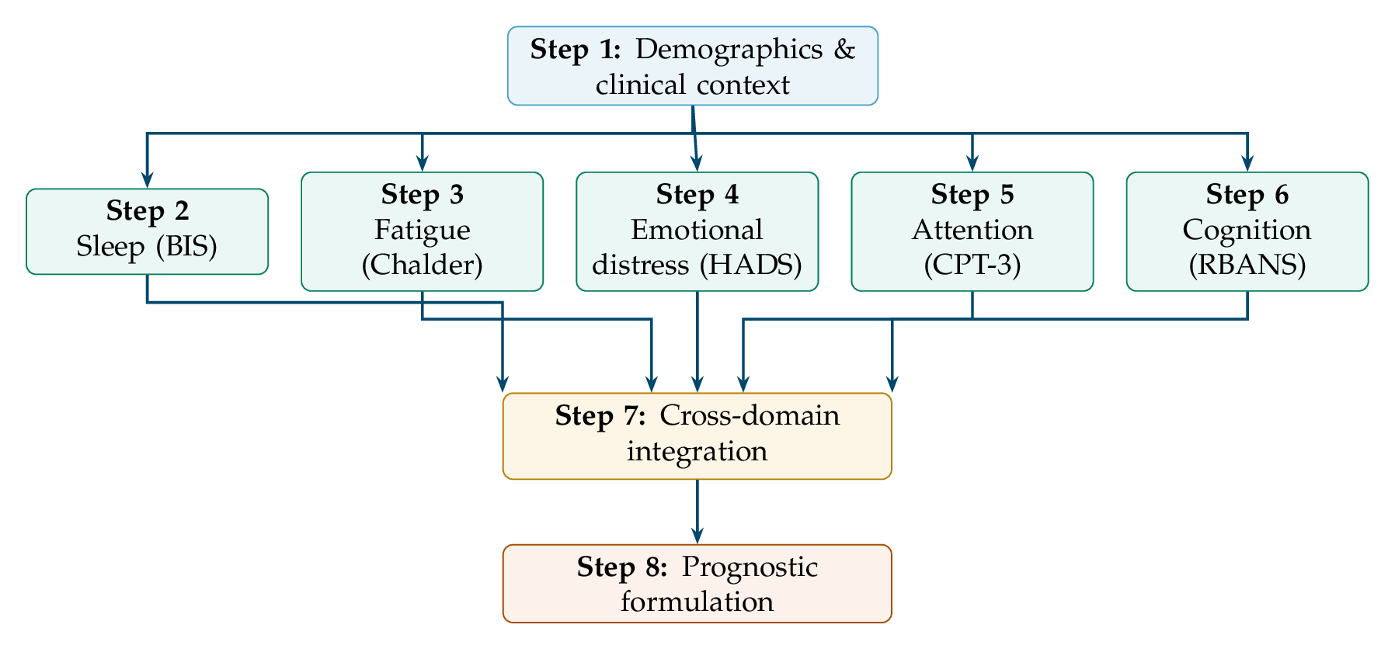
Figure 1

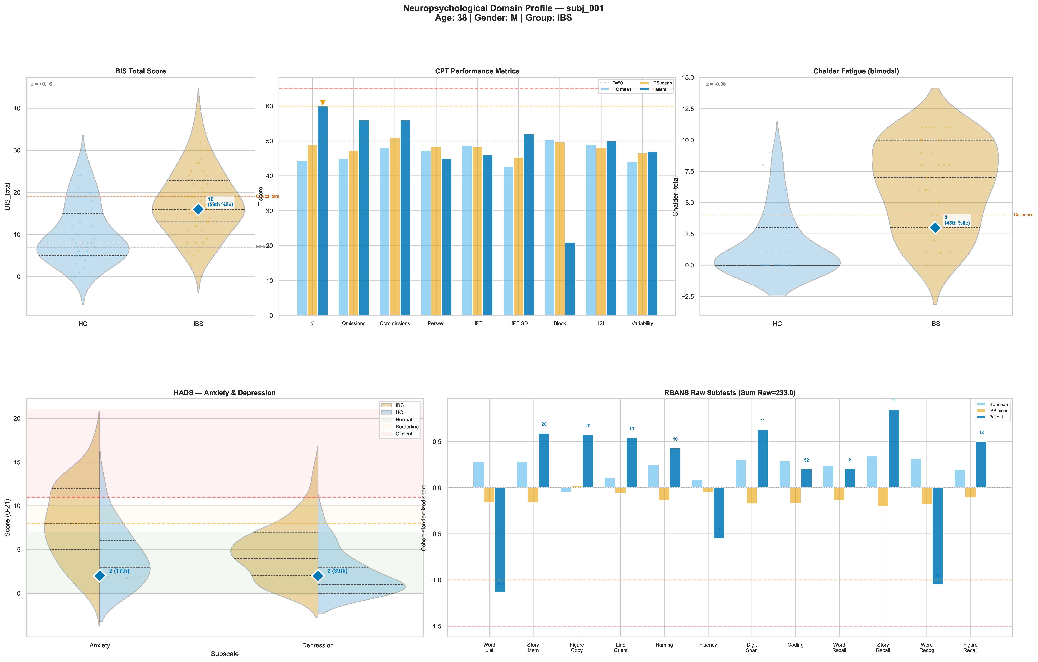
Figure 2

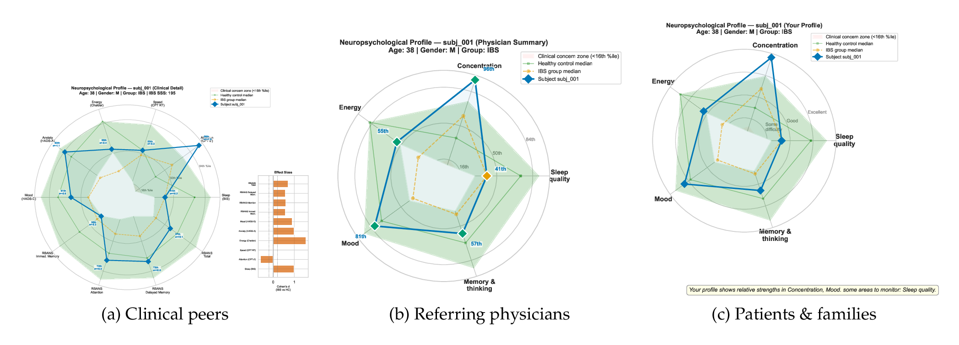
Figure 3

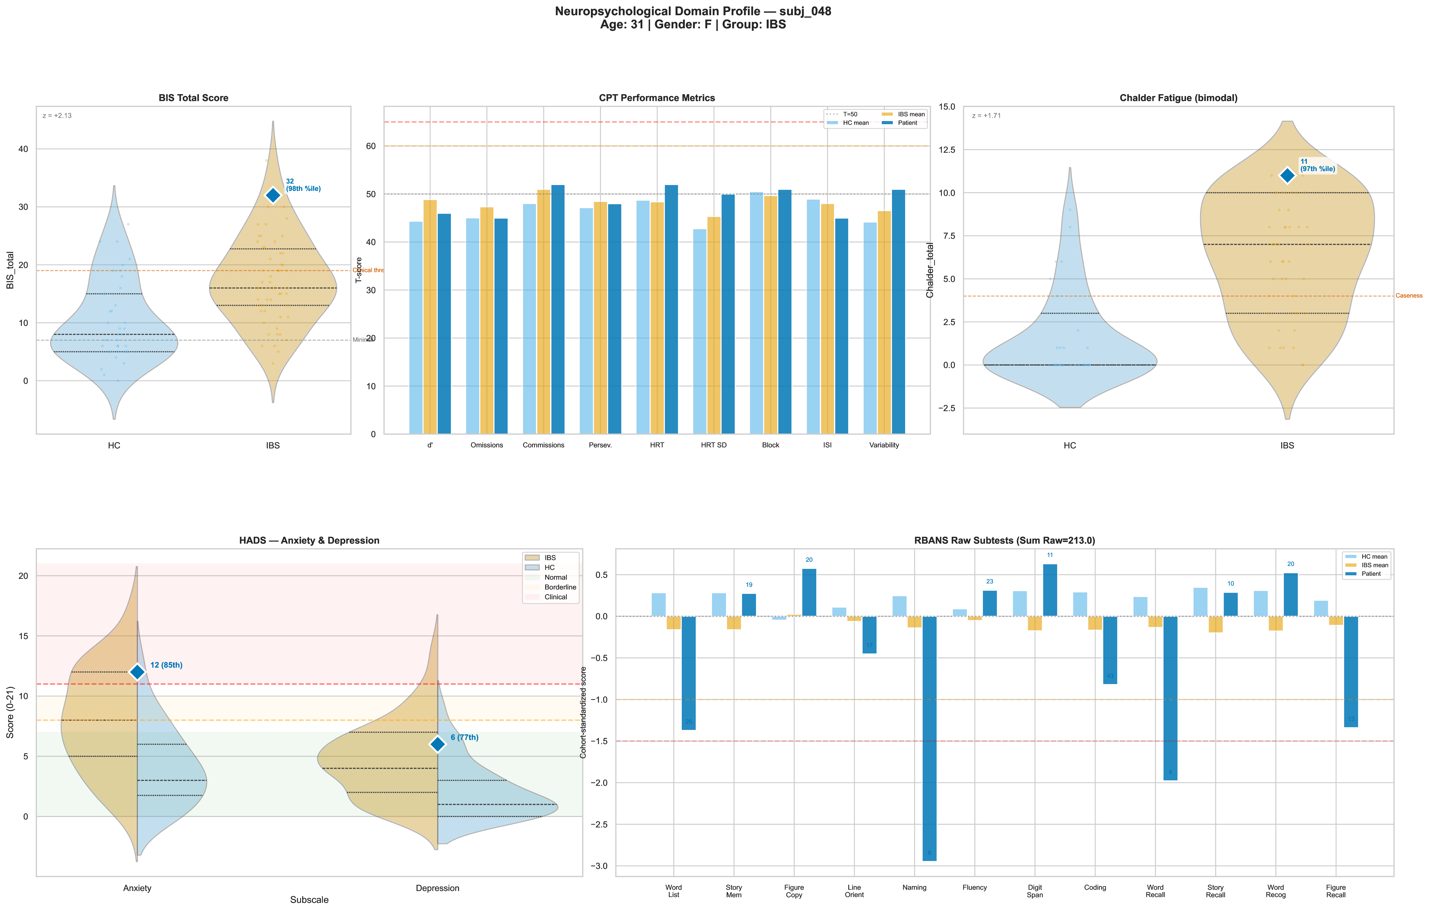
Figure 4

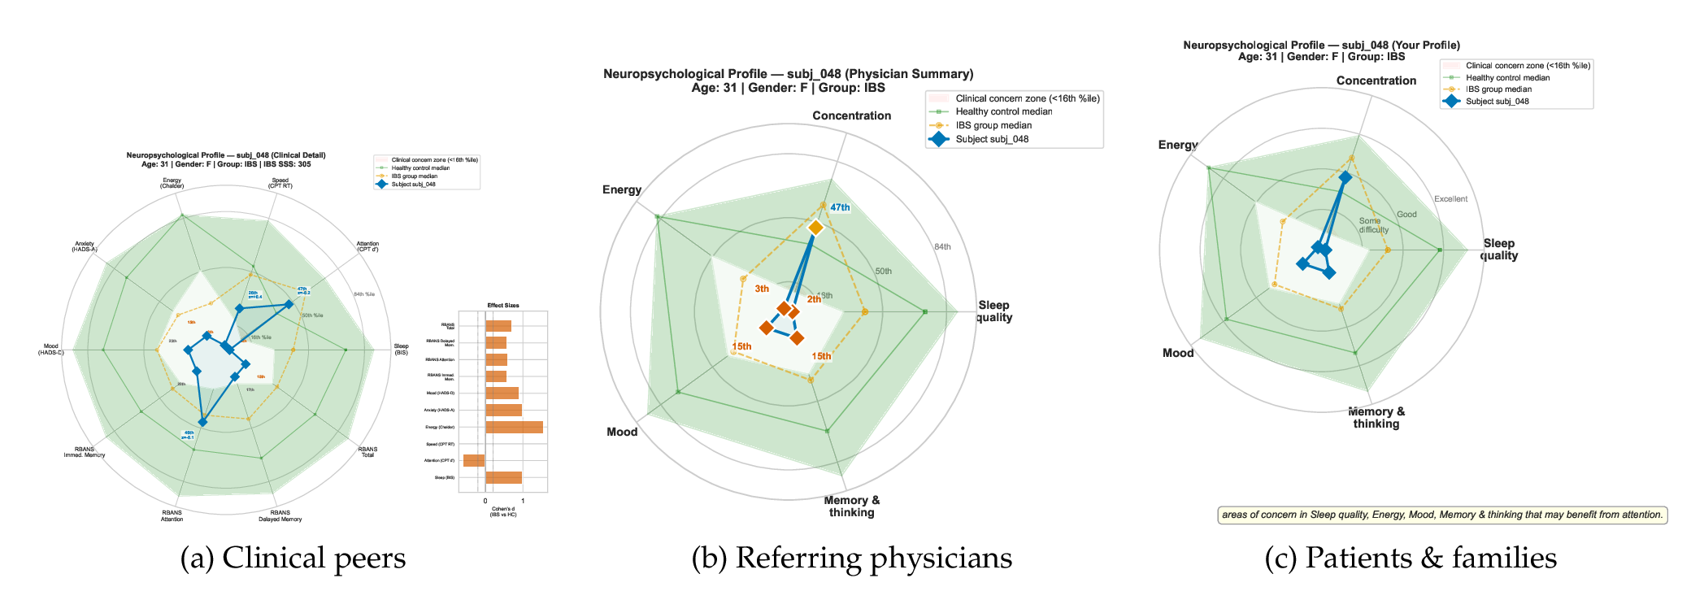
Figure 5

