Mutual Indivisibility

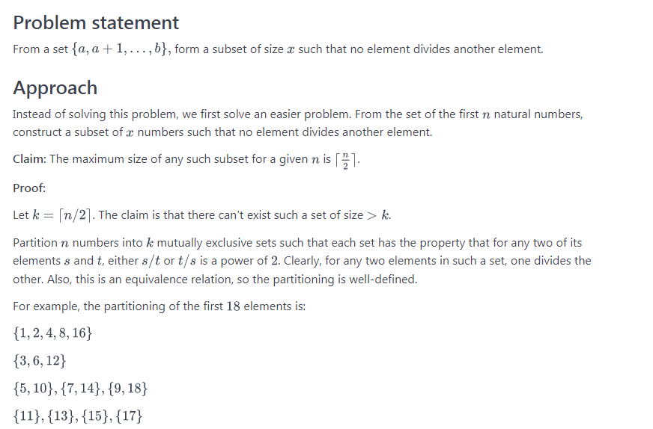

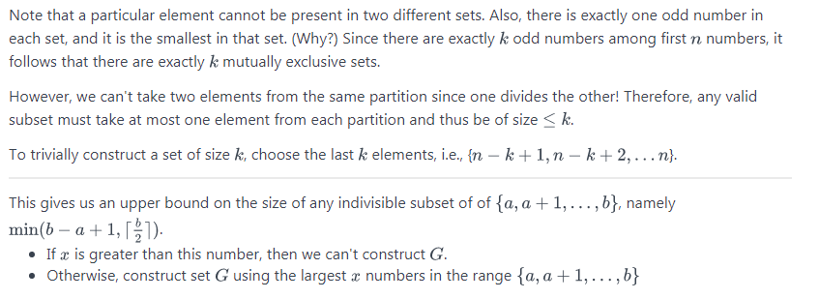

// Anve$hi $hukla
#include <bits/stdc++.h>
using namespace std;
struct ${$(){ios_base::sync_with_stdio(false);cin.tie(NULL);}}$;

int main() {

int t, r, l, x, m;
cin >> t;
while(t--) {
cin >> l >> r >> x;

int m = min(r - l + 1, (r + 1) / 2);
if(x > m) {
cout << -1 << endl;
} else {
for(int i = r; i > r - x; i--) {
cout << i << " ";
}
cout << endl;
}
}

return 0;
}

#include <cmath>
#include <cstdio>
#include <vector>
#include <iostream>
#include <algorithm>
using namespace std;

int main() {
/* Enter your code here. Read input from STDIN. Print output to STDOUT */

int T;
cin >> T;
while (T -- > 0) {
int L, R, x;
cin >> L >> R >> x;

vector<int> ans;
vector<bool> vis(R + 1 ,false);
for (int i = R; i >= L && ans.size() < x; -- i) {
int j = i + i;
bool flag = false;
while (j <= R) {
if (vis[j]) {
flag = true;
break;
}
j += i;
}
if (!flag) {
ans.push_back(i);
vis[i] = true;
}
}

if (ans.size() < x) cout << -1 << endl;
else {
sort(begin(ans), end(ans));
for (int i = 0; i < x; ++ i) cout << ans[i] << (i == x - 1 ? '\n' : ' ');
}
}
return 0;
}

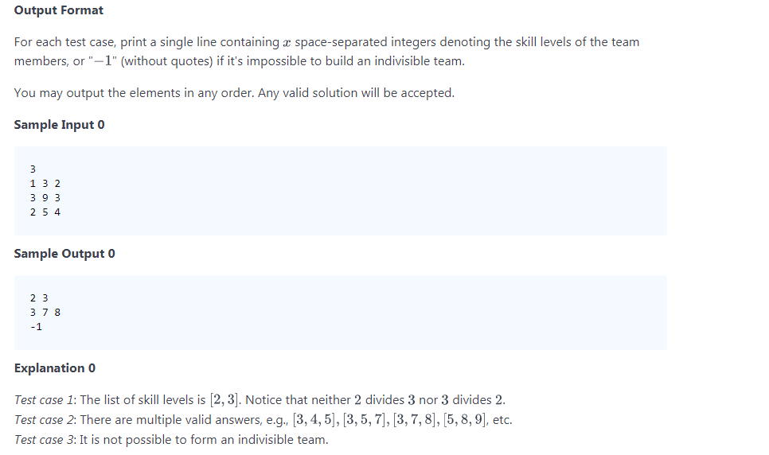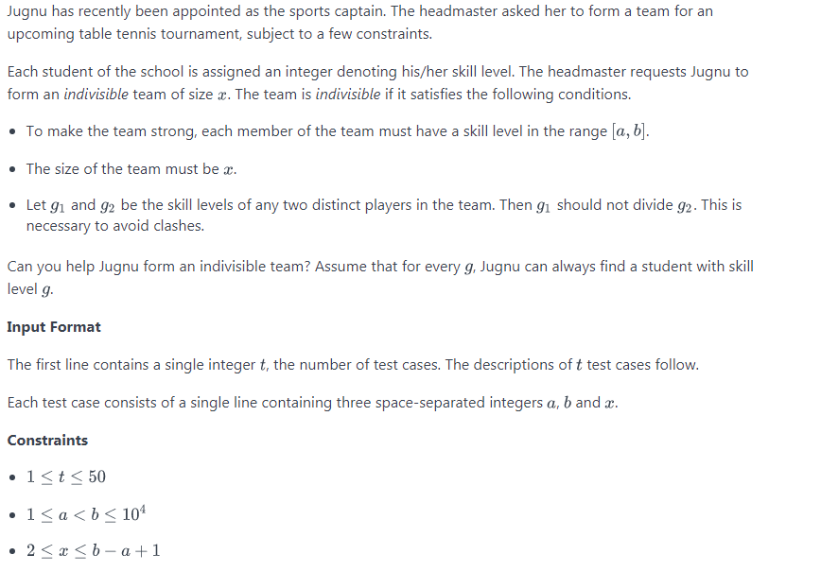
Jugnu has recently been appointed as the sports captain. The headmaster asked her to form a team for an upcoming table tennis tournament, subject to a few constraints.
Each student of the school is assigned an integer denoting his/her skill level. The headmaster requests Jugnu to form an indivisible team of size . The team is indivisible if it satisfies the following conditions.
- To make the team strong, each member of the team must have a skill level in the range .
- The size of the team must be .
- Let and be the skill levels of any two distinct players in the team. Then should not divide . This is necessary to avoid clashes.
Can you help Jugnu form an indivisible team? Assume that for every , Jugnu can always find a student with skill level .
Input Format
The first line contains a single integer , the number of test cases. The descriptions of test cases follow.
Each test case consists of a single line containing three space-separated integers , and .
Constraints

Output Format
For each test case, print a single line containing space-separated integers denoting the skill levels of the team members, or "" (without quotes) if it's impossible to build an indivisible team.
You may output the elements in any order. Any valid solution will be accepted.
Sample Input 0
3
1 3 2
3 9 3
2 5 4
Sample Output 0
2 3
3 7 8
-1
Explanation 0
Test case 1: The list of skill levels is [2,3]. Notice that neither 2 divides 3 nor 3 divides 2.
Test case 2: There are multiple valid answers, e.g., [3,4,5],[3,5,7],[3,7,8],[5.8.9] etc.
Test case 3: It is not possible to form an indivisible team.

Strong Password

Solution 1
#include "bits/stdc++.h"
using namespace std;

const int N = 200005;

int get(char c) {
if(c >= '0' && c <= '9') return 0;
if(c >= 'a' && c <= 'z') return 1;
if(c >= 'A' && c <= 'Z') return 2;
return 3;
}

int main() {
int n;
string s;

cin >> n;
cin >> s;

int ans = 0;

for(int i = 0; i < n; i++) {
ans |= (1 << get(s[i]));
}

cout << max(6 - n, 4 - __builtin_popcount(ans));
return 0;
}

Solution 2
#include "bits/stdc++.h"
using namespace std;

const int N = 200005;

const string numbers = "0123456789";
const string lower_case = "abcdefghijklmnopqrstuvwxyz";
const string upper_case = "ABCDEFGHIJKLMNOPQRSTUVWXYZ";
const string special = "!@#$%^&*()-+";

int main() {

map <char, int> m;

for(auto c: numbers)
m[c] = 0;
for(auto c: lower_case)
m[c] = 1;
for(auto c: upper_case)
m[c] = 2;
for(auto c: special)
m[c] = 3;

set <int> types;

int n; string s;

cin >> n;
cin >> s;

for(auto c: s) {
types.insert(m[c]);
}

cout << max(6 - n, 4 - (int)types.size());
return 0;
}

from string import digits, lowercase, uppercase
raw_input()
s = raw_input()
print max(6 - len(s), sum(not (set(st) & set(s)) for st in (digits, lowercase, uppercase, "!@#$%^&*()-+")))

Louise joined a social networking site to stay in touch with her friends. The signup page required her to input a name and a password. However, the password must be strong. The website considers a password to be strong if it satisfies the following criteria:
- Its length is at least 6.
- It contains at least one digit.
- It contains at least one lowercase English character.
- It contains at least one uppercase English character.
- It contains at least one special character. The special characters are: !@#$%^&*()-+
She typed a random string of length n in the password field but wasn't sure if it was strong. Given the string she typed, can you find the minimum number of characters she must add to make her password strong?
Note: Here's the set of types of characters in a form you can paste in your solution:
numbers = "0123456789"
lower_case = "abcdefghijklmnopqrstuvwxyz"
upper_case = "ABCDEFGHIJKLMNOPQRSTUVWXYZ"
special_characters = "!@#$%^&*()-+"
Input Format
The first line contains an integer n denoting the length of the string.
The second line contains a string consisting of n characters, the password typed by Louise. Each character is either a lowercase/uppercase English alphabet, a digit, or a special character.
Constraints
- 1<- n <= 100.
Output Format
Print a single line containing a single integer denoting the answer to the problem.
Sample Input 0
3
Ab1
Sample Output 0
3
Explanation 0
She can make the password strong by adding 3 characters, for example, $hk, turning the password into Ab1$hkwhich is strong.
2 characters aren't enough since the length must be at least 6.
Sample Input 1
11
#HackerRank
Sample Output 1
1
Explanation 1
The password isn't strong, but she can make it strong by adding a single digit.

Wire Removal

Solution 1
#include "bits/stdc++.h"
using namespace std;

const int N = 100000;
vector <int> adj[N + 1];
bool visited[N + 1];
int sz[N + 1];
int n;
long long num, den;

void dfs(int u, int d) {
visited[u] = 1;
sz[u] = 1;
for(auto v: adj[u]) {
if(!visited[v]) {
dfs(v, d + 1);
sz[u] += sz[v];
}
}
if(u != 1) {
num += (d * 1LL * (n - sz[u]));
den += d;
}
}

int main() {
cin >> n;

for(int i = 0; i < n - 1; i++) {
int u, v;
cin >> u >> v;
adj[u].push_back(v);
adj[v].push_back(u);
}

dfs(1, 0);

long double ans = (long double) num / (long double) den;
cout << fixed << setprecision(10);
cout << ans << endl;
return 0;
}

Solution 2
#include "bits/stdc++.h"
using namespace std;

const int N = 200005;

vector <int> adj[N];
bool visited[N];
int dist[N];

void dfs(int u, int d) {
dist[u] = d;
visited[u] = true;
for(auto v: adj[u]) {
if(!visited[v])
dfs(v, d + 1);
}
}

int main() {
int n, x, y;
cin >> n;

for(int i = 0; i < n; i++) {
cin >> x >> y;
adj[x].push_back(y);
adj[y].push_back(x);
}

dfs(1, 0);
double ans = n;
long long num = 0, den = 0;

for(int i = 2; i <= n; i++) {
num += ((dist[i]) * 1LL * (dist[i] + 1)) / 2;
den += dist[i];
}
ans -= (num) / (double)den;
cout << fixed << setprecision(7);
cout << ans << endl;

return 0;
}

#include <bits/stdc++.h>
using namespace std;

using ll = long long;
vector<int> G[100010];
ll sz[100010];

ll tot = 0;
int n;
ll ans = 0;

void dfs(int u, int fa, int dep) {
sz[u] = 1;
for (int v: G[u]) if (v != fa) {
tot += dep;
dfs(v, u, dep + 1);
sz[u] += sz[v];
}
}

void dfs2(int u, int fa, int dep) {

for (int v: G[u]) if (v != fa) {
ans += dep * (n - sz[v]);
dfs2(v, u, dep + 1);

}
}

int main() {
/* Enter your code here. Read input from STDIN. Print output to STDOUT */

//int n;
cin >> n;
for (int i = 1; i < n; ++ i) {
int u, v;
cin >> u >> v;
G[u].push_back(v);
G[v].push_back(u);
}

dfs(1, 0, 1);
dfs2(1, 0, 1);

cout << fixed << setprecision(6) << (0.0 + ans) / tot << endl;

return 0;
}

While decorating her house for Diwali, Anne noticed a rice light shaped like a rooted tree. We represent the lighting elements as the vertices of the tree and the wires that connect them as the edges. It was hanging from a firm support on the ceiling which we call the root of the rice light. The vertices are numbered 1 to n with 1 as the root.
The probability of any wire breaking is directly proportional to its distance from the support. The distance of a wire joining lighting elements u and v is considered as the maximum of the distance of u or v from the support (root).
If a wire breaks, the portion of the rice light that got disconnected from the support shatters on the floor, while the other portion remains intact and still hanging from the ceiling.
This image illustrates the case where the wire joining lighting elements 1 and 3 breaks. In this case, three elements (3,6 ,7 ) shatters and four elements (1,2 ,4 ,5 ) remain connected to the ceiling.
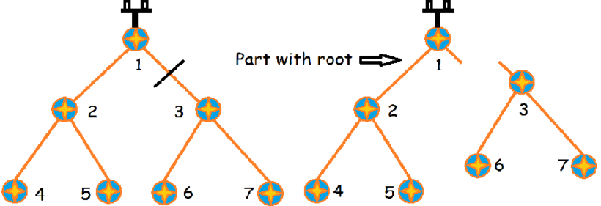
Given that exactly one of the wires randomly breaks, find the expected number of vertices still connected to the ceiling.
Input Format
The first line contains a single integer n denoting the number of vertices in the tree. The vertices are numbered 1 to n, with 1 as the root.
The next n-1 lines each contains two space-separated integers x and y denoting that there is an edge between vertex x and y.
Constraints
- 2<=n<=10^5
- 1<=x, y<=n
- It is guaranteed that the graph is a tree.
Output Format
Print a single line containing a single real number denoting the answer. Your answer is considered correct if its absolute error doesn't exceed 10^-5 .
Sample Input 0
3
1 2
1 3
Sample Output 0
2.0000000000
Explanation 0
Since there are only two edges and both are the same distance from the root, each edge breaks with the same probability. In both cases, the size of the remaining tree containing root is 2. Therefore, the expected size is 2.
Sample Input 1
7
1 2
1 3
2 4
2 5
3 6
3 7
Sample Output 1
5.6000000000
Explanation 1
This is a full binary tree. The figure in the problem statement illustrates it.

Kth Minimum

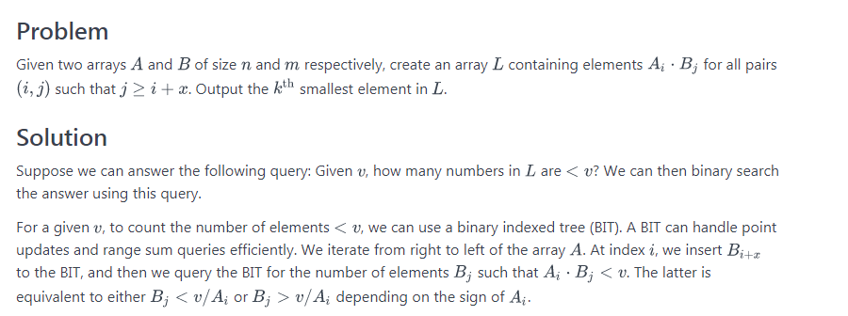

// Anve$hi $hukla
#include <bits/stdc++.h>
using namespace std;
struct ${$(){ios_base::sync_with_stdio(false);cin.tie(NULL);}}$;

const int N = 400008;
const long long INF = (long long)4e10;
const int OFF = N / 2;

vector <int> a, b;
int n, m, off, tree[N];
long long k;

template <typename T>
T sgn(T x) {
return ((x < 0)? 0: 1);
}

void update(int idx, int val) {
assert(idx < N);
while(idx < N) {
tree[idx] += val;
idx += idx & -idx;
}
}

int query(int idx) {
int ret = 0;
while(idx > 0) {
ret += tree[idx];
idx -= idx & -idx;
}
return ret;
}

int query(pair <long long, long long> p) {
long long l = p.first;
long long r = p.second;
if(l >= N || r <= 0) return 0;
l = max(l, 1LL);
r = min(r, N - 1LL);
assert(l <= r);
return query(r) - query(l - 1);
}

pair <long long, long long> get_range(int a, long long b) {
pair <long long, long long> ret;

if(sgn(a)) {
ret.first = -INF;
long long x = b / a;
while(a * 1LL * x > b)
x--;
ret.second = x;
} else {
ret.second = INF;
long long x = b / a;
while(a * 1LL * x > b)
x++;
ret.first = x;
}
ret.first += OFF;
ret.second += OFF;
assert(ret.first <= ret.second);
return ret;
}

int get(int x, long long t) {
pair <long long, long long> range = get_range(x, t);
return query(range);
}

long long f(long long x) {
memset(tree, 0, sizeof tree);
for(int i = n + off; i < m; i++) {
update(b[i] + OFF, 1);
}

long long ret = 0;
for(int i = n - 1; i >= 0; i--) {
if(i + off < m)
update(b[i + off] + OFF, 1);
ret += get(a[i], x);
}
return ret;
}

long long search(long long st, long long end) {
while(st + 1 < end) {
long long mid = (st + end) / 2;
if(f(mid) < k)
st = mid;
else
end = mid;
}
if(f(st) >= k)
return st;
assert(f(end) >= k);
return end;
}

int main() {

cin >> n >> m >> off >> k;

a.resize(n);
b.resize(m);

for(int i = 0; i < n; i++)
cin >> a[i];

for(int i = 0; i < m; i++)
cin >> b[i];

cout << search(-INF, INF) << endl;
return 0;
}

#include <bits/stdc++.h>

using namespace std;

const int N = 200001;
const int S = 2 * N + 2;

int n, m, off;
long long k;
int a[N], b[N];
int f[S];

void add(int i, int d) {
for (; i < S; i += i & (-i)) {
f[i] += d;
}
}

int get(long long r) {
int res = 0;
for (r = min(r, S - 1LL); r > 0; r -= r & (-r)) {
res += f[r];
}
return res;
}

long long div_down(long long x, long long y) {
if (y < 0) {
x = -x;
y = -y;
}
if (x >= 0) {
return x / y;
} else {
return x / y - (x % y != 0);
}
}

long long div_up(long long x, long long y) {
if (y < 0) {
x = -x;
y = -y;
}
if (x >= 0) {
return (x + y - 1) / y;
} else {
return x / y;
}
}

long long count(long long x) {
memset(f, 0, sizeof f);
long long res = 0;
int last = m;
for (int i = n - 1; i >= 0; i--) {
int pos = min(m, i + off);
for (int j = pos; j < last; j++) {
add(b[j] + N, 1);
}
last = min(last, pos);

if (a[i] > 0) {
res += get(div_down(x, a[i]) + N);
} else {
res += (m - pos) - get(div_up(x, a[i]) + N - 1);
}
}
return res;
}

int main() {
ios::sync_with_stdio(0);
cin.tie(0);
cout.tie(0);

cin >> n >> m >> off >> k;
for (int i = 0; i < n; i++) {
cin >> a[i];
}
for (int i = 0; i < m; i++) {
cin >> b[i];
}

long long left = -(N * 1LL * N + 1);
long long right = N * 1LL * N + 1;

while (right - left > 1) {
long long mid = (left + right) / 2;
if (count(mid) >= k) {
right = mid;
} else {
left = mid;
}
}

cout << right << "\n";
return 0;
}

Jen likes playing with lists of nonzero integers. She has many such lists in her almirah. To kill her boredom, she would take some list and look for the K^{th} smallest number in it.
However, she soon lost interest in doing so because it was too easy, so she decided to create a new list L using this procedure:
-- lists are 1-indexed --

procedure generate_list(A, B, x):

let n = length of A
let m = length of B
let L = an empty list

for i from 1 to min(n, m - x), inclusive:
for j from (i + x) to m, inclusive:
Append (A[i]*B[j]) to the end of L

return L
To create L , she takes two lists A and B and an integer x and calls generate_list(A, B, x). She was surprised to see such a big list and got stuck on finding the K^{th} smallest number in it. Can you help her?
Note: The K^{th} smallest number in a list L is the K^{th} element of L when it is sorted. For example, the 4th smallest number in [7,2,7,2,11] is 7.

