First of all, we are going to generate plots to show the composition of different types of variants.

## 1. simple pie chart

The number of SNPs, MNPs, INS, DELs, and COMPLEX in the list of filtered variants by Freebayes (QUAL > 60).

slices <- c(8539874, 137816, 407312, 470210, 324538)  
labels <- c("SNP", "MNP", "INS", "DEL", "COMPLEX")  
pct <- round(slices/sum(slices)*100, digits=2)  
labels <- paste(labels, pct)  
labels <- paste(labels, "%", sep="")  
pie(slices, labels=labels, col=rainbow(length(labels)), main="Different types of variants")

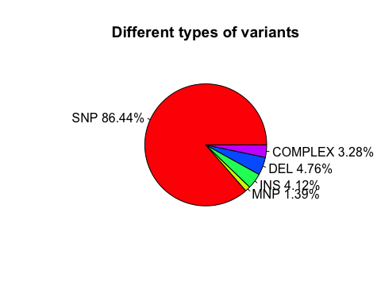

## 2. histogram plot of the data above

variants <- round(slices/sum(slices), digits=2)  
names(variants) <- c("SNP", "MNP", "INS", "DEL", "COMPLEX")  
barplot(variants, col="red", main="Different types of variants", xlab="Type of variant", ylab="Percentage")

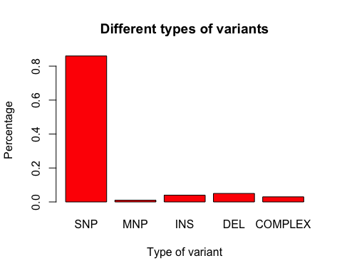

## 3. circos plot

### Now, we are going to use a package "RCircos" to generate circos plot.

First, install RCircos if haven't done it already

#source("http://bioconductor.org/biocLite.R")  
#biocLite("RCircos")  
#biocLite("IdeoViz")  
library(IdeoViz)  
library(RCircos)

Download cytoband ideogram data from UCSC using package IdeoViz.

ideo <- getIdeo("equCab2")

Set up RCircos core components. One may plot both to the inside and outside of the ideogram track. Today, we are going to only plot tracks in the inside of the ideogram.

chr.exclude <- NULL  
cyto.info <- ideo  
tracks.inside <- 10  
tracks.outside <- 0  
RCircos.Set.Core.Components(cyto.info, chr.exclude, tracks.inside, tracks.outside)

##   
## RCircos.Core.Components initialized.  
## Type ?RCircos.Reset.Plot.Parameters to see how to modify the core components.

# plot ideogram  
RCircos.Set.Plot.Area()  
RCircos.Chromosome.Ideogram.Plot()  
  
# plot gene labels, there are limits setup by default for the number of genes that can be plotted for each chromosome based on the size of the chromosomes. The parameter can be changed if necessary. However, plotting too many genes will have the risk of having gene symbols overlapping one another.  
  
gene.label.data <- read.table(file="https://raw.githubusercontent.com/ucdavis-bioinformatics-training/2017-August-Variant-Analysis-Workshop/master/friday/Variant-Analysis-by-R/gene.label", sep="\t", header=F)  
  
# The format of the gene information:  
  
head(gene.label.data)

## V1 V2 V3 V4  
## 1 chr1 11192 15975 SYCE1  
## 2 chr1 29518 67141 ENSECAT00000018774.1  
## 3 chr1 29524 71177 ENSECAT00000018811.1  
## 4 chr1 132226 143850 CYP2E1  
## 5 chr1 171785 172706 ENSECAT00000004254.1  
## 6 chr1 183830 184742 ENSECAT00000004598.1

# The column names of gene information should be set as following.  
  
colnames(gene.label.data) <- c("Chromosome", "chromStart", "chromEnd", "Gene")  
  
# Create a subset of gene list. first remove genes that do not have gene symbols, because ENSEMBL IDs are too long in character and will use up too much space for demonstration purpose. The list of genes would be the genes of interest. In the class, we will randomly select 30 genes.  
  
tmp.list <- gene.label.data[-grep("ENSECAT", gene.label.data$Gene),]  
idx <- sample(1:dim(tmp.list)[1], 30, replace=F)  
gene.list <- tmp.list[idx,]  
name.col <- 4  
side <- "in"  
track.num <- 1  
RCircos.Gene.Connector.Plot(gene.list, track.num, side)  
  
track.num <- 2  
RCircos.Gene.Name.Plot(gene.list, name.col, track.num, side)  
# It's possible that some genes are not plotted because of the limit of plotting for each chromosome.  
  
# check plot parameters, if needed, they may be changed.  
RCircos.Get.Gene.Name.Plot.Parameters()

## chromosomes maxLabels startLoc endLoc labelWidth  
## 1 chr1 12 1 6195 500  
## 2 chr2 8 6495 10523 500  
## 3 chr3 7 10823 14806 500  
## 4 chr4 7 15106 18725 500  
## 5 chr5 6 19025 22348 500  
## 6 chr6 5 22648 25471 500  
## 7 chr7 6 25771 29056 500  
## 8 chr8 6 29356 32491 500  
## 9 chr9 5 32791 35577 500  
## 10 chrM 0 35877 35877 500  
## 11 chrX 8 36177 40315 500  
## 12 chr10 5 40615 43414 500  
## 13 chr11 4 43714 45758 500  
## 14 chr12 2 46058 47161 500  
## 15 chr13 2 47461 48880 500  
## 16 chr14 6 49180 52310 500  
## 17 chr15 6 52610 55662 500  
## 18 chr16 5 55962 58875 500  
## 19 chr17 5 59175 61866 500  
## 20 chr18 5 62166 64917 500  
## 21 chr19 3 65217 67217 500  
## 22 chr20 4 67517 69655 500  
## 23 chr21 3 69955 71880 500  
## 24 chr22 3 72180 73844 500  
## 25 chr23 3 74144 76002 500  
## 26 chr24 3 76302 77860 500  
## 27 chr25 2 78160 79478 500  
## 28 chr26 2 79778 81174 500  
## 29 chr27 2 81474 82806 500  
## 30 chr28 3 83106 84645 500  
## 31 chr29 2 84945 86067 500  
## 32 chr30 2 86367 87370 500  
## 33 chr31 1 87670 88502 500  
## 34 chrUn 7 88802 92718 500

# add extra tracks -- Histogram plot of CNV data. Any extra track will depend on the types of data one wants to include in the plot. The required information is the location of what will be plotted in the genome: chromosome number, start and stop position.  
gene.list$CNV <- floor(runif(30, 1, 7))  
data.col <- 5  
track.num <- 5  
side <- "in"  
RCircos.Histogram.Plot(gene.list, data.col, track.num, side, is.sorted=FALSE, min.value=-2)  
  
  
# add extra tracks -- Scatter plot of RNASeq results  
gene.expr <- gene.list  
colnames(gene.expr)

## [1] "Chromosome" "chromStart" "chromEnd" "Gene" "CNV"

colnames(gene.expr) <- c("chromosome", "start", "stop", "gene.name", "CNV")  
  
# generate random logFC data of 30 in length between -3 and 3  
gene.expr$logFC <- runif(30, -3, 3)  
  
# first three columns are required for plotting and one more column that corresponds to the data to plot   
head(gene.expr)

## chromosome start stop gene.name CNV logFC  
## 8916 chr16 23086533 23163202 LRIG1 5 0.6790339  
## 4176 chr11 19987497 19987688 U2 4 0.7928970  
## 15394 chr23 13401163 13432348 PSAT1 4 2.6083241  
## 14892 chr22 24930537 24947830 EIF2S2 2 -0.5545078  
## 26748 chr9 6377130 6385102 FABP12 1 0.6280568  
## 9259 chr16 42671906 42882999 ANO10 1 1.7709113

data.col <- 6  
track.num <- 6  
side <- "in"  
  
# "by.fold" is a zero or positive number. If it's positive, then any data point with a value >= by.fold will be plotted as red color; any data point with a value <= -by.fold will be plotted as blue color; otherwise, data point will be plotted in black color.  
by.fold <- 1.5  
  
# plot scatter plot  
RCircos.Scatter.Plot(gene.expr, data.col, track.num, side, by.fold, is.sorted=FALSE)  
  
# add extra tracks -- Line plot of Coverage results  
  
genome.cov <- gene.label.data[-grep("ENSECAT", gene.label.data$Gene),]  
colnames(genome.cov) <- c("chromosome", "start", "stop", "gene.name")  
genome.cov$logCOV <- rnorm(dim(genome.cov)[1], 0, 0.9)  
data.col <- 5  
track.num <- 7  
side <- "in"  
RCircos.Line.Plot(genome.cov, data.col, track.num, side, is.sorted=FALSE)  
  
# add most inside track -- link lines and ribbons.  
  
# generate random translocation variants data  
link.data <- data.frame(Chromosome=character(), chromStart=integer(), chromEnd=integer(), Chromosome.1=character(), chromStart.1=integer(), chromEnd.1=integer(), stringsAsFactors=F)  
for (i in 1:15) {  
 n.rand <- floor(runif(1, 1,34))  
 chrom <- ideo$chrom[n.rand]  
 str <- floor(runif(1, ideo$chromStart[n.rand], ideo$chromEnd[n.rand]))  
 ed <- floor(runif(1, ideo$chromStart[n.rand], ideo$chromEnd[n.rand]))  
 n.rand <- floor(runif(1, 1, 34))  
 chrom.1 <- ideo$chrom[n.rand]  
 str.1 <- floor(runif(1, ideo$chromStart[n.rand], ideo$chromEnd[n.rand]))  
 ed.1 <- str.1  
 if (ed < str) {  
 tmp <- ed  
 ed <- str  
 str <- tmp  
 }  
 link.data <- rbind(link.data, data.frame(Chromsome=chrom, chromStart=str, chromEnd=ed, Chromosome.1=chrom.1, chromStart.1=str.1, chromEnd.1=ed.1))  
 i <- i + 1  
}  
  
track.num <- 9  
  
# plot link lines  
RCircos.Link.Plot(link.data, track.num, TRUE, is.sorted=FALSE)  
  
# ribbon data  
ribbon.data <- link.data  
colnames(ribbon.data) <- c("chromA", "chromStartA", "chromEndA", "chromB", "chromStartB", "chromEndB")  
RCircos.Ribbon.Plot(ribbon.data=ribbon.data, track.num=9, by.chromosome=FALSE, twist=FALSE, is.sorted=FALSE)

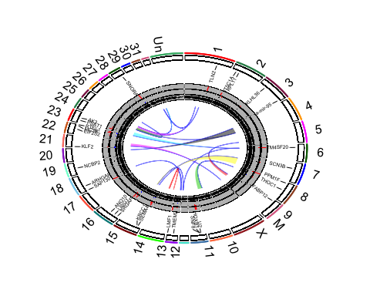

# 4. GWAS data plotting

Install R package "qqman" if it hasn't been done. The develop version of the package can be installed from the source on github.

#biocLite("devtools")  
library(devtools)  
install_github("stephenturner/qqman")  
library(qqman)  
  
# using the example data from qqman package  
head(gwasResults)

## SNP CHR BP P  
## 1 rs1 1 1 0.9148060  
## 2 rs2 1 2 0.9370754  
## 3 rs3 1 3 0.2861395  
## 4 rs4 1 4 0.8304476  
## 5 rs5 1 5 0.6417455  
## 6 rs6 1 6 0.5190959

manhattan(gwasResults)

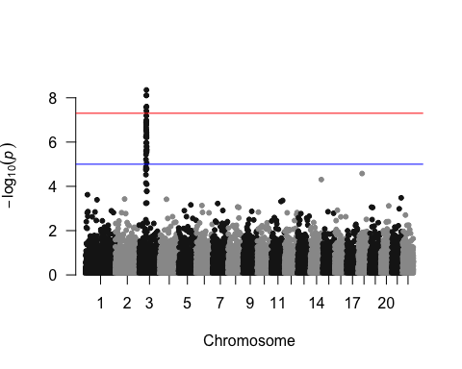

# use colors for chromosomes  
manhattan(gwasResults, col=c("red", "blue", "green"))

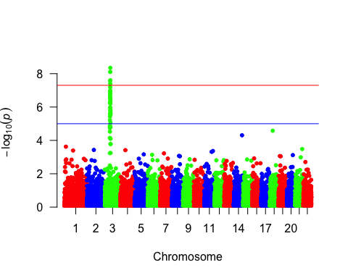

# change default horizontal line position  
manhattan(gwasResults, suggestiveline=-log10(1e-6), genomewideline=-log10(1e-8), col=c("red", "blue", "green"))

