Banzuela, Arvin Andrew L.

CPE 232 – CPE31S71

Fork this repository https://github.com/ajohnsc/SysadClass (Links to an external site.)

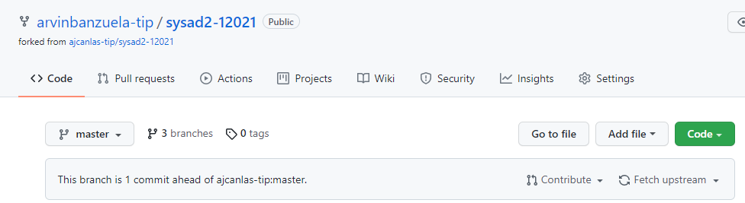

Create a directory named "quiz31" in your student number directory in Quiz 1.3



Create a markdown file named "README.md" in the newly created directory with the directory summary.

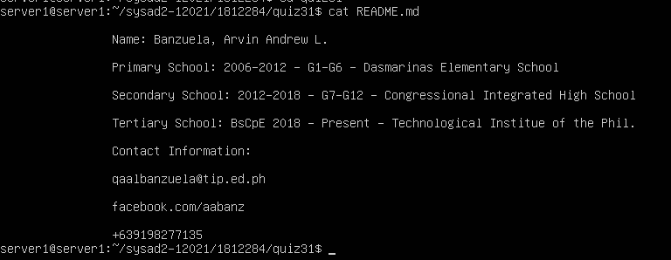

Create a playbook that installs an vsftpd server.

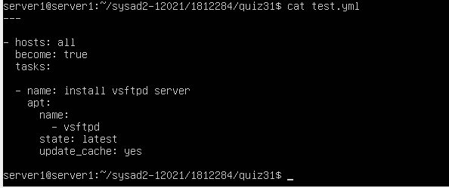

Then create a Pull request and put your forked repo in the only question of this quiz (Note answer this quiz as well as create a pull request).

