# Auto Complete Search for Liferay dxp

Suggestive search is the most prominent feature for quick and easy searches these days in every medium and platform. With the introduction of Liferay DXP users are able to search for various keywords (complete words) from the entire library of documents and portal. We have found an easy and better way to combine “suggestive search” as Auto Complete search which will allow users to search their referenced keywords and terms in real-time. Let’s take a look at the problem, the solutions and configuration of our function on a platform.

## Problem

As of now the Search Portlet of Liferay has an integrated functionality that allows searches for page and web content assets. However, it misses the critical keyword suggestion list and custom keyword selection where in a user can define where he wants that search term to be searched for whether it’s in a blog, document or portal. Another issue is that the search terms (Assets) are never displayed in group, hindering the possibility of suggestive and specific search terms.

## Solution

At KNOWARTH, we have created an absolute search solution that allows users to search for various assets like Blogs, Documents, Media, Webpages and content, Message boards, Wiki and other docs with suggestive keywords. With this Auto Search Portlet as user can not only search for words but also choose in which assets he want to see results. This is an ultimate solution that will meet the growing demand for suggestive search and save the user time and hassel to look into lot of pages and content.

**Below are the steps that show how to configure Auto Search Portlet:**

**Step 1**: Paste the .jar file in the deploy folder on your Tomcat Server

**Step 2:** Now**,** Add **Auto Complete Search Portlet** on any page for search.

**Step 3**: Click on the configuration section of the menu.

Please see the image for more details.

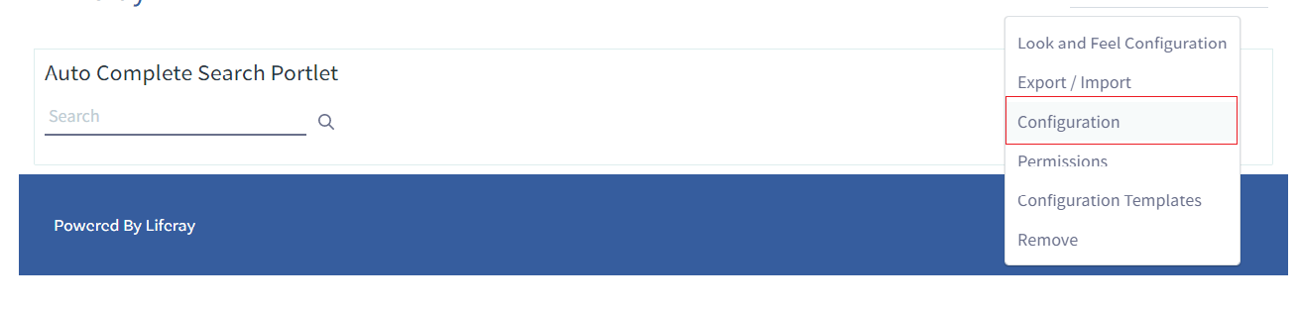

**Step 4**: You will be able to choose from varieties of assets to show the search results.   
Please see the image for reference.

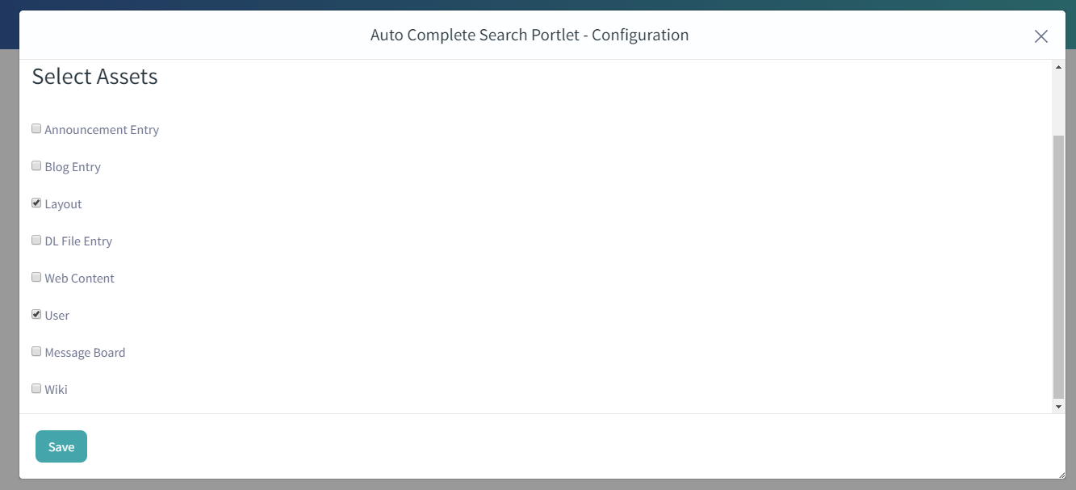

**Step 5**: Now, click on the save button to save your settings for the Portlet search configuration.

Note- Please save and assign specific URLs to your assets like blogs, Message boards, Wiki and Announcements as they do not have their specific URLs.

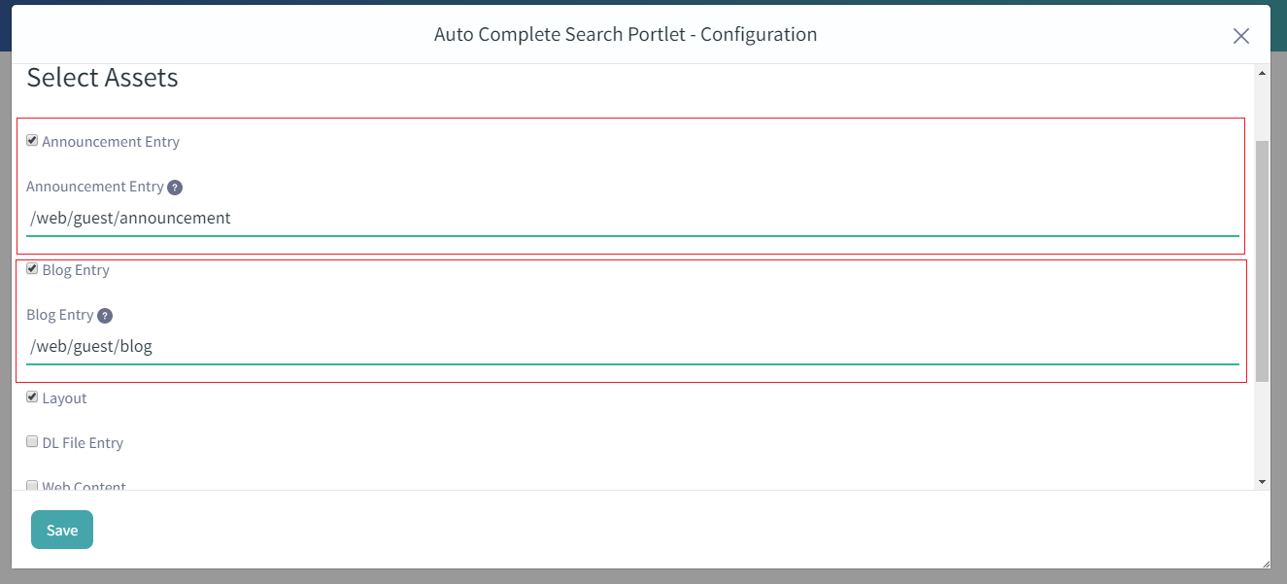

**Step 6**: After typing your keyword, you will be able to see a list of options available for search and select assets to redirect that asset for user’s keyword choice.

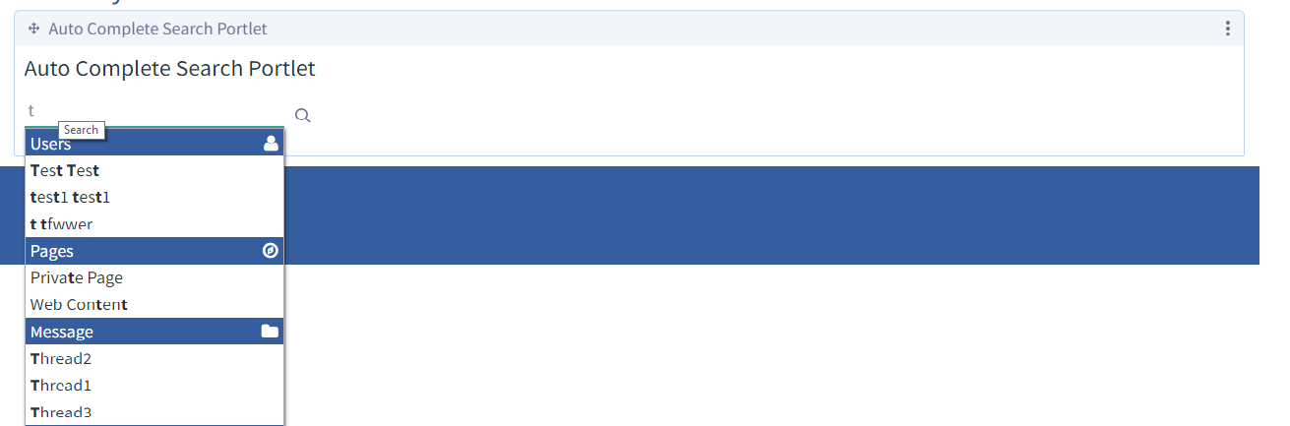

Once you have done that, you are set to enjoy the quick search results within the asset areas of your Portlet. This Suggestive search will make it easy for your portlet’s users to find relevant information with ease.