Programming Assignment 1

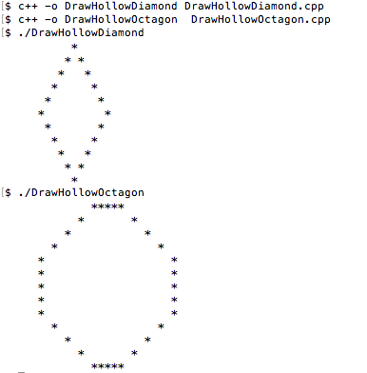

Programming Journal

1. Everything worked.

2. Nothing didn't work.

3. I didn't need help with anything.

4. I learned how to follow instructions for the programming assignment.