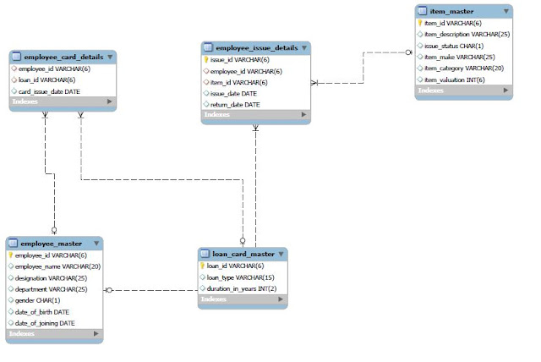

Loan Schema for Assignment

1.Write a query to display category and number of items in that category. Give the count an alias name of Count_category.  
Display the details on the sorted order of count in descending order.

2.Write a query to display the number of employees in HR department. Give the alias name as No_of_Employees

3.Write a query to display employee id, employee name,  
designation and department for employees who have never been issued an item as a loan from the company.  
 Display the records sorted in ascending order based on employee id.

4.Write a query to display the employee id, employee name who was issued an item of highest valuation.  
 In case of multiple records, display the records sorted in ascending order based on employee id.

5.Write a query to display issue_id, employee_id, employee_name.  
Display the records sorted in ascending order based on issue id.

6.Write a query to display employee id, employee name who don’t have loan cards.  
Display the records sorted in ascending order based on employee id.