**PayZang Payment Processor Installation Instructions-**

Linux version - Ubuntu 12.04.2

Apache webserver version - 2.2.22

MySQL version - 5.5.31

Drupal version - 7.22

CiviCRM version - 4.4

PHP version - 5.3.25

**Install Requirements:**

1. Server root access, or member of sudoers group.
2. Installed copy of CiviCRM 4.4.x

**PayZang Payment Processor Sandbox Account Information:**

Merchant ID: Existing Card accounts are supported from First Data, Global, TSYS, Elavon and Vantiv. Sandbox credentials provided after account signing.

Password: Existing Card accounts are supported from First Data, Global, TSYS, Elavon and Vantiv. Sandbox credentials provided after account signing.

API URL: Existing Card accounts are supported from First Data, Global, TSYS, Elavon and Vantiv. Sandbox credentials provided after account signing.

**Installation Instructions-**

**(Snapshots given are for Drupal installation. Make changes as per your CMS. e.g. sites folder is not available in wordpress or joomla)**

1. Download installation package for “**com.payzang.payment.module**” and **“com.payzang.payment.pzpayments”** and unzip into any directory.
2. Create an extension folder into your site (eg. /var/www/<CMS_dir>/extension).
3. Copy both unzipped folder into extension folder.
4. Now Set this extension folder path into civicrm.
5. Click on Administer->System Settings->Directories
6. Fill in Civicrm Extensions Directory.

<Siteroot>/<CMS_dir>/extension/ (**include trailing slash and remove any space after it**)

A description...

1. Click tab “Administer” in CiviCRM Admin Dashboard and navigate to “System Settings”

and then click on “Resource URLs” In the “Extension Resource URL” field, Enter: http://<SITE_URL>/extension/

A description...

1. Click tab “Administer” in CiviCRM Admin Dashboard and navigate to System

Settings -> Option Groups :

* 1. Scroll down to Recurring Frequency Units
  2. Click options on the row.
  3. Edit the “title” AND “value” for units “week”, “month”, and “year” to be “weekly”, “monthly”, and “yearly”
  4. Create 4 additional units with the “title” AND “value” set to “bi-weekly”, “bi-monthly”, “quarterly”, and “semiannually”

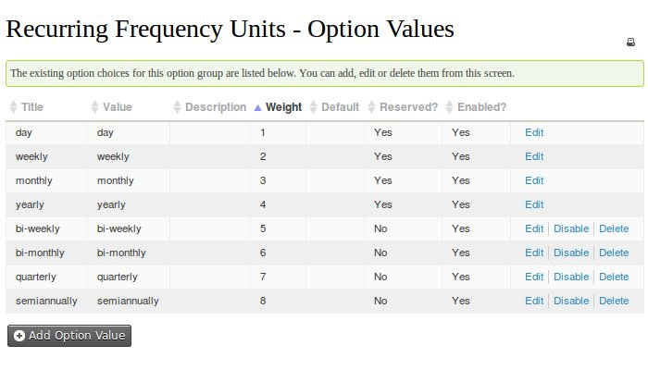

1. Enable both extensions by going to **Administer->System Settings->Manage Extensions**

First enable the “**com.payzang.payment.pzpayments**” extension by clicking on install link against it then enable “**com.payzang.payment.module**”.

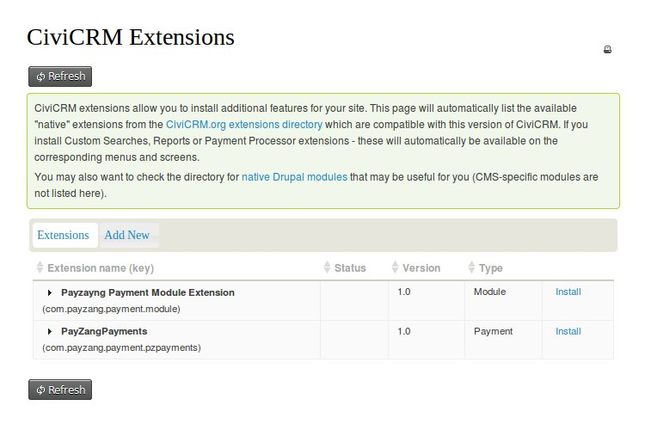

10. Activate **Payzang Payment Processor** by going to Administer->System Settings->Payment Processors

Click on “**Add Payment Processor**”

1. In the “payment Processor Type ” section select **“PayZangPayments (com.payzang.payment.pzpayments)”**
2. In the 'Name' field fill “**PayZangPayments (com.payzang.payment.pzpayments)**”
3. In description write “Payzang single and recurrent payment processing”
4. Select appropriate financial account.
5. Fill test or/and live credentials for payment.
6. Hit Save

11. Add the payment type “ACH” as a payment instruments option by going to **Administer->CiviContribute->Payment Instruments**

* 1. enter “ACH” for the label
  2. hit 'save'
  3. move 'ACH' to the top of the list