1. Creating Jenkins job.

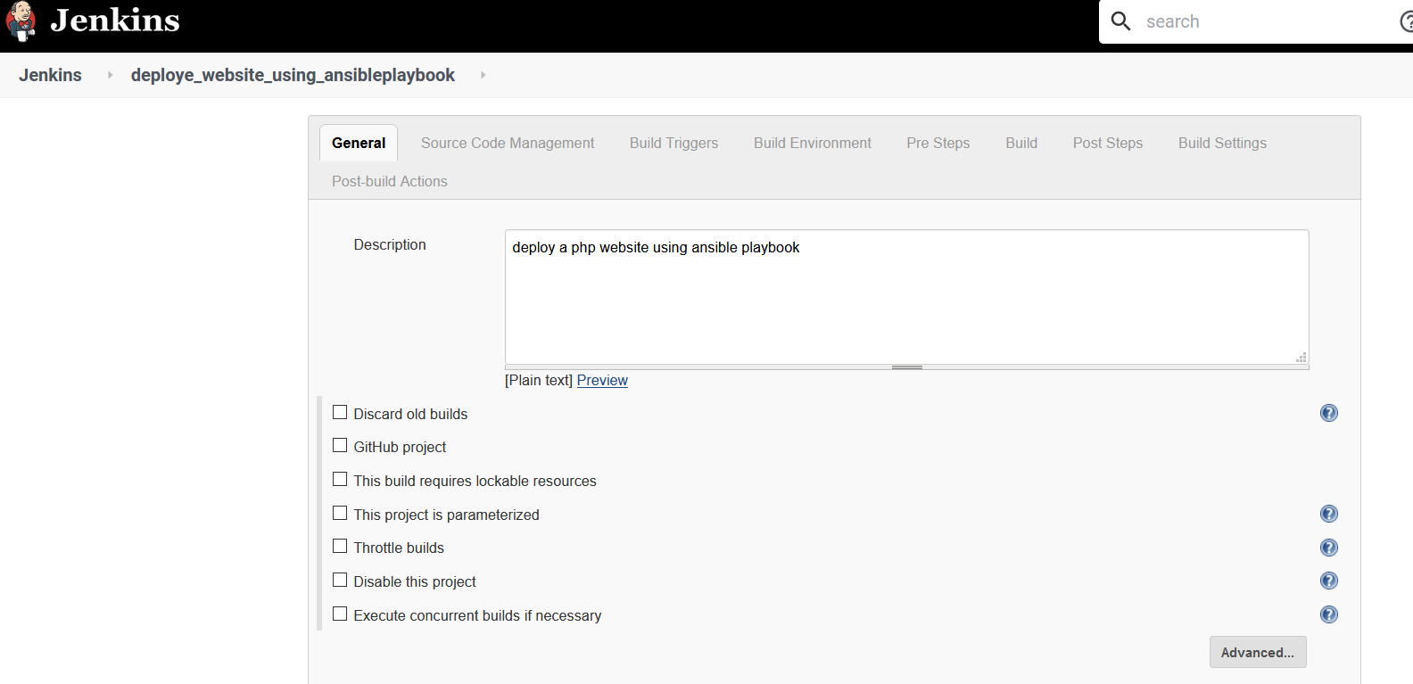

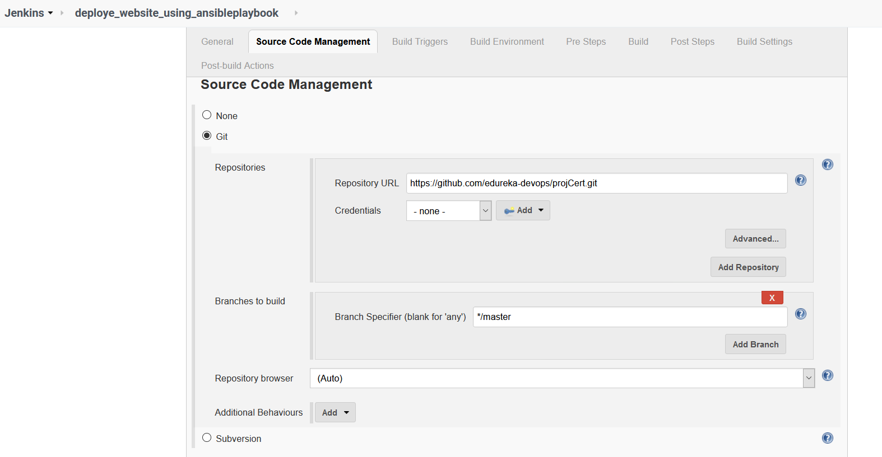

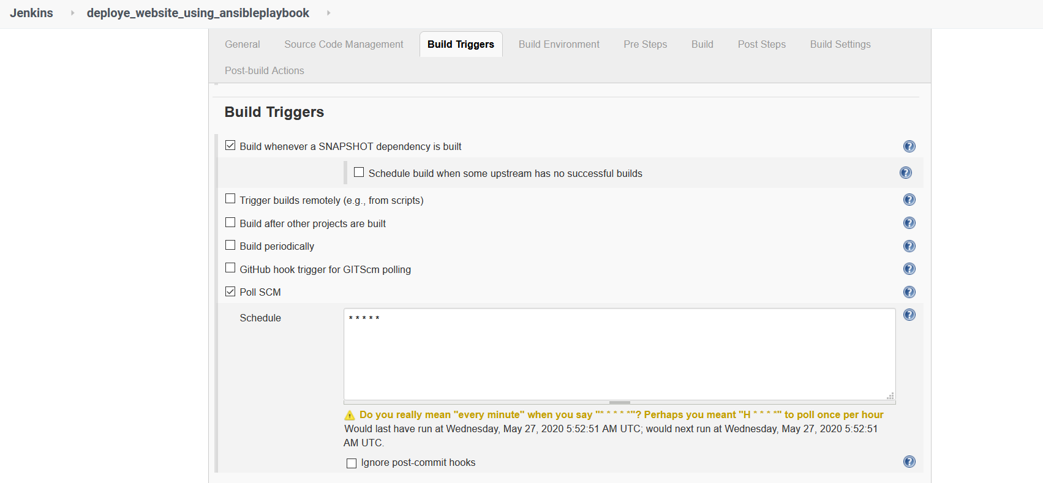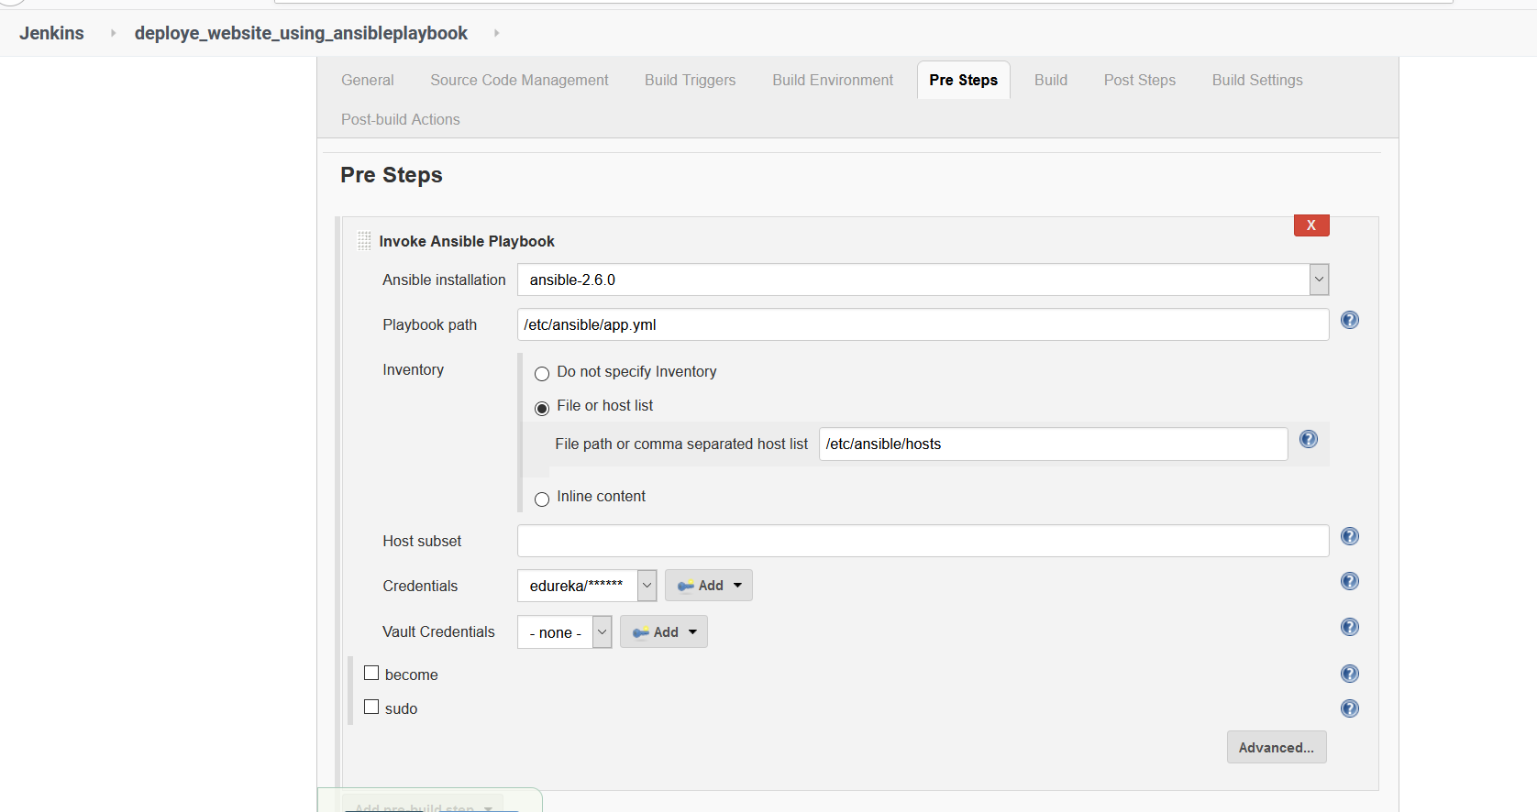

2 .Ansible components setup

* Command used to create roles for php and apache

$ansible-galaxy init –offline –init-path=roles apache

$ansible-galaxy init –offline –init-path=roles php

$ansible-galaxy init –offline –init-path=roles frontennd -- to deploye website from repo

3 . rest code zipped in folder

$ ansible-playbook app.yml

<https://localhost:81>

4. final output.

Screenshot of php website before commit

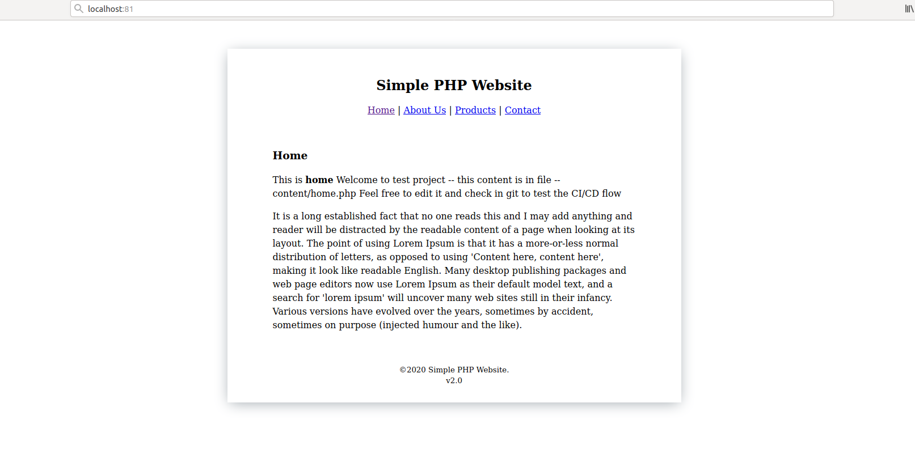

Screenshot after making change and apply commit

