Saint Louis University

School of Computing and Information Sciences

2nd Semester, A.Y. 2017 – 2018

Control Management System Documentation

Installation Manual

Group I

Baquiran, Clarke

Bernabe, Casey

Dagang, Arvin

Fernandez, Ervin

Gayaso, Genrie

Oñate, Prins

Pinto, Michael

Sese, John Patrick

Buse, Victoria

9364B

1:00 – 2:30 TF

Title Page

1. **WORDPRESS**

We used WordPress because it is a versatile software that can be used in the category of all the control management system out there, one of the reasons for picking WordPress is the ability of to choose and download plugins/themes while editing your website which would save the trouble of starting from the very beginning.

1. **Features/Plugins that was used in our website**

* **Image Slider -** allows the user to see the images of our school clinic while automatically changing pictures.

1. **Goal of our website**

The goal of our website is to inform the students of the Saint Louis University Maryheights campus about the school clinic (medical & dental) about the procedures performed when going to the clinic.

1. **Downloading and installing VirtualBox**

**VirtualBox Installation**

**1. Download the VirtualBox in this url:****<https://www.virtualbox.org/wiki/End-user_documentation>**

**2. Click Download Just as seen in Image 1.1 to navigate to the download page of the VirtualBox just as seen in Image 1.2**

**Image 1.1**

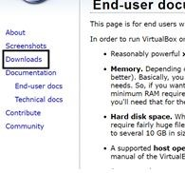

**Image 1.2**

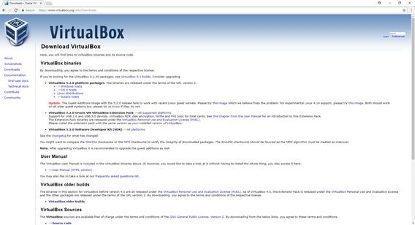

**3. Decide which package you need to download based on what operating system you are using in this case you are going to use the Windows package just as seen in Image 1.3**

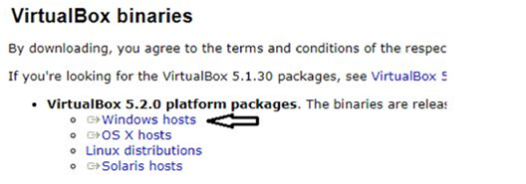

**Image 1.3**

**4. After downloading you are going to install it so open the file you just have downloaded, after opening the file a new window will open it is the installation window just like seen in Image 1.4**

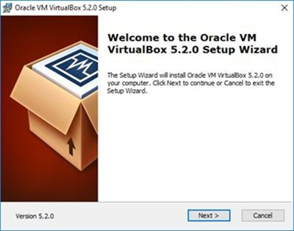

**Image 1.4**

**5. Click next and you will be directed to the next step in which you are going to choose what features you want to install just like in Image 1.5 and the location where you want to install it just like in Image 1.6**

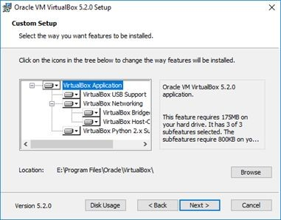

**Image 1.5**

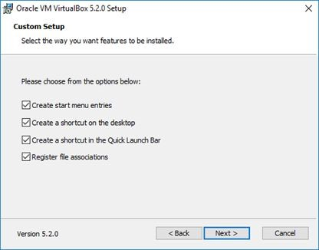

**Image 1.6**

**6. Click Yes just like in Image 1.7 and click install just like in Image 1.8**

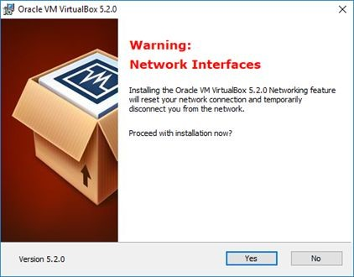

**Image 1.7**

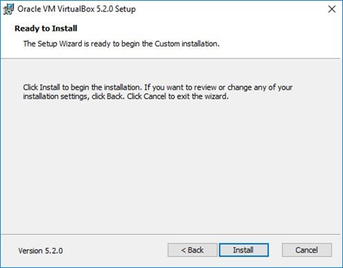

**Image 1.8**

**7. Wait for VirtualBox to install just like seen in Image 1.9**

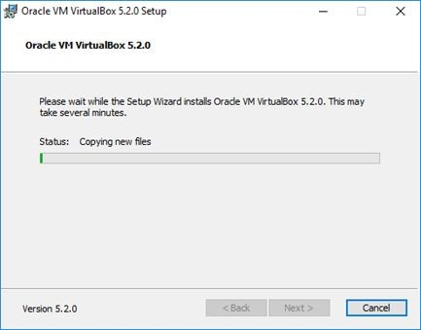

**Image 1.9**

**8. After successfully installing VirtualBox just click finish just like seen in Image 1.10**

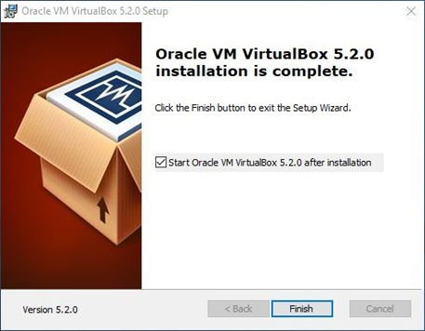

**Image 1.10**

**9. This is the user interface of the VirtualBox Image 1.11**

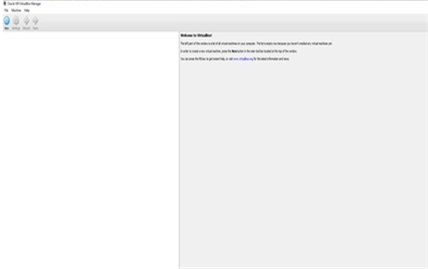

**Image 1.11**

1. **Additional Setup Ubuntu Server 16.04 LTS**

Setup the Ubuntu Server until you reach the “Software Selection”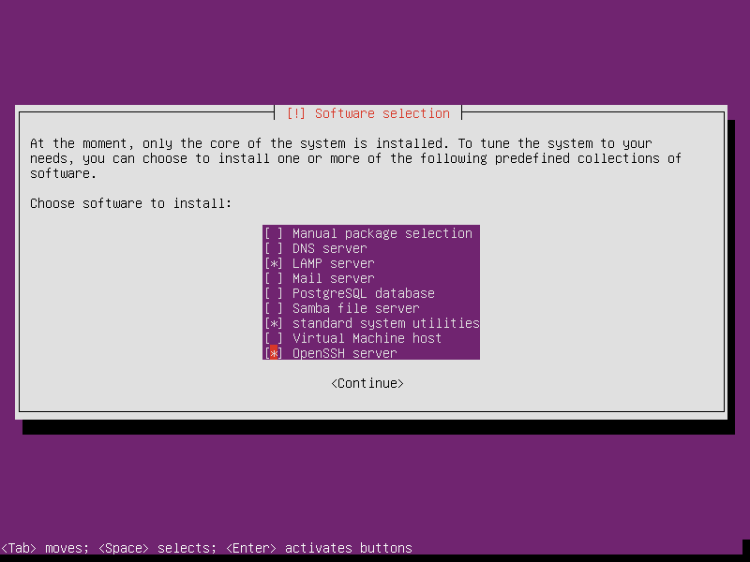

*Note, the normal setup of Ubuntu doesn’t require the LAMP server option, but this time we need to check the LAMP server.

1. **Importing the ubuntu server in Virtualbox**
2. **Setting up the ubuntu server**

**//kunin nlng yung installation ng server sa documentation dati para mabilis**

1. **Installation of wordpress in ubuntu**

**//paano ilagay wordpress sa ubuntu**

1. **Setting up wordpress**
2. **Admin-side wordpress**
3. **User-side wordpess**