Saint Louis University

School of Computing and Information Sciences

2nd Semester, A.Y. 2017 – 2018

Control Management System Documentation

User Manual

Group I

Baquiran, Clarke

Bernabe, Casey

Dagang, Arvin

Fernandez, Ervin

Gayaso, Genrie

Oñate, Prins

Pinto, Michael

Sese, John Patrick

Buse, Victoria

9364B

1:00 – 2:30 TF

Title Page

1. General Information

WordPress is an open source project that allows anyone to improve its code according to the user’s liking. Featuring thousands of themes, widgets and other tools that allows user to create any type of website, portfolios, electronic shops and many more. WordPress supports all hosting platforms and also the content management system is constantly updated in which it improves and includes new features with a good performance.

1. System Overview

This tool has the ability to create, publish and modify digital content that supports multiple users called content management system. This tool lets the user to publish a content without the knowledge of using HTML. It provides different or various designs and templates for the user to use. It contains group functions and also user functions.

1. Getting Started

First be familiarized with the VirtualBox, let’s check the setting of the VirtualBox for the user not to get problem when s/he configure the Ubuntu server. Click on the name of the server ‘webtechlab2018’. Now click on the ‘Settings’ button, and a window will open as shown in Figure 1.

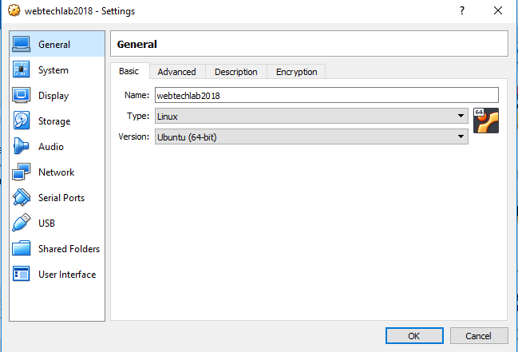

Figure 1.

This window is the setting of the Ubuntu server named ‘webtechlab2018’. Each of the buttons on the left are the configuration of the VirtualBox server. The first one is the ‘General’ configuration in which you can configure the fundamental aspects of the machine which is the “Basic”, “Advance”, “Description” and the “Encryption”. Next is the ‘System’ configuration in which these configurations are for basic hardware of the machine. ‘Display’ configurations are for the size of the memory to be use, the virtual graphics card availability and more. Next is the ‘Storage’ configuration in which the VM will allow you to connect to a virtual disk. ‘Audio’  configuration is for the sound card. ‘Network’  configuration is for the VM to setup the network present on the VM virtual network card. ‘Serial Ports’  configuration is for setting up primitive network in case Ethernet connection is not available. ‘USB’ configuration allows the VM to configure USB support. ‘Shared Folders’ configuration allows the access to exchange data from host to VM or vice versa. And lastly, the ‘User interface’ configuration that allows user to change the aspects of the interface.

For the user instructions, first download ‘WordPress’ from <https://wordpress.org> and save it to desktop with a sample file name ‘webtechlab2018’. On the ‘System’ configuration, ‘Processor’ tab adjust it to your desired processor for the server. Next is the ‘Display’, on the ‘Screen’ tab, ‘Video Memory’, adjust it to maximum range. Before setting up the ‘Storage’ configuration, download the ‘VboxGuestAdditions.iso’ from Oracle site and add it to the ‘Controller: IDE’. On the ‘Network’ menu, under the ‘Adapter 1’, change the ‘Attached to:’ option from NAT to ‘Bridged Adapter’. On the ‘Name’ dropdown menu, use the current network connection you have. Lastly, go to ‘Shared folders’ menu, click on ‘Add new shared folder’  and attached the folder named ‘webtechlab2018’ for later use. Press ‘Ok’ button and ‘Start’ the Server.

1. Ubuntu Server

Before you can access fully the server be sure to login your username and password. 

Next is to check for the IP address of the server. ‘ifconfig’ is a command to configure the network interface in Linux, therefore, on the command line type in ‘ifconfig’ and look for your server ‘inet address’. 

To configure your network IP address, type in ‘sudo vi /etc/network/interfaces’ and change the ‘primary network interface’ to dynamic or static. But for now, leave as it is. First, we need to create a directory for our ‘webtechlab2018’ file that contains the WordPress file that we downloaded earlier. On the command, type in ‘sudo mkdir /media/shared’ and press enter. Now, for us to access the file from desktop into our directory, we need to mount and install the VboxGuessAdditions.exe. Now type in ‘sudo mount -r /dev/cdrom /mnt’ in which in this command we will open the VboxGuessAdditions in the directory ‘/mnt’. Go to directory ‘mnt’ by typing in ‘cd /mnt’ and press enter. Now we will install the ‘VboxLinuxAdditions.run’ for us to transfer and access the ‘webtechlab2018’ into the server. Type in ‘sudo ./VboxLinuxAdditions.run’ and press enter. There will be an error but its ok for now. Reboot the server. Then repeat the previous command ‘sudo mount -r /dev/cdrom /mnt’ and then run another command ‘sudo mount -t vboxsf webtechlab2018 /media/shared’ in which this command is to transfer the file from desktop to /media/shared directory. Go to folder /media/shared and then type in ‘ls’, as you can see the file from the desktop is now ready to copy.

You can access the default html file from the server which is in ‘/var/www/html’ and change it to our downloaded file WordPress by typing ‘sudo cp -a /media/shared/wordpress/. /var/www/html’. After copying the file, go to the html directory which is in ‘/var/www/html’ and delete the html file ‘index.html’. Next is to edit the ‘wp-config.php’ and also creating a database.

1. Configuring the Server with WordPress

This time, we edit the WordPress configuration file and create a database for our CMS to work. First, we need to create a database, type in ‘mysql -u root -p’ and then press enter. Input the password you’ve created in the Installation manual on LAMP. To show the databases, type in ‘show databases;’. It will show the default databases in MySQL. Now we create a database named ‘webtechlab’, type in ‘CREATE DATABASE webtechlab’. After creating the database, we need to edit also the path for us to access the html. Type in ‘use webtechlab;’ for the user to see the tables and edit the ‘wp_options’, the home path and the siteurl path. Next is to type ‘show tables;’ and then query the ‘wp_options’ by typing in the command ‘select * from wp_options where option_id = 1; ‘. As you can see, it consists of 4 column, the option_id, option_name, option_value and autoload. We only need to change the path which is the option_value. To edit, type in ‘update wp_options set option_value=’http://www.sluclinic.com’ where option_id =1;’ where the option_value is the address of your website. Repeat the previous command but this time change the option_id to 2 which is the home page. After those commands, type in exit.

Now go to root directory ‘/var/www/html’ and edit the ‘wp-config.php’ file by typing ‘sudo vi /var/www/html/wp-config.php’. On the line ‘define(‘DB_NAME’, ‘database-name ’);’ type into the ‘database-name’ the name of the database we just created which is the ‘webtechlab’. Then after typing the database name, type in also the MySQL database password in which we created in the installation process. After doing that, you may now save and exit the file.

Next is to create a configuration file in apache2 for the website to host in VirtualBox. Create a copy of the 000-default.conf configuration file and named it as ‘website.com.conf’ in which in our case we will name it as ‘www.sluclinic.com.conf’. by typing ‘sudo cp /etc/apache2/sites-available/00

Next is to configure the VirtualHost, by doing ‘sudo vi /etc/apache2/sites-available/000-default.conf [www.sluclinic.com.conf](http://www.sluclinic.com.conf)’ and then we edit the new configuration file by typing ‘sudo vi /etc/apache2/sites-available/www.sluclinic.com.conf’ and press enter. Now we first delete everything, by typing ‘shift+v’ and ‘arrow up’ in the keyboard until it highlights all the text and press the ‘Delete’ button in the keyboard. Now enter the following command shown in Figure 2.

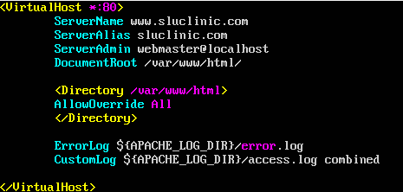

Figure 2.

Now save and exit the editor. Next is to edit the hosts in our windows host, simply locate the hosts file at ‘C:\Windows\System32\drivers\etc\hosts’ and edit using notepad++. At the bottom type in the IP Address of the server and the server name beside the IP Address. Example ‘192.168.5.190 [www.sluclinic.com](http://www.sluclinic.com)’. Save the file twice and now we are ready to access through our browser.

1. Configuring the website through a web browser

Open your web browser and type in [www.sluclinic.com](http://www.sluclinic.com), the name of the created website. Then follow the instruction of the WordPress installations. After installation,