The benchmark was written by logging application data to a CSV format through running the VTUNE profiler. A python script then parsed the data and displayed the results. Also, the benchmark was run with 200 managed glib hashtables and 500k entries. The number of threads was the independent variable, which was set from 1 to 16 threads. The number of hashtables and number of entries are program arguments as well.

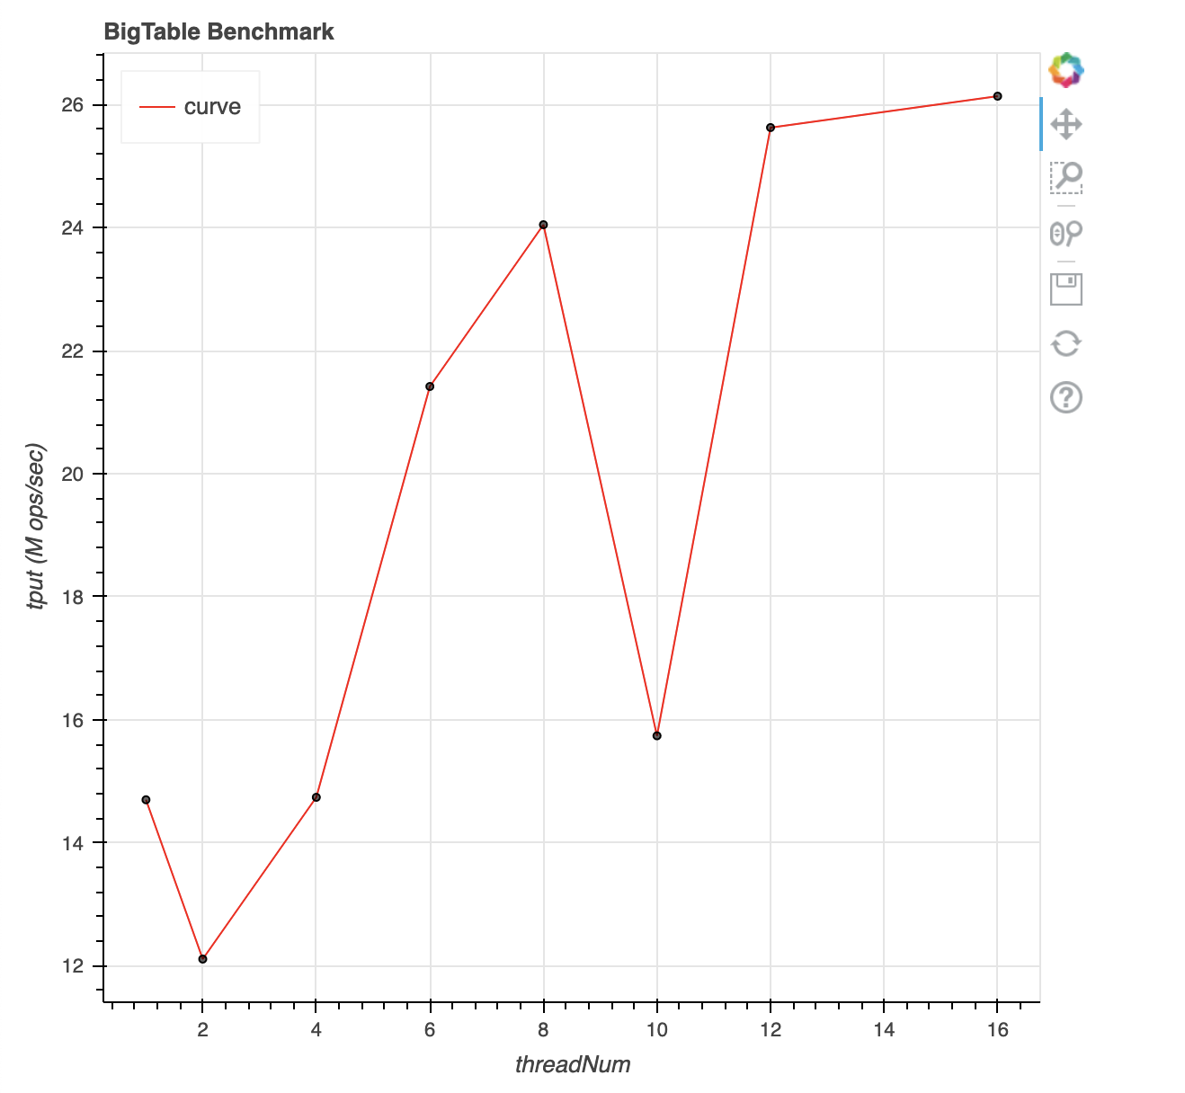

As seen in the scalability plot above, the BigTable implementation with many smaller hashtables, and many locks, resulted in better scalling for higher thread counts.

By looking at the trace, we can also see that all they keys have been inserted and validated:

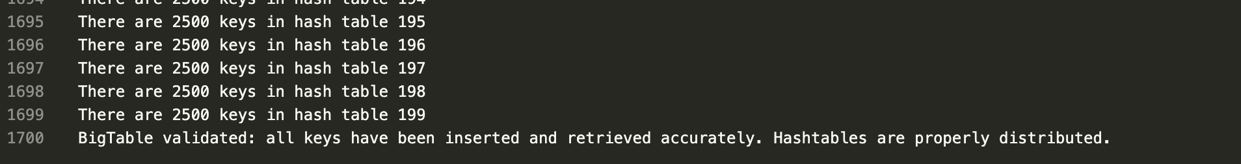

The validation check passed for all the cases above as well. This information was obtained by looking at the trace.txt content. The validation check is a simple counter that determines if the total number of valid keys is equal to the starting value of n. This is validation is done on exit.