**Practical : 3**

**OBJECTIVE :**

Fuzzy Weighted Average and Application

**Introduction**

The fuzzy weighted average (FWA), which is a function of fuzzy numbers and is useful as an aggregation method in engineering or management science based on fuzzy sets theory. It provides a discrete approximate solution by α-cuts level representation of fuzzy sets and interval analysis.

**Theory**

The multiple criteria decision making (MCDM) problems usually involve a set of alternatives. These alternatives are to be evaluated based on several criteria, which are independent of each other. Due to some criteria that may involve imprecise or vague information, the final synthetic results for each alternative can be computed using the fuzzy qualitative method. Many practical group decision-making problems are decisions that are generally made with available data and information that are mostly vague, imprecise, and uncertain by nature. Therefore, fuzzy sets or fuzzy numbers can appropriately represent imprecise parameters, and can be manipulated through different operations of fuzzy sets or fuzzy numbers. Since imprecise parameters are treated as imprecise values instead of precise ones, the process will be more powerful and its results more credible.

The FWA method has been seen as an aggregated function for handling MCDM group decision problems based on fuzzy sets theory, and it has been successfully applied in many fields such as engineering and management science.

The conceptual formulation of the FWA method proposed in 1977 by Baas and Kwakernaak is briefly reviewed. Generally speaking, a FWA may be defined as the process that via obtaining the fuzzy (criteria) ratings of some alternatives Aj, j = 1, 2, ... , m with respect to a set of criteria, attributes or factors i as Cji, i ε {1, 2, ... , n}, and via obtaining the fuzzy weightings or importance of the criteria, Wi, i ε {1, 2, ... , n}, finally reaches the objective function that aggregates the fuzzy criteria ratings and weightings into the FNs Yj for the objects. Therefore, the FWA are also an aggregation process for the multicriteria decision making problems. Based on the outcomes of FWA, the objects may be ranked through a ranking method. Thus, it consists of the fuzzy addition, fuzzy multiplication, and fuzzy division and can be defined by

Yj = f ( Cj1, . . ,Cji, . . . ,Cin, W1, . . .,Wi, . . .,Wn )

**Procedure :**

1. Click arbitrarily within the triangles to input Pressure.

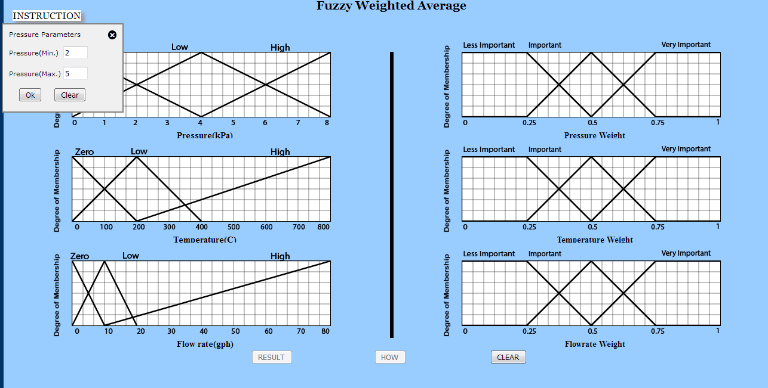

1. Give the values in the input box within range to input Pressure.

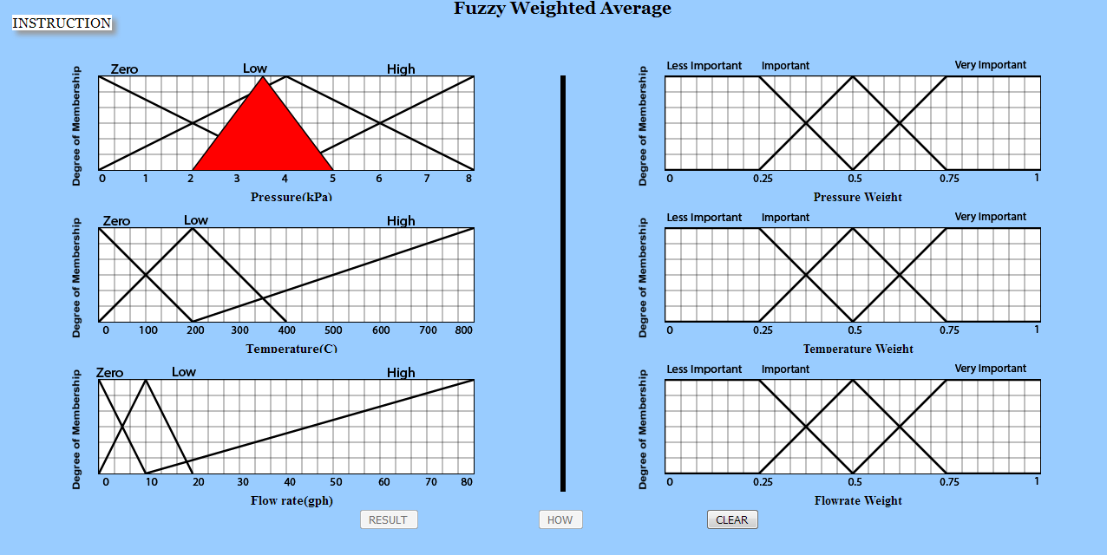

1. Click arbitrarily within the triangles and give values to input Temperature.

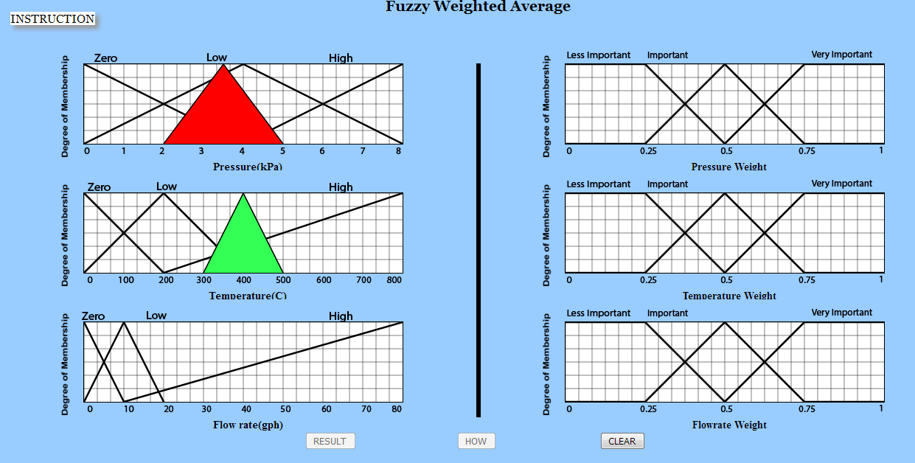

1. Click arbitrarily within the triangles and give values to input Flowrate.

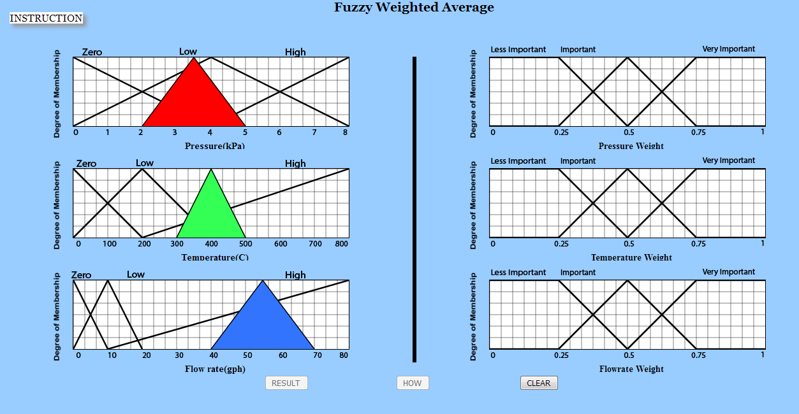

1. Click two points on the X-axis to input Pressure Weight.

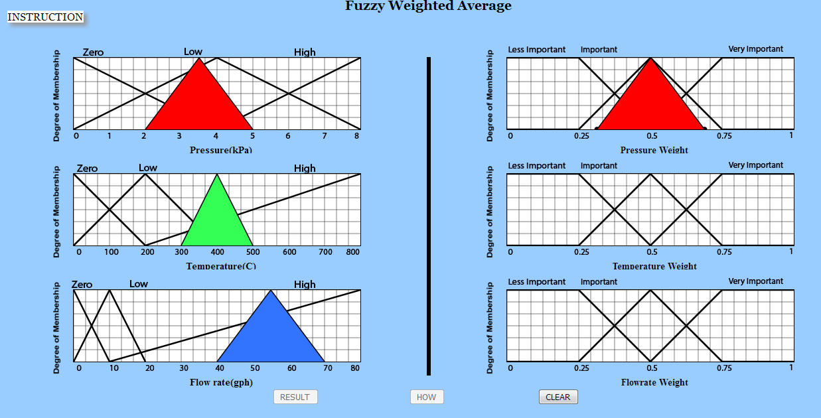

1. Click two points on the X-axis to input Temperature Weight.

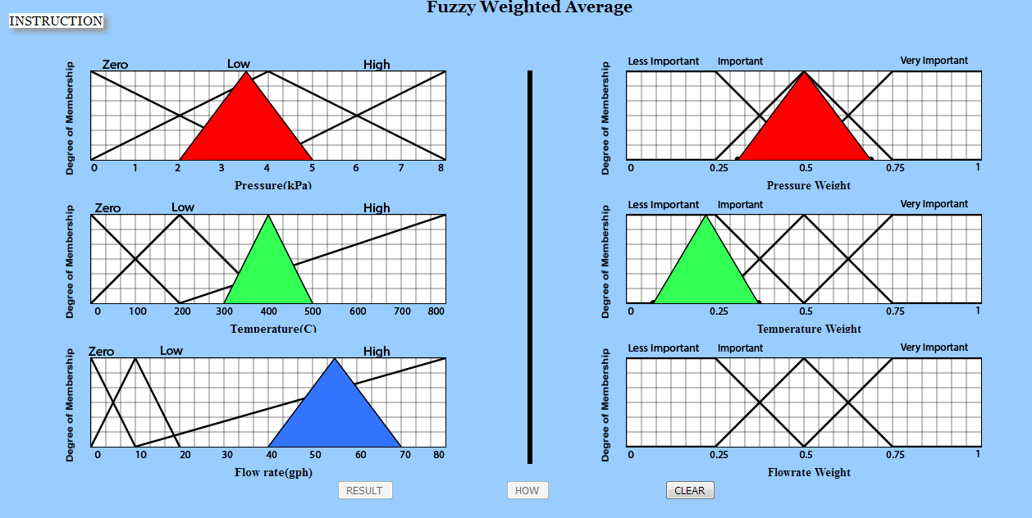

1. Click two points on the X-axis to input Flowrate Weight.

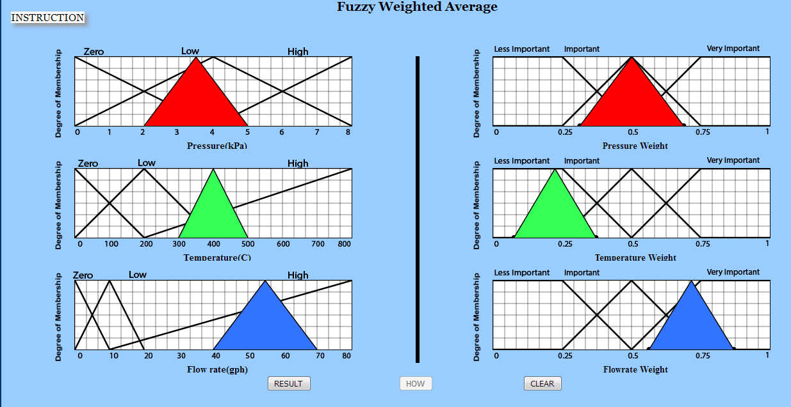

1. Click Result button to check what operation was performed.

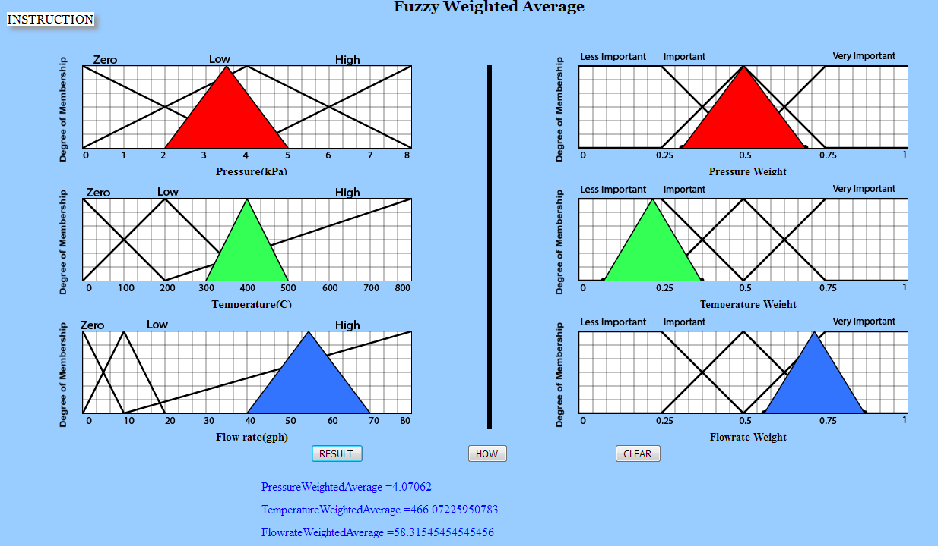

1. Click on How button to know how the operation was performed .

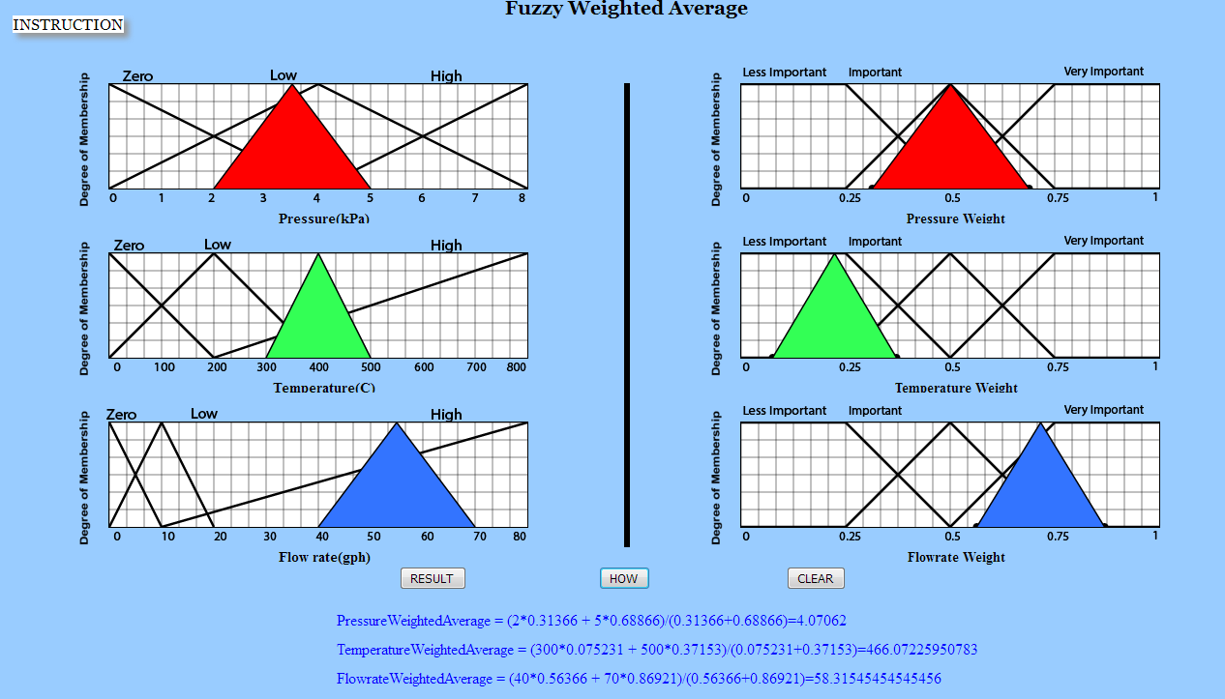

**OUTPUT (2nd Run)**

