**Practical : 5**

**Topic :**

Introduction to Neural Networks and Perceptron Example

**Theory :**

**Perceptron**

* The method of storing and recalling information and experiences in the brain is not fully understood. However, experimental research has enabled some understanding of how neurons appear to gradually modify their characteristics because of exposure to particular stimuli. The most obvious changes have been observed to occur in the electrical and chemical properties of the synaptic junctions. For example the quantity of chemical transmitter released into the synaptic cleft is increased or reduced, or the response of the post-synaptic neuron to receive transmitter molecules is altered. The overall effect is to modify the significance of nerve impulses reaching that synaptic junction on determining whether the accumulated inputs to post-synaptic neuron will exceed the threshold value and cause it to fire. Thus learning appears to effectively modify the weighting that a particular input has with respect to other inputs to a neuron.effectively modify the weighting that a particular input has with respect to other inputs to a neuron.
* Perceptron may have continuous valued inputs. It works in the same way as the formal artificial neuron defined previously. Its activation is determined by equation:



Moreover, its output function is:

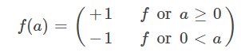

having value either +1 or -1.

* Now, consider such a perceptron in N dimensional space , the equation:



that is,



defines a hyperplane.

* This hyperplane divides the input space into two parts such that at one side, the perceptron has output value +1, and in the other side, it is -1.
* A perceptron can be used to decide whether an input vector belongs to one of the two classes, say classes A and B.
* The decision rule may be set as to respond as class A if the output is +1 and as class B if the output is -1.
* The perceptron forms two decision regions separated by the hyperplane.
* The equation of the boundary hyperplane depends on the connection weights and threshold.
* The Structure of a Perceptron is given below:

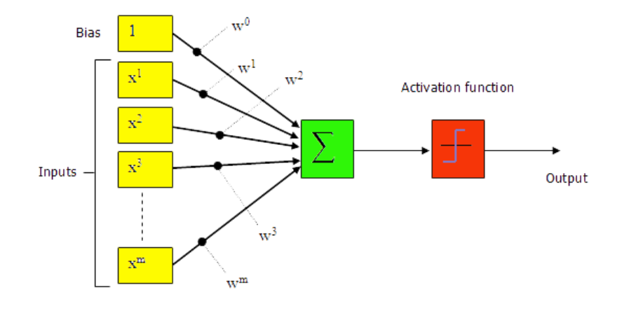

**Procedure :**

1. Left click on the board to plot blue color samples.
2. Right click on the board to plot Red color samples.
3. Adjust Learning rate to level of your choice.
4. Input no. of Iterations to be performed.
5. Click on Learn Button to plot Perceptron line dividing the Blue and Red Samples.

**Output :**

