Software Testing Lab

ITPC-421

Information Technology



Dr. B.R. Ambedkar National Institute of Technology, Jalandhar

Submitted to: Dr. Jitendra Kumar Samriya (Department of IT)

Submitted by:

Name: Arvinder Singh

Roll no: 1824004

Dept: Information Technology

Date: 1 December 2021

**Objective: (Even Roll no: Section B)**

1. Count objects on webpage
2. Write and test a program to login a specific web page.

**Requirements:**

1. Windows PC (Windows 7/8/10) / Mac
2. Eclipse IDE
3. Selenium
4. Chrome or any other browser with it’s driver to use with selenium
5. **Count Total objects on a page:**

In this program we are counting different types of objects in a given webpage for example count total links, total images, total unordered lists used on a given webpage.

**Code:**

**import** java.util.List;

**import** org.openqa.selenium.By;

**import** org.openqa.selenium.WebDriver;

**import** org.openqa.selenium.WebElement;

**import** org.openqa.selenium.chrome.ChromeDriver;

**public** **class** NumberOFObjects {

**static** String *driverType* = "webdriver.chrome.driver";

**static** String *driverLoc* = "C:\\Users\\arvindersingh\\Desktop\\Labs\\02.SoftwareTesting\\Resources\\chromedriver_96.exe";

**static** String *baseURL* = "https://www.nitj.ac.in/";

**public** **static** **void** main(String[] args) {

System.*setProperty*(*driverType*, *driverLoc*);

WebDriver driver = **new** ChromeDriver();

driver.get(*baseURL*);

List< WebElement> mylist=driver.findElements(By.*xpath*("//a"));

System.***out***.println("Number of links =" +mylist.size());

List< WebElement> mylist2=driver.findElements(By.*xpath*("//img"));

System.***out***.println("Number of images =" +mylist2.size());

List< WebElement> mylist3=driver.findElements(By.*xpath*("//ul"));

System.***out***.println("Number of unordered_Lists =" +mylist3.size());

List< WebElement> mylist4=driver.findElements(By.*xpath*("//ol"));

System.***out***.println("Number of ordered_Lists =" +mylist4.size());

// to get screenshot following is commented

//driver.close();

}}

**Output**

(to capture browser screenshot driver.close() was commented)

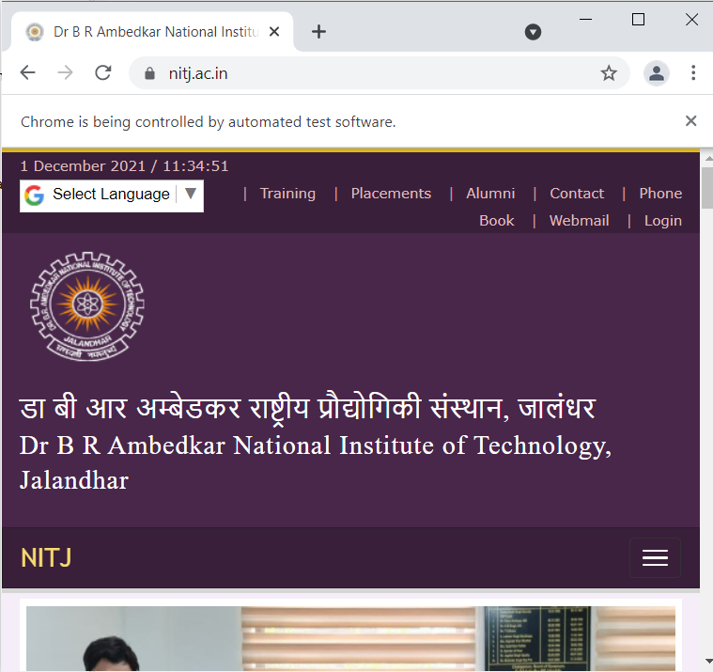

Website opened

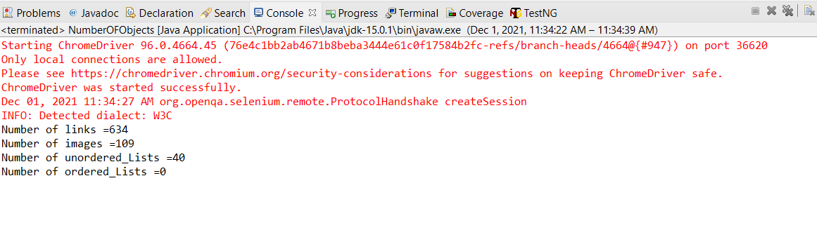

Output as count of objects in eclipse console

1. **Login to specific website :**

Here we are using Facebook to test login functionality.

After we log in, in landing page there’s some specific elements i.e. HTML tags with specific id. We will be using them to check if landing page is opened after automated login is done. One such element is “ssrb_root_start”

**Code:**

**import** org.openqa.selenium.By;

**import** org.openqa.selenium.WebDriver;

**import** org.openqa.selenium.WebElement;

**import** org.openqa.selenium.chrome.ChromeDriver;

**public** **class** Current {

**static** String *driverType* = "webdriver.chrome.driver";

**static** String *driverLoc* = "C:\\Users\\arvindersingh\\Desktop\\Labs\\02.SoftwareTesting\\Resources\\chromedriver_96.exe";

**static** String *baseURL* = "https://www.facebook.com";

**static** String *uname_val* = "ArvinderSingh@gmail.com";

**static** String *password_val* = "RollNo_18124004";

**public** **static** **void** main(String[] args) **throws** InterruptedException {

System.*setProperty*(*driverType*, *driverLoc*);

WebDriver driver = **new** ChromeDriver();

driver.get(*baseURL*);

WebElement username = driver.findElement(By.*id*("email"));

WebElement password = driver.findElement(By.*id*("pass"));

WebElement Login = driver.findElement(By.*name*("login"));

username.sendKeys(*uname_val*);

password.sendKeys(*password_val*);

Login.click();

Thread.*sleep*(2000);

**try** {

@SuppressWarnings("unused")

WebElement e= driver.findElement(By.*id*("ssrb_root_start"));

System.***out***.println("TEST CASE PASS..");

driver.close();

} **catch** (Exception e) {System.***out***.println("TEST CASE FAILED...");

driver.close();

}

}

}

**Output**

(to capture browser screenshot driver.close() was commented)

|  |
| --- |
|  |
|  |

Login Successful: valid username and password

|  |
| --- |
|  |
|  |

Login Insuccessful: Invalid username and/or password