Cloud Computing Lab

ITPC-423

Information Technology



Dr. B.R. Ambedkar National Institute of Technology, Jalandhar

Submitted to: Dr. Mohit Kumar (Department of IT)

Submitted by: Group 1

|  |  |
| --- | --- |
| **Roll No.** | **Name** |
| 18124004 | Arvinder Singh |
| 18124012 | Harsh Gupta |
| 18124015 | Maheep Singh |
| 18124029 | Vishwas Tak |

**Groupwise Lab Task**

**Objective:**

WAP to implement the GA & DE algorithm in Cloud computing

**Requirements:**

1. Windows PC (Windows 7/8/10) / Mac
2. Eclipse Ide
3. JDK 15
4. CloudSim Jar files

**Problem Definition**

Suppose that there are m tasks T={t1,t_2,...,tm}, and n virtual machines VM={[vm]_1,[vm]_2,...,[vm]_n}.

It is a NP-complete problem which has n^m ways to allocate these tasks to VMs. When a task is bound to a virtual machine [vm]_i the occupation time of [vm]_j depends on the length of task and the CU of the VM. The execution time for t_ij on vmj is given by t_ij

t_ij=L_i/C_j

where i∈{1,2,…,m}, j∈{1,2,…,n}, L_(i ) represents the length of task t_i, and C_j denotes the CU (Compute Unit) of virtual machine [vm]_j.

**Genetic Algorithm:**

Proposed Method:

The population is evaluated and selected to create a new generation by the fitness function. To find the correctness of the schedule the fitness function is used:

fitness(P)=min(U_1,U_2,…..,U_n)

where U_1,U_2,…..,U_n are the chromosomes that represent the time taken to finish all the cloudlets execution for their respective assignment

**Algorithm:**

Step 1: Start

Step 2: Calculate the process priority as per their time

Step 3: Initialize the population as per the process priority

Step 4: Evaluate the fitness function to determine the fitness of each individual.

Step 5: Select the fittest chromosome.

Step 6: Perform crossover mapping over chromosomes.

Step 7: Perform mutation by changing the genes of individual parents.

Step 8: Add the chromosome to a new population

Step 9: Repeat steps 2 to 7 for all new arrival process Step

10: Exit

**Sample Output:**

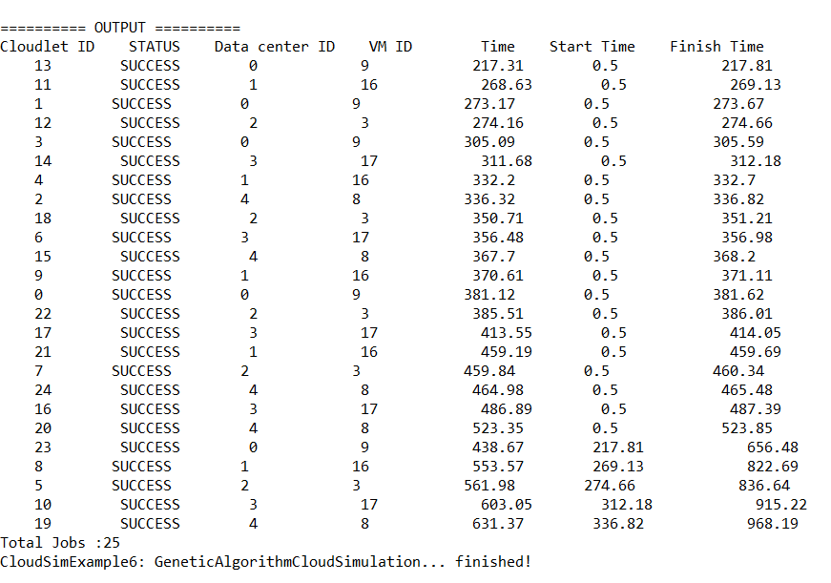

**Differential Evolution:**

The DE approach is mainly affected by three factors, namely:

Crossover factor (F), Crossover probability (CR), and number of iterations (I).

These factors must be carefully selected to maximize efficiency.

**Algorithm:**

1. Input of the number of tasks (t) versus the number of processors (p).

2. Input of the execution time matrix E = tXp (times of each task corresponding

to each processor).

3. Input of the population size (s).

4. Input of the number of DE iterations (I).

5. Generation of a random population matrix P = sXt (each element Pij is a

processor number allocated to task ‘Tj’ under population vector ‘Vi’).

6. Calculate the fitness value (simply the reciprocal of the sum of the execution

times corresponding to processor Pij with task Tj) of each vector and pick the

maximum value.

7. Pick three random vectors (a, b, c) from the population corresponding to the

first vector (Pi = 1).

8. Also select a random probability rj and random crossover index R and apply

crossover formula: If (rj < CR OR i = R) M = (floor [a + F * abs(b − c)]

modulo p) + 1 Where M is the mutated vector and F is the mutation factor

(0 < F ≤ 2).

9. Calculate the fitness values for P1 and M.

10. If fitness value of M exceeds that of P1, replace P1 by M in the population

matrix P

11. Apply steps 5–7 for every vector of the population matrix.

12. Calculate the maximum fitness value among all vectors of the latest population

matrix obtained at the end of step 8.

13. Take the final population as the initial population for the next iteration and

repeat steps 6–12, I-1 times more.

**Sample Output:**

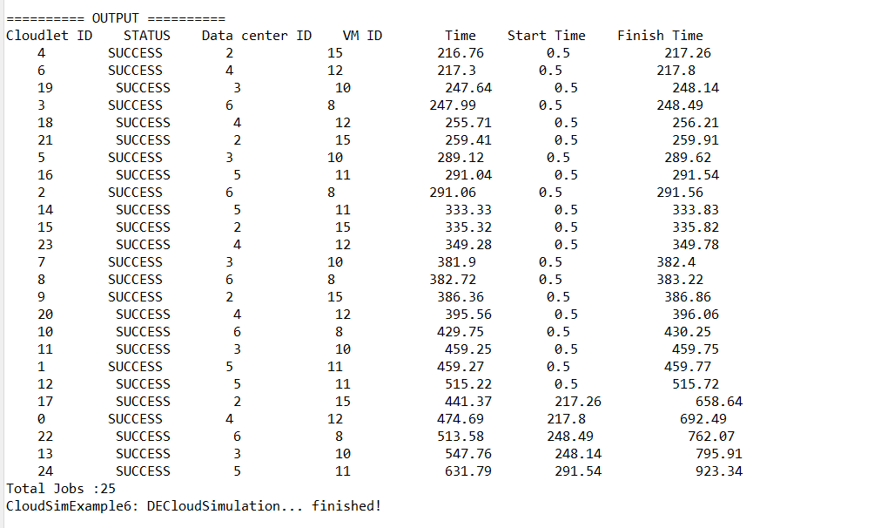

**Performance Evaluation:**

**Configuration:**

|  |  |
| --- | --- |
| No of Datacenters | 5 |
| No of VMs | 25 |
| No of Iterations (both GA and DE) | 25 |

**No of Tasks vs Time:**

|  |  |  |
| --- | --- | --- |
| **Number of Tasks** | **Time taken by Genetic Algorithm (micro sec)** | **Time taken by Differential Evolution Algorithm (micro sec)** |
| 25 | 1311 | 1073 |
| 50 | 1683 | 1551 |
| 100 | 2774 | 2839 |
| 500 | 14218 | 12709 |
| 800 | 28095 | 25754 |
| 1000 | 32561 | 29799 |

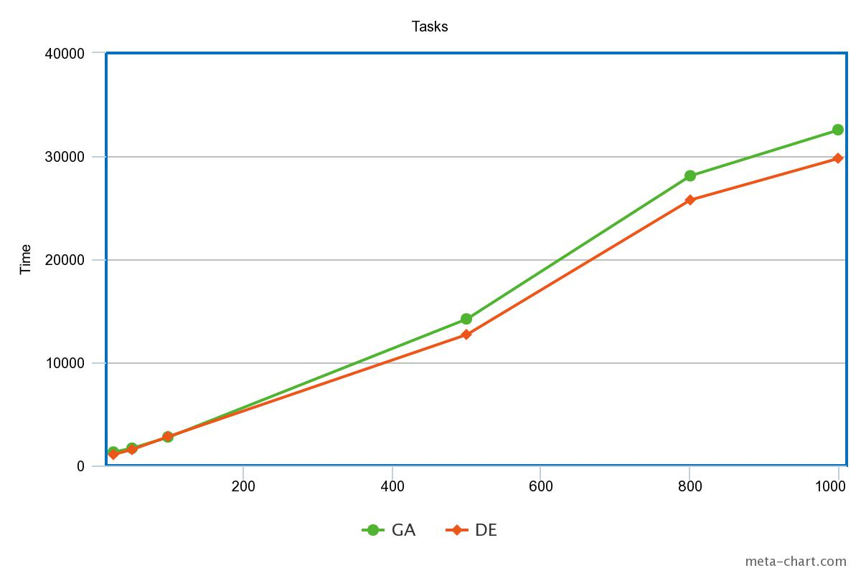

Comparison between GA and DE