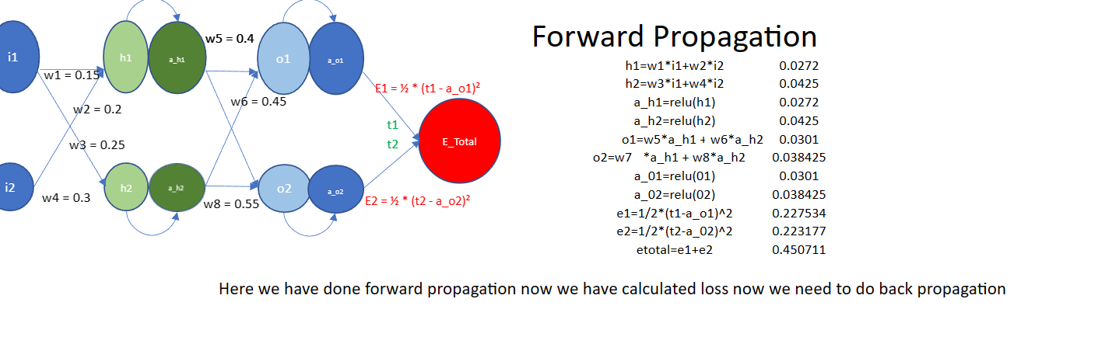

Here we look carefully This above picture shows us how forward propagation is done and how weights are being calculated, and every neuron is connected to every single neuron in next layer. And we have applied relu as a activation function in this. After that we have caculated total loss and after this step this goes in backpropagation for learning.

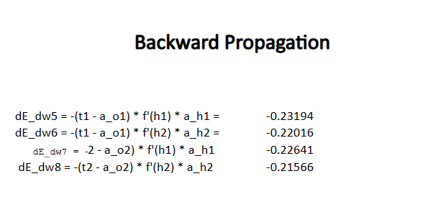

This image helps us to learn how weights are re calculated using chain rule partial differentiation, this is done so neuron could learn efficiently and change weights better way so, every neuron remember outcome which he had given in last output so it could change weights.

