Retail Analysis With Walmart Data
Screenshots

1. Importing Required Libraries
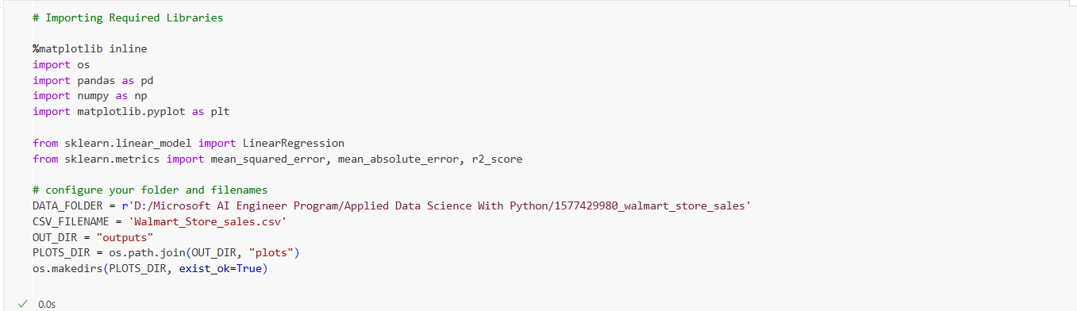

2. Loading Walmart Sales Dataset
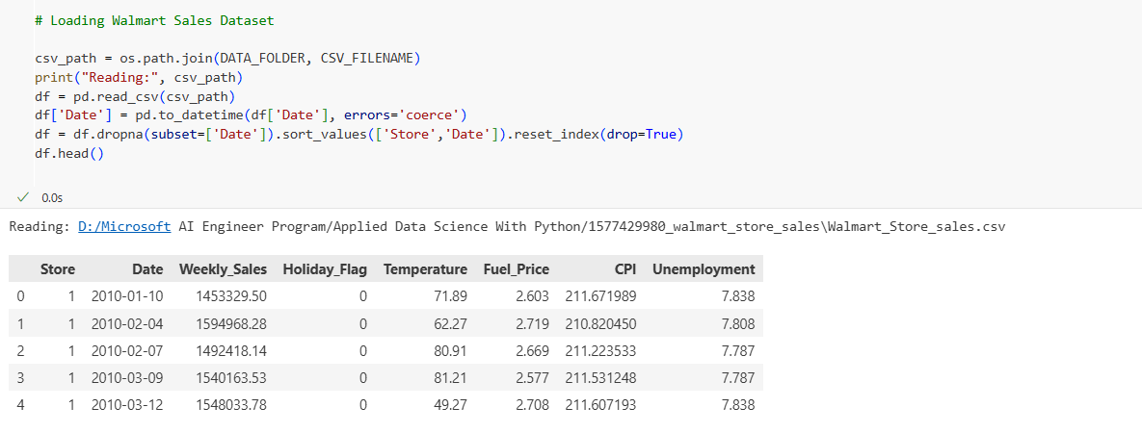

3. Store Statistics (Total Sales, Mean, Std Dev, Coefficient of Variation)
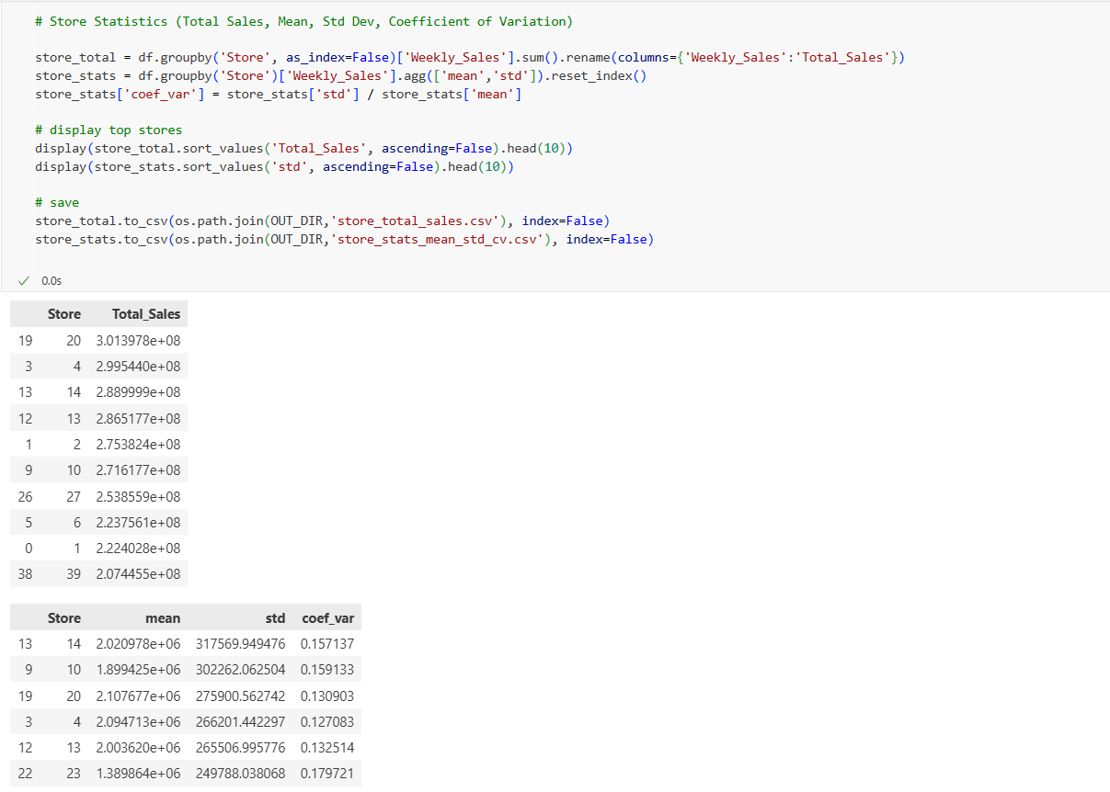

4. Store with Maximum Sales & Quarterly Growth (Q2 → Q3 2012)
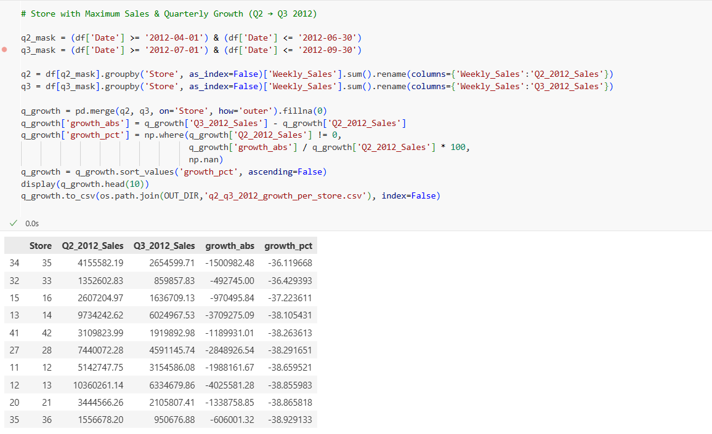
5. Store with Maximum Std Dev & Holiday vs Non-Holiday Sales Analysis

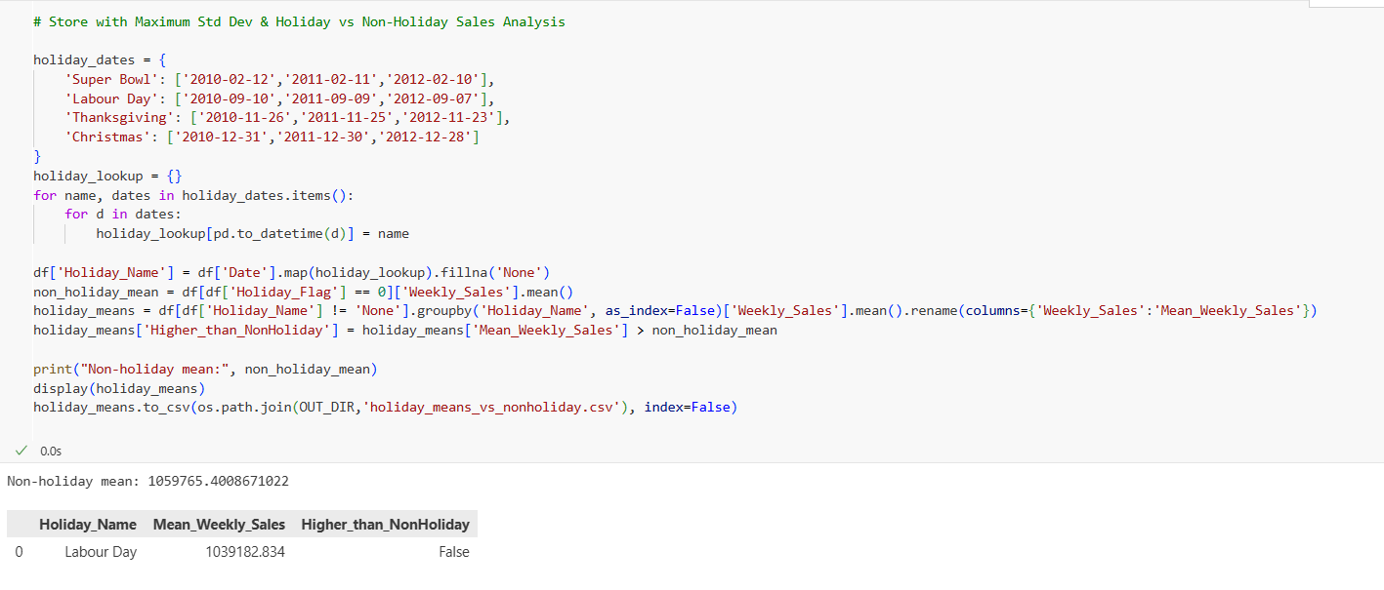
6. Quarterly Growth in Q3 2012 + Monthly & Semester Aggregates
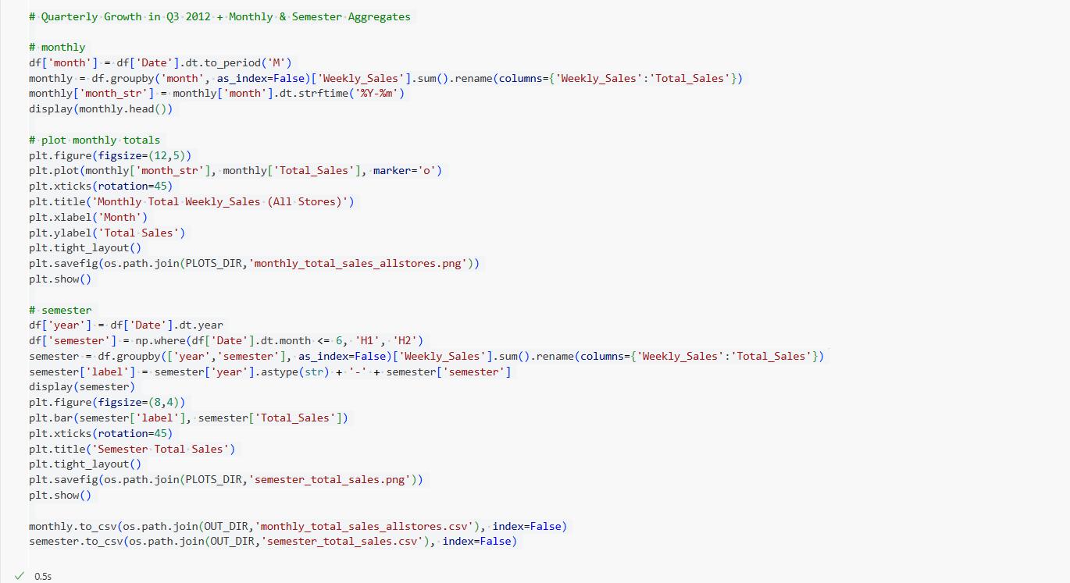
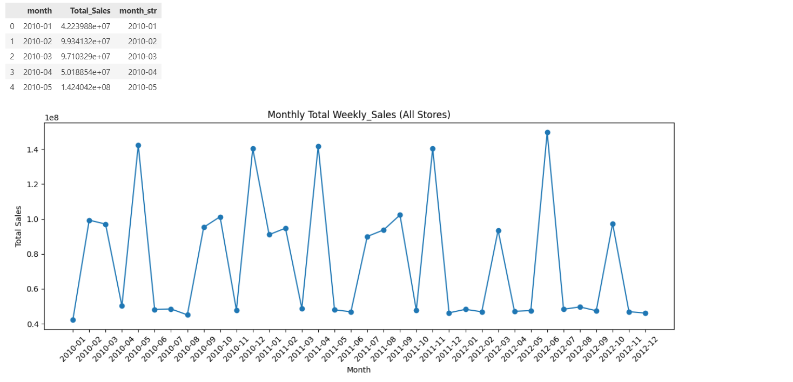
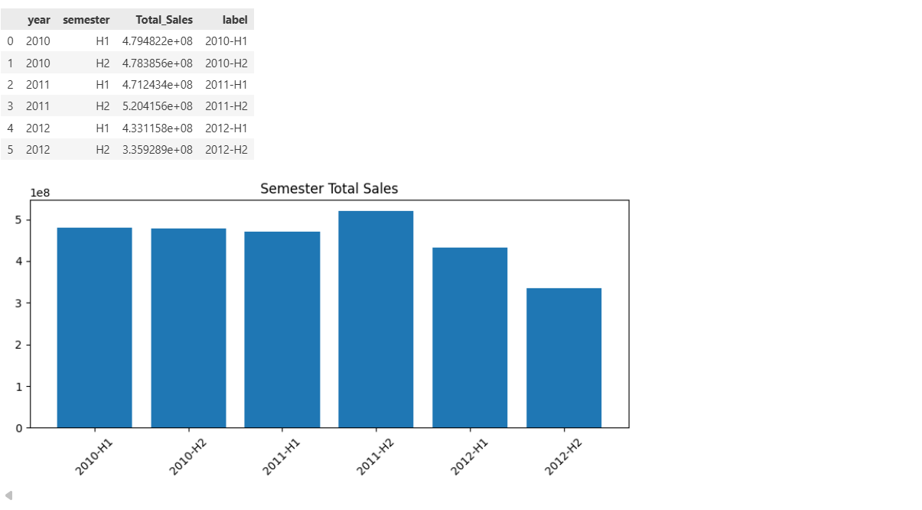

7. Prepared Data for Store 1 Forecasting
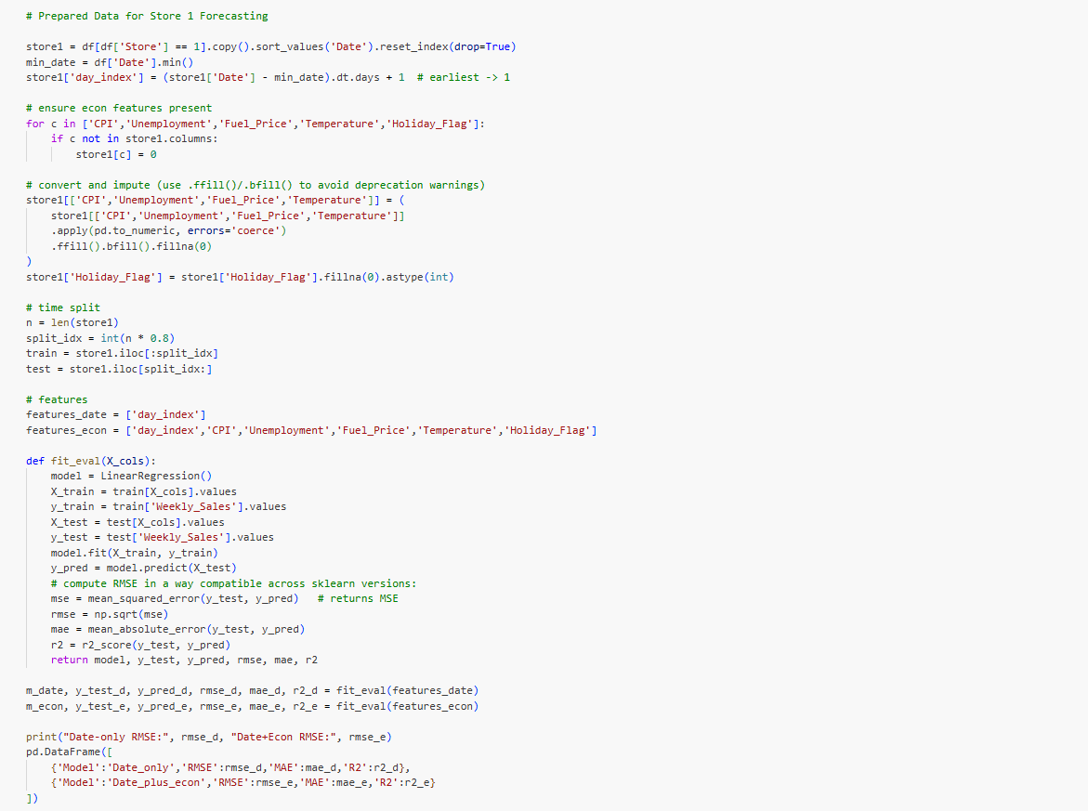
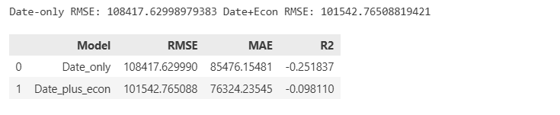
8. Linear Regression Models
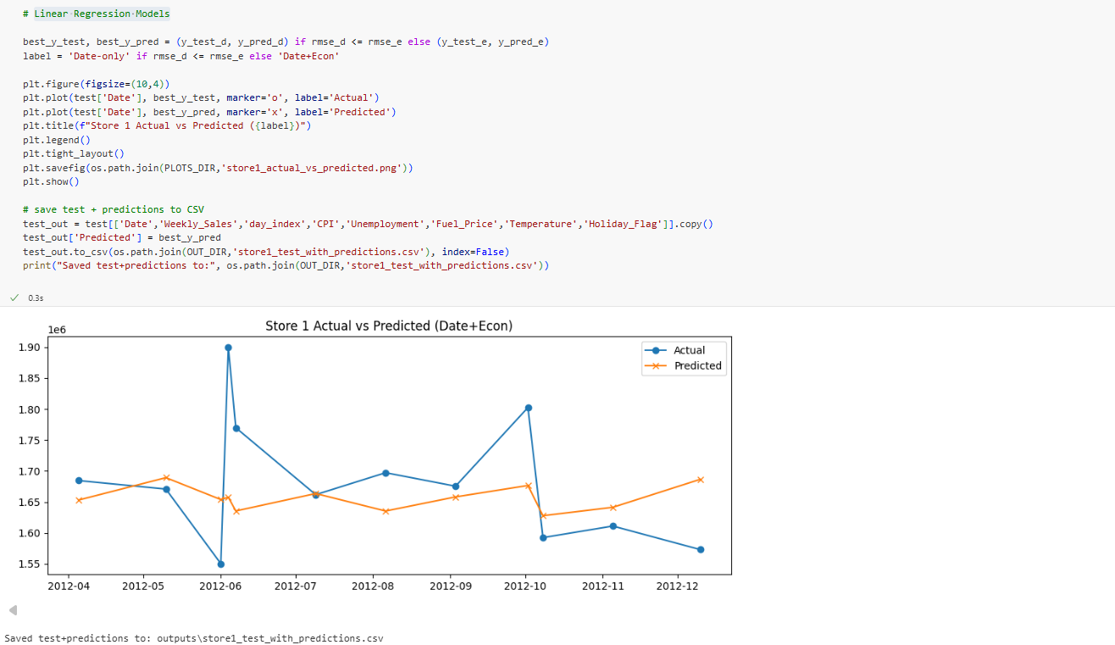

9. Manual OLS Regression for Store 1
