Employee Turnover Analytics
Screenshots

1.Importing statements and loading data set
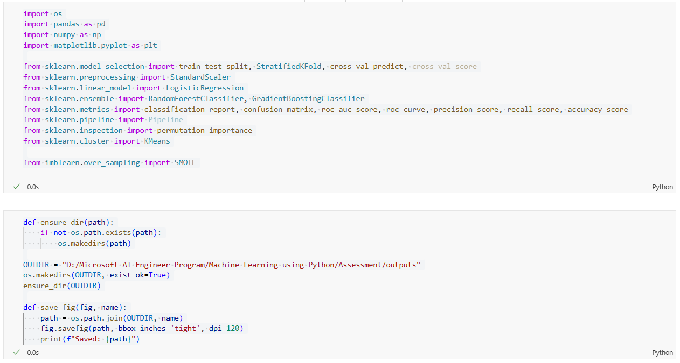
2. Data quality checks by checking for missing values, if any
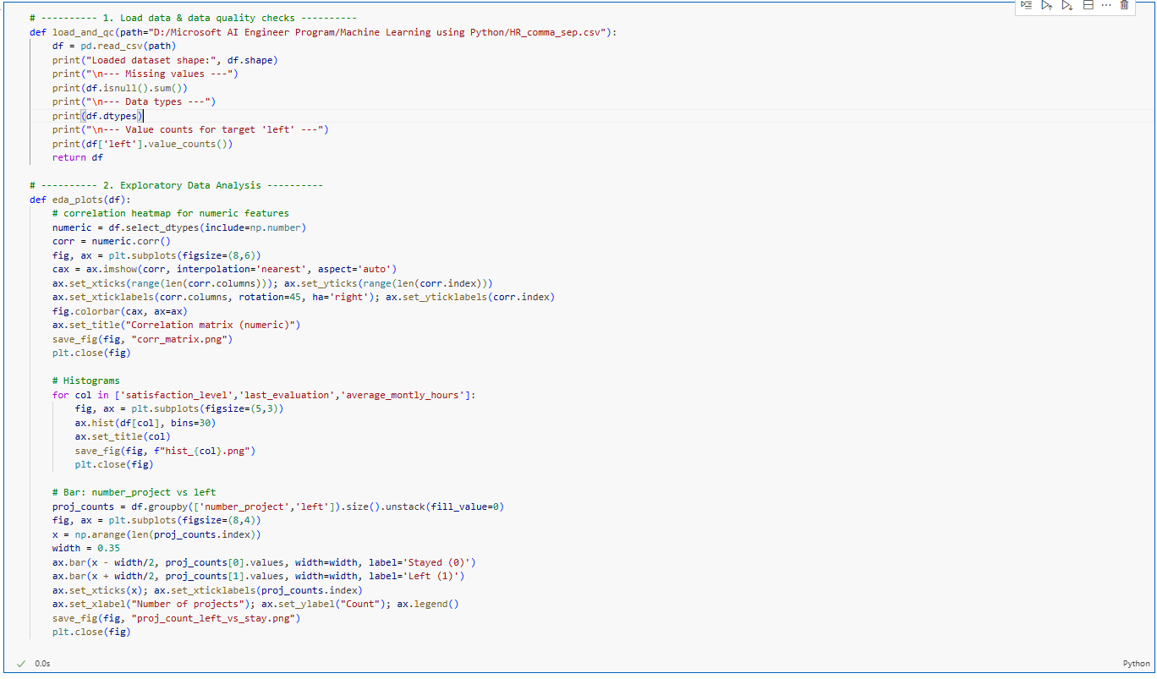
3. Factors contributed most to employee turnover at EDA
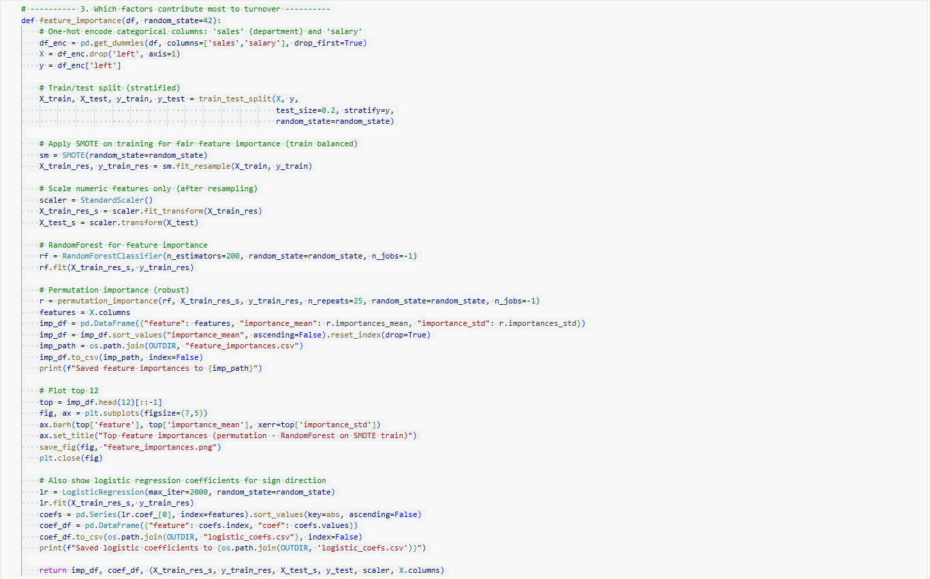
4. Clustering of employees who left based on their satisfaction and evaluation
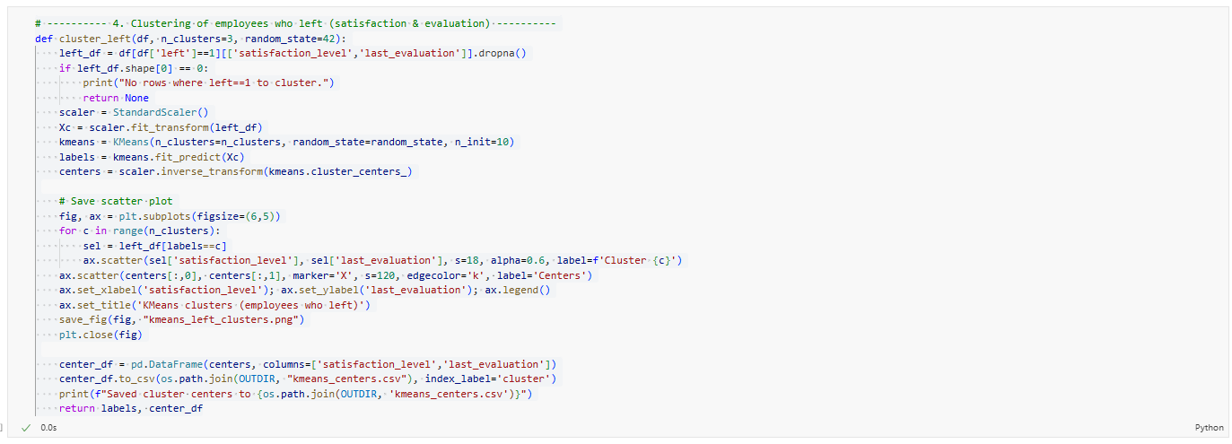
5. Left Class Imbalance using the SMOTE technique
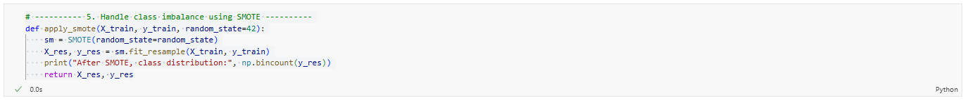
6. k-fold cross-validation model training and evaluate performance
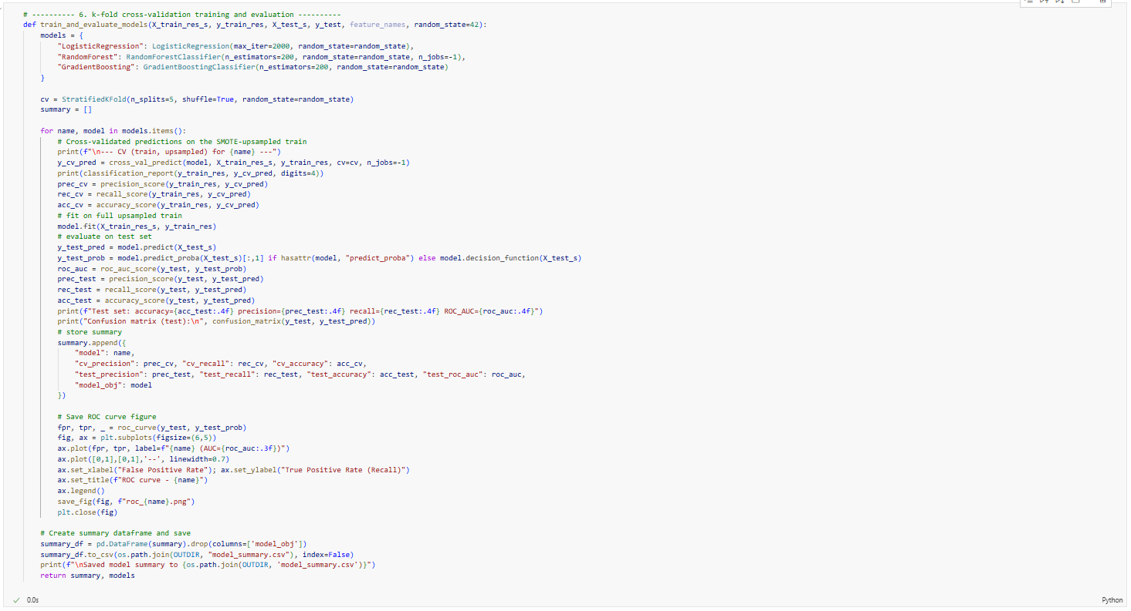
7. The best model and justification for the evaluation metrics used
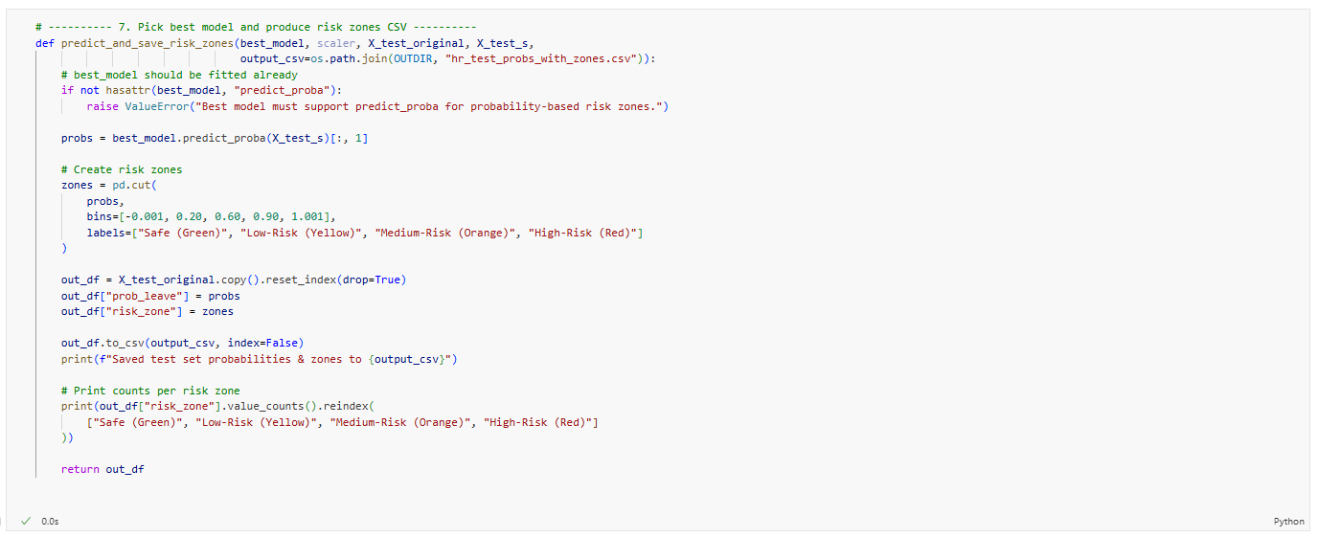
8. Retention strategies for targeted employees
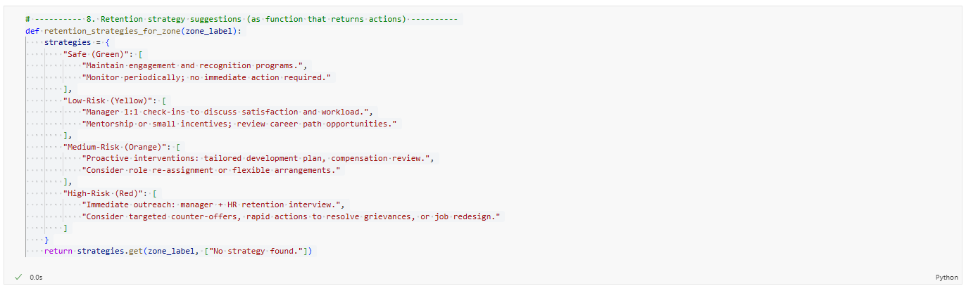
9.Main method to call all these method and save output in an location
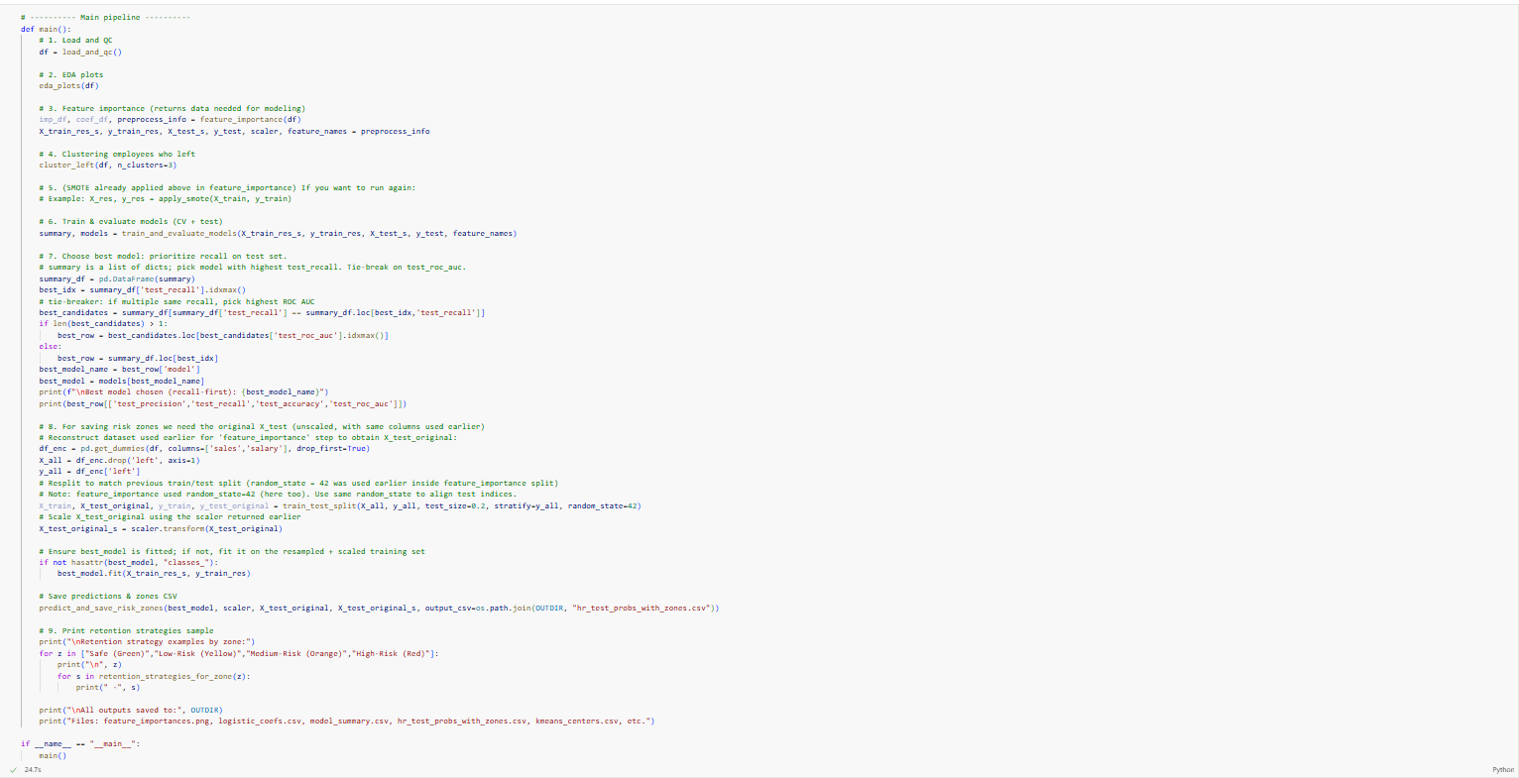

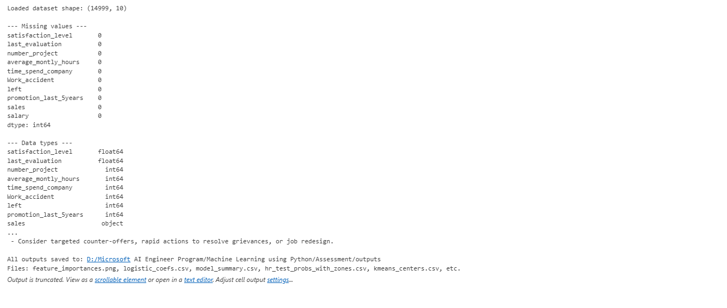

Outputs:
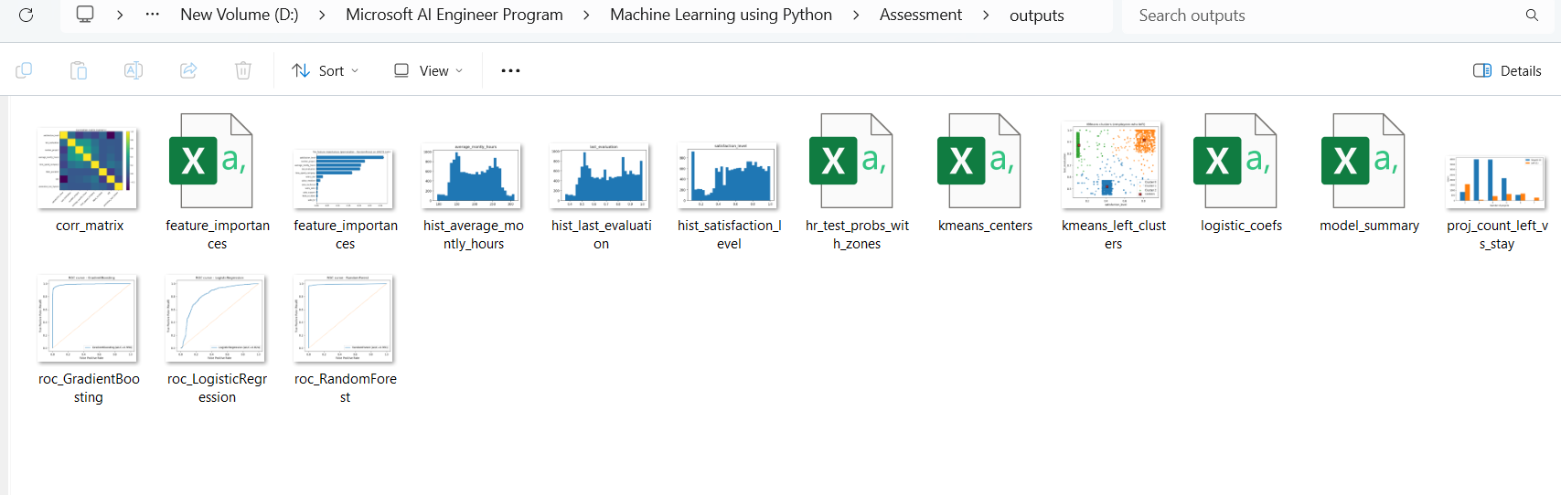

Output folder of analytics:

