Fairness-Aware and Explainable Facial Emotion Recognition Using a VGGFace2-Pretrained ResNet-50 Ensemble and Action Unit Grounding

Arvindh Kumar V
Department of Networking and Communications
SRM Institute of Science and Technology
Kattankulathur, Chennai, India
[email address]
Dr. V. M. Gayathri
Department of Networking and Communications
SRM Institute of Science and Technology
Kattankulathur, Chennai, India
[email address]

Abstract—Facial emotion recognition (FER) models are usually reported with a single overall accuracy, which hides weak performance on rare emotions, and they rarely explain their decisions. We present FA&EFER, a fairness-aware and explainable FER system with two engines built on face-recognition pretraining. The emotion engine fine-tunes the official VGGFace2 ResNet-50 on RAF-DB with a class-weighted, label-smoothed cross-entropy loss, selects checkpoints by validation macro-F1 and combines models in a validation-selected ensemble with per-class calibration. An Action Unit (AU) engine trained on RAF-AU for 76 AUs explains each prediction through multi-layer class activation maps and a Facial Action Coding System (FACS) rule cross-check. Because RAF-DB carries no demographic labels in our setup, fairness is audited across emotion classes using recall disparity, the four-fifths rule and balanced accuracy, and every prediction is returned with a reliability context. On the 3,068-image RAF-DB test set the system reaches 90.38% accuracy and 85.65% macro-F1, compared with 83.67% accuracy for an ImageNet-pretrained ResNet-18 baseline. Against an otherwise identical model trained without fairness mitigation (90.0% accuracy), it improves macro-F1 by 0.9 points and the recall of the weakest class, Fear, from 68.9% to 71.6%, although the worst-to-best recall ratio (0.746) remains below 0.80. The system is deployed as a web application that produces per-image explanations and batch PDF audit reports.
Keywords—facial emotion recognition, fairness, explainable AI, facial action units, VGGFace2, class imbalance, class activation maps

Introduction
Facial emotion recognition (FER) lets a machine estimate a person’s emotional state from a face image. It underpins adaptive human–computer interfaces, driver monitoring and assistive tools, and is increasingly considered for sensitive settings such as mental-health support. Deep convolutional networks trained on in-the-wild datasets such as RAF-DB [1] now exceed 90% accuracy, yet three practical problems remain.
First, accuracy is dominated by frequent classes. In the RAF-DB training set Happiness has 4,772 images while Fear has 281, a ratio of about 17:1, so a model can report a high overall accuracy while failing on Fear, Disgust and Anger. Second, most models output a label and a confidence score without any evidence of which facial regions or muscle movements led to the decision. Third, fairness is rarely audited: earlier studies found measurable bias in FER datasets and models [2], [3], [4], but published systems seldom report how evenly they serve each class or group.
This paper describes FA&EFER (Fairness-Aware and Explainable Facial Emotion Recognition), a system that addresses all three problems in one pipeline. Its emotion engine starts from the official VGGFace2 ResNet-50 [5], [6], a backbone trained to recognise faces rather than generic objects. A second engine detects 76 facial Action Units (AUs) [7], [8], which ground each emotion in measurable muscle movements and provide visual explanations through class activation maps [9]. A fairness layer measures per-class disparity on the full test set and attaches a reliability context to every prediction. The main contributions are:
- a faithful re-implementation of the VGGFace2 ResNet-50 in its original Caffe layout and input format, which we show is essential for transfer to FER;
- an imbalance-aware training and selection protocol (class-weighted loss, macro-F1 model selection, a validation-selected ensemble with per-class calibration) that reaches 90.38% accuracy on RAF-DB;
- a class-level fairness audit with a controlled comparison against a model trained without fairness mitigation, reported honestly including where mitigation did not help;
- AU-grounded explanations using multi-layer LayerCAM heatmaps and a FACS rule cross-check, delivered in a web application with batch PDF audit reports.

Related Work

Face-Pretrained FER Backbones
Pretraining on face-recognition data is now the standard starting point for FER. TransFER [10] combines an IR-50 stem pretrained on MS-Celeb-1M with transformer blocks and reaches 90.91% on RAF-DB. Erasing Attention Consistency [11] reports 90.35% on clean RAF-DB with a ResNet-50 and shows ResNet-50 outperforming ResNet-18 in every setting. DMUE [12] models label ambiguity and reaches 89.42%. FaRL [13] shows that face-domain representation learning transfers better than generic pretraining, especially with limited labelled data. These works motivate our VGGFace2 ResNet-50 backbone, but none of them reports per-class fairness or muscle-level explanations.

Class Imbalance in FER
Face2Exp [14] combats the class imbalance of FER data by adapting a network on large face-recognition data with a meta-learning feedback loop, and reports mean (class-averaged) accuracy rather than overall accuracy. Zhang et al. [15] mine minority-class knowledge from all samples through re-balanced attention maps and smooth labels, raising mean accuracy on RAF-DB from 78.53% to 82.44%. Both works show that class-averaged metrics are the right lens for imbalanced FER; we adopt macro-F1 and balanced accuracy for model selection and reporting.

Interpretable FER and Action Units
The Facial Action Coding System [7] describes expressions as combinations of AUs. RAF-AU [8] provides in-the-wild faces annotated with both AUs and perceived emotion, and ME-GraphAU [16] models relations between AUs with a ResNet-50 backbone. Belharbi et al. [17] guide the spatial attention of an FER network towards AU regions and raise attention-localisation quality from 0.38 to 0.85 on RAF-DB with no loss of accuracy. Gradient-based class activation maps such as Grad-CAM [18] and LayerCAM [9] are the most common way to visualise CNN decisions. Our system links AU detection, AU heatmaps and FACS rules to each emotion prediction.

Fairness in FER
Xu et al. [2] found measurable demographic bias on RAF-DB and showed that data augmentation alone does not remove it. Dominguez-Catena et al. [3] organise metrics for dataset demographic bias, and Hosseini et al. [4] find bias across all major FER datasets and model families, with residual CNNs among the least biased. These studies require demographic labels; when such labels are unavailable, disparity between emotion classes is the measurable form of unequal treatment, which is the view taken in this work.

Datasets
RAF-DB [1] contains 15,339 aligned in-the-wild face images (100×100 pixels) labelled with seven basic emotions, split into 12,271 training and 3,068 test images (Table I). For model selection we hold out a stratified 10% validation split of the training set (1,228 images, fixed seed 42, shared by every model); the test set is used once, for the final evaluation. RAF-AU [8] contains 4,601 faces with multi-label AU annotations. Including left/right variants (e.g., L12, R12), it defines 76 AU labels; AU25 (lips part) appears in 61.5% of faces while several labels occur only once. We split it 80/20 into 3,680 training and 921 validation faces.
- RAF-DB Class Distribution
Emotion | Train | Train share | Test
Surprise | 1,290 | 10.5% | 329
Fear | 281 | 2.3% | 74
Disgust | 717 | 5.8% | 160
Happiness | 4,772 | 38.9% | 1,185
Sadness | 1,982 | 16.2% | 478
Anger | 705 | 5.7% | 162
Neutral | 2,524 | 20.6% | 680
Total | 12,271 | 100% | 3,068

Proposed System
Fig. 1 shows the architecture. An input face is processed by two engines: the emotion engine decides the emotion, and the AU engine explains it. A fairness and reliability layer combines their outputs with the results of an offline fairness audit.
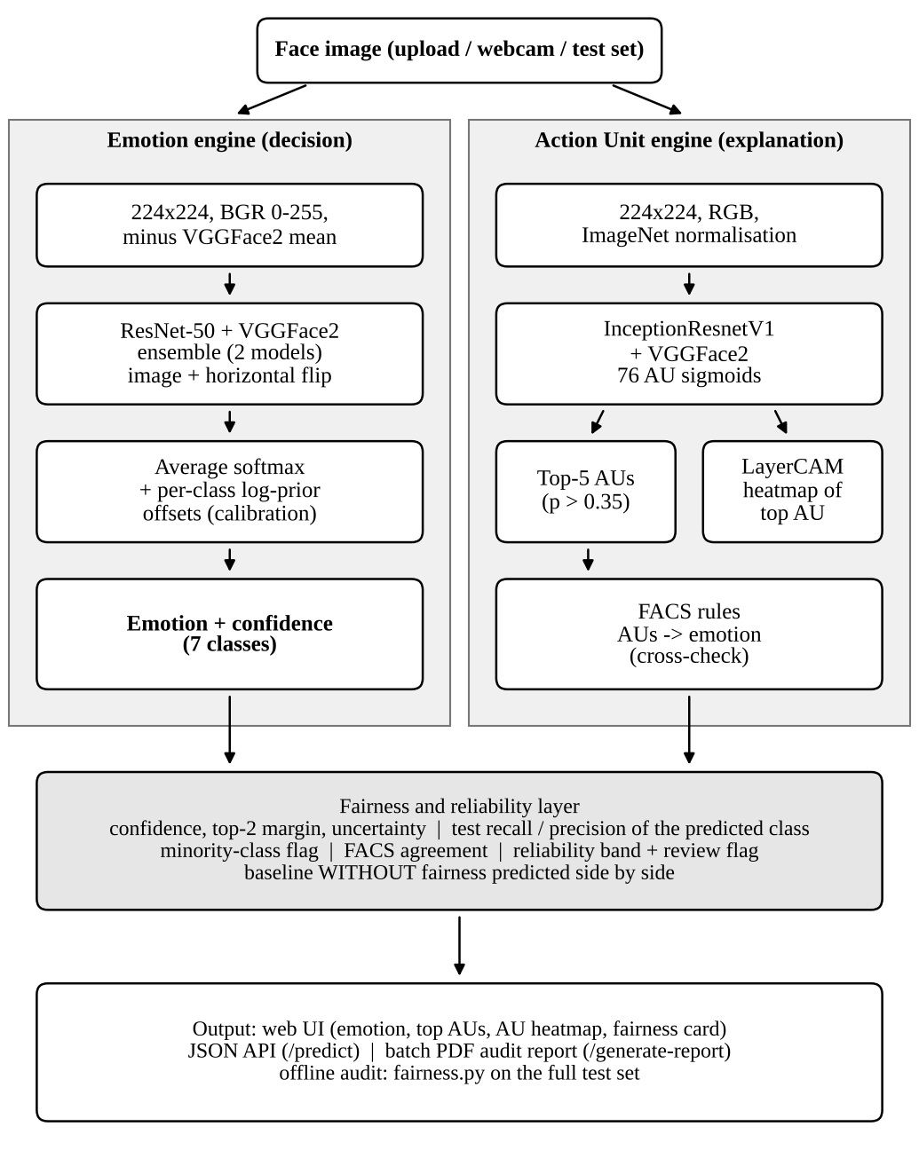
- Architecture of FA&EFER. The emotion engine makes the decision; the AU engine, the FACS rules and the fairness layer explain it and qualify how much it can be trusted.

Emotion Engine: VGGFace2 ResNet-50
We use the official VGGFace2 ResNet-50 (pretrained on MS-Celeb-1M and fine-tuned on VGGFace2: 3.31 million images of 9,131 identities) [5]. The released weights were converted from Caffe, whose ResNet-50 layout differs from common re-implementations: each down-sampling bottleneck places its stride on the first 1×1 convolution rather than on the 3×3 convolution, and the max-pooling layer uses no padding with ceiling rounding. Loading the weights into a standard library ResNet-50 raises no error but produces wrong features. We rebuilt the original layout, verified that all 265 backbone tensors load, and replaced the 8,631-way identity layer with dropout (0.3) and a 2048→7 linear classifier. Inputs follow the format the weights were trained with: images are resized to 224×224, converted to BGR, kept in the 0–255 range and reduced by the VGGFace2 channel mean (91.4953, 103.8827, 131.0912), with no division by a standard deviation. Using ImageNet normalisation instead was the main reason early attempts in this project stalled at 30–40% accuracy.

Imbalance-Aware Training
Each class c with n_{c} training images receives a weight
${\tilde{w}}_{c}={\left(\frac{N}{7 n_{c}}\right)}^{p}, w_{c}=\frac{7 {\tilde{w}}_{c}}{\sum_{j=1}^{7}{{\tilde{w}}_{j}}}$ (1)
where N is the number of training images and the power p softens full inverse-frequency weighting (p = 0.5 or 0.3; p = 0.5 gives Fear about 4.1 times the weight of Happiness). The loss is weighted cross-entropy with label smoothing ε = 0.1:
$L=−\left(1−ε\right) w_{y}log{\hat{p}}_{y}−\frac{ε}{7}\sum_{c=1}^{7}{w_{c}}log{\hat{p}}_{c}$ (2)
where y is the true class and p̂_{c} the predicted probability. Training runs two head-only epochs, then fine-tunes all layers with AdamW (weight decay 10⁻⁴), a learning rate of 10⁻⁴ for the backbone and 10⁻³ for the head, a one-epoch linear warm-up followed by cosine decay, batch size 64, mixed precision and gradient clipping at 5. Augmentation consists of random resized crops (scale 0.8–1.0), horizontal flips, rotation of ±10° (probability 0.5), colour jitter (0.2) and random erasing (probability 0.25). Training lasts up to 25 epochs with early stopping when validation macro-F1 has not improved for six epochs, so that the selected checkpoint is the one that serves all classes best rather than the majority classes.

Ensemble and Per-Class Calibration
Several models trained with different seeds and weighting powers are combined. For an image x and its horizontal flip x̃, the ensemble of M models f_{m} averages the class probabilities and adds offsets:
$\overset{‾}{p}\left(x\right)=\frac{1}{2M}\sum_{m=1}^{M}{\left[σ\left(f_{m}\left(x\right)\right)+σ\left(f_{m}\left(\tilde{x}\right)\right)\right]}$ (3)
$\hat{p}\left(x\right)=\text{softmax}\left(log\overset{‾}{p}\left(x\right)+b\right)$ (4)
where σ is the softmax function, b the vector of per-class log-prior offsets and x̃ the flipped image. The model subset is chosen by validation macro-F1 over all subsets, and b is found by a coordinate search on the validation split; offsets are kept only if they raise validation macro-F1 by at least 0.3 points. The deployed system combines two models (p = 0.3, seeds 7 and 2024) with offsets +0.4 for Happiness, −0.4 for Sadness and −0.1 for Neutral.

Action Unit Engine
The AU engine is an InceptionResnetV1 [19] initialised with VGGFace2 face-recognition weights, with 76 sigmoid outputs. To counter the extreme label imbalance, the binary cross-entropy for AU k with P_{k} positive examples among N uses the positive weight
${\text{pw}}_{k}=\frac{N−P_{k}}{P_{k}}$ (5)
which ranges from 0.62 for AU25 to several thousand for single-example labels. It is trained with AdamW (learning rate 2×10⁻⁴, weight decay 10⁻³), and the learning rate is reduced when validation macro-F1 plateaus. At inference, AUs above 0.35 probability are ranked and the top five are reported with their anatomical descriptions.

Explanations: AU Heatmaps and FACS Rules
For the top-ranked AU we compute a LayerCAM [9] map at three depths of the AU network (the repeat_2, mixed_7a and block8 stages). For a target score y^{c} and feature maps A^{k},
Mc=ReLUk​ReLU∂yc∂Ak⊙Ak (6)
The maps are averaged across layers (and across the image and its mirror for symmetric AUs only, because left/right AUs swap sides when flipped), smoothed with a Gaussian filter, normalised between the 30th and 99.5th percentiles and faded towards the image border. Compared with a single Grad-CAM [18] map on the final 5×5 block, this removes block artefacts and the tendency of min–max normalisation to colour the whole face. A FACS rule engine [7] then maps AU probabilities to an emotion, e.g., Happiness from AU6 + AU12, Surprise from AU1 + AU2 + AU5 + AU26/27, Fear from AU1 + AU2 + AU20, Sadness from AU1 + AU4 + AU15, Disgust from AU9 + AU10 and Anger from AU4 + AU23/24, after merging left/right variants into the base AU. Its output is shown as an independent, muscle-based cross-check of the learned decision.

Fairness Audit and Reliability Context
Since our copy of RAF-DB has no demographic labels, each emotion is treated as a group and the audit asks whether every emotion is recognised equally well (equal opportunity). With per-class recall R_{c}, we report balanced accuracy and the recall ratio
$\text{BA}=\frac{1}{7}\sum_{c=1}^{7}{R_{c}}, ρ=\frac{{\text{min}}_{c} R_{c}}{{\text{max}}_{c} R_{c}}$ (7)
together with the recall gap (best minus worst), false-negative and false-positive rates, the difference between predicted and true class shares, and the mean recall of minority classes (Fear, Disgust and Anger, each under 7% of the training data). A ratio ρ ≥ 0.80 satisfies the four-fifths rule of thumb. The audit evaluates every model, the uncalibrated ensemble and the deployed system on the full test set. To measure the effect of mitigation, we also train a baseline without fairness: the same network, data, seed (42) and recipe, but with no class weights (p = 0), the best epoch chosen by validation accuracy, and no ensemble or calibration.
Each prediction additionally receives a reliability context: confidence, the margin to the second-ranked class, the normalised entropy, the test-set recall and precision of the predicted class, whether that class is a minority class, and whether the FACS rules agree. A prediction is rated Low if its confidence is below 0.5 or the predicted class has a test F1 below 0.78, High if its confidence is at least 0.7 and the class F1 at least 0.85, and Medium otherwise; Low ratings and margins below 0.15 are flagged for human review. The baseline’s prediction is shown alongside.

Implementation
The system is implemented in PyTorch 2.6 and served by a FastAPI application. A single-image endpoint returns the emotion, its confidence and class probabilities, the top AUs, the AU heatmap, the reliability context and the baseline prediction; a batch endpoint samples five test images per emotion and writes a PDF audit report with per-image results, sample-level and full-test-set fairness tables and the with/without comparison. Training uses one NVIDIA RTX 4060 Laptop GPU (about 90–110 s per epoch); training notebooks for Google Colab are provided for users without a GPU.

Results

Overall Performance
Table II compares all configurations on the 3,068-image test set. The VGGFace2 ResNet-50 raises accuracy from 83.67% (ImageNet ResNet-18 baseline from the earlier stage of this project) to 89.15–90.16% for single models. The deployed ensemble reaches 90.38% accuracy and 85.65% macro-F1, in line with published face-pretrained ResNet-50 results on RAF-DB (e.g., 89.42% [12] and 90.35% [11]). The third model was trained in a run interrupted by an out-of-memory error; its best saved checkpoint (epoch 6) is therefore weaker (87.26%); the validation-based selection still included it in the deployed pair.
- Test Results of All Configurations (RAF-DB, 3,068 Images)
Configuration | Acc. (%) | Bal. acc. (%) | Macro-F1 (%) | Worst class recall (%) | ρ
ResNet-18 + ImageNet (earlier stage) | 83.67 | – | – | – | –
Without fairness (p = 0, acc. selection) | 90.00 | 84.60 | 84.80 | Fear 68.9 | 0.723
Model 1 (p = 0.5) | 89.15 | 84.43 | 83.69 | Fear 67.6 | 0.717
Model 2 (p = 0.3, seed 7) | 90.16 | 84.51 | 85.45 | Fear 67.6 | 0.711
Model 3 (p = 0.3, interrupted) | 87.26 | 81.10 | 80.97 | Disgust 62.5 | 0.678
Ensemble, no calibration | 90.29 | 85.13 | 85.54 | Fear 70.3 | 0.740
Ensemble + calibration (deployed) | 90.38 | 85.02 | 85.65 | Fear 71.6 | 0.746
- Models 1–3 and the ensemble use class weighting and macro-F1 selection. Baseline values are rounded to one decimal as reported by the audit tool.

Per-Class Performance
Table III lists per-class results of the deployed system. Happiness, the majority class, is recognised best (96.0% recall), while Fear (71.6%) and Disgust (74.4%) remain the weakest. Fear has the lowest false-positive rate of all classes (0.4%) but a false-negative rate of 28.4%, so the model tends to miss Fear rather than over-predict it; Disgust has balanced precision and recall (74.4%). The minority classes reach a mean recall of 77.5% against 90.7% for the other classes, a gap of 13.2 points.
- Per-Class Results of the Deployed System
Emotion | Prec. (%) | Recall (%) | F1 (%) | Recall w/o fairness (%)
Surprise | 89.6 | 88.8 | 89.2 | 89.7
Fear | 80.3 | 71.6 | 75.7 | 68.9
Disgust | 74.4 | 74.4 | 74.4 | 76.2
Happiness | 95.5 | 96.0 | 95.8 | 95.3
Sadness | 90.4 | 88.3 | 89.3 | 89.5
Anger | 87.0 | 86.4 | 86.7 | 84.6
Neutral | 87.4 | 89.7 | 88.5 | 88.1

With versus Without Fairness Mitigation
Fig. 2 compares per-class recall of the deployed system with the baseline trained without fairness mitigation. Mitigation improves accuracy by 0.4 points (90.0% to 90.4%), balanced accuracy by 0.4 points, macro-F1 by 0.9 points (84.8% to 85.7%) and, most importantly, the recall of the worst class, Fear, by 2.7 points (68.9% to 71.6%). The recall gap narrows from 26.4 to 24.3 points and the ratio ρ rises from 0.723 to 0.746; Anger (+1.8) and Neutral (+1.6) also gain, whereas Disgust (−1.9), Sadness (−1.3) and Surprise (−0.9) lose slightly. The four-fifths rule is still not met.
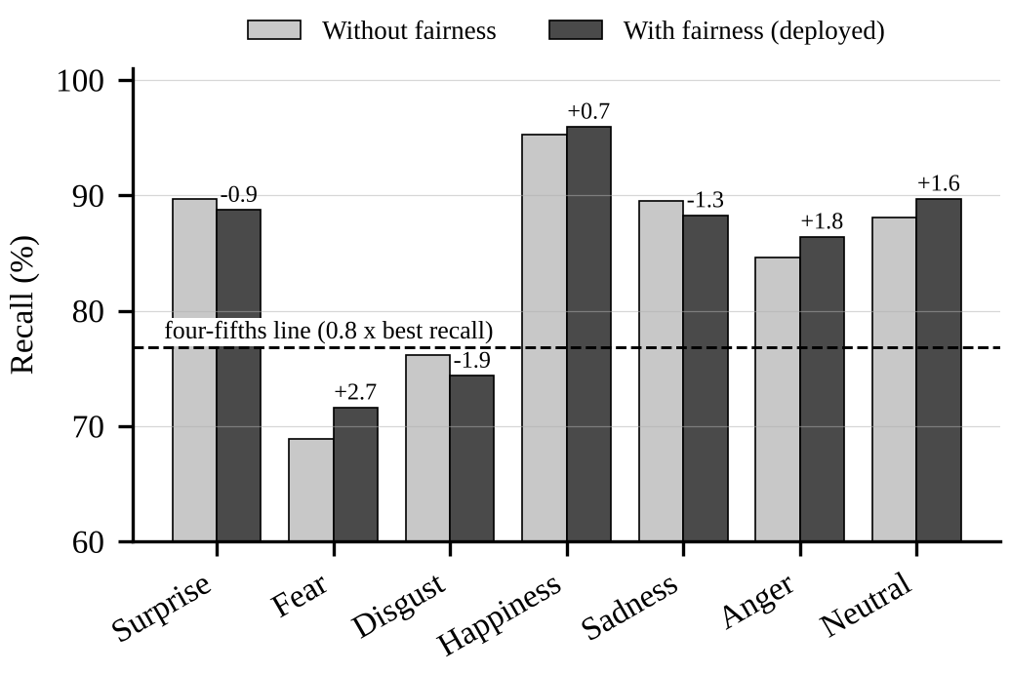
- Per-class test recall with and without fairness mitigation. Labels give the change in percentage points; the dashed line marks 0.8 times the best class recall.
The comparison also shows the limits of the mitigation. A single class-weighted model (model 1) is not better than the baseline: it has lower accuracy (89.15% vs. 90.0%), similar balanced accuracy (84.43% vs. 84.6%) and lower Fear recall (67.6% vs. 68.9%). The gains come from ensembling and per-class calibration; since the deployed system combines two models while the baseline is a single model, part of the improvement is attributable to ensembling itself. Class weighting alone does not compensate for having only 281 Fear training images.

Action Units and Explanations
On its 921-face validation split, the AU engine reaches a micro-F1 of 53.83%, a macro-F1 of 17.35%, a Hamming loss of 6.35% and an exact-match ratio of 4.02%; the low macro-F1 reflects the many rare left/right AU variants. Used alone, the FACS rules classify about 31% of 175 RAF-DB test images correctly, and in sampled audit reports they agreed with the learned emotion on 40–46% of images. This confirms that the rules are useful as an explanation and cross-check but not as the decision-maker. Fig. 3 shows multi-layer AU heatmaps: AU5 (upper lid raiser) concentrates on the eyes, AU2 (outer brow raiser) on the brows and AU25 (lips part) on the mouth, i.e., on the anatomically correct regions.
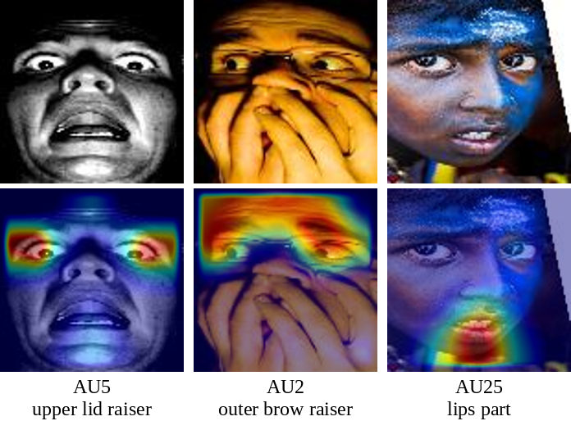
- RAF-DB test faces (top) and LayerCAM heatmaps of the top-ranked Action Unit (bottom).
We also examined heatmaps of the emotion model itself. Gradient-based maps of the VGGFace2 ResNet-50 consistently peaked at the centre of the face (the nose) regardless of the emotion: the final feature map is only 7×7, so each cell covers nearly the whole aligned face, and earlier layers show a regular grid pattern caused by the stride-on-1×1 layout. Occlusion sensitivity, which hides one 40×40-pixel patch at a time, produced more specific maps (e.g., brows and eyes for Anger) but costs hundreds of forward passes per image. The deployed system therefore explains decisions through the AU heatmap, the AU list and the FACS cross-check.

Discussion and Limitations
Two lessons concern evaluation integrity. First, an earlier prototype of this project reported 91.4–94.3% from its batch report; this figure was not a measurement, because the report passed the ground-truth label into the prediction function. All results in this paper come from the model alone, with the test set used once. Second, the batch PDF samples five images per emotion, so its accuracy varies by several points between runs (we observed 80.0% to 88.6% on 35-image samples); only full-test-set numbers should be used for conclusions.
The main limitations are as follows. Fairness is measured between emotion classes, not between demographic groups; the audit tool supports gender, race and age groups (accuracy gap, macro-F1 gap and an equalized-odds gap) but requires attribute labels that were not available to us. The web application does not yet detect and align faces, so accuracy on webcam images is lower than on the aligned test set. Confidence-based review flags did not catch every error: in one sampled report, confident misclassifications of Disgust were not flagged. Finally, Fear remains below the four-fifths threshold, which more training data for the minority classes is more likely to fix than further reweighting.

Conclusion
FA&EFER combines a faithfully reproduced VGGFace2 ResNet-50, imbalance-aware training and selection, AU-grounded explanations and a class-level fairness audit in one deployable system. It reaches 90.38% accuracy and 85.65% macro-F1 on RAF-DB and, compared with a baseline trained without fairness mitigation, improves macro-F1 and the recall of the weakest class while reporting openly that the four-fifths criterion is not yet met. Future work includes a demographic audit using RAF-DB attribute annotations, face detection and alignment in the application, additional minority-class data, AU relation modelling [16] and AU-guided attention [17] to make the emotion model’s own spatial evidence interpretable.

Acknowledgment
The authors thank the School of Computing, SRM Institute of Science and Technology, for computing support, and the creators of RAF-DB, RAF-AU and VGGFace2 for making their data and models available for research.

References
- S. Li, W. Deng, and J. Du, “Reliable crowdsourcing and deep locality-preserving learning for expression recognition in the wild,” in Proc. IEEE Conf. Comput. Vis. Pattern Recognit. (CVPR), 2017, pp. 2852–2861.
- T. Xu, J. White, S. Kalkan, and H. Gunes, “Investigating bias and fairness in facial expression recognition,” in Proc. Eur. Conf. Comput. Vis. Workshops (ECCVW), 2020, pp. 506–523.
- I. Dominguez-Catena, D. Paternain, and M. Galar, “Metrics for dataset demographic bias: A case study on facial expression recognition,” IEEE Trans. Pattern Anal. Mach. Intell., 2024, doi: 10.1109/TPAMI.2024.3361979.
- M. M. Hosseini, A. P. Fard, and M. H. Mahoor, “Faces of fairness: Examining bias in facial expression recognition datasets and models,” 2025, arXiv:2502.11049.
- Q. Cao, L. Shen, W. Xie, O. M. Parkhi, and A. Zisserman, “VGGFace2: A dataset for recognising faces across pose and age,” in Proc. 13th IEEE Int. Conf. Autom. Face Gesture Recognit. (FG), 2018, pp. 67–74.
- K. He, X. Zhang, S. Ren, and J. Sun, “Deep residual learning for image recognition,” in Proc. IEEE Conf. Comput. Vis. Pattern Recognit. (CVPR), 2016, pp. 770–778.
- P. Ekman and W. V. Friesen, Facial Action Coding System: A Technique for the Measurement of Facial Movement. Palo Alto, CA, USA: Consulting Psychologists Press, 1978.
- W.-J. Yan, S. Li, C. Que, J. Pei, and W. Deng, “RAF-AU database: In-the-wild facial expressions with subjective emotion judgement and objective AU annotations,” in Proc. Asian Conf. Comput. Vis. (ACCV), 2020.
- P.-T. Jiang, C.-B. Zhang, Q. Hou, M.-M. Cheng, and Y. Wei, “LayerCAM: Exploring hierarchical class activation maps for localization,” IEEE Trans. Image Process., vol. 30, pp. 5875–5888, 2021.
- F. Xue, Q. Wang, and G. Guo, “TransFER: Learning relation-aware facial expression representations with transformers,” in Proc. IEEE/CVF Int. Conf. Comput. Vis. (ICCV), 2021, pp. 3601–3610.
- Y. Zhang, C. Wang, X. Ling, and W. Deng, “Learn from all: Erasing attention consistency for noisy label facial expression recognition,” in Proc. Eur. Conf. Comput. Vis. (ECCV), 2022, doi: 10.1007/978-3-031-19809-0_24.
- J. She, Y. Hu, H. Shi, J. Wang, Q. Shen, and T. Mei, “Dive into ambiguity: Latent distribution mining and pairwise uncertainty estimation for facial expression recognition,” in Proc. IEEE/CVF Conf. Comput. Vis. Pattern Recognit. (CVPR), 2021, pp. 6248–6257.
- Y. Zheng, H. Yang, T. Zhang, J. Bao, D. Chen, Y. Huang, L. Yuan, D. Chen, M. Zeng, and F. Wen, “General facial representation learning in a visual-linguistic manner,” in Proc. IEEE/CVF Conf. Comput. Vis. Pattern Recognit. (CVPR), 2022, pp. 18697–18709.
- D. Zeng, Z. Lin, X. Yan, Y. Liu, F. Wang, and B. Tang, “Face2Exp: Combating data biases for facial expression recognition,” in Proc. IEEE/CVF Conf. Comput. Vis. Pattern Recognit. (CVPR), 2022, pp. 20291–20300.
- Y. Zhang, Y. Li, L. Qin, X. Liu, and W. Deng, “Leave no stone unturned: Mine extra knowledge for imbalanced facial expression recognition,” in Proc. Adv. Neural Inf. Process. Syst. (NeurIPS), 2023.
- C. Luo, S. Song, W. Xie, L. Shen, and H. Gunes, “Learning multi-dimensional edge feature-based AU relation graph for facial action unit recognition,” in Proc. 31st Int. Joint Conf. Artif. Intell. (IJCAI), 2022, pp. 1239–1246.
- S. Belharbi, M. Pedersoli, A. L. Koerich, S. Bacon, and E. Granger, “Guided interpretable facial expression recognition via spatial action unit cues,” in Proc. 18th IEEE Int. Conf. Autom. Face Gesture Recognit. (FG), 2024.
- R. R. Selvaraju, M. Cogswell, A. Das, R. Vedantam, D. Parikh, and D. Batra, “Grad-CAM: Visual explanations from deep networks via gradient-based localization,” in Proc. IEEE Int. Conf. Comput. Vis. (ICCV), 2017, pp. 618–626.
- C. Szegedy, S. Ioffe, V. Vanhoucke, and A. A. Alemi, “Inception-v4, Inception-ResNet and the impact of residual connections on learning,” in Proc. AAAI Conf. Artif. Intell., 2017, pp. 4278–4284.

