Fairness-Aware and Explainable Facial Emotion Recognition Using a VGGFace2-Pretrained ResNet-50 Ensemble and Action Unit Grounding

Dr. V. M. Gayathri
Networking and Communications
SRM Institute of Science and Technology
Kattankulathur, Chennai, India
[email address]
Arvindh Kumar V
Networking and Communications
SRM Institute of Science and Technology
Kattankulathur, Chennai, India
av0872@srmist.edu.in
Biswadip Ghosh
Networking and Communications
SRM Institute of Science and Technology
Kattankulathur, Chennai, India
biswadipghosh03@gmail.com

Asmit Srivastava
Networking and Communications
SRM Institute of Science and Technology
Kattankulathur, Chennai, India
itsasmit.code@gmail.com
Vaishnav Anand
Networking and Communications
SRM Institute of Science and Technology
Kattankulathur, Chennai, India
vaishnavanand1234abcd@gmail.com
P. Balamurugan
Networking and Communications
SRM Institute of Science and Technology
Kattankulathur, Chennai, India
[email address]

Abstract—Facial emotion recognition (FER) models are usually judged by one accuracy number, which hides how poorly they do on rare emotions, and they rarely explain why they made a prediction. In this paper we present FA&EFER, a fairness-aware and explainable FER system with two engines that both start from VGGFace2 face-recognition weights. The emotion engine fine-tunes the official VGGFace2 ResNet-50 on RAF-DB with a class-weighted, label-smoothed cross-entropy loss, picks checkpoints by validation macro-F1 and combines the best models in an ensemble with per-class calibration, both chosen on the validation split. The Action Unit (AU) engine, trained on RAF-AU for 76 AUs, explains each prediction with multi-layer class activation maps and a cross-check based on the Facial Action Coding System (FACS). Since RAF-DB has no demographic labels in our setup, fairness is measured across emotion classes using recall disparity, the four-fifths rule and balanced accuracy, and every prediction comes with a reliability context. On the 3,068-image RAF-DB test set the system reaches 90.38% accuracy and 85.65% macro-F1, compared with 83.67% accuracy for an ImageNet-pretrained ResNet-18 baseline. Against the same model trained without fairness mitigation (89.99% accuracy), it improves macro-F1 by 0.9 points and the recall of the weakest class, Fear, from 68.9% to 71.6%, although the worst-to-best recall ratio (0.746) is still below 0.80.
Keywords—facial emotion recognition, fairness, explainable AI, facial action units, VGGFace2, class imbalance, class activation maps

Introduction
Facial emotion recognition (FER) lets a system estimate how a person feels from an image of their face. It supports human–computer interaction, driver monitoring and assistive tools, and it is now being considered for sensitive settings such as mental-health support. Deep convolutional networks trained on in-the-wild datasets such as RAF-DB [1] already cross 90% accuracy, but three practical problems are still open.
First, accuracy is dominated by the frequent classes. In the RAF-DB training set, Happiness has 4,772 images while Fear has only 281, roughly 17:1, so a model can report a high overall accuracy while still failing on Fear, Disgust and Anger. Second, most models return a label and a confidence score without showing which facial regions or muscle movements led to the decision. Third, fairness is rarely checked: earlier studies found measurable bias in FER datasets and models [2], [3], [4], yet published systems seldom report how evenly they serve each class or group.
This paper introduces FA&EFER (Fairness-Aware and Explainable Facial Emotion Recognition), a system that tackles all three problems in one pipeline. Its emotion engine is built on the official VGGFace2 ResNet-50 [5], [6], a network trained to recognise faces rather than everyday objects. A second engine predicts 76 facial Action Units (AUs) [7], [8], which ground each emotion in specific muscle movements and give visual explanations through class activation maps [9]. A fairness layer measures per-class disparity on the full test set and attaches a reliability context to every prediction. The main contributions of this work are:
- Faithful backbone: a re-implementation of the VGGFace2 ResNet-50 in its original Caffe layout and input format, which we found to be essential for transfer to FER;
- Imbalance-aware training: class-weighted loss, macro-F1 model selection and a validation-selected ensemble with per-class calibration, reaching 90.38% accuracy on RAF-DB;
- Fairness audit: a class-level audit with a controlled comparison against a model trained without fairness mitigation, reported honestly, including where the mitigation did not help;
- AU-grounded explanations: multi-layer LayerCAM heatmaps and a FACS rule cross-check, served through a web application with batch PDF audit reports.

Related Works
Our review of the literature points to four lines of work that FA&EFER builds on, and to the gap between them.

Face-Pretrained FER Backbones
Pretraining on face-recognition data has become the usual starting point for FER. TransFER [10] combines an IR-50 stem pretrained on MS-Celeb-1M with transformer blocks and reaches 90.91% on RAF-DB. Erasing Attention Consistency [11] reports 90.35% on clean RAF-DB with a ResNet-50 and shows ResNet-50 beating ResNet-18 in every setting. DMUE [12] models label ambiguity and reaches 89.42%. FaRL [13] shows that face-specific representation learning transfers better than generic pretraining, especially when little labelled data is available. These works motivate our VGGFace2 ResNet-50 backbone, but none of them reports per-class fairness or muscle-level explanations.

Class Imbalance in FER
Face2Exp [14] tackles class imbalance by adapting a network on large face-recognition data with a meta-learning feedback loop, and reports mean (class-averaged) accuracy instead of overall accuracy. Zhang et al. [15] mine minority-class knowledge from all samples using re-balanced attention maps and smooth labels, raising mean accuracy on RAF-DB from 78.53% to 82.44%. Both papers show that class-averaged metrics are the right lens for imbalanced FER, which is why we use macro-F1 and balanced accuracy.

Interpretable FER and Action Units
The Facial Action Coding System [7] describes an expression as a combination of AUs. RAF-AU [8] provides in-the-wild faces labelled with both AUs and perceived emotion, and ME-GraphAU [16] learns the relations between AUs on a ResNet-50 backbone. Belharbi et al. [17] steer the spatial attention of an FER network towards AU regions and raise attention-localisation quality from 0.38 to 0.85 on RAF-DB without losing accuracy. Gradient-based class activation maps such as Grad-CAM [18] and LayerCAM [9] are the most common way to visualise CNN decisions. Our system links AU detection, AU heatmaps and FACS rules to every emotion prediction.

Fairness in FER
Xu et al. [2] found measurable demographic bias on RAF-DB and showed that data augmentation alone does not remove it. Dominguez-Catena et al. [3] organise metrics for dataset demographic bias, and Hosseini et al. [4] report bias in all major FER datasets and model families, with residual CNNs among the least biased. These studies need demographic labels. When such labels are not available, the disparity between emotion classes is the unequal treatment we can actually measure, and that is the view taken in this paper.
To our knowledge, few existing works combine a face-pretrained, imbalance-aware FER model with AU-level explanations and a fairness audit in one deployable system. FA&EFER is aimed at this gap.

Proposed System
Fig. 1 shows the architecture. An input face goes through two engines: the emotion engine decides the emotion and the AU engine explains it. A fairness and reliability layer then combines their outputs with the results of an offline fairness audit.
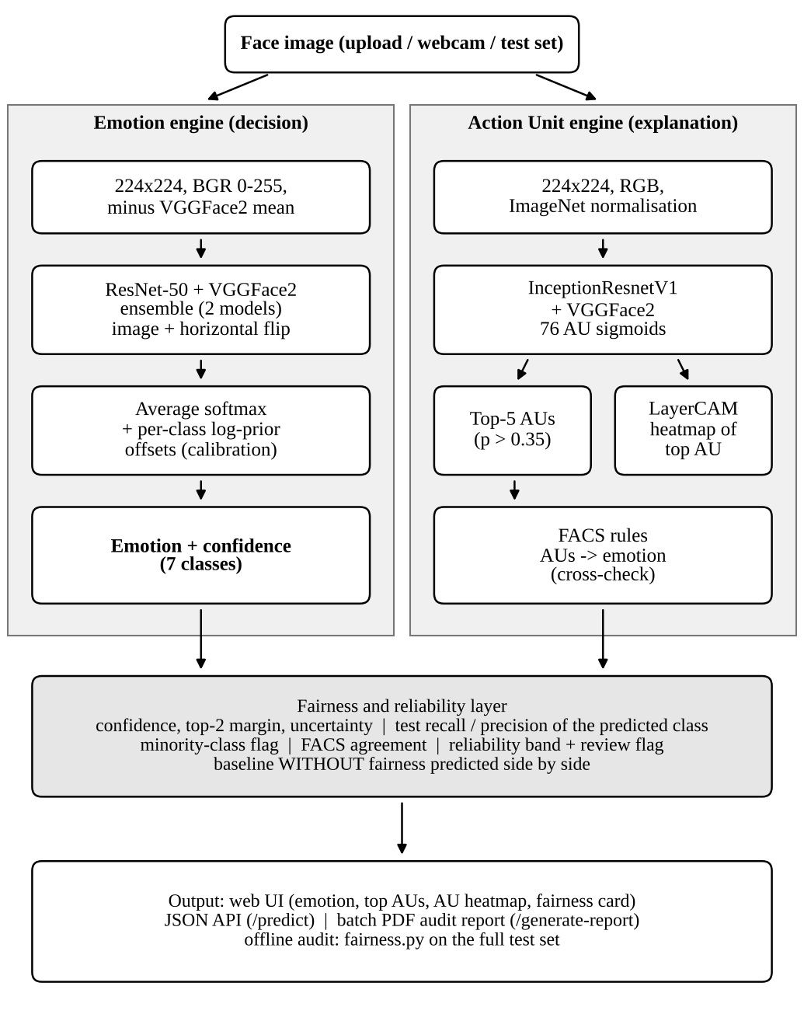
- Architecture of FA&EFER. The emotion engine makes the decision; the AU engine, the FACS rules and the fairness layer explain it and qualify how much it can be trusted.

Input Data and Preprocessing
RAF-DB [1] contains 15,339 aligned in-the-wild face images (100×100 pixels), each labelled with one of seven basic emotions and split into 12,271 training and 3,068 test images (Table I). For model selection we hold out a stratified 10% validation split of the training set (1,228 images, fixed seed 42, shared by every model); the test set is used only once, for the final evaluation. RAF-AU [8] contains 4,601 faces with multi-label AU annotations. Counting left/right variants (e.g., L12 and R12), it defines 76 AU labels; AU25 (lips part) appears in 61.5% of the faces while some labels occur only once. We split it 80/20 into 3,680 training and 921 validation faces.
For the emotion engine, every image is resized to 224×224, converted to BGR, kept in the 0–255 range and reduced by the VGGFace2 channel mean (91.4953, 103.8827, 131.0912), without dividing by a standard deviation, which is exactly the format the weights were trained with. The AU engine uses the usual RGB input with ImageNet normalisation. Using ImageNet normalisation for the emotion engine was the main reason our early attempts stalled at 30–40% accuracy.
- RAF-DB Class Distribution
Emotion | Train | Train share | Test
Surprise | 1,290 | 10.5% | 329
Fear | 281 | 2.3% | 74
Disgust | 717 | 5.8% | 160
Happiness | 4,772 | 38.9% | 1,185
Sadness | 1,982 | 16.2% | 478
Anger | 705 | 5.7% | 162
Neutral | 2,524 | 20.6% | 680
Total | 12,271 | 100% | 3,068

Emotion Engine: VGGFace2 ResNet-50
We use the official VGGFace2 ResNet-50, pretrained on MS-Celeb-1M and fine-tuned on VGGFace2 (3.31 million images of 9,131 identities) [5]. The released weights come from Caffe, and the Caffe ResNet-50 differs from common re-implementations: every down-sampling block puts its stride on the first 1×1 convolution instead of the 3×3 one, and the max-pooling layer uses no padding with ceiling rounding. Loading these weights into a standard library ResNet-50 raises no error but silently produces wrong features. We rebuilt the original layout, checked that all 265 backbone tensors load, and replaced the 8,631-way identity layer with dropout (0.3) and a 2048→7 linear classifier.
Each class c with n_{c} training images receives a weight
${\tilde{w}}_{c}={\left(\frac{N}{7 n_{c}}\right)}^{p}, w_{c}=\frac{7 {\tilde{w}}_{c}}{\sum_{j=1}^{7}{{\tilde{w}}_{j}}}$ (1)
where N is the number of training images and the power p softens full inverse-frequency weighting (p = 0.5 or 0.3; with p = 0.5, Fear gets about 4.1 times the weight of Happiness). The loss is weighted cross-entropy with label smoothing ε = 0.1:
$L=−\left(1−ε\right) w_{y}log{\hat{p}}_{y}−\frac{ε}{7}\sum_{c=1}^{7}{w_{c}}log{\hat{p}}_{c}$ (2)
where y is the true class and p̂_{c} the predicted probability of class c. The best epoch is the one with the highest validation macro-F1, so the saved checkpoint is the one that serves all classes best rather than just the majority classes.

Ensemble and Per-Class Calibration
Several models trained with different seeds and weighting powers are then combined. For an image x and its horizontally flipped copy x̃, an ensemble of M models f_{m} averages the class probabilities and adds per-class offsets:
$\overset{‾}{p}\left(x\right)=\frac{1}{2M}\sum_{m=1}^{M}{\left[σ\left(f_{m}\left(x\right)\right)+σ\left(f_{m}\left(\tilde{x}\right)\right)\right]}$ (3)
$\hat{p}\left(x\right)=\text{softmax}\left(log\overset{‾}{p}\left(x\right)+b\right)$ (4)
where σ is the softmax function and b is a vector of per-class log-prior offsets. The subset of models is chosen by validation macro-F1 over all possible subsets, and b is found by a coordinate search on the validation split; the offsets are kept only if they raise validation macro-F1 by at least 0.3 points. The deployed system combines two models (p = 0.3, seeds 7 and 2024) with offsets of +0.4 for Happiness, −0.4 for Sadness and −0.1 for Neutral.

Action Unit Engine
The AU engine is an InceptionResnetV1 [19] initialised with VGGFace2 face-recognition weights and ending in 76 sigmoid outputs. Because the AU labels are extremely unbalanced, the binary cross-entropy for AU k with P_{k} positive examples out of N uses the positive weight
${\text{pw}}_{k}=\frac{N−P_{k}}{P_{k}}$ (5)
which ranges from 0.62 for AU25 to several thousand for labels that appear only once. At inference, the AUs above 0.35 probability are ranked and the top five are returned together with their anatomical descriptions.

Explainability Module: AU Heatmaps and FACS Rules
For the top-ranked AU we compute a LayerCAM [9] map at three depths of the AU network (the repeat_2, mixed_7a and block8 stages). For a target score y^{c} and feature maps A^{k},
Mc=ReLUk​ReLU∂yc∂Ak⊙Ak (6)
The maps are averaged across the three layers (and across the image and its mirror for symmetric AUs only, since left/right AUs swap sides when the image is flipped), smoothed with a Gaussian filter, normalised between the 30th and 99.5th percentiles and faded towards the image border. Compared with a single Grad-CAM [18] map on the final 5×5 block, this removes the blocky artefacts and stops min–max normalisation from colouring the whole face. A FACS rule engine [7] then maps the AU probabilities to an emotion, for example Happiness from AU6 + AU12, Surprise from AU1 + AU2 + AU5 + AU26/27, Fear from AU1 + AU2 + AU20, Sadness from AU1 + AU4 + AU15, Disgust from AU9 + AU10 and Anger from AU4 + AU23/24, after merging left/right variants into the base AU. Its answer is shown as an independent, muscle-based cross-check of the learned decision, not as the decision itself.

Fairness Audit and Reliability Context
Since our copy of RAF-DB has no demographic labels, each emotion is treated as a group and the audit asks whether every emotion is recognised equally well (equal opportunity). Using the per-class recall R_{c}, we report balanced accuracy and the recall ratio
$\text{BA}=\frac{1}{7}\sum_{c=1}^{7}{R_{c}}, ρ=\frac{{\text{min}}_{c} R_{c}}{{\text{max}}_{c} R_{c}}$ (7)
together with the recall gap (best minus worst), false-negative and false-positive rates, the difference between predicted and true class shares, and the mean recall of the minority classes (Fear, Disgust and Anger, each under 7% of the training data). A ratio ρ ≥ 0.80 meets the four-fifths rule of thumb. The audit evaluates every model, the uncalibrated ensemble and the deployed system on the full test set. To measure what the mitigation actually does, we also train a baseline without fairness: the same network, data, seed (42) and recipe, but with no class weights (p = 0), the best epoch chosen by validation accuracy, and no ensemble or calibration.
Every prediction also gets a reliability context: its confidence, the margin to the second-ranked class, the normalised entropy, the test-set recall and precision of the predicted class, whether that class is a minority class, and whether the FACS rules agree. A prediction is rated Low if its confidence is below 0.5 or the predicted class has a test F1 below 0.78, High if its confidence is at least 0.7 and the class F1 is at least 0.85, and Medium otherwise. Low ratings and margins below 0.15 are flagged for human review.

System Output
For each input face, FA&EFER returns a four-part output:
- Emotion prediction: the predicted emotion with its confidence and the probability of all seven classes.
- Muscle evidence: the top five AUs with their anatomical names, and the FACS rule cross-check.
- Visual explanation: the face overlaid with the LayerCAM heatmap of the top AU.
- Fairness and reliability: the reliability rating and review flag, the prediction of the baseline without fairness for the same image, and the test-set audit summary.

Implementation
FA&EFER was implemented as a complete end-to-end system, from data loading and training to a web application for explainable inference and audit reports.

Environment and Tools
The whole system is written in Python. Models are built and trained with PyTorch 2.6 and torchvision on one NVIDIA RTX 4060 Laptop GPU; the InceptionResnetV1 definition comes from the facenet-pytorch package and the heatmaps from pytorch-grad-cam. Evaluation uses scikit-learn, and figures use Matplotlib. The application is served by FastAPI with Uvicorn, and PDF reports are generated with fpdf2. Google Colab notebooks are provided for users without a local GPU.

Training and Fine-Tuning Strategy
The emotion models are trained in two phases. In the first two epochs only the new classifier head is trained, with the backbone frozen. After that, all layers are fine-tuned with AdamW (weight decay 10⁻⁴), using a learning rate of 10⁻⁴ for the backbone and 10⁻³ for the head, a one-epoch linear warm-up and cosine decay, batch size 64, mixed precision and gradient clipping at 5. Augmentation consists of random resized crops (scale 0.8–1.0), horizontal flips, rotation of ±10° (probability 0.5), colour jitter (0.2) and random erasing (probability 0.25). Training runs for up to 25 epochs and stops early if validation macro-F1 has not improved for six epochs; one epoch takes about 90–110 s. A checkpoint is saved after every epoch so that a crashed run can resume. The AU engine is trained with AdamW (learning rate 2×10⁻⁴, weight decay 10⁻³), and the learning rate is halved whenever validation macro-F1 stops improving.

Explainable Web Application
A FastAPI application loads all models once at start-up. When a user uploads a face image or captures one from a webcam, the single-image endpoint runs the full pipeline and returns the outputs listed above as JSON. The browser interface shows the predicted emotion, the AU list, the heatmap viewer (split slider, side-by-side or overlay) and a Fairness & Reliability card that places the with-fairness and without-fairness predictions side by side. Fig. 2 shows the interface for a Fear image from the test set.
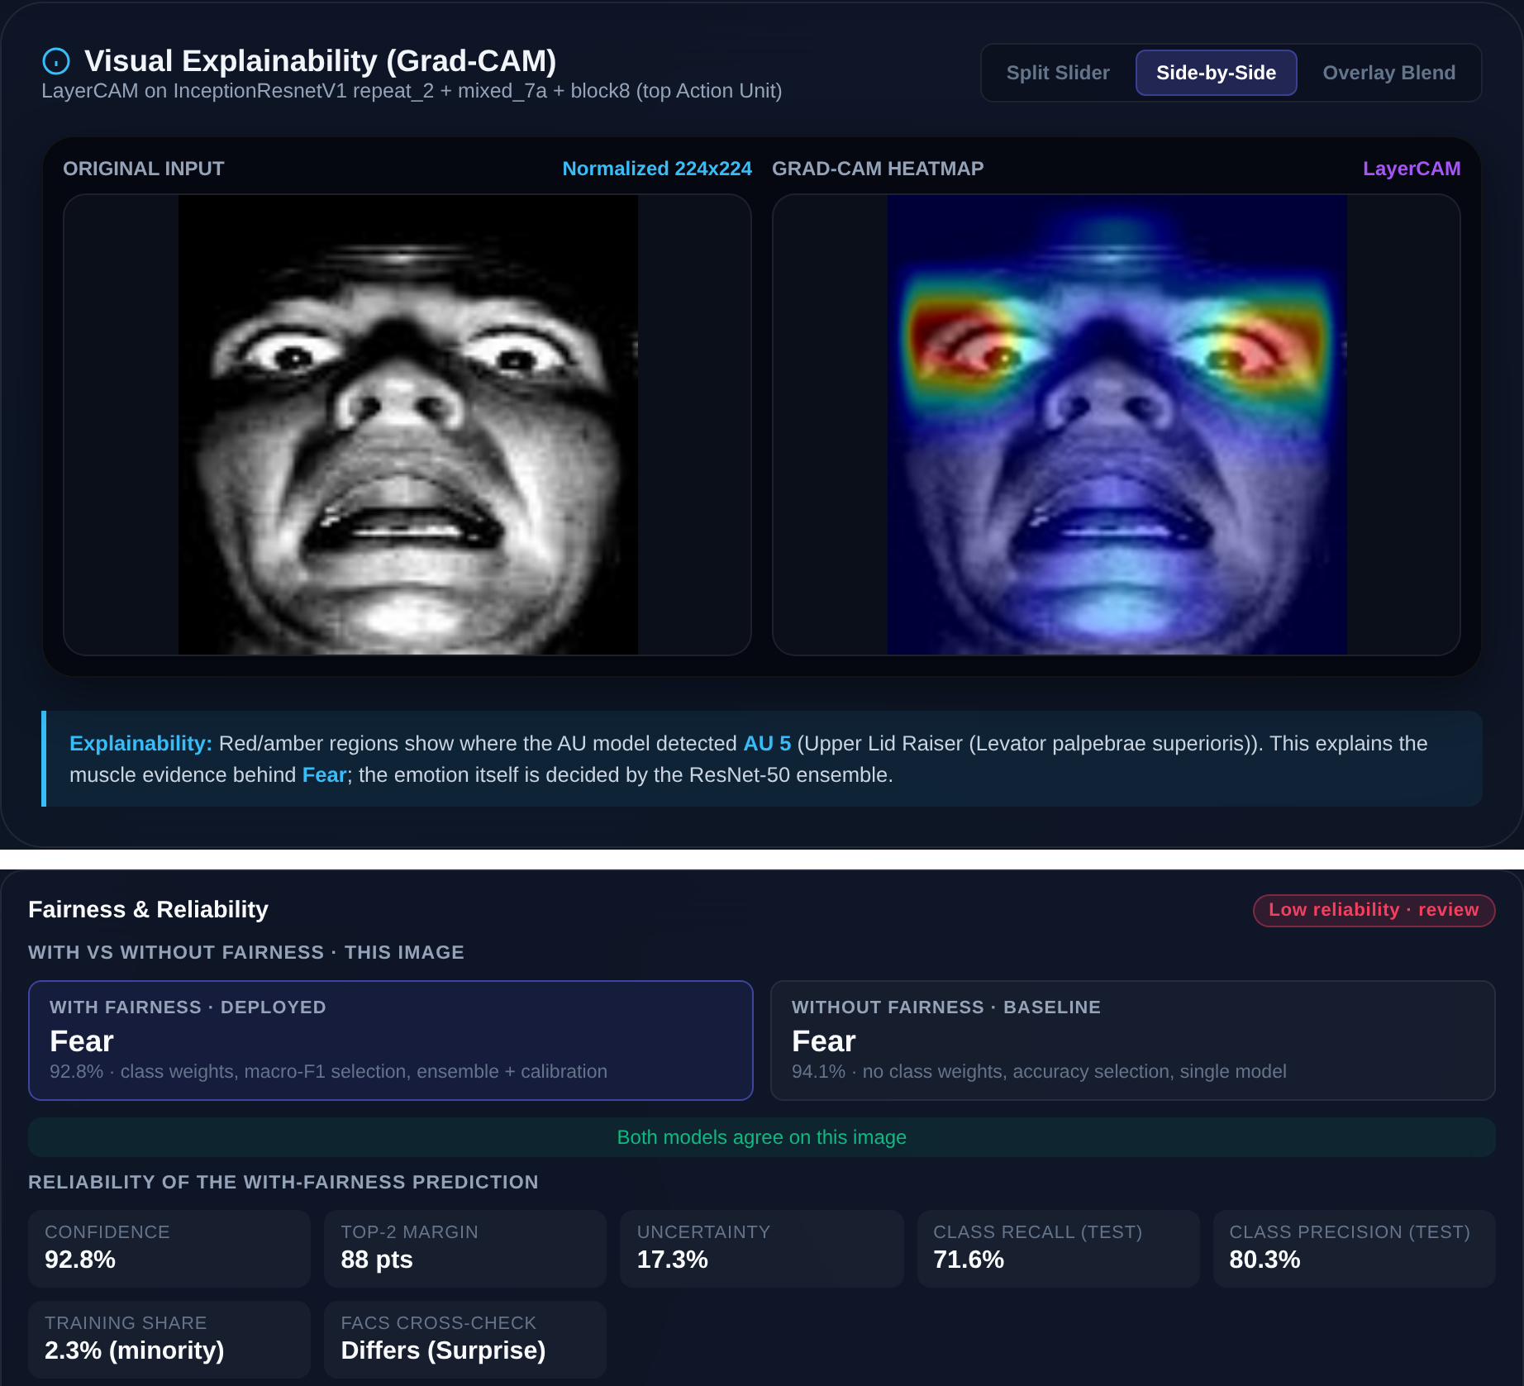
- Web application: AU heatmap viewer (top) and the Fairness & Reliability card (bottom) for a Fear test image. The prediction is confident, but it is rated Low because Fear is a weak minority class on the test set.

Batch Audit Report
A second endpoint samples five random test images per emotion and writes a PDF report. For every image it lists the prediction with and without fairness, the AU heatmap, the detected AUs, the reliability rating and the FACS cross-check. A final section gives per-class metrics for the sample and for the full test set, together with the with/without fairness comparison. Because the sample has only 35 images, the report states that conclusions should be drawn from the full-test-set figures.

Results

Overall Performance
Table II compares all configurations on the 3,068-image test set. The VGGFace2 ResNet-50 lifts accuracy from 83.67% (the ImageNet ResNet-18 baseline from the earlier stage of this project) to 89.15–90.16% for single models. The deployed ensemble reaches 90.38% accuracy and 85.65% macro-F1, which is in line with published face-pretrained ResNet-50 results on RAF-DB (e.g., 89.42% [12] and 90.35% [11]). The third model was trained in a run that was interrupted by an out-of-memory error, so its best saved checkpoint (epoch 6) is weaker (87.26%); the validation-based selection still kept it in the deployed pair.
- Test Results of All Configurations (RAF-DB, 3,068 Images)
Configuration | Acc. (%) | Bal. acc. (%) | Macro-F1 (%) | Worst class recall (%) | ρ
ResNet-18 + ImageNet (earlier stage) | 83.67 | – | – | – | –
Without fairness (p = 0, acc. selection) | 89.99 | 84.62 | 84.78 | Fear 68.9 | 0.723
Model 1 (p = 0.5) | 89.15 | 84.43 | 83.69 | Fear 67.6 | 0.717
Model 2 (p = 0.3, seed 7) | 90.16 | 84.51 | 85.45 | Fear 67.6 | 0.711
Model 3 (p = 0.3, interrupted) | 87.26 | 81.10 | 80.97 | Disgust 62.5 | 0.678
Ensemble, no calibration | 90.29 | 85.13 | 85.54 | Fear 70.3 | 0.740
Ensemble + calibration (deployed) | 90.38 | 85.02 | 85.65 | Fear 71.6 | 0.746
- Models 1–3 and the ensemble use class weighting and macro-F1 selection. ρ = worst / best class recall.

Per-Class Performance
Table III gives the per-class results of the deployed system. Happiness, the majority class, is recognised best (96.0% recall), while Fear (71.6%) and Disgust (74.4%) remain the weakest. Fear has the lowest false-positive rate of all classes (0.4%) but a false-negative rate of 28.4%, so the model tends to miss Fear rather than over-predict it; Disgust has equal precision and recall (74.4%). The minority classes reach a mean recall of 77.5% against 90.7% for the other classes, a gap of 13.2 points.
- Per-Class Results of the Deployed System
Emotion | Prec. (%) | Recall (%) | F1 (%) | Recall w/o fairness (%)
Surprise | 89.6 | 88.8 | 89.2 | 89.7
Fear | 80.3 | 71.6 | 75.7 | 68.9
Disgust | 74.4 | 74.4 | 74.4 | 76.3
Happiness | 95.5 | 96.0 | 95.8 | 95.3
Sadness | 90.4 | 88.3 | 89.3 | 89.5
Anger | 87.0 | 86.4 | 86.7 | 84.6
Neutral | 87.4 | 89.7 | 88.5 | 88.1

With versus Without Fairness Mitigation
Fig. 3 compares the per-class recall of the deployed system with the baseline trained without fairness mitigation. Mitigation improves accuracy by 0.4 points (89.99% to 90.38%), balanced accuracy by 0.4 points, macro-F1 by 0.9 points (84.78% to 85.65%) and, most importantly, the recall of the worst class, Fear, by 2.7 points (68.9% to 71.6%). The recall gap narrows from 26.4 to 24.3 points and the ratio ρ rises from 0.723 to 0.746. Anger (+1.8) and Neutral (+1.6) also improve, while Disgust (−1.9), Sadness (−1.3) and Surprise (−0.9) drop slightly. The four-fifths rule is still not met.
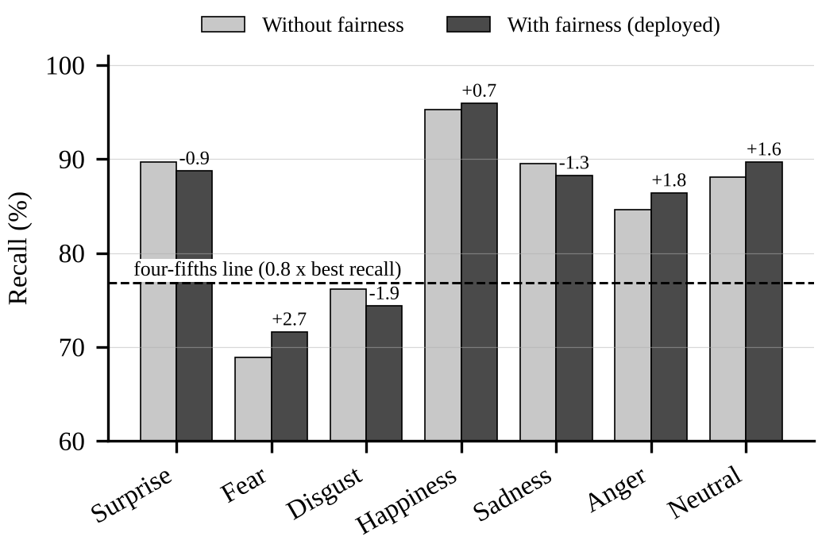
- Per-class test recall with and without fairness mitigation. Labels give the change in percentage points; the dashed line marks 0.8 times the best class recall.
The comparison also shows the limits of the mitigation. A single class-weighted model (Model 1) is not better than the baseline: it has lower accuracy (89.15% vs. 89.99%), similar balanced accuracy (84.43% vs. 84.62%) and lower Fear recall (67.6% vs. 68.9%). The gains come from ensembling and per-class calibration, and because the deployed system combines two models while the baseline is a single model, part of the improvement is simply the effect of ensembling. Class weighting on its own cannot make up for having only 281 Fear training images.

Action Units and Explanations
On its 921-face validation split, the AU engine reaches a micro-F1 of 53.83%, a macro-F1 of 17.35%, a Hamming loss of 6.35% and an exact-match ratio of 4.02%; the low macro-F1 comes from the many rare left/right AU variants. Used on their own, the FACS rules classify about 31% of 175 RAF-DB test images correctly, and in sampled audit reports they agreed with the learned emotion on 40–46% of images. This indicates that the rules are useful as an explanation and cross-check but not as the decision-maker. Fig. 4 shows multi-layer AU heatmaps: AU5 (upper lid raiser) concentrates on the eyes, AU2 (outer brow raiser) on the brows and AU25 (lips part) on the mouth, i.e., on the anatomically correct regions.
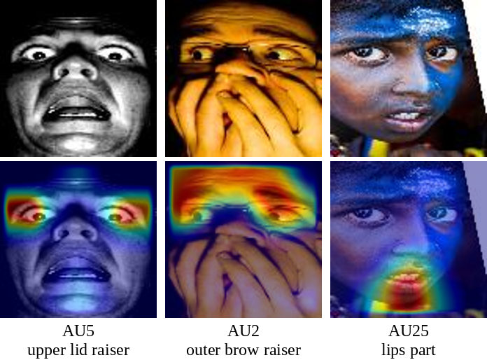
- RAF-DB test faces (top) and LayerCAM heatmaps of the top-ranked Action Unit (bottom).
We also tried heatmaps of the emotion model itself. Gradient-based maps of the VGGFace2 ResNet-50 kept peaking at the centre of the face (the nose) whatever the emotion: its last feature map is only 7×7, so each cell sees almost the whole aligned face, and earlier layers show a regular grid pattern caused by the stride-on-1×1 layout. Occlusion sensitivity, which hides one 40×40-pixel patch at a time, gave more specific maps (e.g., brows and eyes for Anger) but needs hundreds of forward passes per image. The deployed system therefore explains its decisions through the AU heatmap, the AU list and the FACS cross-check.

Discussion and Limitations
Two lessons concern evaluation integrity. First, an earlier prototype of this project reported 91.4–94.3% from its batch report. That number was not a real measurement, because the report passed the ground-truth label into the prediction function. Every result in this paper comes from the model alone, with the test set used once. Second, the batch report samples only five images per emotion, so its accuracy moves by several points between runs (we saw 80.0% to 88.6% on 35-image samples). Only full-test-set numbers should be used to draw conclusions.
The main limitations are as follows. Fairness is measured between emotion classes, not between demographic groups; the audit tool can compute accuracy, macro-F1 and equalized-odds gaps across gender, race and age, but it needs attribute labels that we did not have. The web application does not yet detect and align faces, so it is less accurate on webcam images than on the aligned test set. The review flags did not catch every error: in one sampled report, confident Disgust mistakes were not flagged. Finally, Fear is still below the four-fifths threshold, and more training data for the minority classes is more likely to fix that than further reweighting.

Conclusion
This paper presented FA&EFER, which brings a faithfully reproduced VGGFace2 ResNet-50, imbalance-aware training and selection, AU-grounded explanations and a class-level fairness audit together in one deployable system. It reaches 90.38% accuracy and 85.65% macro-F1 on RAF-DB. Compared with a baseline trained without fairness mitigation, it improves macro-F1 and the recall of the weakest class, while openly reporting that the four-fifths criterion is not yet met. Instead of returning only a label, the system shows the muscle evidence behind each prediction and says how far that prediction can be trusted.

Future Work
FA&EFER works as a proof of concept for fair and explainable FER, and several directions can make it stronger.
Demographic fairness audit: RAF-DB also comes with gender, race and age annotations, which Xu et al. [2] used in their bias study. Using them would let the existing audit tool measure group fairness and the equalized-odds gap directly.
More minority-class data: Fear has only 281 training images. Adding Fear and Disgust faces from other licensed datasets, or targeted oversampling, is the most direct way to close the remaining recall gap.
A cleaner fairness comparison: retraining the interrupted model and comparing an ensemble trained without fairness against the deployed ensemble would separate the effect of fairness mitigation from the effect of ensembling.
Face detection and alignment: adding a face detector and aligner to the application would bring webcam and real-world accuracy closer to the aligned test results.
Interpretable emotion evidence: AU relation modelling [16] and AU-guided attention [17] could make the emotion model's own spatial evidence interpretable, instead of relying only on the AU engine for explanations.

Acknowledgment
The authors thank the School of Computing, SRM Institute of Science and Technology, for its computing support, and the creators of RAF-DB, RAF-AU and VGGFace2 for making their data and models available for research.

References
- S. Li, W. Deng, and J. Du, “Reliable crowdsourcing and deep locality-preserving learning for expression recognition in the wild,” in Proc. IEEE Conf. Comput. Vis. Pattern Recognit. (CVPR), 2017, doi: 10.1109/CVPR.2017.277.
- T. Xu, J. White, S. Kalkan, and H. Gunes, “Investigating bias and fairness in facial expression recognition,” in Proc. Eur. Conf. Comput. Vis. Workshops (ECCVW), 2020, pp. 506–523.
- I. Dominguez-Catena, D. Paternain, and M. Galar, “Metrics for dataset demographic bias: A case study on facial expression recognition,” IEEE Trans. Pattern Anal. Mach. Intell., 2024, doi: 10.1109/TPAMI.2024.3361979.
- M. M. Hosseini, A. P. Fard, and M. H. Mahoor, “Faces of fairness: Examining bias in facial expression recognition datasets and models,” 2025, arXiv:2502.11049.
- Q. Cao, L. Shen, W. Xie, O. M. Parkhi, and A. Zisserman, “VGGFace2: A dataset for recognising faces across pose and age,” in Proc. 13th IEEE Int. Conf. Autom. Face Gesture Recognit. (FG), 2018, doi: 10.1109/FG.2018.00020.
- K. He, X. Zhang, S. Ren, and J. Sun, “Deep residual learning for image recognition,” in Proc. IEEE Conf. Comput. Vis. Pattern Recognit. (CVPR), 2016, pp. 770–778.
- P. Ekman and W. V. Friesen, Facial Action Coding System: A Technique for the Measurement of Facial Movement. Palo Alto, CA, USA: Consulting Psychologists Press, 1978.
- W.-J. Yan, S. Li, C. Que, J. Pei, and W. Deng, “RAF-AU database: In-the-wild facial expressions with subjective emotion judgement and objective AU annotations,” in Proc. Asian Conf. Comput. Vis. (ACCV), 2020.
- P.-T. Jiang, C.-B. Zhang, Q. Hou, M.-M. Cheng, and Y. Wei, “LayerCAM: Exploring hierarchical class activation maps for localization,” IEEE Trans. Image Process., 2021.
- F. Xue, Q. Wang, and G. Guo, “TransFER: Learning relation-aware facial expression representations with transformers,” in Proc. IEEE/CVF Int. Conf. Comput. Vis. (ICCV), 2021, pp. 3601–3610.
- Y. Zhang, C. Wang, X. Ling, and W. Deng, “Learn from all: Erasing attention consistency for noisy label facial expression recognition,” in Proc. Eur. Conf. Comput. Vis. (ECCV), 2022, doi: 10.1007/978-3-031-19809-0_24.
- J. She, Y. Hu, H. Shi, J. Wang, Q. Shen, and T. Mei, “Dive into ambiguity: Latent distribution mining and pairwise uncertainty estimation for facial expression recognition,” in Proc. IEEE/CVF Conf. Comput. Vis. Pattern Recognit. (CVPR), 2021, pp. 6248–6257.
- Y. Zheng, H. Yang, T. Zhang, J. Bao, D. Chen, Y. Huang, L. Yuan, D. Chen, M. Zeng, and F. Wen, “General facial representation learning in a visual-linguistic manner,” in Proc. IEEE/CVF Conf. Comput. Vis. Pattern Recognit. (CVPR), 2022, pp. 18697–18709.
- D. Zeng, Z. Lin, X. Yan, Y. Liu, F. Wang, and B. Tang, “Face2Exp: Combating data biases for facial expression recognition,” in Proc. IEEE/CVF Conf. Comput. Vis. Pattern Recognit. (CVPR), 2022, pp. 20291–20300.
- Y. Zhang, Y. Li, L. Qin, X. Liu, and W. Deng, “Leave no stone unturned: Mine extra knowledge for imbalanced facial expression recognition,” in Proc. Adv. Neural Inf. Process. Syst. (NeurIPS), 2023.
- C. Luo, S. Song, W. Xie, L. Shen, and H. Gunes, “Learning multi-dimensional edge feature-based AU relation graph for facial action unit recognition,” in Proc. 31st Int. Joint Conf. Artif. Intell. (IJCAI), 2022, pp. 1239–1246.
- S. Belharbi, M. Pedersoli, A. L. Koerich, S. Bacon, and E. Granger, “Guided interpretable facial expression recognition via spatial action unit cues,” in Proc. 18th IEEE Int. Conf. Autom. Face Gesture Recognit. (FG), 2024, p. 929.
- R. R. Selvaraju, M. Cogswell, A. Das, R. Vedantam, D. Parikh, and D. Batra, “Grad-CAM: Visual explanations from deep networks via gradient-based localization,” in Proc. IEEE Int. Conf. Comput. Vis. (ICCV), 2017, doi: 10.1109/ICCV.2017.74.
- C. Szegedy, S. Ioffe, V. Vanhoucke, and A. A. Alemi, “Inception-v4, Inception-ResNet and the impact of residual connections on learning,” in Proc. AAAI Conf. Artif. Intell., 2017, pp. 4278–4284, doi: 10.1609/aaai.v31i1.11231.

