**ANZ Mortgage Calculator Automation Execution flow**

Prerequisites:

1. JDK ( version 1.7)

2. Eclipse ide

3. Testng plugin

4. Selenium (2.53.0)

5. Firefox (45.0.2)

Project Structure:

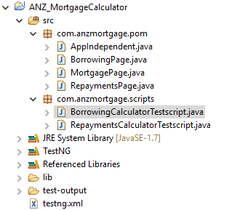

**ANZ Mortgage Calculator Project** consists of **com.anzmortgage.pom** package which has following java files for each page.

1. Application Independent java which consists of re-usable methods such as click, waitFor, etc and application dependent java classes based on pages.
2. c**om.anzmortgage.scripts** which has Actual Test scripts of the test cases which are TestNG classes. These java files are the runner files which has **@BeforeClass** and **@AfterClass**

***@BeforeClass*** contains initial setup such as launching firefox browser, navigating to application, etc. which will be executed every time before every TestNG class.

***@AfterClass*** contains closures such as closing application which will be executed every time after every TestNG class.

***@Test*** methods are the actual test cases.

4) testng.xml consists of all the test scripts as **packagename.className.**

Run **testng.xml as TestNG suite** to execute the test scripts. Default report will be generated in the test-output folder.

**Note:**

1. Do not use Selenium 3 or latest Firefox (>=47) for automating. Selenium 2.53 does not support latest browsers. Latest version of selenium 3 is not stable.
2. Run the scripts multiple times for the successful execution of all scripts.