**Niki Automation step Execution flow**

Prerequisites:

1.JDK (used 1.8)

2.Eclipse ide

3.Testng plugin

4.Appium Tool (1.4.16.1)

5.Appium Jacva Client Jars(4.1.2)

6.Selenium (2.53)

Project Structure:

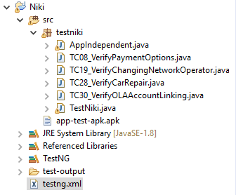

**Niki Project** consists of testniki package which has following java files.

1. **Application Independent java** which consists of re-usable methods such as click, waitFor, etc
2. Actual Test scripts of the test cases which are TestNG classes.
3. **TestNiki java** is the runner java which has **@BeforeMethod** and **@AfterMethod**.

***@BeforeMethod*** contains initial setup like APK path setting, Desired capabilities, launching the app, etc. Which will be executed every time before every TestNG class.

***@AfterMethod*** contains closures such as closing the Niki session, closing the driver,etc Which will be executed every time after every TestNG class.

1. testng.xml consists of all the test scripts as **packagename.className.**

Run **testng.xml as TestNG suite** to execute the test scripts. Default report will be generated in the test-output folder.