

GREGG R. DREILINGER, ESQ.  Admitted in FL  DEREK R. COURNOYER, ESQ.  Admitted in FL & RI  DIANA A. CARPINTERO, ESQ.  Admitted in IL  JOSEPH M. DOLBEN, ESQ.  Admitted in NH, MA & RI | GARY D. MARINOSCI, ESQ.  Admitted in RI & MA  DAVID M. BENGS, ESQ.  Admitted in IN  CHRISTOPHER K. BAXTER, ESQ.  Admitted in AR, TX, GA & NY | ROBERT S. COLEMAN, JR, ESQ.  Admitted in AR & TN  DAVID V. NOYCE, ESQ.  Admitted in KS & MO  CHAD A. MORRONE, ESQ.  Admitted in MA  EILEEN C. O’SHAUGHNESSY, ESQ.  Admitted in CT & RI
________________________________________________________________________________________

2110 Calumet Avenue, Valparaiso, IN 46383 Phone (219) 462-5104 Facsimile (219) 462-9344
275 West Natick Road, Suite 500, Warwick, RI 02886 Phone (401) 234-9200 Facsimile (401) 398-2594

July 16, 2018

Natalie D. Inniger
119 W Main Street
Thorntown, IN 46071

Natalie D. Inniger
5946 Deerwood Court
Indianapolis, IN 46254

RE: Bank of America, N.A. v. Natalie D. Inniger, The Villas of Oakbrook, Inc.
Loan No.: 67256860
FHA No.: 151-7683091734
Our File No.: 17-17850-2
Redemption Expires: Upon Confirmation of Sheriff’s Sale

A VISO IMPORTANTE PARA PERSONNAS DE HABLA HISPANA. ESTE ES UN A VISO MUY IMPORTANTE. SI NO ENTIENDE EL CONTENDIO, OBTENGA UN TRADUCCION IMMEDIATAMENTE. SI USTED NO RESPONSE DENTRO DE VEINTE (20)DIAS PUEDE SER QUE LO HAGAN MUDAR DE LA CASA O APARTAMENTO EN DONDE VIVE.

Dear Natalie D. Inniger and/or Unknown Occupants:

The mortgage for the property in which you are living is about to be foreclosed (sometimes referred to as repossessed). We expect that ownership of the property will be transferred to our client, Bank of America, N.A., probably within the next 60 to 90 days. Shortly thereafter, it is probable that ownership will be transferred to the Secretary of Housing and Urban Development (HUD).

HUD generally requires that there be no one living in properties conveyed to the Secretary as a result of a foreclosure. As the Federal Housing Administration’s (FHA) Single Family Program is a mortgage insurance program, it must sell all acquired properties and use the proceeds of sale to help replenish the FHA Mortgage Insurance Fund. It is not a rental program. There are other programs within HUD that assist in making rental housing available.

However, beforeBank of America, N.A. conveys the property to HUD, you may be entitled to remain in the property for some period of time, pursuant to federal, state, or local law. If applicable, a separate notice regarding occupancy rights will be provided to you when complete title to the property is transferred to Bank of America, N.A. as a result of an order of a court or pursuant to provisions in the mortgage, deed of trust or security deed.

If you are not entitled to remain in the property under federal, state, or local law, you may nevertheless be eligible to remain in the property upon conveyance to HUD, if certain conditions are met, as described in Attachment 3, Conditions for Continued Occupancy. To be considered for continued occupancy upon conveyance to HUD, you must submit a written request to HUD within 20 days of the date at the top of this letter or the property must be vacated before the time HUD is scheduled to acquire it. . Oral requests will not be accepted.

Please use the enclosed, Form HUD-9539, Request for Occupied Conveyance (Attachment 1) in making your request, as it gives HUD information it needs to make its decision. You must send your request and the enclosed Request for Verification of Employment (Attachment 2) to HUD’s Mortgagee Compliance Manager (MCM), at the following address:

ISN Corporation
Shepherd Mall Office Complex
2401 NW 23rd St Suite 1D
Oklahoma City, OK 73107

As the occupant requesting the occupied conveyance, you have sole responsibility for submission of a signed Verification of Employment form with your Occupied Conveyance request.

If you or a member of your household suffers from an illness or injury that would be aggravated by the process of moving from the property, please also provide supporting documentation of the illness or injury. This documentation must include a projection of the date that the individual could be moved without aggravating the illness or injury and a statement by a state-certified physician establishing the validity of your claim.

Please ensure that you include all required documentation with your request; incomplete
requests will be denied. Additional information that you wish to include with your request may be written on additional pages that you attach to the Request for Occupied Conveyance form.

If HUD approves your request to remain in the property, you will be required to sign a month-to month lease and pay rent at the prevailing fair market rate. If HUD does not become owner of this property, any decision it may make with respect to your continued occupancy will no longer apply.

Your right to continued occupancy of the property under HUD’s Occupied Conveyance policies will only be temporary, depending on the circumstances, as described in the attached document, Temporary Nature of Continued Occupancy (Attachment 4).

For assistance in finding affordable housing, you may wish to contact one or more of HUD’s approved housing counseling agencies. These agencies usually provide services at little or no cost. A counselor may be able to recommend other organizations that can also be of assistance. If you have access to the Internet, you may locate a local housing counseling agency by visiting the following webpage: http://www.hud.gov/offices/hsg/sfh/hcc/hcs.cfm. Alternatively, you may call the HUD Housing Counseling and Referral Line, weekdays between 9:00 am and 5:00 pm EST. The Referral Line telephone number is (800) 569-4287.

If you have any questions concerning this notice, please contact Bank of America, N.A. at P.O. Box 31690, FL1-908-01-51, Tampa, FL 33631-3690, 1-800-669-1904.

Very truly yours,

MARINOSCI LAW GROUP, P.C.

By: _____________________________
Jennifer L. Snook

JLS/JH
Enclosures
cc: ISNC

Attachment #1
CONDITIONS FOR CONTINUED OCCUPANCY

The following conditions must be met before HUD can approve the occupied conveyance of an acquired property.

1. One or more of the following must be met:

(a)Your occupancy is necessary to protect it from
vandalism.
(b)The average time in inventory for HUD’s unsold inventory
in the residential area in which the property is located
exceeds six months.
(c)With respect to two-to-four-unit properties, the
marketability of the property would be improved by your
continuing in occupancy.
(d)An individual residing in the property suffers from a
permanent, temporary, or long-term illness or injury
that would be aggravated by the process of moving from
the property.

2. The house must be habitable (except for approval under condition 1(d)).

3. You must have been living in the house at least 90 days prior to the date the lender acquires title to the house (except for approval under condition 1(d)).

4. You must agree to sign a month-to-month lease at fair market rental on a form prescribed by HUD at the time HUD acquires the house.

5. You must have the financial ability to make the monthly rental payments under the terms of the lease.

6. You must agree to pay one month’s advance rent when you sign the lease (except for approval under conditions 1 (d)).

7. You must allow access to the property during normal business hours:

- By HUD representatives for a physical inspection of the property, with two days notice.
- By HUD contractors doing repairs, with two day notice.
- By real estate brokers and their clients.

8. You must disclose and verify the Social Security Numbers of all family members six years of age and older.
Attachment #2

Attachment #3

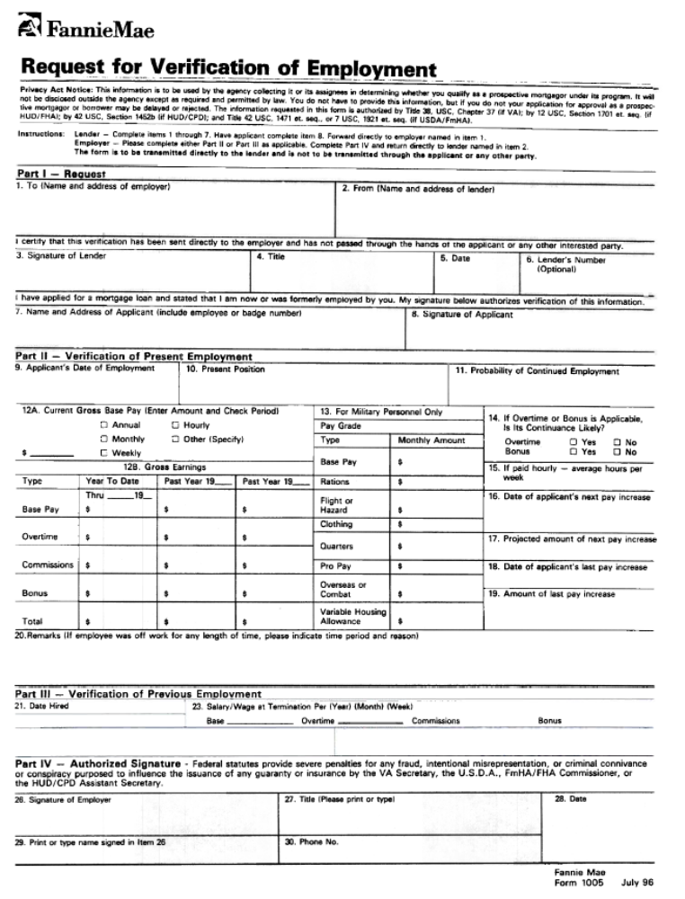
Attachment #4

TEMPORARY NATURE OF CONTINUED OCCUPANCY

This is to advise you that occupancy of HUD-owned property is not permanent but is only temporary in all cases and is subject to termination to facilitate preparing the property for sale and completing its sale. Temporary means that your lease arrangement with HUD is subject to termination at the convenience of the government upon 30 day’s notice. You should not view your living in this property as a permanent or long-term arrangement. It is HUD’s policy to ask you to vacate the property and, if necessary, take appropriate eviction action for the following causes:

- Failure to execute the lease.

- Failure to pay the required rent, including the initial payment at the time of execution of the lease.

- Failure to comply with the terms of the lease.

- Failure to allow access to the property to accomplish necessary repairs, inspect the property, or allow real estate brokers to show the property to a prospective purchaser.

- Preparation of the property for sale.

- Assignment of the property by the Field Office to a different use or program.

