**NOVARTIS GLOBAL**

**Doc. ID:** CIT.ACT.DS.001.DICE2.V1.1

**Title:** ACTalya-EVICO Integration

**Application Clarity ID:** 45620

**Design Specification**

|  |  |  |
| --- | --- | --- |
| **Author:** | **Date:** | **Signature:** |
| C. Arvind Kumar  Technical SME  Novartis |  |  |
|  |  |  |
| **Approval:** | **Date:** | **Signature:** |

|  |  |  |  |
| --- | --- | --- | --- |
| **Lakshmana Kalimisetty**  Project / Program Manager  Novartis |  |  | |
| **Omar K.M.A.**  IT System Owner – EVICO  Novartis |  |  | |
| **Venkatraman Naganathan**  TAD Architect  Novartis |  |  | |
| **Daniel Gomez**  IT System Owner – ACTalya  Novartis |  |  | |
| **John Lacagnina**  Project Quality Manager  Novartis |  | |  |

**Document History**

|  |  |  |  |
| --- | --- | --- | --- |
| **Version** | **Date** | **Author** | **Comments** |
| 1.0 | 26-Sep-2019 | C. Arvind Kumar | Initial Version. |

**Table of Contents**

1. Introduction 4

1.1 Purpose 4

1.2 Prerequisites 4

1.3 Reference to Standards 4

1.4 Definitions 4

2. Overview 4

3. System Design & Customization 4

3.1 General Specifications 5

3.1.1 Supported Spark Actions 6

3.1.2 Notification service 6

3.2 Data Flow & Data Model 6

3.2.1 Business Layer Data Model 6

3.3 Interfaces 7

4. References, Attachments, Abbreviations/Acronyms 11

4.1 References 11

4.2 Attachments 11

4.3 Abbreviations / Acronyms 11

5. Publishing 12

# Introduction

## Purpose

This document is Design Specification (DS) for the ACTalya, which is being implemented on top of EVICO data platform.

## Prerequisites

The document(s) listed below must be approved prior to the approval of this document.

Functional Specification(s) -CIT.ACT.FS.001.DICE2.V1.2 – Application.

## Reference to Standards

N/A

## Definitions

* Configuration: Setting of configuration parameters, no coding.
* Customizing: Creation of custom code (new / changed functionalities).

# Overview

The primary goal of the described solution is to receive Sales data (Direct Sales & IQVIA Sales) from DICE EVICO platform for Spain (ES) and Australia (AU) countries so that, Aktana can visualize this data through Qlik Sense or provide suggestions / insights .

Business purpose is to receive Sales vs Target Data from DICE EVICO platform for Spain (ES) and Australia (AU) countries so that, Aktana can visualize this data through Qlik Sense or provide suggestions / insights.

# System Design & Customization

Below is the data flow diagram that has been designed for ACTalya

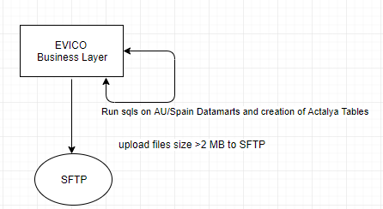

1. After Australia and spain datamarts are created on evico platform,
2. We run the sqls for creating actalya related tables for respective countries.
3. Next we convert the files to csv using spark submit
4. Upload files which are greater than 2 mb to SFTP

Development is done in Agile methodology. Programming languages used

* Scala
* Bash

Frameworks

* Apache Spark

Infrastructure needed

* Apache Hadoop (HDFS + YARN)
* Apache Hive
* Apache Spark

## General Specifications

| **DS-ID** | **Reference to FS** | **Function / Feature** | **Detailed Specification** |
| --- | --- | --- | --- |
| *(short title)* |
| DS-GEN-01 | FS-GEN-6-1-1 | Data Retention | Data Retention Period |
| DS-GEN-02 | FS-GEN-6-1-3 | Data Refresh | Data Refresh Frequency |
| DS-GEN-03 | FS-GEN-6-1-4 | Data Cleansing, transformation & aggregation | Data cleansing, transformation & aggregation rules applied. |
| DS-GEN-04 | FS-MOD-6-2-1 | Spain Targets - View / Table | Monthly Sales vs Target Data for Spain Country |
| DS-GEN-05 | FS-MOD-6-2-2 | Australia Targets - View / Table | Monthly Sales vs Target Data for Australia Country |
| DS-GEN-06 | FS-MOD-6-2-3 | Spain Direct Sales - View / Table | Monthly Direct Sales Data for Spain Country |
| DS-GEN-07 | FS-MOD-6-2-4 | Australia Direct Sales - View / Table | Monthly Direct Sales Data for Australia Country |
| DS-GEN-08 | FS-MOD-6-2-5 | Spain IQVIA Sales - View / Table | Monthly IQVIA Sales Data for Australia Country |
| DS-GEN-09 | FS-MOD-6-2-5 | Australia IQVIA Sales - View / Table | Monthly IQVIA Sales Data for Spain Country |
| DS-GEN-10 | FS-MOD-6-2-6 | Spain IQVIA Sales - Excel | Monthly IQVIA Sales Data for Australia Country |
| DS-GEN-11 | FS-MOD-6-2-6 | Australia IQVIA Sales - Excel | Monthly IQVIA Sales Data for Spain Country |
| DS-GEN-12 | FS-MOD-6-2-7 | Australia Brick Code - View / Table | Brick Code data for Australia |
| DS-GEN-13 | FS-MOD-6-2-7 | Australia SRA Code - View / Table | SRA Code for Australia |
| DS-GEN-14 | FS-MOD-6-2-8 | Data Integrity | Data Integrity maintained |

### Supported Spark Actions

Australia

au_dm_to_csv.sh – converting parquet files to csv

Spain

es_dm_to_csv.sh - converting parquet files to csv

### Notification service

Evico sends notification to API Gateway team through rest calls.

## Data Flow & Data Model

Business Data Layer is the only layer used in Actalya

### Business Layer Data Model

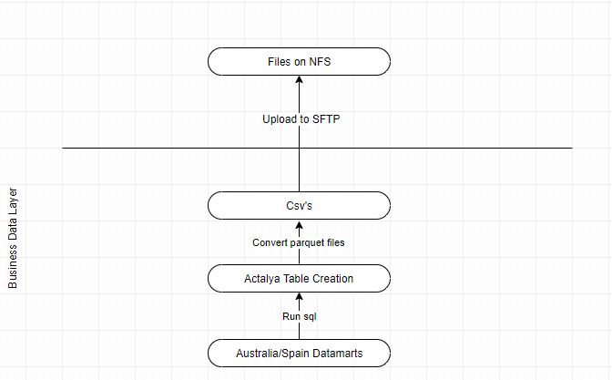

3.2.1.1

|  |  |
| --- | --- |
| **Database** | **Description** |
| ph_com_b_dice | DICE business layer |

#### DICE Core

EVICO data marts created on the business layer

| **Data mart** | **Description** |
| --- | --- |
| dm_aktana_au_iqvia_sales | This table consists of Sales data of Australia from IQVIA as source |
| dm_aktana_au_sales_target | This table consists of Targets data for Australia of Novartis brands such as ENTRESTO |
| dm_aktana_au_postcode_brick_reference | This table consists of Brick code details in Australia |
| dm_aktana_au_sra_brick_reference | This table consists of SRA code details in Australia |
| dm_aktana_es_iqvia_sales | This table consists of Sales data of Spain from IQVIA as source |
| dm_aktana_es_sales_target | This table consists of Targets data for Spain of Novartis brands such as ENTRESTO |
| dm_aktana_es_direct_sales | This table consists of Sales data of Spain from Direct Sales |

## Interfaces

This section covers the interface design / customization made based on the specifications given in the FS CIT.ACT.FS.001.DICE2.V1.2

ACTalya Australia Jobs

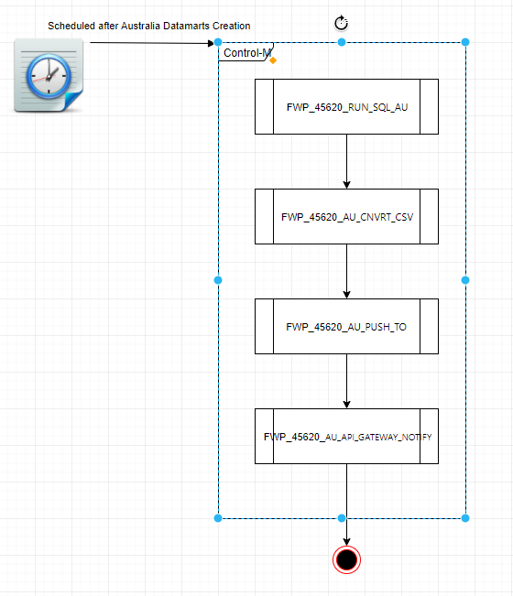

Adhoc Job for Historical Data Loading

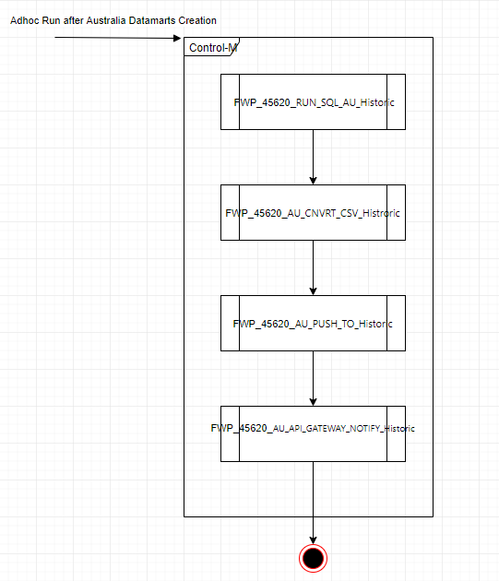

ACTalya Spain Control M Jobs

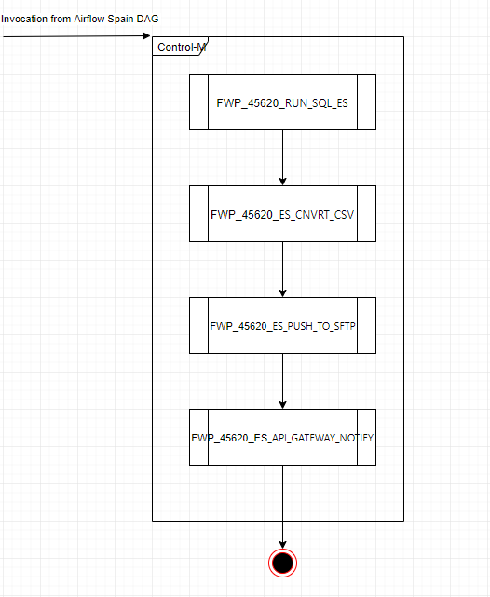

Adhoc Job for Historical Data Loading

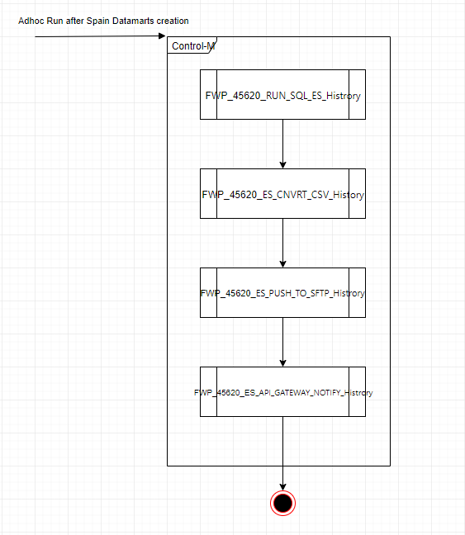

| **DS-ID** | **Reference to FS** | **Function / Feature** | **Detailed Specification** |
| --- | --- | --- | --- |
| *(short title)* |
| DS-INT-01 | FS-MOD-6-2-5 | Australia IQVIA Sales  - View / Table | EVICO System should be able to extract and load Monthly IQVIA Sales Data for Spain to excel file and place it in SFTP Go Anywhere location so that SFTP Go Anywhere will send this file to Aktana [section 6.7] |
| DS-INT-02 | FS-MOD-6-2-6 | Australia IQVIA Sales - Excel | EVICO System should be able to extract and load Monthly IQVIA Sales Data for Australia to excel file and place it in SFTP Go Anywhere location so that SFTP Go Anywhere will send this file to Aktana [section 6.8] |

Source Code Repository: GIT_REPO_ACTALYA [R4]

# References, Attachments, Abbreviations/Acronyms

## References

|  |  |  |  |
| --- | --- | --- | --- |
| **#** | **ID** | **Title** | **Storage Location** |
| [R1] | Quality Manual 3.14 | “GxP Computerized Systems Compliance” | Intranet, Group Quality - Quality Manual |
| [R2] | Quality Manual 3.2 | “Document and Data Management” | Intranet, Group Quality - Quality Manual |
| [R3] | SOP-7037712 | GOP “Computerized System Validation” | ESOPS |
| [R4] | GIT_REPO_ACTALYA | “ GIT Repository of ACTalya” | https://gitlab.evico.novartis.net/ project_ph_com_actalya10/ project_ph_com_actalya10 |

## Attachments

| **#** | **ID** | **Title** | **Storage Location** |
| --- | --- | --- | --- |
|  | CIT.ACT.URS.001.DICE2.V1.2 | ACTalya-EVICO Integration URS | https://my.novartis.net/:w:/r/personal/omarkm1_novartis_net/Documents/DICE%20File%20Share/Actalya |
|  | CIT.ACT.FS.001.DICE2.V1.2 | ACTalya-EVICO Integration FS | https://my.novartis.net/:w:/r/personal/omarkm1_novartis_net/Documents/DICE%20File%20Share/Actalya |

## Abbreviations / Acronyms

| **Abbreviation / Acronym** | **Description** |
| --- | --- |
| COTS | Commercial Off The Shelf |
| FS | Functional Specification |
| SIPOC | Suppliers/Inputs/Process/Outputs/Customers |
| SQL | Structured Query Language |
| URS | User Requirement Specification |

# Publishing

This document is published in https://my.novartis.net/:w:/r/personal/omarkm1_novartis_net/Documents/DICE%20File%20Share/Actalya/CIT.ACT.DS.001.DICE2.V1.1.docx?d=w3832371f6d784e0fa7b3755d9c82f842&csf=1&e=wO7cRF