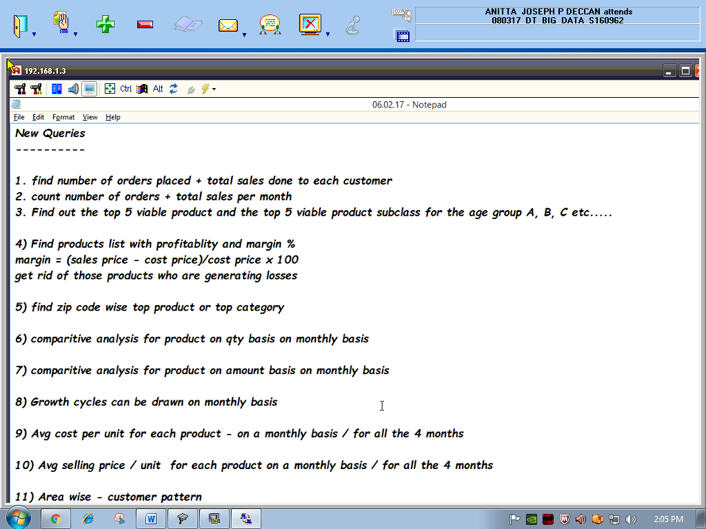

12)Find the total sales in each day of a week I a given data ?