Test 1:

1.      Write a program to accept studentname and studentmarkes of 5 subject. Calculate the percentage and display the GRAD for the student

               1. Between 100 to 85 Grade = A+

               2. Between 84 to 75 Grade = A

               3. Between 74 to 65 Grade = B

               4.Between 64 to 50 Grade = c

               5.Below 50 Grade = Fail

Display name along with grade of student.

public class Student

{

String name;

int num1,num2,num3,num4,num5;

float sum,t,per;

public void getDetails()

{

Scanner in=new Scanner(System.in);

System.out.println("Enter student name");

name=in.nextLine();

System.out.println("Enter marks obtained in 1st subject out of 100");

num1=in.nextInt();

System.out.println("Enter marks obtained in 2st subject out of 100");

num2=in.nextInt();

System.out.println("Enter marks obtained in 3st subject out of 100");

num3=in.nextInt();

System.out.println("Enter marks obtained in 4st subject out of 100");

num4=in.nextInt();

System.out.println("Enter marks obtained in 5st subject out of 100");

num5=in.nextInt();

}

public void show()

{

sum=num1+num2+num3+num4+num5;

t=sum/500;

per=t*100;

if(per>=85 && per<=100)

{

System.out.println(name+"has got grade A+");

}

else if(per>=75 && per<=84)

{

System.out.println(name+"has got grade A");

}

else if(per>=65 && per<=74)

{

System.out.println(name+"has got grade B");

}

else if(per >=50 && per<=64)

{

System.out.println(name+" has got grade C");

}

else

{

System.out.println(name+"is fail");

}

}

public static void main(String[] args)

{

Student s=new Student();

s.getDetails();

s.show();

}

}

Output:----

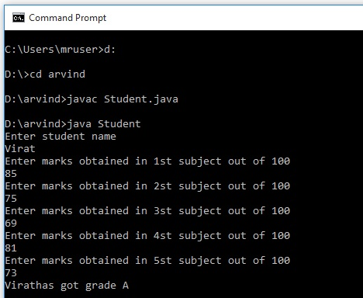

2.      Write a program to accept Customer name and number of product purchased by customer along with price and quality of product. If the salary of customer is 10000 per month then what percentage of salary customer spent on purchase?

import java.util.*;

public class Customer

{

String name;

float price;

int qunt;

float spent;

float sal=10000;

float total;

float t;

public void accept()

{

Scanner in=new Scanner(System.in);

System.out.println("Enter name of customer");

name=in.nextLine();

System.out.println("Enter price of product he purchased:");

price=in.nextFloat();

System.out.println("Enter quanty of that product ");

qunt=in.nextInt();

}

public void display()

{

total=price*qunt;

t=total*100;

spent=t/sal;

System.out.println("Customer "+name+" spending "+spent+"% on purchasing ");

}

public static void main(String[] args)

{

Customer c=new Customer();

c.accept();

c.display();

}

}

Output:---

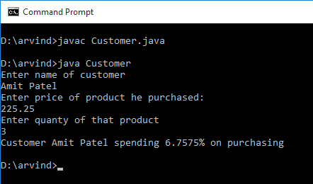

3.      Write a Program to accept 10 customers name and customers rating for Android one mobile phone. Display the average rating for the product.

class Customer

{

private String cus_name;

private float cus_rating;

public String getCus_name()

{

return cus_name;

}

public void setCus_name(String cus_name)

{

this.cus_name = cus_name;

}

public Customer()

{

// TODO Auto-generated constructor stub

}

public float getCus_rating()

{

return cus_rating;

}

public void setCus_rating(int cus_rating)

{

this.cus_rating = cus_rating;

}

public Customer(String cus_name, float cus_rating)

{

this.cus_name = cus_name;

this.cus_rating = cus_rating;

}

}

import java.util.ArrayList;

import java.util.Scanner;

public class CustomerImpl

{

int i;

public ArrayList<Customer> list = new ArrayList<>();

public void accept() {

for ( i = 1; i <=10; i++)

{

Scanner scan = new Scanner(System.in);

System.out.println("Enter " + i + "th customer name");

String name = new Scanner(System.in).nextLine();

System.out.println("Enter " + name + " rating for android one mobile");

float rating = new Scanner(System.in).nextFloat();

Customer cust = new Customer(name, rating);

list.add(cust);

}

}

public float getSum(ArrayList arr)

{

float sum = 0;

for (Customer c : list)

{

sum =sum+c.getCus_rating();

}

return sum;

}

public void display()

{

System.out.println("Average of rating of for product:"+getSum(list)/i);

}

public static void main(String[] args)

{

CustomerImpl cu=new CustomerImpl();

cu.accept();

cu.display();

}

}

Output:-----

