Commented Screenshots of Balanced brackets program

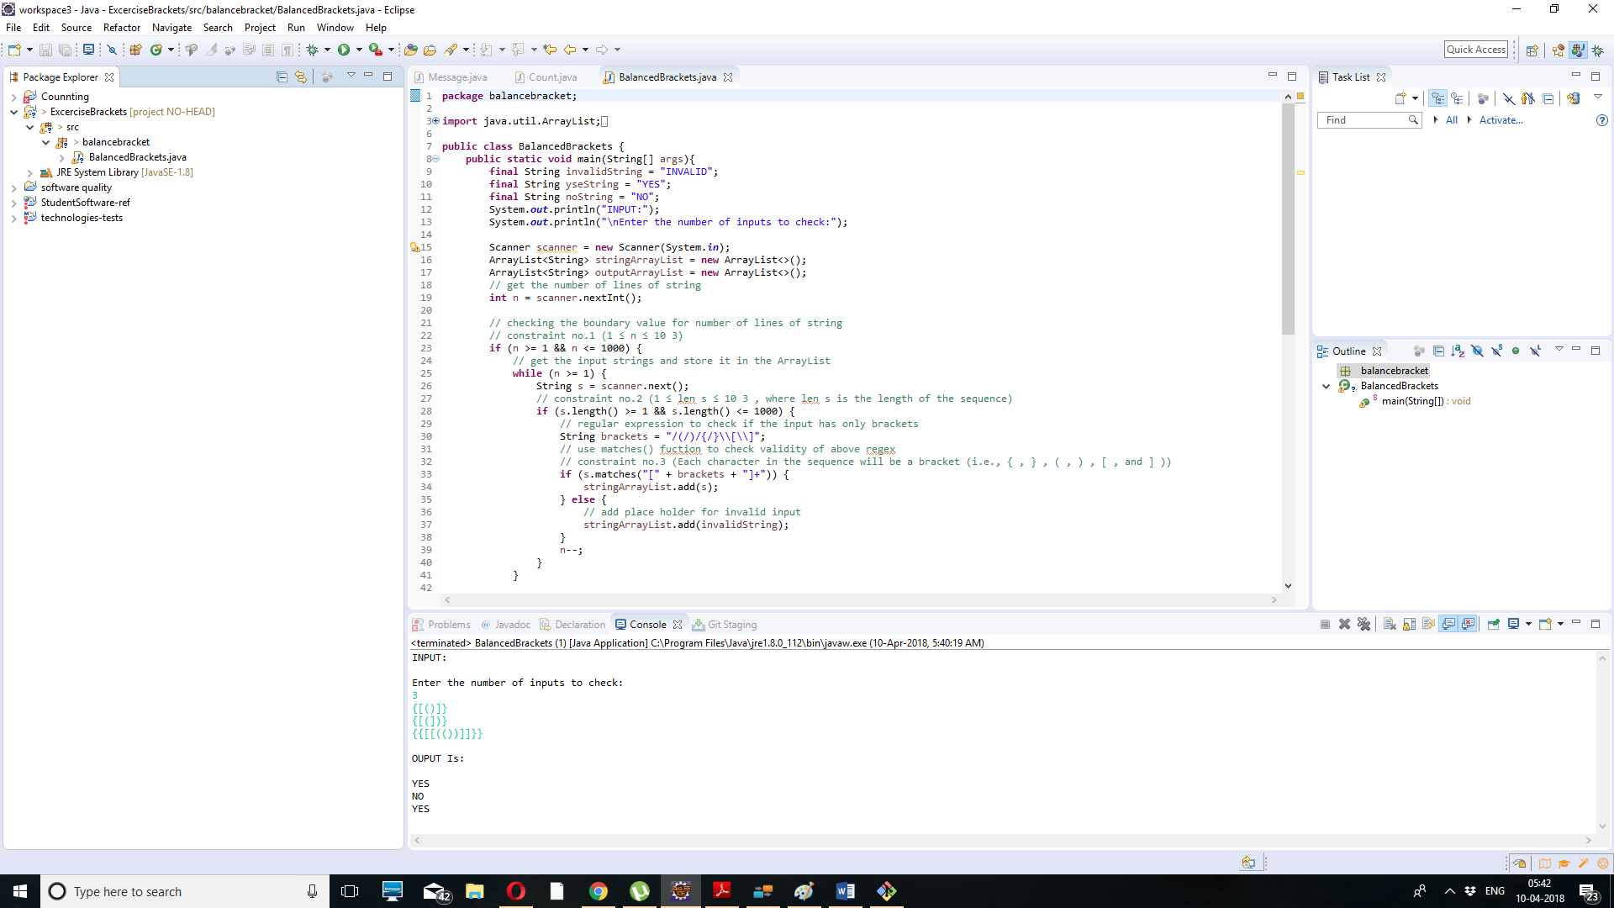

- The program is totally focusing on balancing brackets.
- The program included 3 constraints which was assigned in programming task.
- The output is matching the sample output requirements which is given in programming task.
- Programming task is completed successfully.

