**Iron Man Website**

Name : K . Aravind Kumar Reddy

Email :[aravindkumar7855@gmail.com](mailto:aravindkumar7855@gmail.com)

phone no: 8247283166

Roll NO : 20KT1A4729 (CSE - IOT & CS INCL BCT)

College: Potti Sriramulu Chalavadi Mallikarjunarao College of Engineering & Technology

**source code**

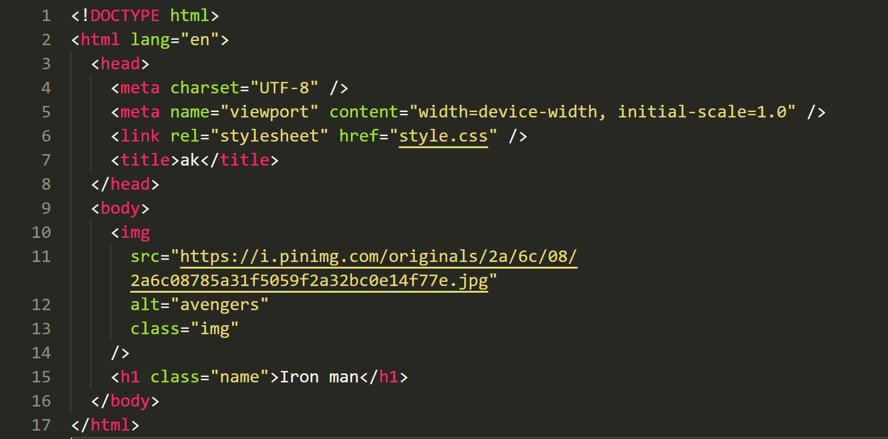**:**

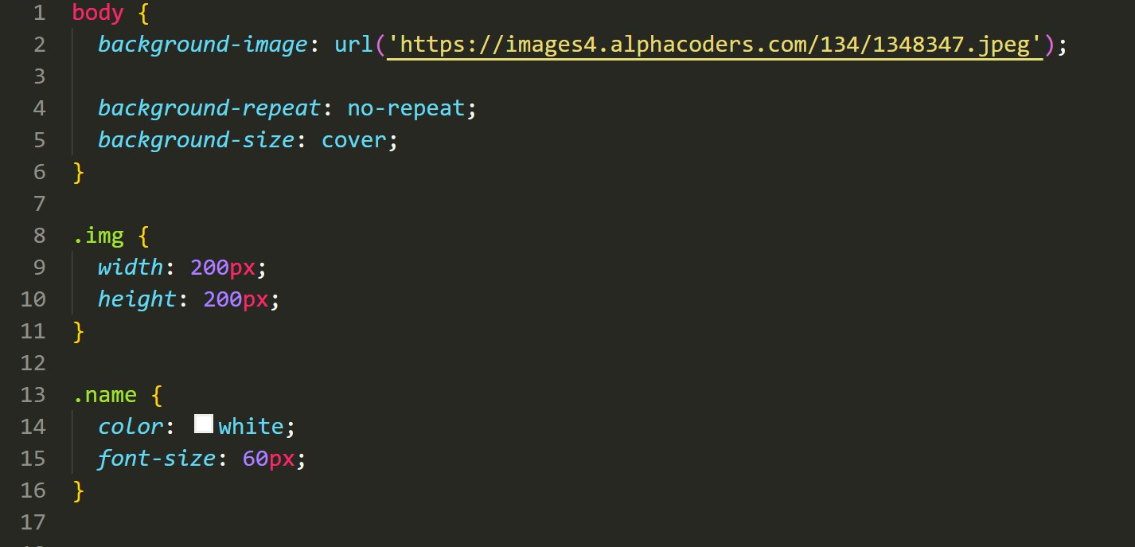

**flnal output :**

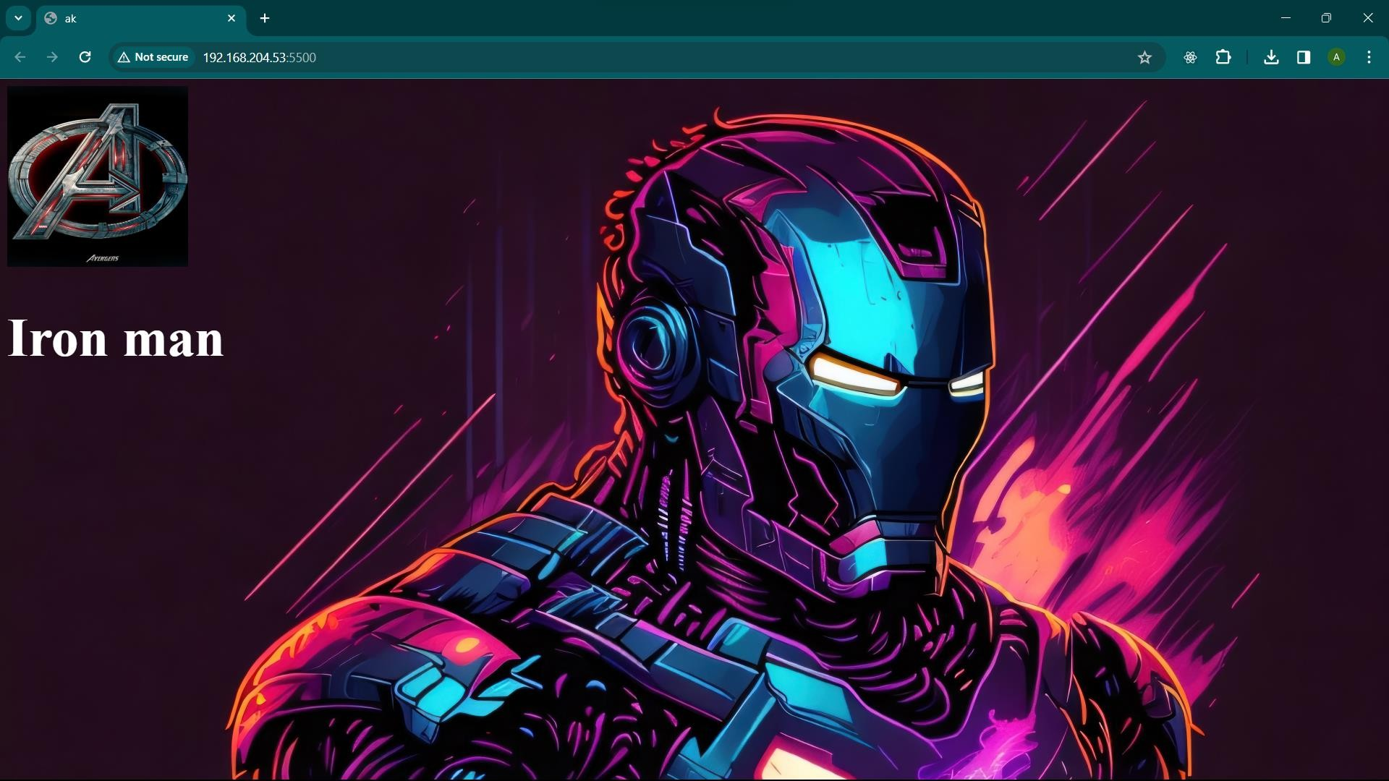

live demo : https://aravind-ironman.netlify.app/