React.js Component Creation

name : K . Aravind Kumar Reddy

email :[aravindkumar7855@gmail.com](mailto:aravindkumar7855@gmail.com)

phone no 8247283166

Roll NO : 20KT1A4727 (CSE - IOT & CS INCL BCT)

College: Potti Sriramulu Chalavadi Mallikarjunarao College of Engineering & Technology

source code :

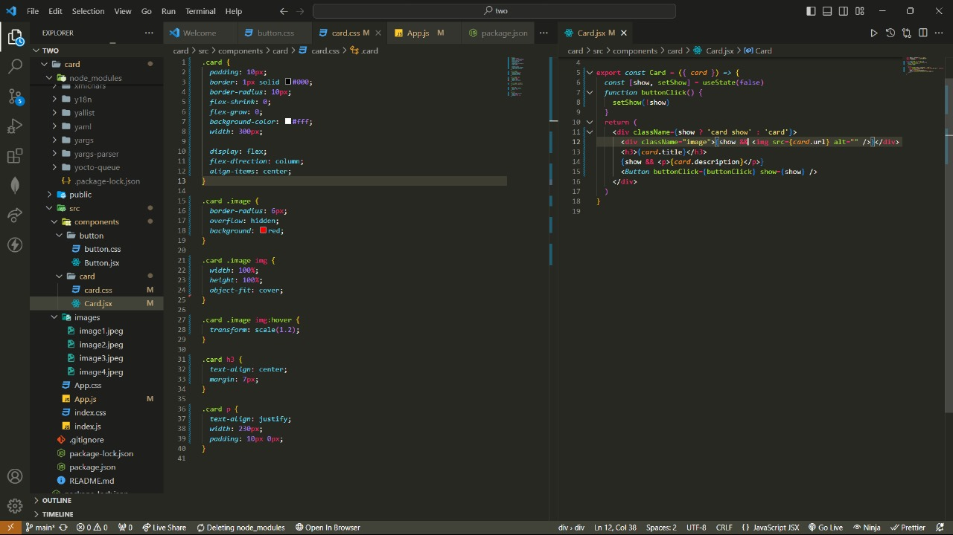

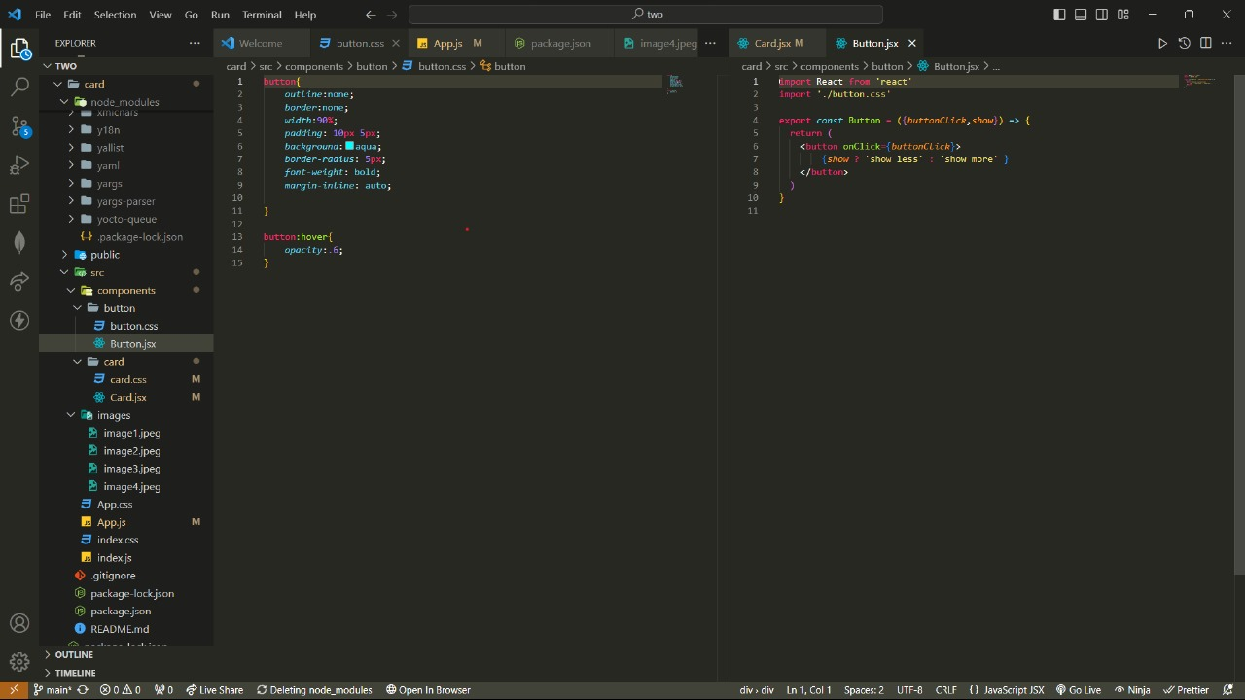

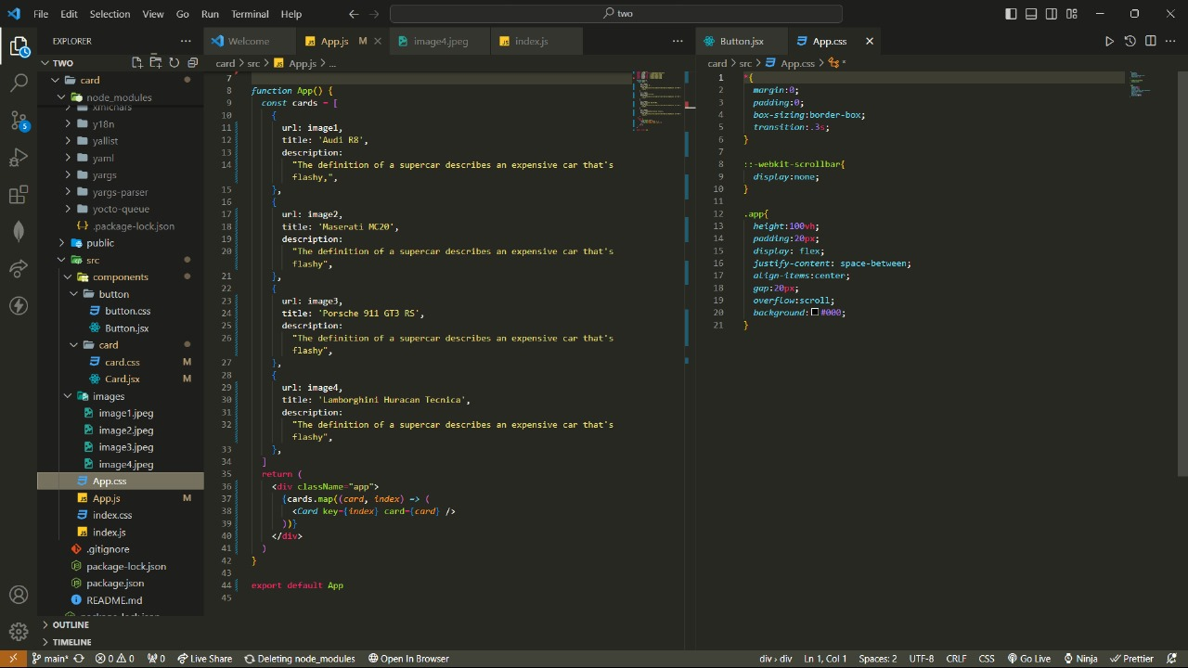

OUTPUT :

