Programming-1 (Outputs)
Southeast Missouri State University
CS634 Machine Learning
Instructor : Dr. Ziping Liu
Date : 09/01/2021

Group 10 (Members)
Naga Sai Charan Gubba (S02033804)
Sai Charan Reddy Kurella(S02035802)
Mounisha Nelluru(S02031713)
Soumya Kandela (S02029017)

1 Write a Python program to check a couple of email addresses and validate them. Then the program extracts the domain from the email.
Output

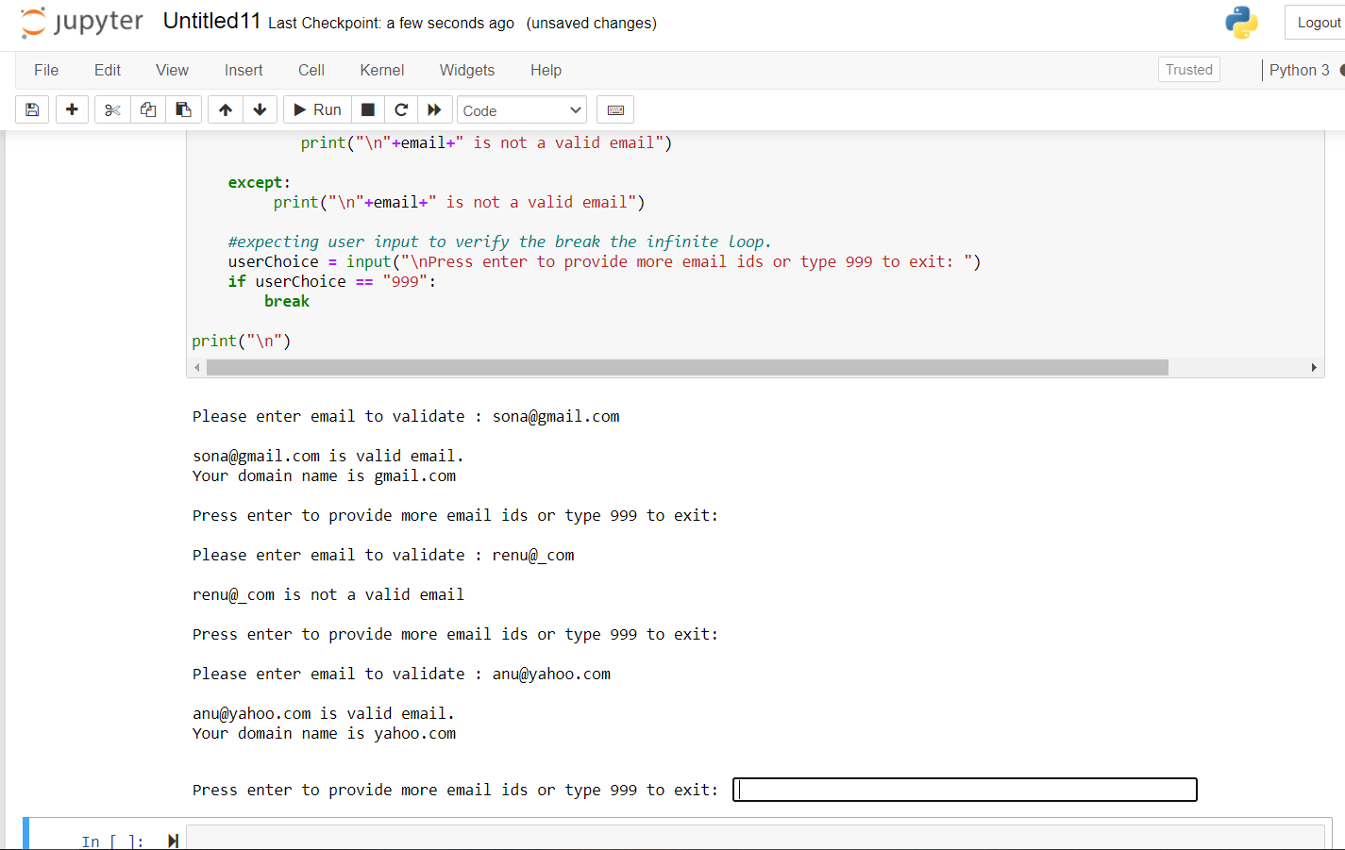

2 The open prices of SP500 between January 2, 2018, to January 16, 2018, are listed as following: 2683.72998,2697.850098,2719.310059,2731.330078,2742.669922,2751.149902,2745.550049,2752.969971,2770.179932,2798.959961
The close prices of SP500 between January 2, 2018, to January 16, 2018, are listed as following:
2695.810059,2713.060059,2723.98999,2743.149902,2747.709961,2751.290039,2748.22998,2767.560059,2786.23999,2776.419922
Write a Python program to assign the open prices and the close prices to two Python lists, calculate the daily earnings during that period and output them.
Write a Python function to calculate the mean of a numerical list(any Python math/statistics/numpyrelated package is not allowed).
Write a Python function to calculate the standard deviation of a numerical list(any Python math/statistics/numpy related package is not allowed).
Write a Python program to call the above two functions to calculate the mean and the standard deviation of the daily earnings for SP500 between January 2, 2018, to January 16, 2018, then output the mean and the standard deviation. Create a dictionary to store the daily earnings as one standard deviation of the mean, two standard deviations of the mean, three standard deviations of the mean, etc.
Output
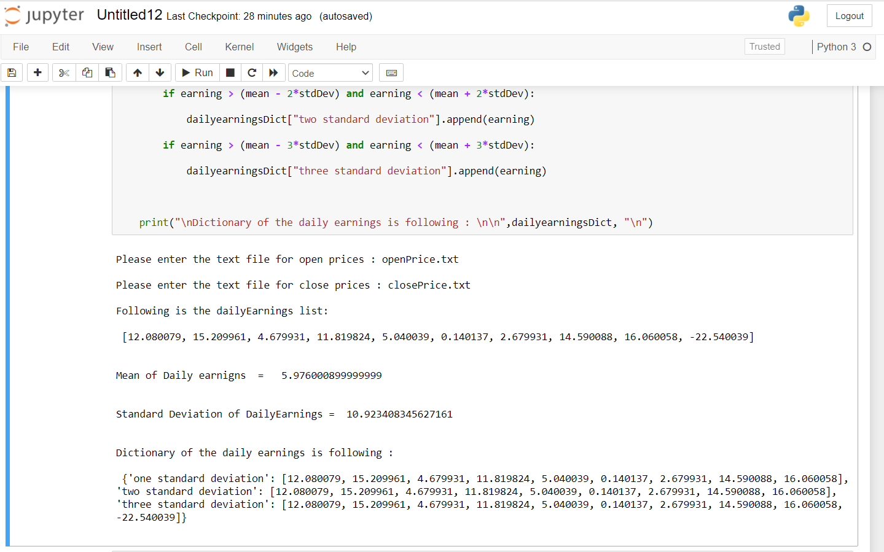
3. Write a Python program to remove tuple(s)which has certain given value from a list of tuples.

Output
