Alumni Testing

1.upload alumni gallery image not available, even after uploading the proper image.

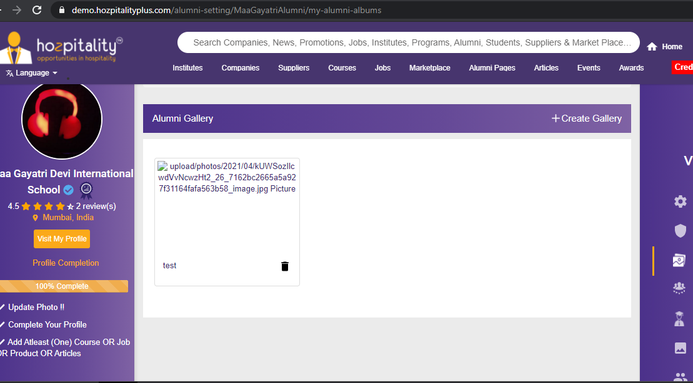

2.not able to add testimonial-**DONE**

3. tab highlighted not showing with active page-**DOne**

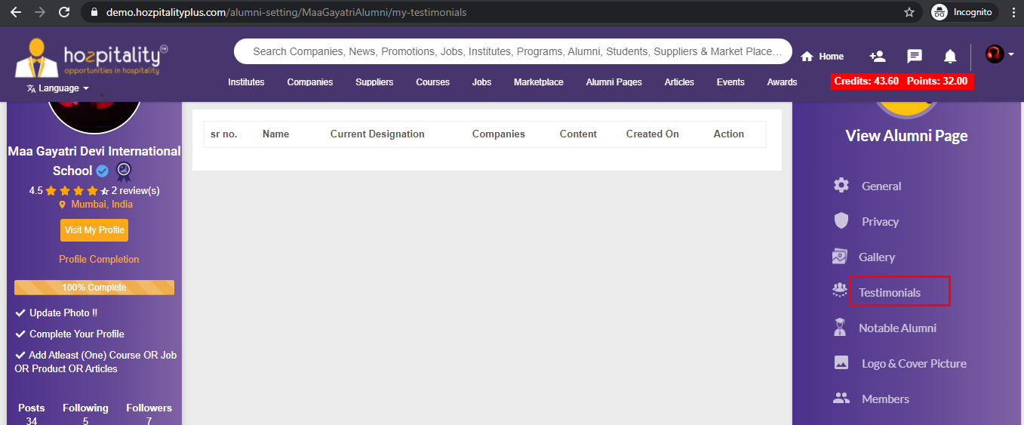

4.Image not getting uploaded

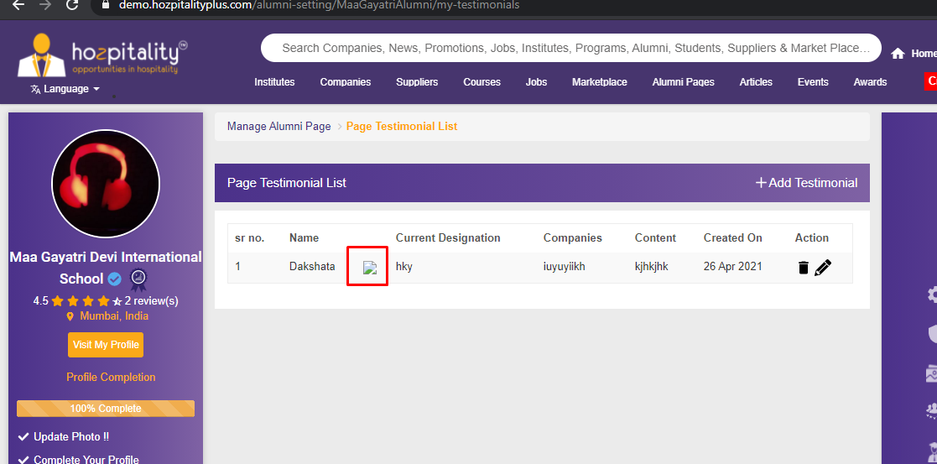

5. notable alumni image not getting uploaded.

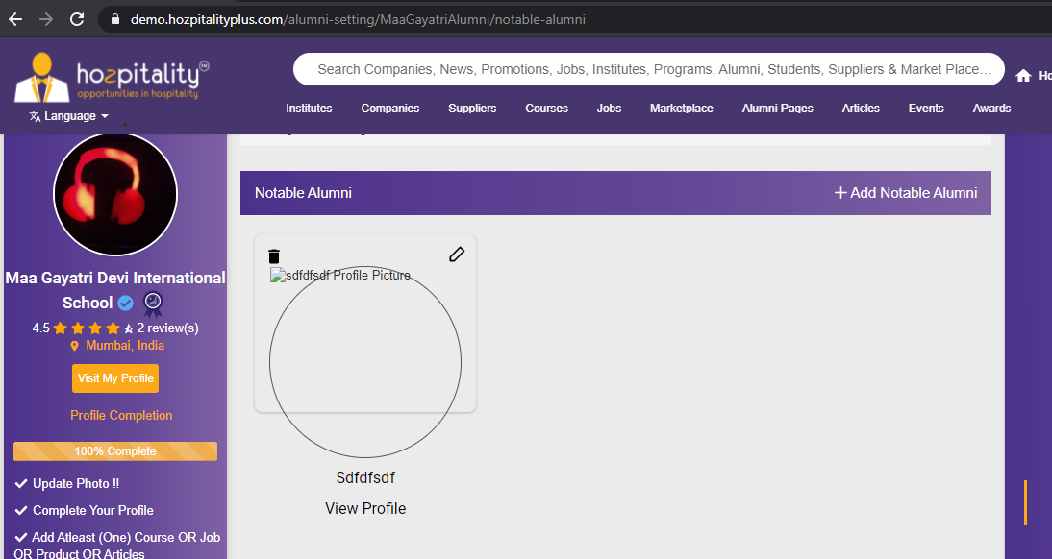

6. on click of testimonial, redirecting to 404 page**-Done**

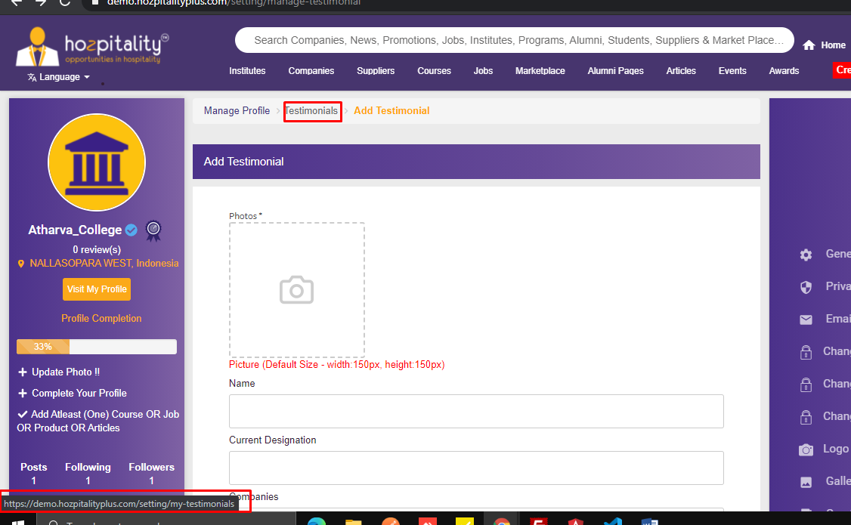

7. Plz add Gaps.-**Atithi**

https://demo.hozpitalityplus.com/my-network?lang=arabic

