Alumni Testing

1.upload alumni gallery image not available, even after uploading the proper image.

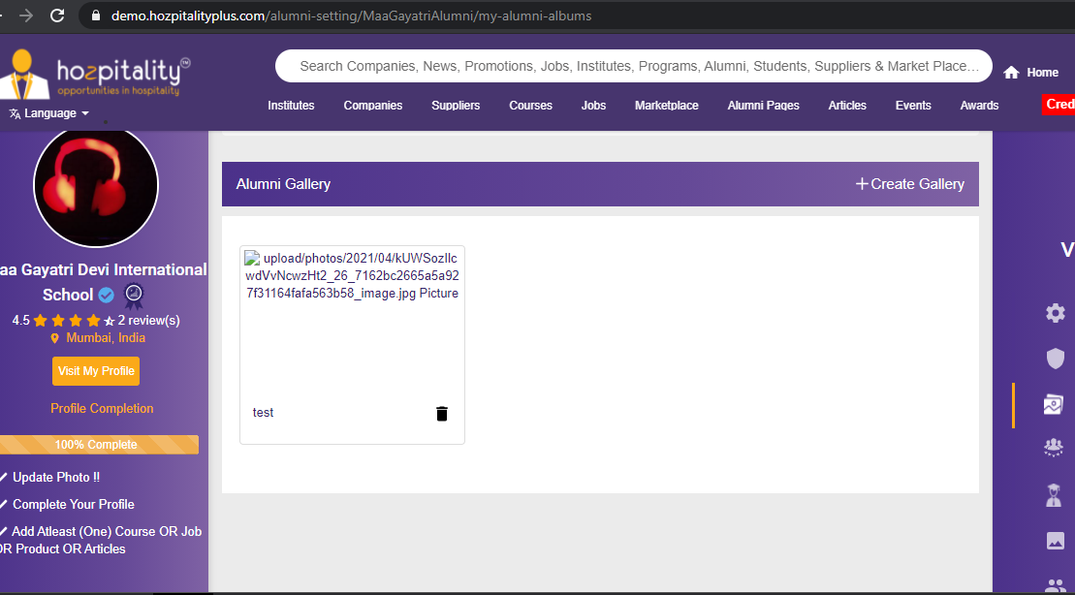

2.not able to add testimonial

3. tab highlighted not showing with active page

