List of Points which I need to be discussed with Bimal

Module: Files and Folder Module

1. If I want to show the list of files and folder of a parent folder using same library and js. So How can I do that in current code structure because I have done with data listing including files and folder against parent folder id. But while displaying it's shows me again parent folder record. I have created separate function as you (Bimal) told... in that function I am getting data into json format which I want but while loading the page. It is displaying because of Folder.js which runs on page load.

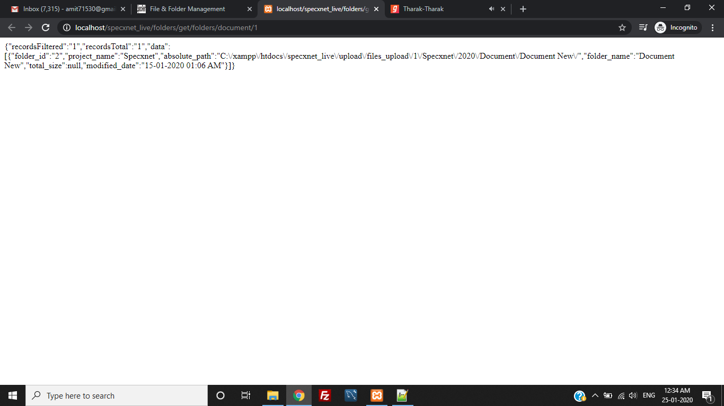

Data Received into JSON Format.

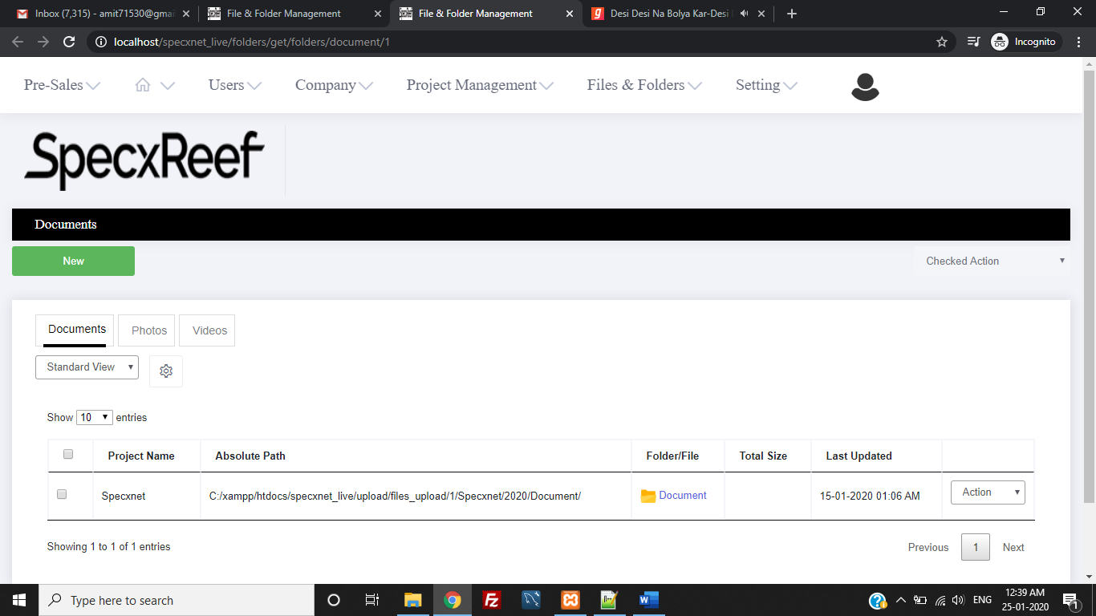

This is my parent folder record.

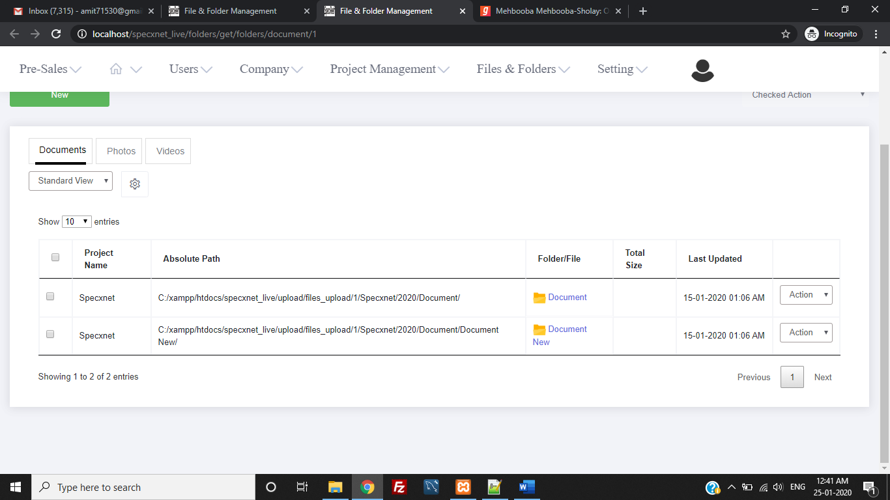

These are the two record which I have inserted into the table. I must display parent folder record different page and its content such as files and folder which needs to be display into separate page.

Into the above screenshot you will be able to see that there is two set of records. I have added Document New Folder Inside the Document Folder. When I will click on Document then It should show Document New details.