**Interface Changes**

Remove logo on left hand corner so more space.-**Done**

Remove the thick black Line so we can see more of the page. –**No required**

Change size of pop-up windows with forms etc. –**It changes according to form content changes**

Setting> Manage Dropdown.

Remove Division drop down b/c repetition with Department Dropdown. -**Done**

Company > Supplier > edit Supplier Company. -**Pending**

Under Additional Info, need to add company profile and catalog.

Users> internal Users> edit user> contact type.

Need to add email, phone, and mobile as drop-down option.-**DOne**

Users> internal Users> edit user>permissions tab.

* What does Neetu Soman mean?-**Removed**
* Get clarification of the meaning of all the different types of permissions.
* Diff between upload bid, upload bid admin and upload bid supplier.

Users> internal users> edit users. **-Pending**

Permissions for internal Users do not reflect once you select their role – should be set automatically depending on their role.

Presales >Lead Opportunity

* Change salesperson to “Lead Generated By”.-**Done**
* Projected Sales date to “Projected Contract date”-**Done**
* Confidence to “Conversion Probability”-**Done**
* Opportunity Title to “Opportunity Type”-**Done**
* Change Lead Opportunity to “Lead Inquiry”-**Done**

Users> internal Users> edit user> notification tab.

* Who gets the email notifications? The user being created or the admin internally?-**To the User**
* What does Job Access mean?-**Once the proposal is done on any project, the job shows the status of the project finalized to admin , and to who ever user we give access to.**

Setting > manage role > role management.

* A picture containing text

  Description automatically generatedCannot delete roles, able to select items but not able to delete.-**Done**
* Need to remove Sales Executive, Salesperson, Data Verifier, Production-**Done**

**Creating / Deleting Users**

Need to remove inactive users from list when deleted. -**Done**

When a user is deleted, cannot add the same contact info to create new user. Error message “invalid email format or email already exist” appears. -**DOne**

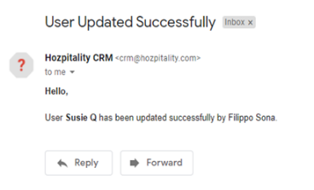

When creating new user contact information, email was sent to supplier that a user was created and was being updated, this should not happen b/c suppliers only need to know of jobs assigned to them/ be able to upload bids. **Pending**

When a new user is created and is invited via email:**Pending**

* the email goes to the junk folder in their email.
* the link leads to an invalid page
* username and password provided in the email also do not work “invalid username and password message.”