INTRODUCTION
In the past decade though whole genome sequencing is completed to analyse the genome due its vast requirement of memory for storing the genome while processing the genome to exploit the various properties of DNA. Now, with the introduction of Big Date it became easier to handle the date and many algorithms have been proposed for analysing the genome which led to detection that the tandem repeats play an important role in abnormality. If we can detect the abnormalities earlier and accurately it would aid for getting treatment which could save many lives.

DEOXYRIBONUCLEIC ACID (DNA) :
Deoxyribonucleic acid is molecule that contains the genetic instructions used in the growth, development, functioning and reproduction of all known living organisms and many viruses. It is made up of two strands called polynucleotides. Since they are made of simple monomers called nucleotides. Nucleotides are mainly made up of four components Adenine (A), Guanine (G), Cytosine (C) and Thymine (T).
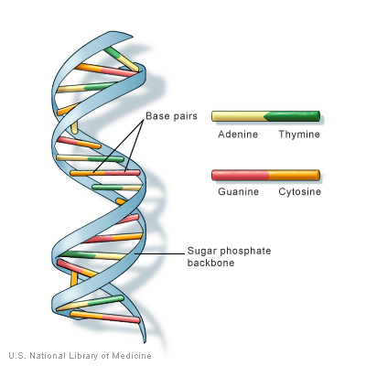
Fig. 1

TANDEM REPEATS:
Tandem repeats occur in DNA when one or more nucleotides are repeated and the repetitions are adjacent to each other.In most organisms, the bulk of the intergenic DNA is made up of repeated sequences. Repetitive DNA can be divided into two categories: interspersed repeats, where repeat units are distributed in the genome in an apparently random fashion, and tandem repeats, where repeat units are placed next to each other in an array. The functions of DNA repeats are still largely unclear, but, in recent years, it has been found that a number of tandem repeats are related to diseases and play an important role in gene regulation.
Next-generation sequencing (NGS) machines do not read out an entire genomic template. Instead, they produce short random fragments of nucleotide sequences known as sequence reads. A quality score, expressing the confidence that a particular nucleotide has actually been found at a specific location, is associated with each nucleotide in a sequence read. This raw sequencing data generated by NGS machines is commonly stored in FASTQ files. Recently, several tools for FASTQ compression have been developed, which – without performing any kind of internal alignment or assembly – are approaching the Kolmogorov complexity. FASTQ data can be aligned with tools such as BWA , SAMtools or Bowtie2. Subsequently, the data is stored in Sequence Alignment/Map (SAM) format files which, compared to FASTQ files, contain the alignment/mapping information as well as additional meta data. Mapped sequencing data represented in SAM files contains more redundancy, as multiple sequence reads are typically mapped to the same location on the donor genome. The average amount of reads mapping to the same location is referred to as coverage.

VARIABLE NUMBER TANDEM REPEATS
Is a location in an genome where a small nucleotide is organised as a tandem repeat. They often show variations in length among each individual.

CLASSIFICATION
Instead of processing the genome sequence which is made of millions of base pairs it would be better if it is processed once the repetitive parts are removed which would increase efficiency in both time and cost.

PROBLEM STATEMENT
Though human genome is more than 99 percent common in all humans the current available methods of processing biological data reprocess the complete sequence (on average of 3 million base pairs) each time. Human analysis of the genome is more error prone.

OBJECTIVE
When processing the data it is enough to consider only the parts of genome that has changes when compared to reference genome. Integration of intelligence in order to analyse the genome in order to find any abnormalities.

