**CONTOSO FINAL DATA INTEGRATION AND BUSINESS INTELLIGENCE PROJECT**

**By:-**

**TEAM 01 SECTION02**

**Kishore Kumar Mohan**

**Sowmiya Dayalan**

**Arvind Venkatasubramanian**

**TALEND JOB**

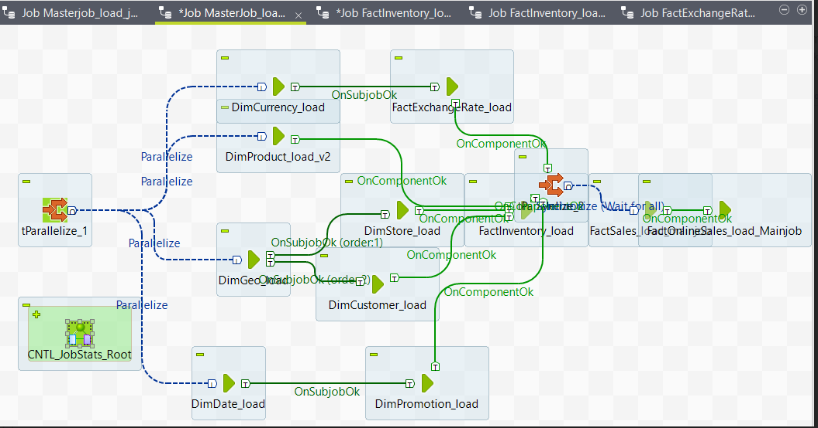

**ONLINE SALES**

Sales & Profit By Customer Education

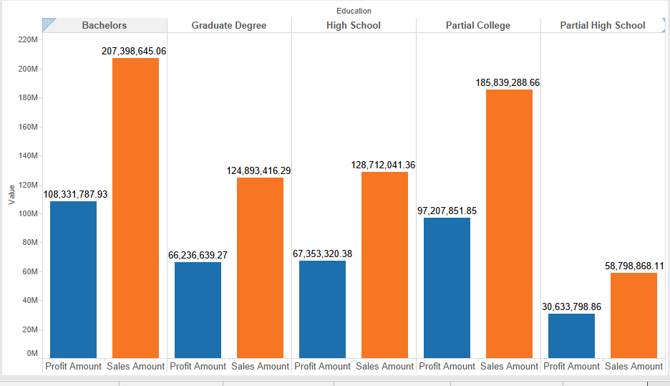

Sales & Profit By Customer Gender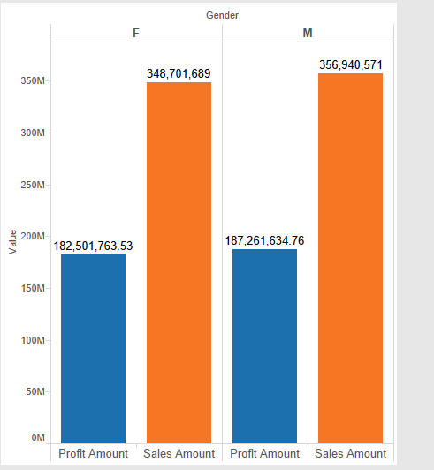

Sales & Profit By Period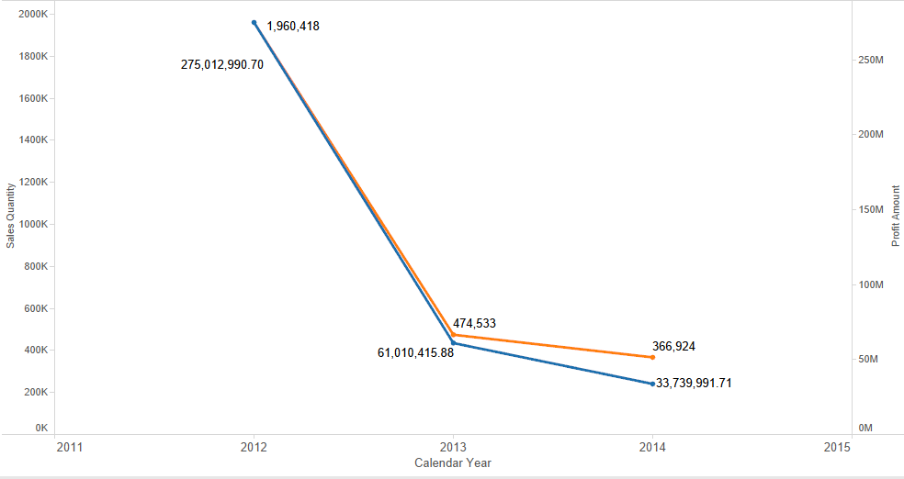

Top 20 Customer By Sales

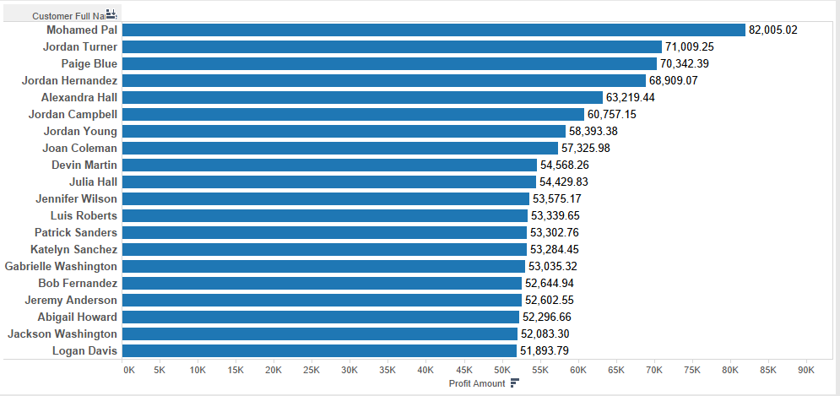

Contribution Analysis By PC

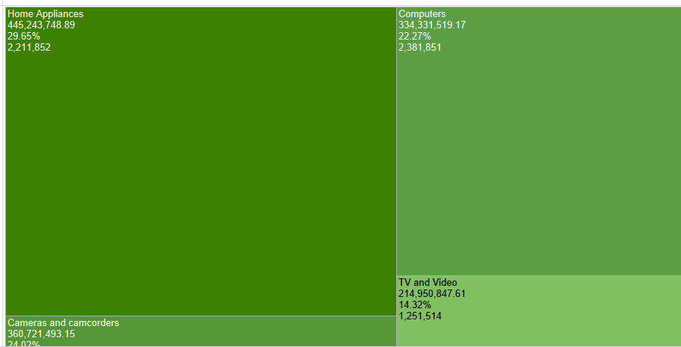

Top Selling ProductByGeo

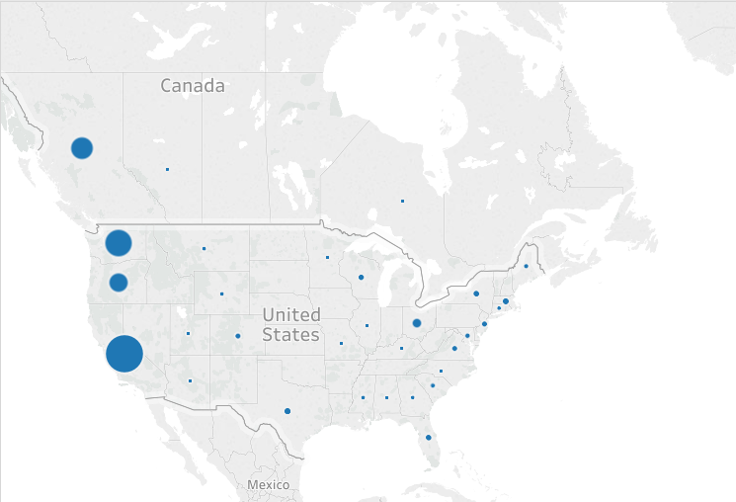

YearlySalesByPromotion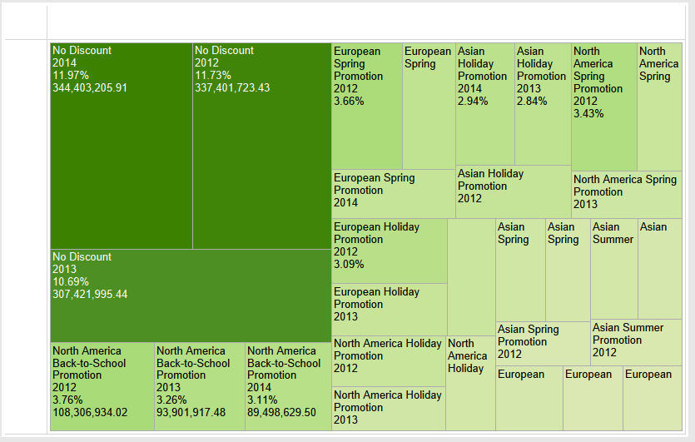

**Inventory Sales**

Inventory Cost By Time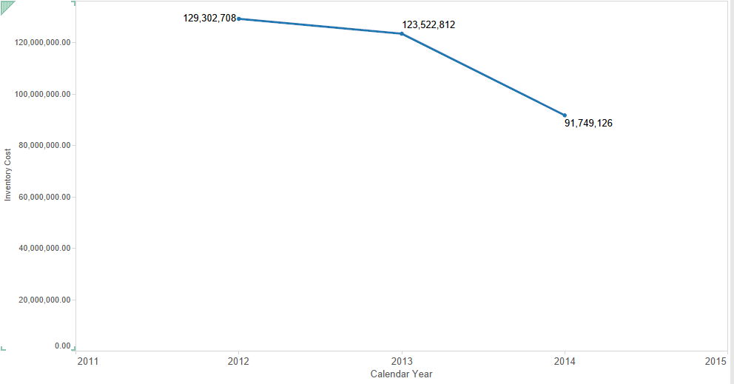

Inventory Cost By Product Category

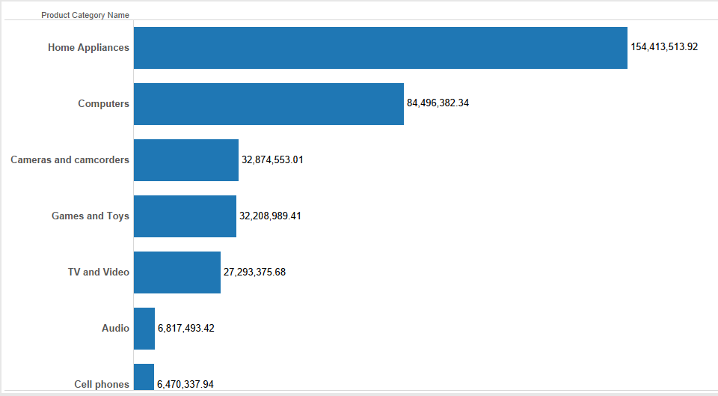

Inventory Cost By Product Sub Category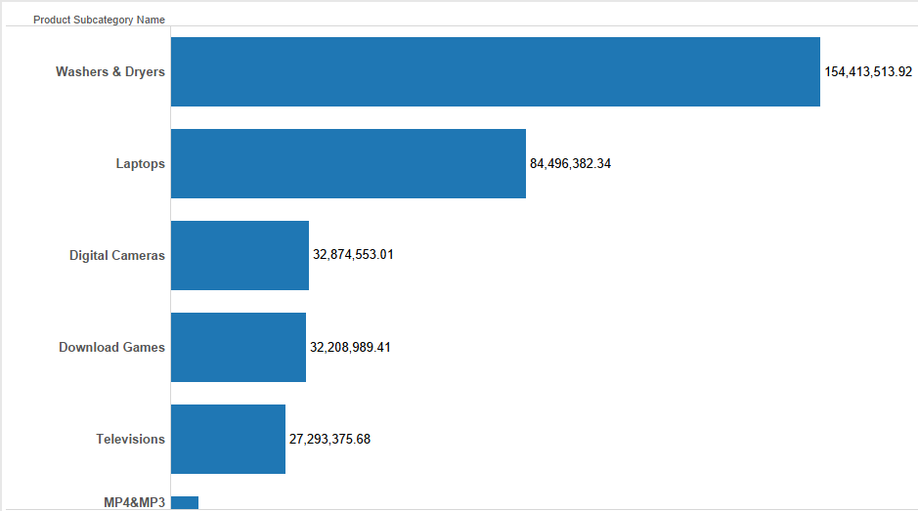

Inventory Cost By Country

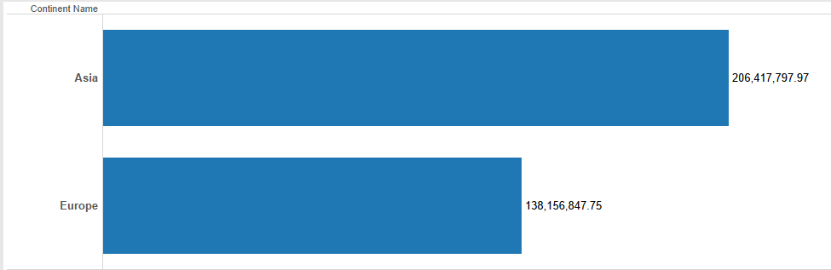

Inventory Cost By State

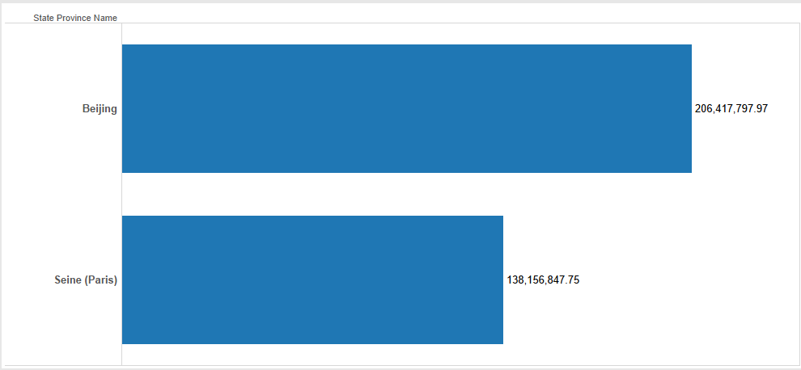

Inventory Cost By Store

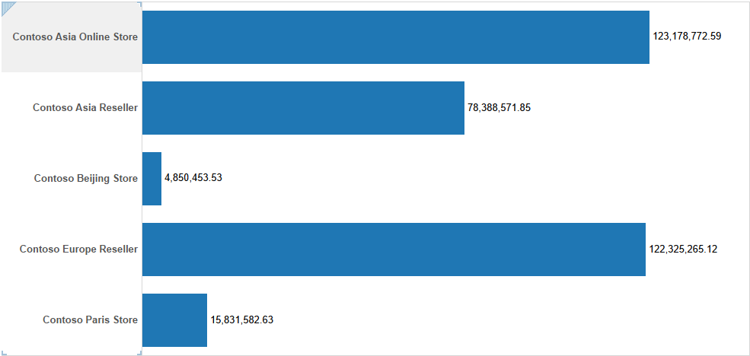

Product Contribution on Inventory Cost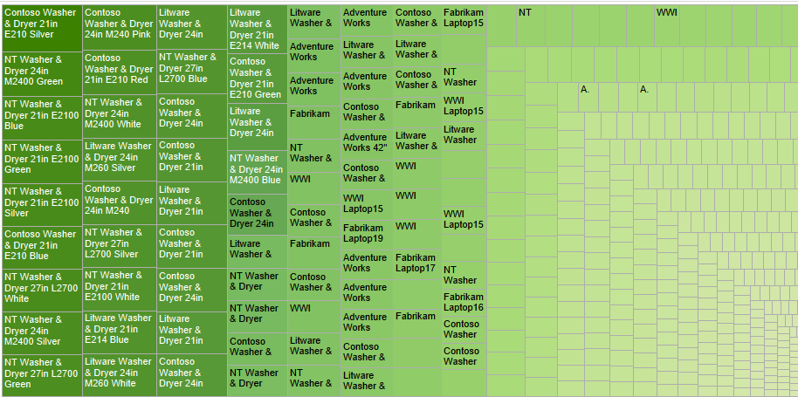

Store Contribution on Inventory Cost

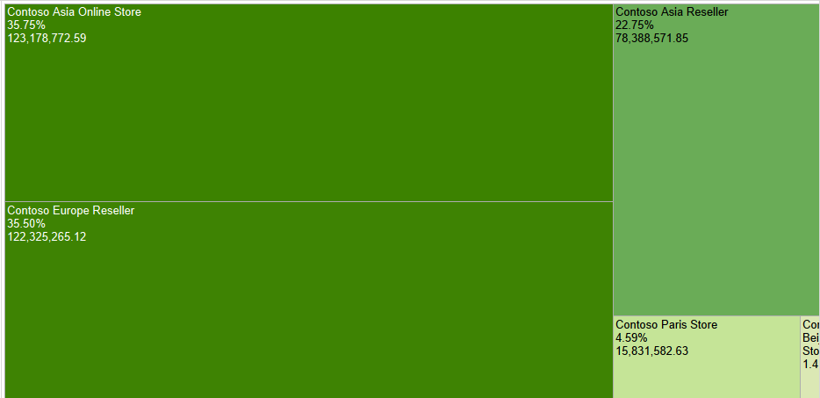

Geo Sales Analysis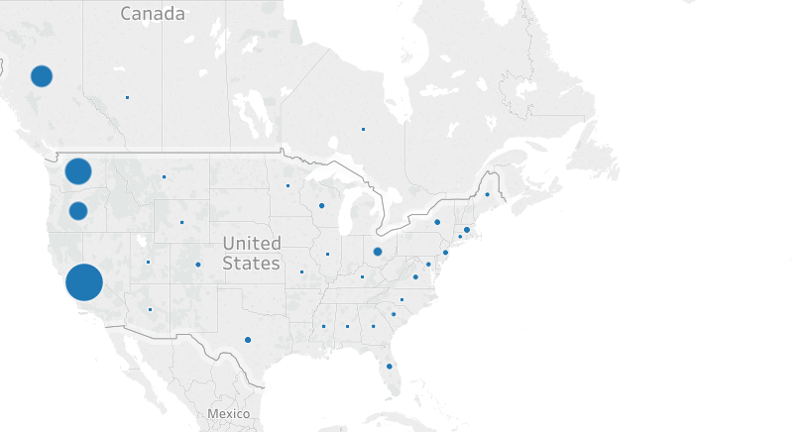

**SALES**

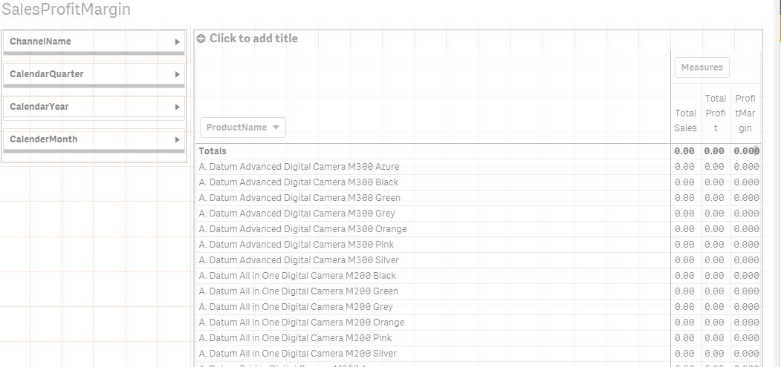

**RANK SALES**

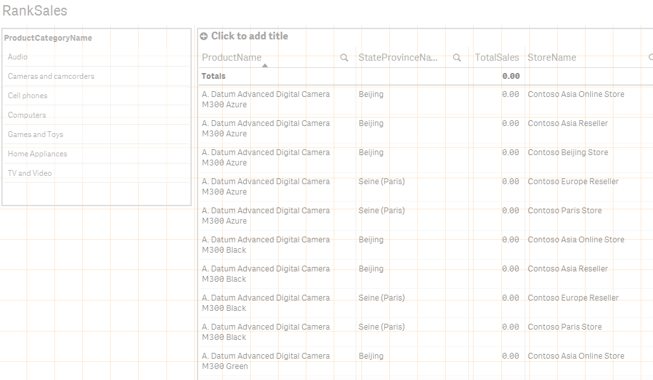

RANK SALES

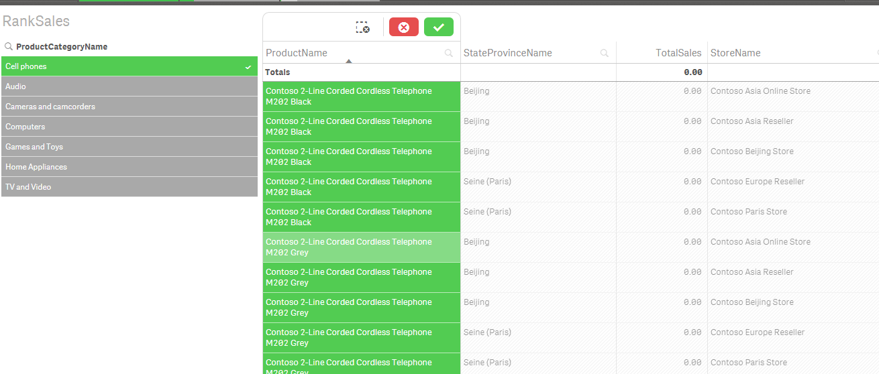

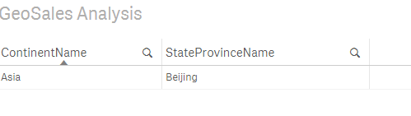

CONTRIBUTION ANALYSIS

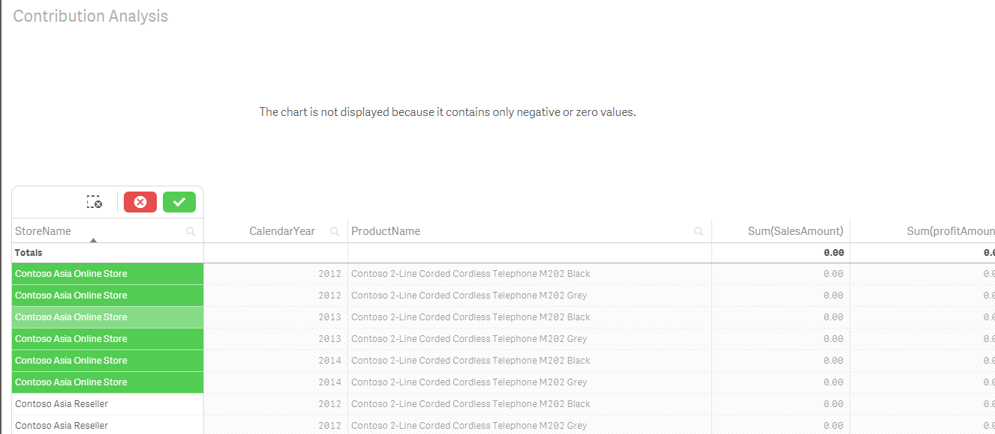

Differences between 3 BI tools used

|  |  |  |  |
| --- | --- | --- | --- |
| Tool | Qlik Sense | Tableau | Power BI |
| Advantage | a. In Memory b. Experienced better Drill down to the lowest Granularity due to UI programming | a. Good UX for a better and simpler programming experience. B. Easier to create calculated facts and measures for data manipulation | a. Better option for Slicing and dicing of the data. B. Easily represented with the ER and relationship models. |
| Disadvantage | Issues while adding data as it kept creating new synthetic keys for itself explicitely. | Could not find the option to write Custom SQL | Does not provide a good and beautiful presentation |