BrightEdge: Execution Ste[s

Simple steps to execute the exe file.

Note:- The code was in Python 3.6.0. There are very little exe packaging tools for this version. Hence, I had to package all the libraries in my Python environment to ensure that it gets all the files.

**Step 1**:

Unzip the folder

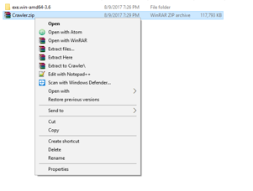

**Step 2:**

Open the folder

**Step 3:**

Once opened, Navigate to crawler.exe

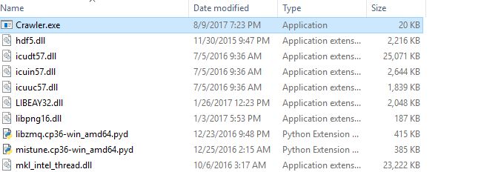

**Step 4:**

Double click and open the exe file

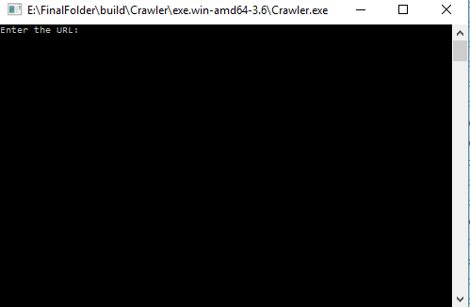

**Step5:**

Enter the URL and Press Enter

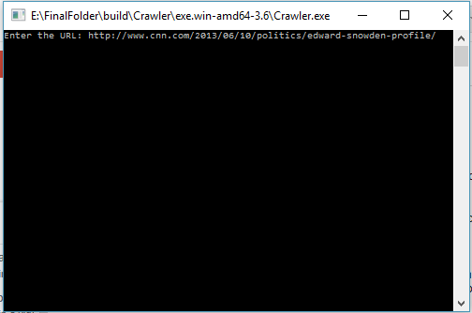

**Step 6:**

Check the results

