BrightEdge: Software Coding Challenge

This document is a technical design document for the BrightEdge software challenge taken by Arvind Venkatasubramanian.

1. Introduction

BrightEdge is one of the key players in the Search Engine Optimization industry. One of the key challenges that is faced is to crawl a particular web page and identify its relevancy. Big and powerful search engines perform web crawling where they go around the web searching for pages and the ones are visited are marked as ‘visited’. To optimize their search, they have also started classifying the pages based on the content, to easily identify and filter out results based on key search terms.

This coding challenge was to take any URL as a user input and identify its relevant key terms which will help identify that particular page. This relevance index are the different key terms, which can be used as a ‘key word’ while searching. The better the relevance, the better will be the search results.

2. Architecture Design

The requirements of the development of this project were to take a user URL input, and provide the most relevant text in those URL. The relevant text are to be returned as a list.

For this phase, we have used Python and its rich libraries to perform the crawling and the cleaning functions.

3. Steps

- Take a user Input as a URL
- Verify if that is a valid URL or not.
- Use the python library BeautifulSoup to crawl the data from the webpage. BeautifulSoup returns a soup, which contains all the HTML tags and the raw HTML of the page.
- Clean the raw HTML tags and take only the content.
- Split the raw HTML input into lines
- Using NLTK library, clean the punctuation marks and the stop words. Also stem the words to get the correct values.
- Get the most frequently mentioned words in the text.
- The highest mentioned words in the texts are rated as the most relevant for search optimization.

4. Unit Testing

TEST 1:
When the input URL in invalid
Input: asdsaaasd
Expected Result: The code should throw an error
Actual Result: ERROR
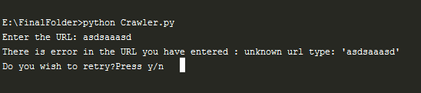
Status : PASSED

TEST 2:
When the input URL is incorrect
Input: http://blog.rei.com/camp/how-to-introduce-your-indoorsy-friend-to-the-
Expected: The code should throw a 404 error
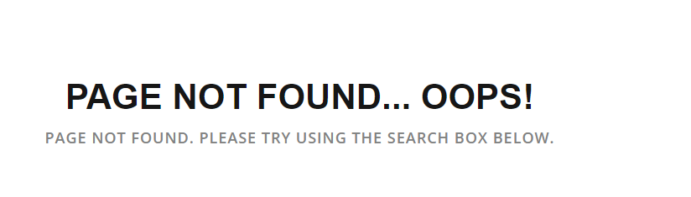

Actual Result:
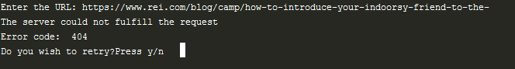
Status: PASSED
TEST 3:
When the network is not working (Connectivity issue)
Test Data: http://www.cnn.com/2013/06/10/politics/edward-snowden-profile/
Expected Result: Connection Issue
Actual Result:
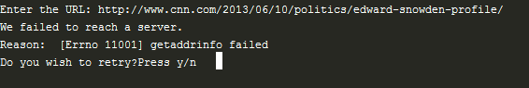
Status: PASSED

5. OUTPUT

- Input:

http://www.amazon.com/Cuisinart-CPT-122-Compact-2-Slice-Toaster/dp/B009GQ034C/ref=sr_1_1?s=kitchen&ie=UTF8&qid=1431620315&sr=1-1&keywords=toaster

Output:

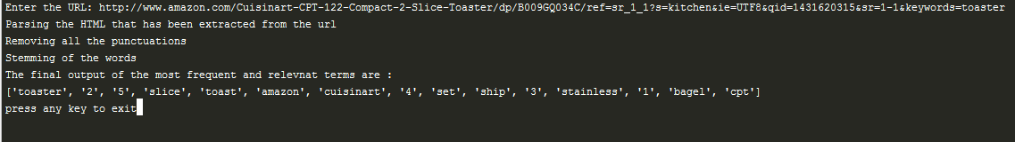

['toaster', '2', '5', 'slice', 'toast', 'amazon', 'cuisinart', '4', 'set', 'ship', '3', 'stainless', '1', 'bagel', 'cpt']

- Input:

http://blog.rei.com/camp/how-to-introduce-your-indoorsy-friend-to-the-outdoors/

Output:

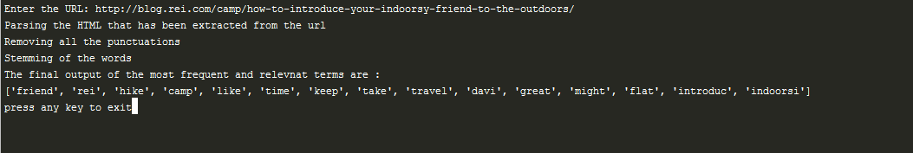

['friend', 'rei', 'hike', 'camp', 'like', 'time', 'keep', 'take', 'travel', 'davi', 'great', 'might', 'flat', 'introduc', 'indoorsi']

- Input:

http://www.cnn.com/2013/06/10/politics/edward-snowden-profile/

Output:

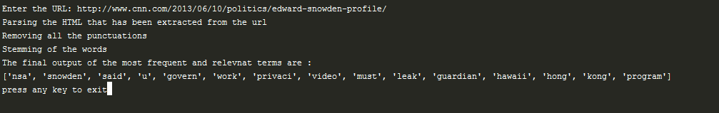

['nsa', 'snowden', 'said', 'u', 'govern', 'work', 'privaci', 'video', 'must', 'leak', 'guardian', 'hawaii', 'hong', 'kong', 'program']

6. References

- https://docs.python.org/
- https://github.com/charlieg/A-Smattering-of-NLP-in-Python/blob/master/A%20Smattering%20of%20NLP%20in%20Python.ipynb
- https://zhiyu-chen.gitbooks.io/notes-of-nlp-with-python-/content/stemmer.html

