ASSIGNMENT 11.1

This assignment was completed mainly by following the steps in the blog https://acadgild.com/blog/streaming-twitter-data-using-flume

But the problem with above blog is the twitter agent does not filter based on keywords. So, the following blog was referred to https://www.eduonix.com/blog/bigdata-and-hadoop/flume-installation-and-streaming-twitter-data-using-flume/

But there were some changes which were done. The detailed steps followed by me are listed below:

1. Create a Twitter App:
The steps for the same are already given in the above two links. The consumer key, consumer secret, access token and access token secret were noted down

2. Download flume tarball

3. Untar the tarball.
A folder called apache-flume-1.7.0-bin is created. Let us call this FLUME_HOME

4. Build the flume-sources jar
We can use the standard TwitterSource class which ships with Flume but the problem is it does not filter based on keywords. Therefore, we will use the Cloudera Twitter flume source. To build it , follow these steps:
a. download maven
b. Navigate to https://github.com/cloudera/cdh-twitter-example in your web browser
c. Click Clone or download -> Download as Zip
d. unzip the downloaded zip
e. Navigate to the cdh-twitter-example-master\flume-sources directory
f. Open the pom.xml and add the following XML snippet inside the plugins tag
<plugin>
<groupId>org.apache.maven.plugins</groupId>
<artifactId>maven-dependency-plugin</artifactId>
<version>3.0.1</version>
<executions>
<execution>
<id>copy-dependencies</id>
<phase>package</phase>
<goals>
<goal>copy-dependencies</goal>
</goals>
<configuration>
<outputDirectory>${project.build.directory}/lib</outputDirectory>
<overWriteReleases>false</overWriteReleases>
<overWriteSnapshots>false</overWriteSnapshots>
<overWriteIfNewer>true</overWriteIfNewer>
</configuration>
</execution>
</executions>
</plugin>
g. In the pom.xml, for maven-compiler-plugin chnage the source and target java versions to the one you are using in your system
h. Change the dependency version for twitter4j-stream to the most recent one (as of now it is 4.0.4)
i. Save the pom.xml (modified pom.xml is included in the assignment under the conf folder)
j. From the cdh-twitter-example-master\flume-sources directory, run mvn clean install
k. Copy the flume-sources-1.0-SNAPSHOT.jar from the cdh-twitter-example-master\flume-sources\target directory and twitter4j-core-4.0.4.jar and twitter4j-stream-4.0.4.jar from cdh-twitter-example-master\flume-sources\target\lib directory to a temporary directory say tmp

4. Delete unwanted JARs
Navigate to FLUME_HOME/lib and delete twitter4j-core-3.0.3.jar, twitter4j-media-support-3.0.3.jar and twitter4j-stream-3.0.3.jar

5. Copy the flume-sources JAR and its dependencies
Copy the jars from tmp to FLUME_HOME/lib (These JARs are included with the assignment solution in the lib directory)

6. Configure flume
Navigate to FLUME_HOME/conf and paste the following contents in flume-conf.properties(The flume-conf.properties file is included with this assignment in the conf folder)

TwitterAgent.sources = Twitter
TwitterAgent.channels = MemChannel
TwitterAgent.sinks = HDFS

# Describing/Configuring the source
#TwitterAgent.sources.Twitter.type = org.apache.flume.source.twitter.TwitterSource
TwitterAgent.sources.Twitter.type = com.cloudera.flume.source.TwitterSource
TwitterAgent.sources.Twitter.consumerKey=XXXX
TwitterAgent.sources.Twitter.consumerSecret=XXXX
TwitterAgent.sources.Twitter.accessToken=XXXX
TwitterAgent.sources.Twitter.accessTokenSecret=XXXX
TwitterAgent.sources.Twitter.keywords=hadoop, bigdata, mapreduce, mahout, hbase, nosql

TwitterAgent.sinks.HDFS.channel=MemChannel
TwitterAgent.sinks.HDFS.type=hdfs
TwitterAgent.sinks.HDFS.hdfs.path=hdfs://localhost:19000/user/arvind/flume/acadgild/assignment_11.1/output/tweets
TwitterAgent.sinks.HDFS.hdfs.fileType=DataStream
TwitterAgent.sinks.HDFS.hdfs.writeformat=Text
TwitterAgent.sinks.HDFS.hdfs.batchSize=1000
TwitterAgent.sinks.HDFS.hdfs.rollSize=128000
TwitterAgent.sinks.HDFS.hdfs.rollCount=200
TwitterAgent.sinks.HDFS.hdfs.rollInterval=600

TwitterAgent.channels.MemChannel.type=memory
TwitterAgent.channels.MemChannel.capacity=10000
TwitterAgent.channels.MemChannel.transactionCapacity=1000

TwitterAgent.sources.Twitter.channels = MemChannel
TwitterAgent.sinks.HDFS.channel = MemChannel

Change the various parameters as per your requirement. The consumerKey, consumerSecret, accessToken and accessTokenSecret are the ones which we noted down in step 1 while creating the twitter app.

7. Create the directory in HDFS where the Twitter feeds are going to be stored
Start HDFS and create the directory mentioned in the flume-conf.properties as the property TwitterAgent.sinks.HDFS.hdfs.path
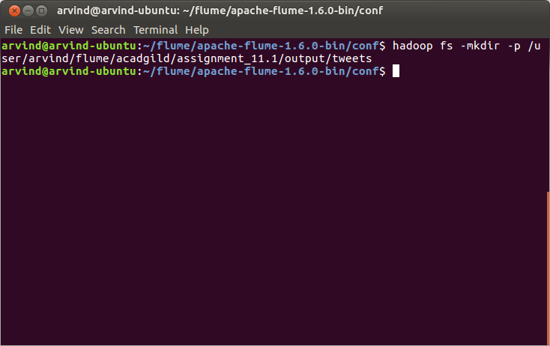
8. Run the flume-agent:
- Run the flume agent using the followgin command:
flume-ng agent -n TwitterAgent -f flume-conf.properties
- Allow the agent to run for some time.

9. Open a browser window and hit http://localhost:50070 and navigate to Utilities -> Browse the file system
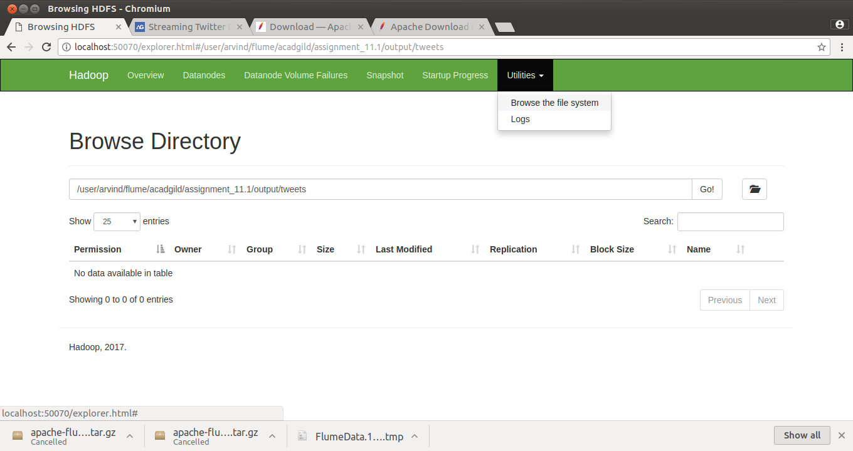
10. In the text box, enter the path which you had specofoed in the flume-conf.properties and click Go. You should be able to see some files (the same has been included in the assignment inside the output folder)
