ASSIGNMENT 12.3
Spark was not installed in Acadgild VM. So following steps were followed to install the same:

1. Open a web browser and navigate to google.com and type Apache Spark download
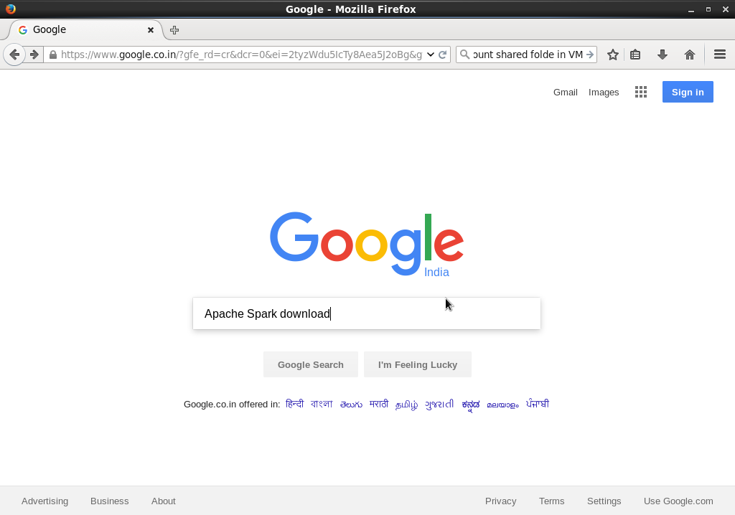
2. Click the first link which appears in the search results
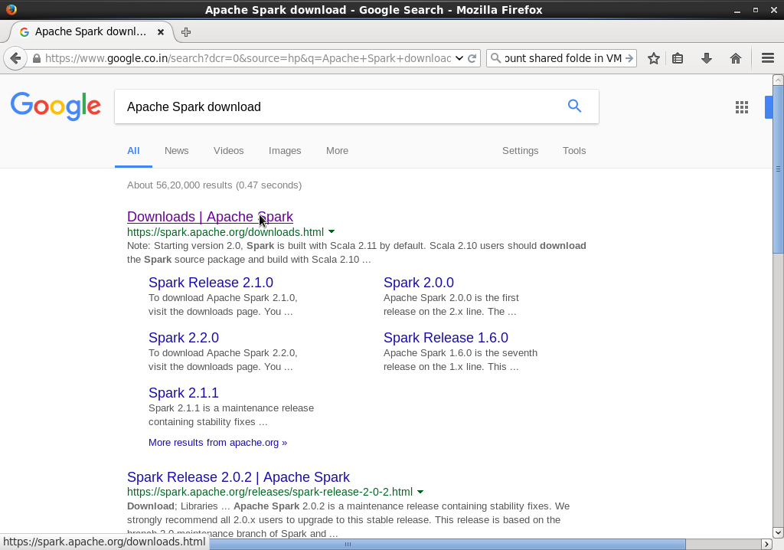

3. In the Spark downloads page, in the Choose a package type dropdown, select Pre-built for Apache Hadoop 2.6
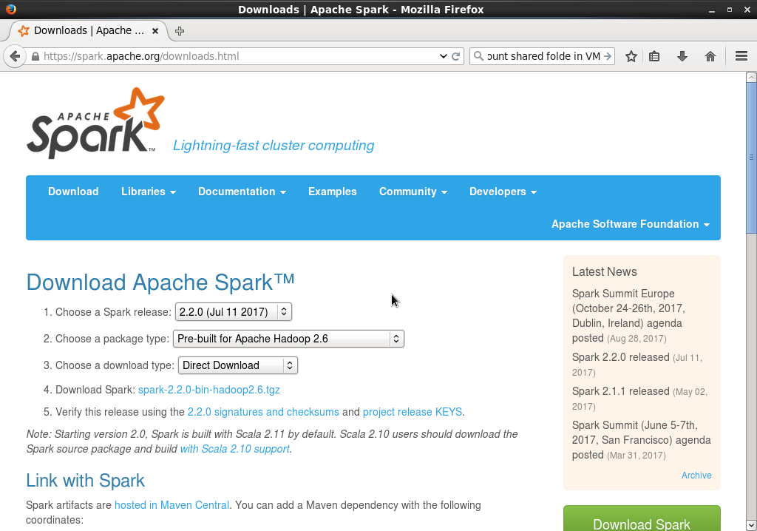
4. Right click the Download Spark link and in the popup menu, click Copy Link Location
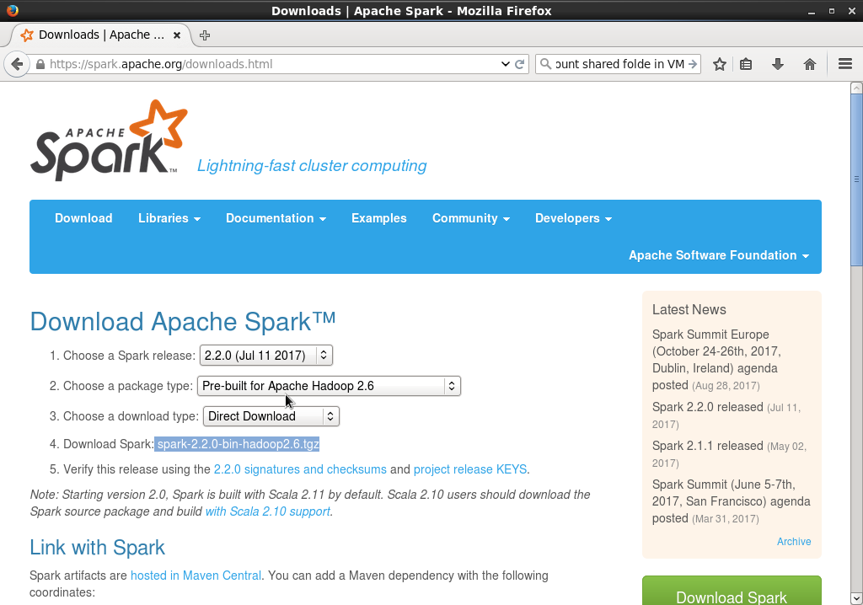

5. Open a terminal and navigate to /usr/local using the command:
cd /usr/local
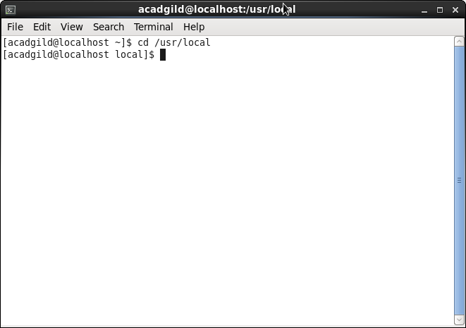
6. Create a directory called spark using the command
sudo mkdir spark
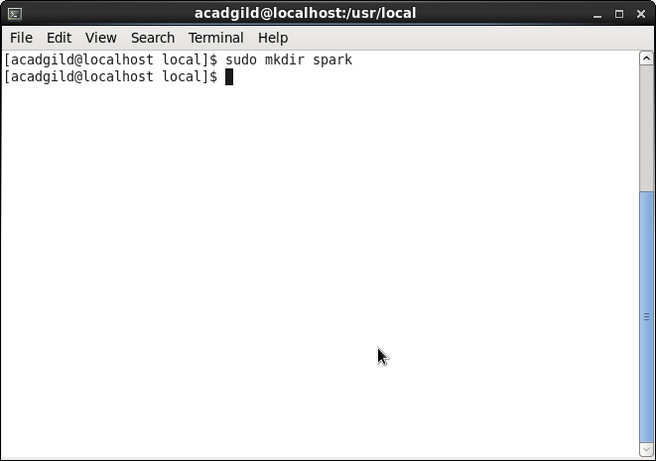
7. The directory spark created in step 6 was created using the sudo command. Therefore the owner and group are root and root respectively. We need to change the owner and group to acadgild and acadgild respectively. To do that run the following commands
sudo chown -R acadgild
sudo chgrp -R acadgild

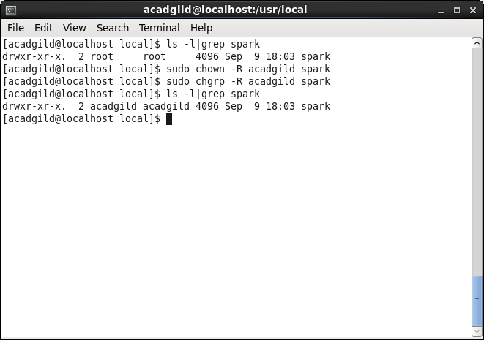
8. Navigate into the spark directory using the command:
cd spark

9. Now to download Spark, run wget command with the link copied in step 4 as follows(the download will take some time depending on your internet bandwidth):
wget <link_copied_in_step_4>

In my case it was:
wget https://d3kbcqa49mib13.cloudfront.net/spark-2.2.0-bin-hadoop2.6.tgz

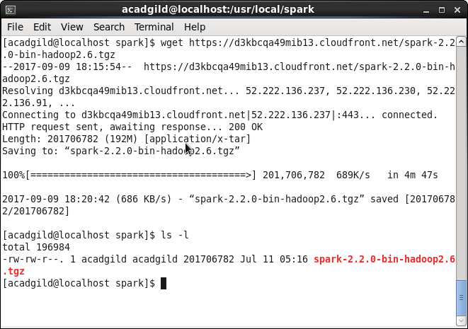

10. Untar the downloaded tar file using the command:
tar xvzf spark-2.2.0-bin-hadoop2.6.tgz
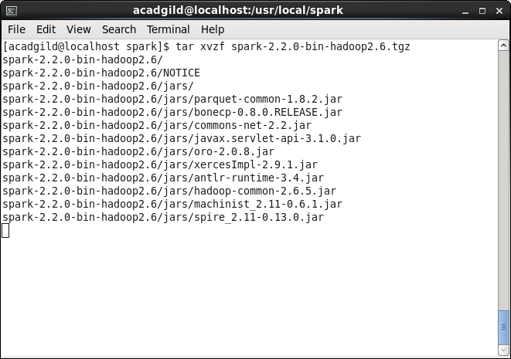
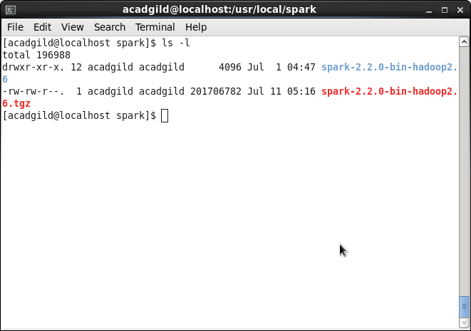

11. Delete the tar file using the command:
rm spark-2.2.0-bin-hadoop2.6.tgz
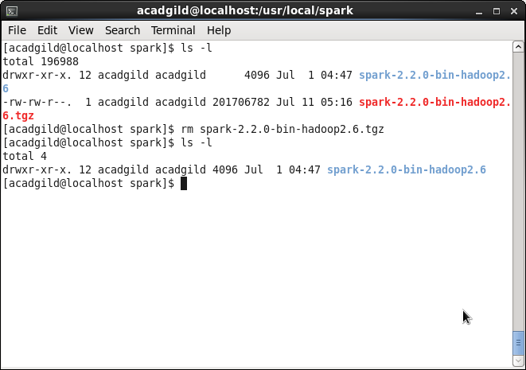
12. Navigate into the untar-ed directory using the command:
cd spark-2.2.0-bin-hadoop2.6/

And also check if the contents of the directory are as shown in the screenshot
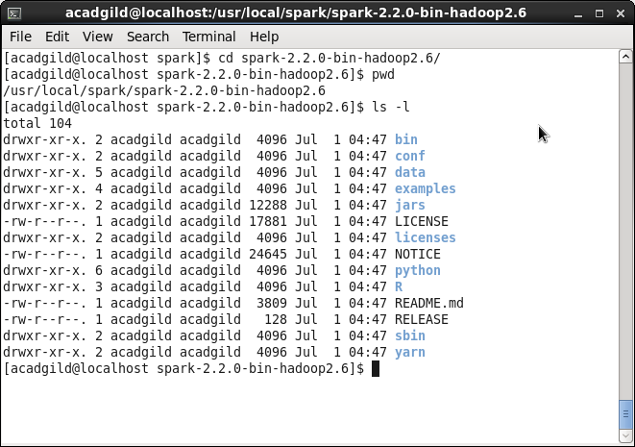

13. Let us call the directory in which we are currently as SPARK_HOME. Type pwd to know the current directory. Copy the output of the command and keep it in some place.

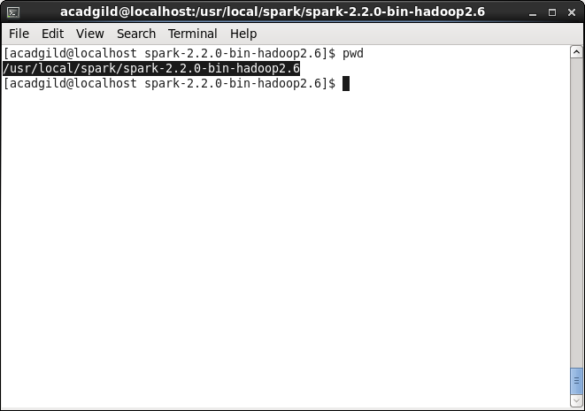
14. Navigate to the home directory using the command cd or cd ~
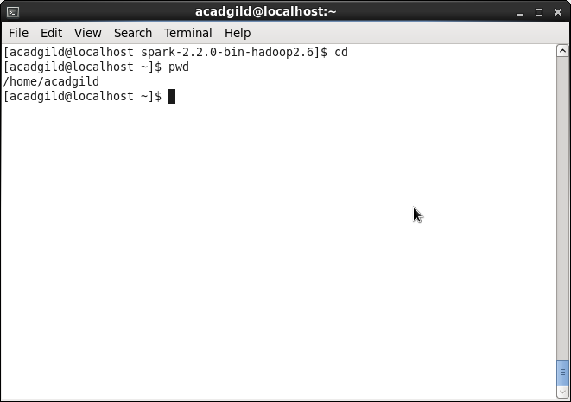

15. Open .bashrc for editing using vi .bashrc
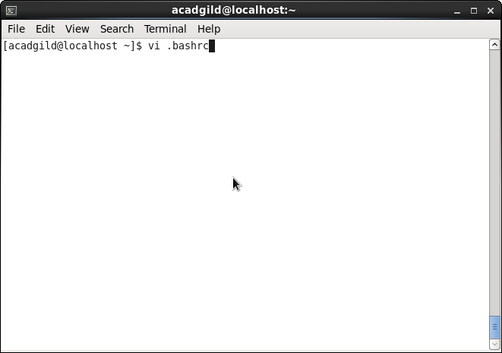
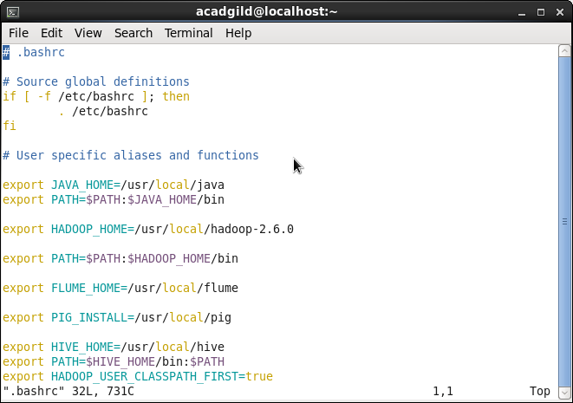

16. Press 'i' to edit the file and add/modify the following lines as shown in the following screenshots(these lines define SPARK_HOME as an environment variable, add SPARK_HOME/bin and SPARK_HOME/sbin to the PATH environment variable and define aliases for start-all.sh and stop-all.sh which are present inside the SPARK_HOME/sbin folder)
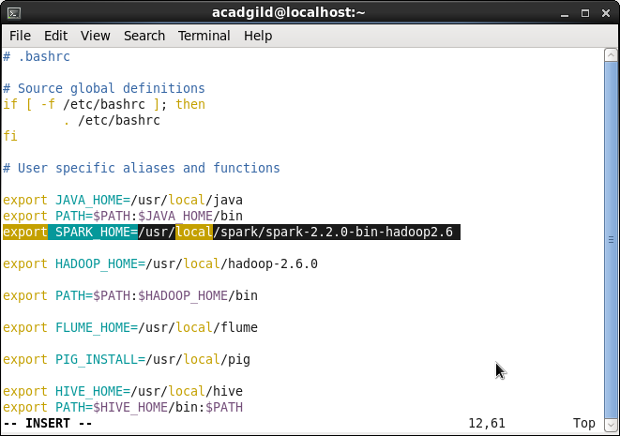
Note: You will get the value of SPARK_HOME from step 13

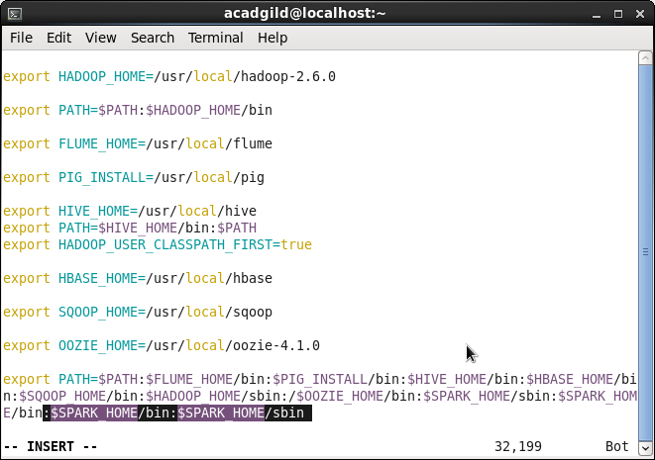

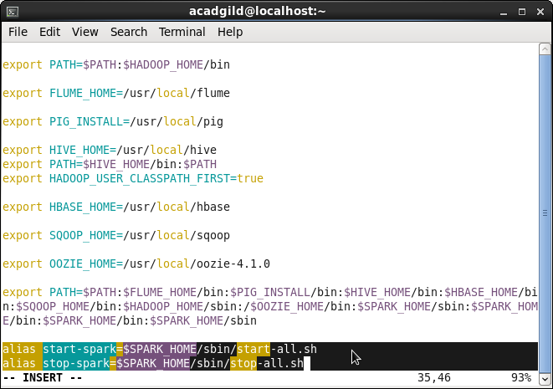

17. Press Esc to come out of the insert mode in vi. And then type :wq and hit Enter to save the file and quit vi

18. Since we have made changes in .bashrc file, the changes would be reflected only when the user logs out and logs in again. You may logout and login again.

Alternatively run the following command(in this case the environment variables will be loaded only for the current terminal session):
source ~/.bashrc

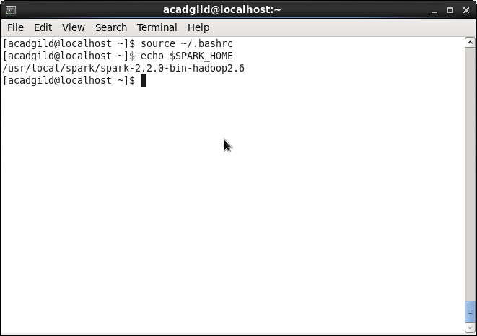
19. Start spark daemons using start-spark alias
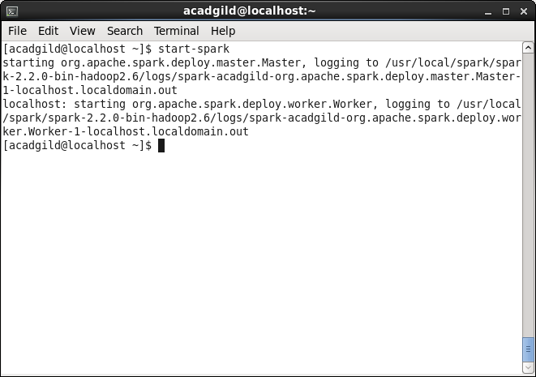

20. Verify whether Spark daemons are running using the command:
jps
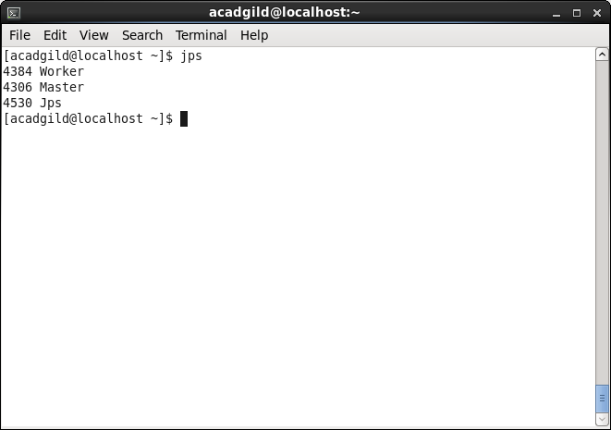
21. To stop Spark daemons use stop-spark alias
