ASSIGNMENT 13.2

This assignment has two tasks

Task 1: Create a simple pairRDD of (1, 2), (3, 4), (3, 6)

Following steps were performed to complete this assignment(It is assumed that Spark is already installed and there is an environment variable called SPARK_HOME whose value is the path to the directory where Spark is installed)

1. Navigate to SPARK_HOME/sbin using the command:
cd $SPARK_HOME/sbin

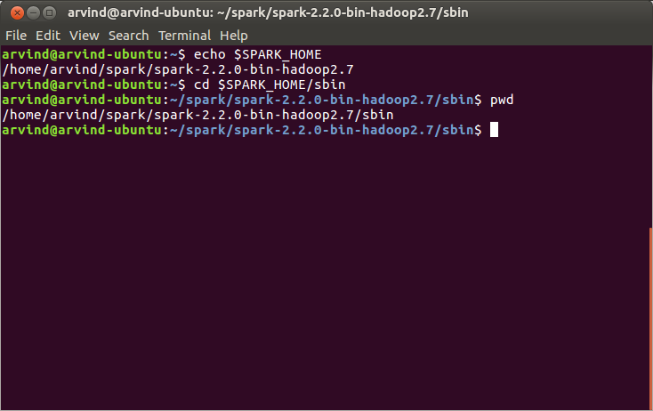

2. Start the Spark daemons using the command:
./start-all.sh

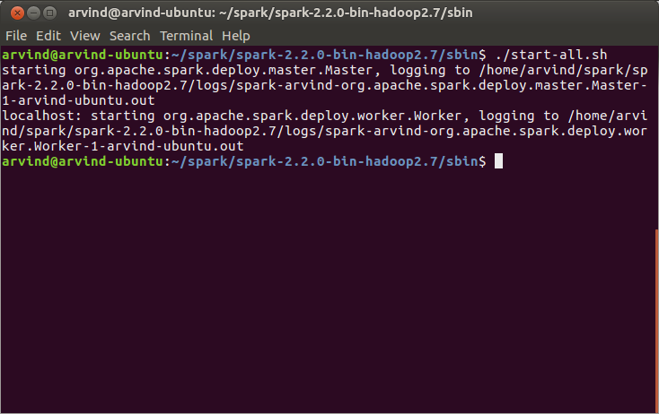

3. Verify that Spark dameons are running using the command(you should see a Master and a Worker process running):
jps

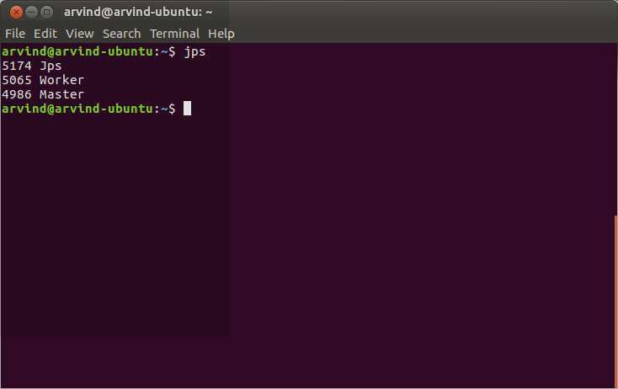

4. Navigate to the SPARK_HOME/bin using the command:
cd $SPARK_HOME/bin

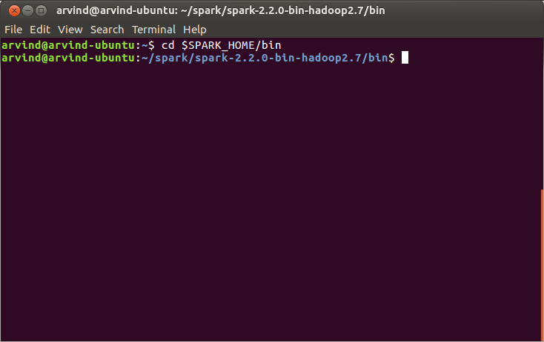

5. Start the Spark Scala shell using the command:
spark-shell

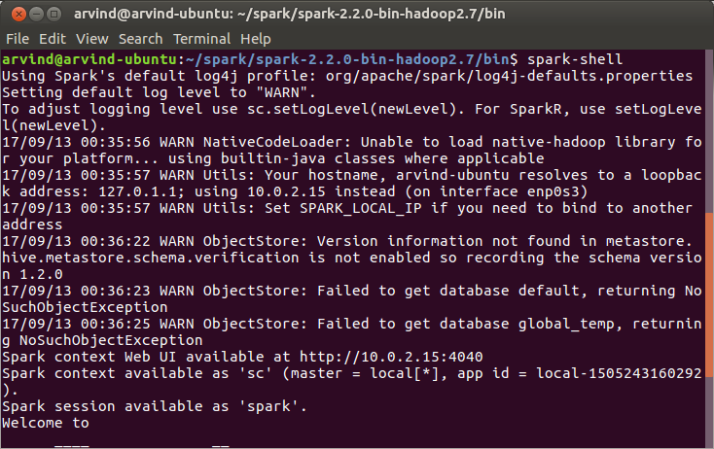

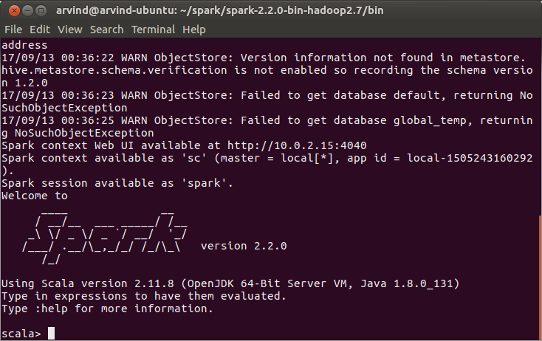

6. In the Spark Scala shell create a pair array using the statement:
val pairArray = Array((1,2),(3,4),(3,6))

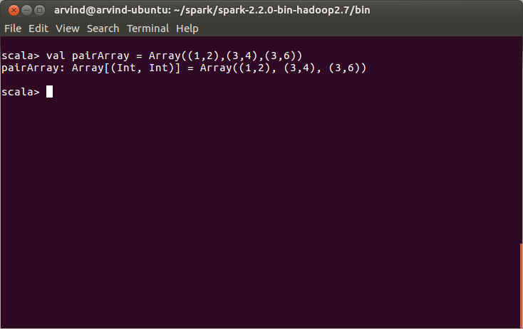

7. Create an RDD out of the Scala array using the followign statement
val pairRDD = sc.parallelize(pairArray)

8. Verify using the command:
pairRDD.collect()

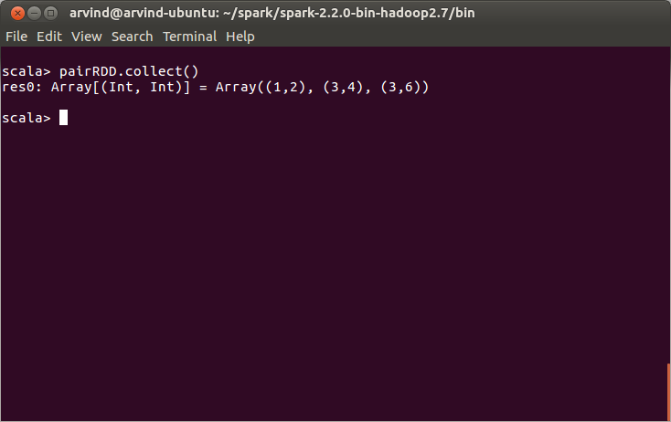

Task 2: Transform an RDD of ("a","b","c","d","e") to PairRDD (a,0), (b,1), (c,2), (d,3), (e,4)

1. Follow steps 1 to 5 under Task 1

2. Create an alphabets Scala list using the statement:
val alphabets = List("a","b","c","d","e")

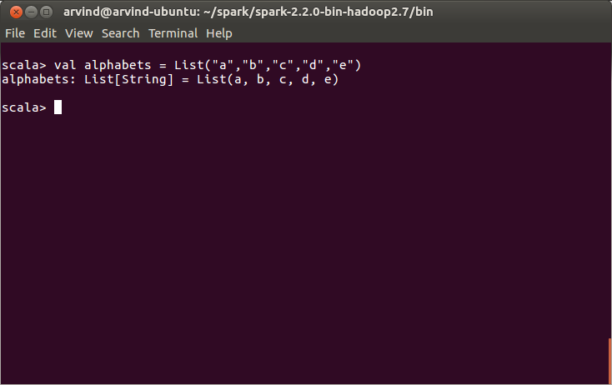

3. Convert this list into an RDD using parallelize as follows:
val alphaRDD = sc.parallelize(alphabets)

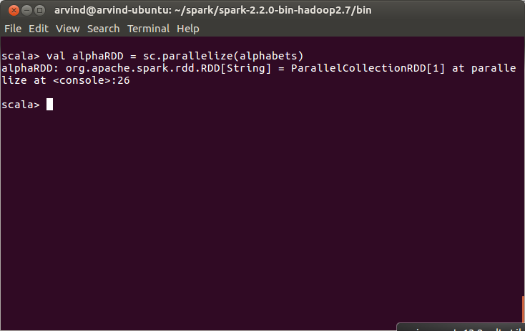
4. Transform it into a pairRDD using the following statement(Using the map transformation, we generate a pair RDD. The first element in the pair will be the list element itself, The second element calculates distance between the first charater of the elemtn and the character ‘a’. In other words we are calculating alphabetical distance):
val pairRDD = alphaRDD.map(x=> (x,x.charAt(0)-'a'))

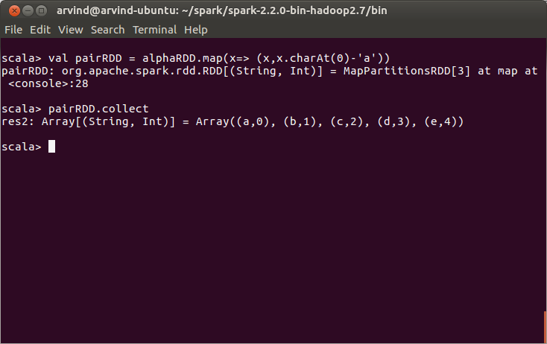

Alternatively we can use the following statement
val pairRDD = alphaRDD.zipWithIndex

