ASSIGNMENT 13.3

Task: Write a code to turn a collection into a RDD and perform map operation on it to cube
every number and filter the number which are divided by two and three

Following steps were performed to complete this assignment(It is assumed that Spark is already installed and there is an environment variable called SPARK_HOME whose value is the path to the directory where Spark is installed)

1. Navigate to SPARK_HOME/sbin using the command:
cd $SPARK_HOME/sbin

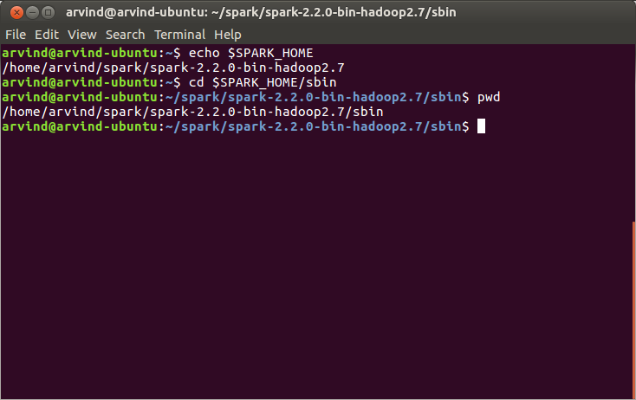

2. Start the Spark daemons using the command:
./start-all.sh

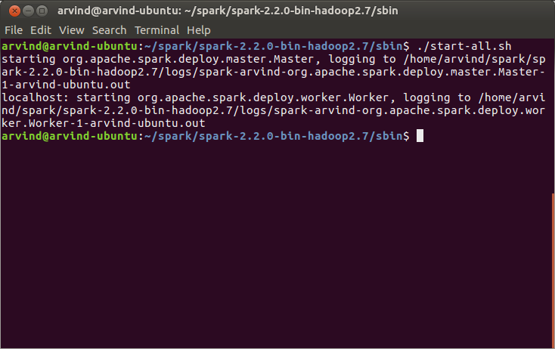

3. Verify that Spark dameons are running using the command(you should see a Master and a Worker process running):
jps

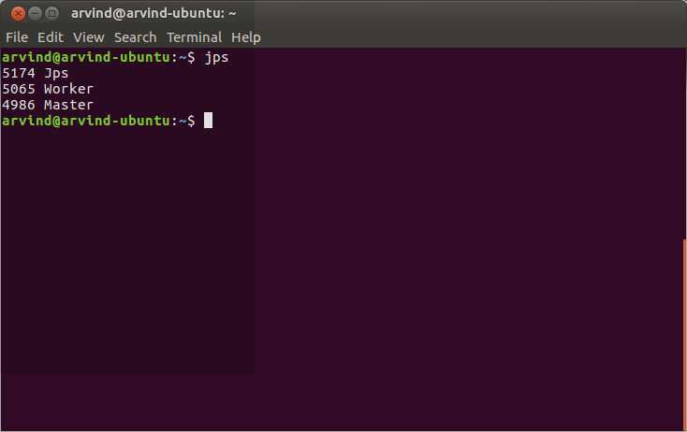

4. Navigate to the SPARK_HOME/bin using the command:
cd $SPARK_HOME/bin

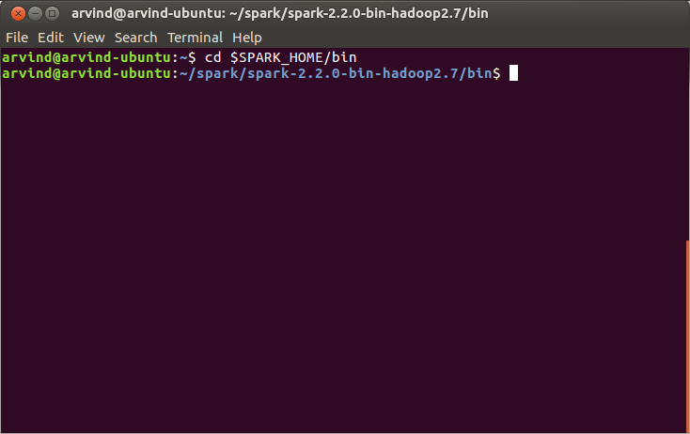

5. Start the Spark Scala shell using the command:
spark-shell

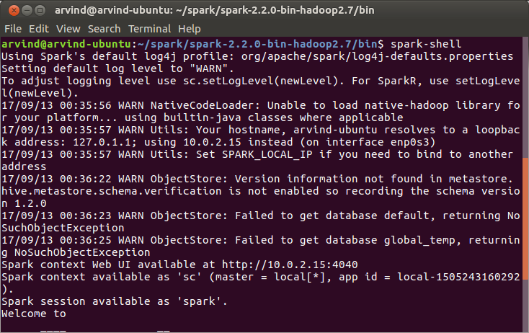

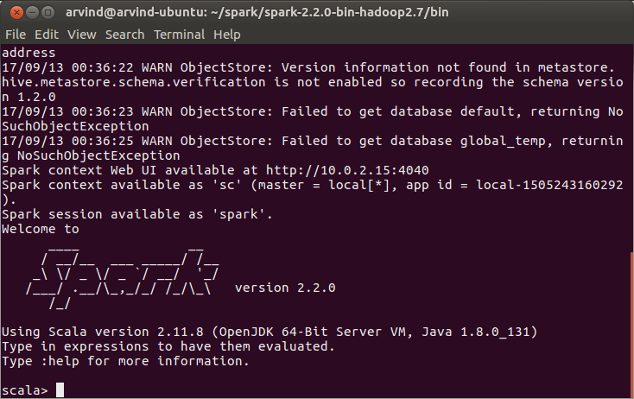

6. Create an array of numbers and an RDD out of it using the following two statements
val numList = (1 to 30).toArray
val numListRDD = sc.parallelize(numList)

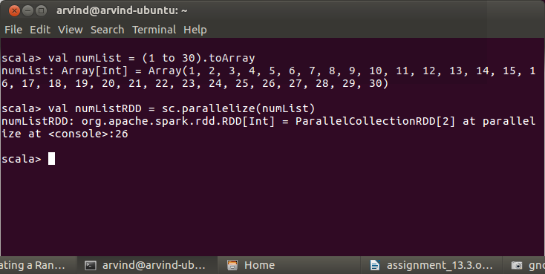

7. Cube every element in the RDD using the following statement:
val cubedRDD = numListRDD.map(x=>x*x*x)
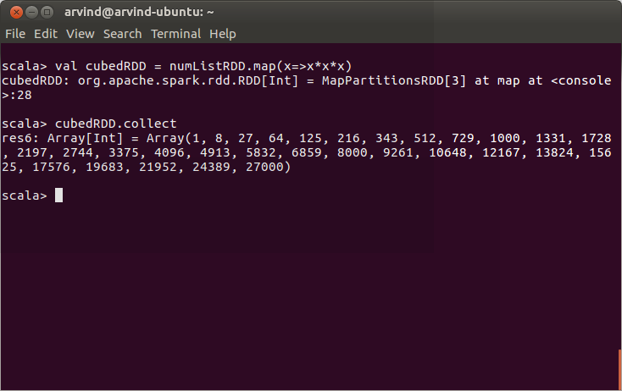

8. Filter out numbers from the cubed RDD which are divisible by 2 and 3 using the following statement:
val filteredRDD = cubedRDD.filter(x => (x%2)==0 && (x%3)==0)

