ASSIGNMENT 14.1

Following were the steps executed to perform this assignment:

1. Install Hive and set up necessary environment variables especially HIVE_HOME

2. Configure MySQL as the metastore for Hive by following the instructions in this blog http://syed-rizvi.blogspot.in/2016/02/mysql-configuration-as-hive-metastore-db.html

3. To execute Hive in local mode, add the following lines to hive-site.xml
<property>
<name>mapred.job.tracker</name>
<value>local</value>
</property>
<property>
<name>fs.default.name</name>
<value>file:////home/arvind/hive/tmp</value>
</property>
<property>
<name>hive.metastore.warehouse.dir</name>
<value>file:////home/arvind/hive/warehouse</value>
</property>

4. Now this assignment can be executed by running the assignment_14.1.hql file inside the sources directory. Self-explanatory comments are already added in the file.

5. Run assignment_14.1.hql as:
hive -f assignment_14.1.hql

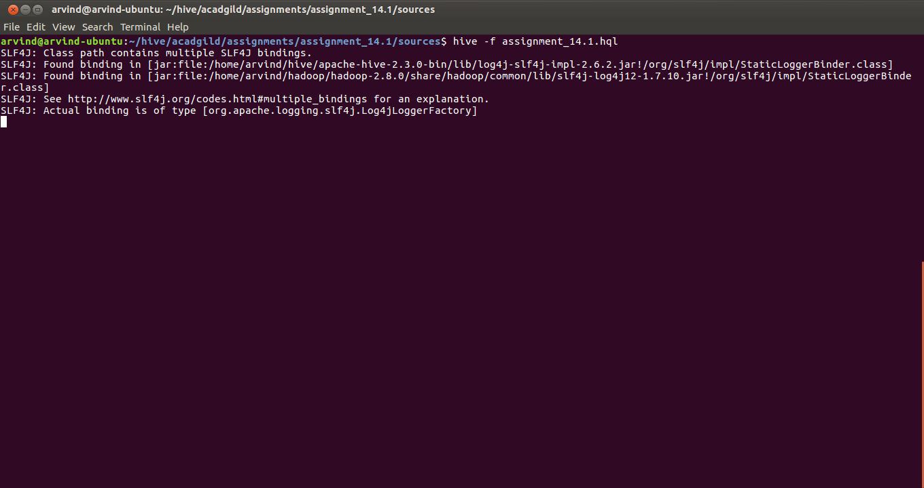

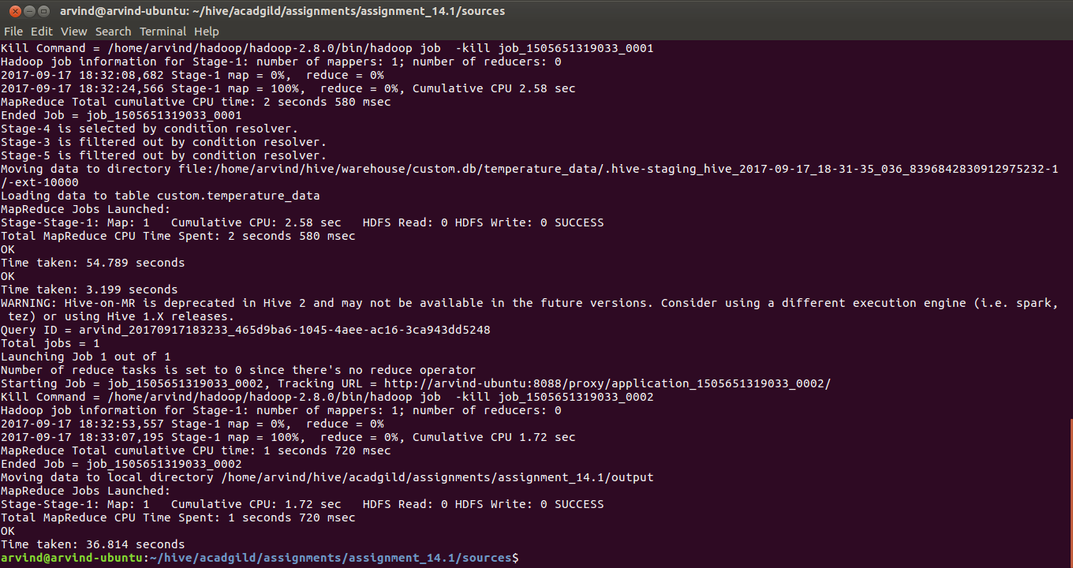
6. After successful execution of the hql script, navigate to the directory as configured in the property hive.metastore.warehouse.dir in hive-site.xml using the command:
cd /home/arvind/hive/warehouse/

7. Verify that a folder called custom.db is present using the command:
ls -l | grep custom.db

8. Navigate into the custom.db directory using the command:
cd custom.db

9. Verify that a folder called temperature_data is present using the command:
ls -l | grep temperature_data

10. Navigate into that directory using the command:
cd temperature_data

11. List the files in the current directory using the command:
ls

12. Display the contents of the file using:
cat 000000_0

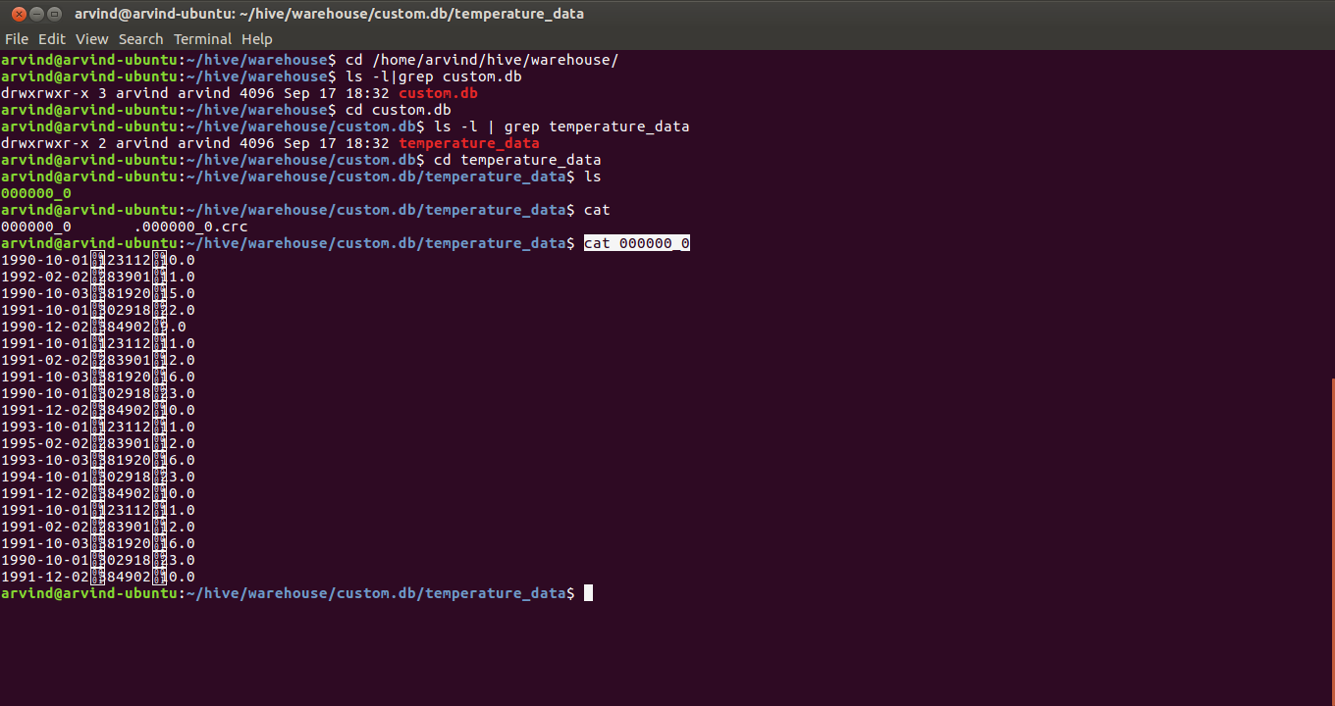

13. Navigate to the output folder of the assignment using the command:
cd /home/arvind/hive/acadgild/assignments/assignment_14.1/output

14. List out the contents of the output folder using the command:
ls

15. Verify the output contents by using the command
cat 000000_0

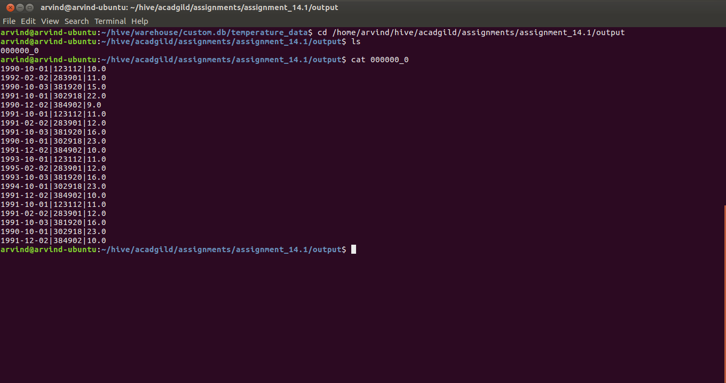
16. Start hive using the command:
hive

17. In the hive prompt run the hive command:
show databases;

And verify whether ‘custom’ is listed as one of the databases

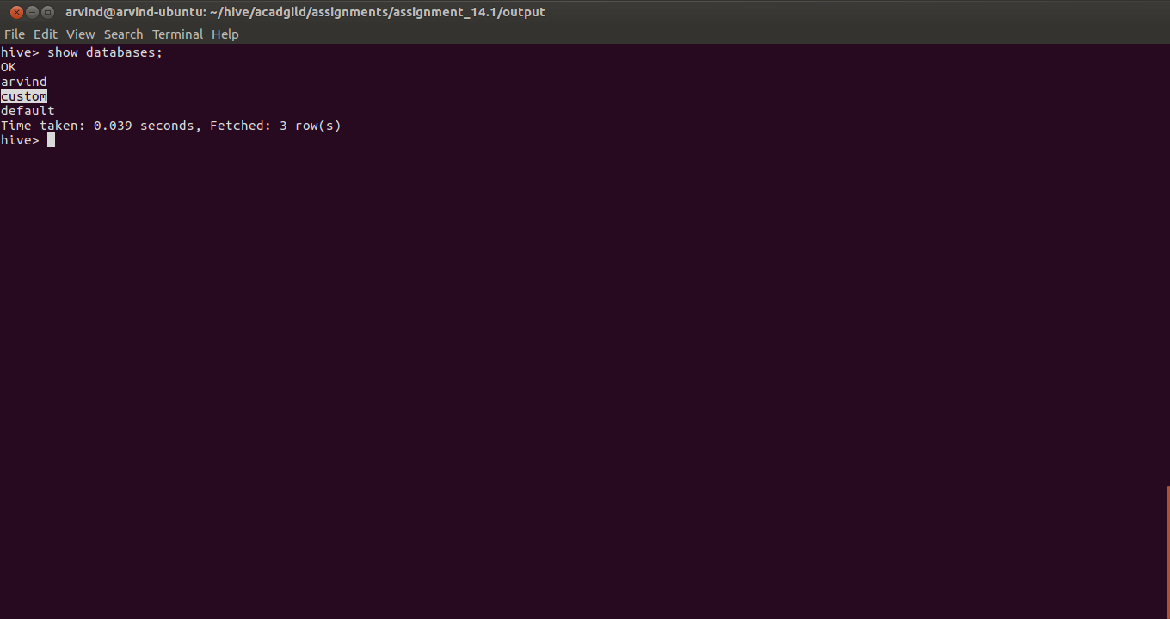

18. Switch to the custom database in the hive prompt using the hive command:
use custom;

19. Verify you have switched to the custom database by using the hive command:
set hive.cli.print.current.db=true;

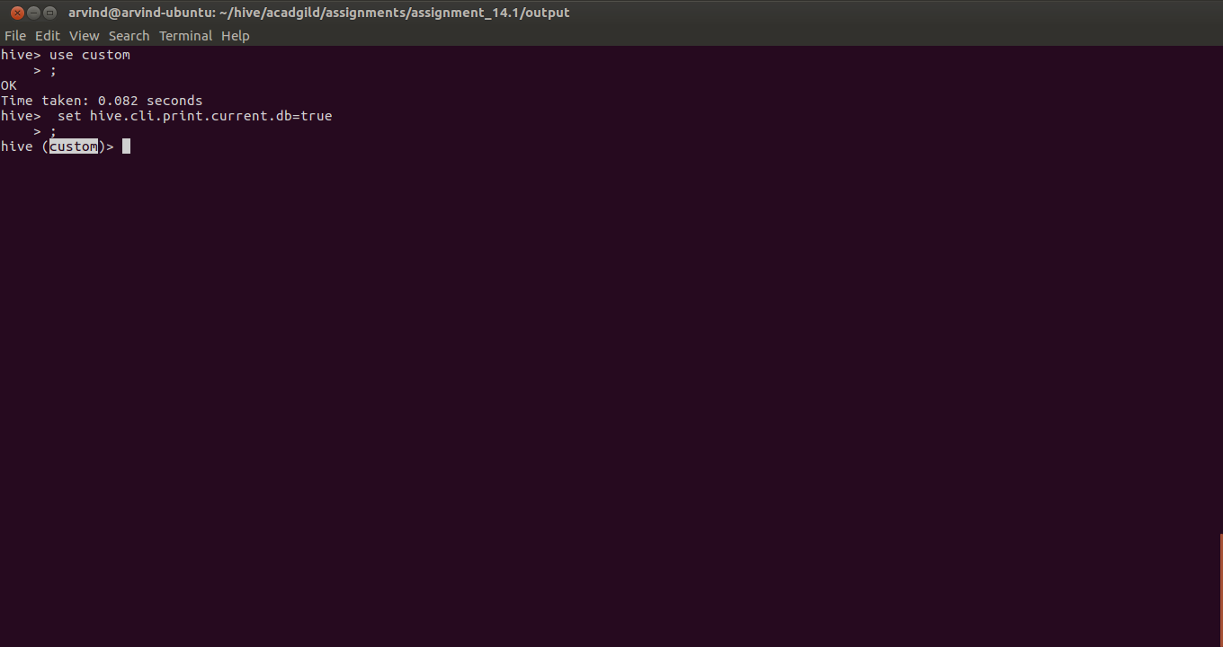
20. List the tables in the custom database using the hive command:
show tables;

And verify whether temperature_data is listed in the list of tables

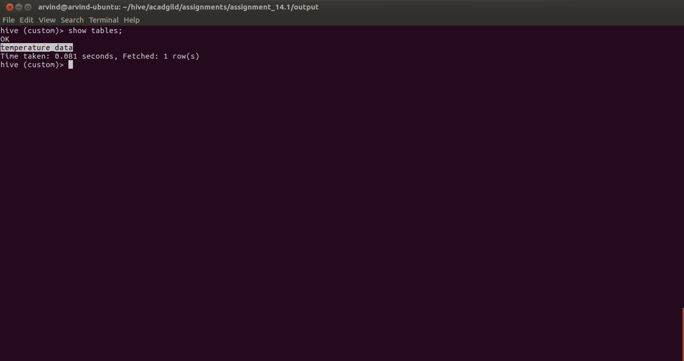
21. View the data in the temperature_data table using the hive command:
select * from temperature_data;

