ASSIGNMENT 14.2

I have divided this assignment into 5 tasks:
Task 1:
Fetch date and temperature from temperature_data where zip code is greater than
300000 and less than 399999.

Task 2:
Calculate maximum temperature corresponding to every year from temperature_data
table.

Task 3
Calculate maximum temperature from temperature_data table corresponding to those
years which have at least 2 entries in the table.

Task 4
Create a view on the top of last query, name it temperature_data_vw. (Since this is just a create statement it would not have any output folder)

Task 5
Export contents from temperature_data_vw to a file in local file system, such that each
file is '|' delimited.

Following were the steps executed to perform this assignment:

1. Install Hive and set up necessary environment variables especially HIVE_HOME

2. Configure MySQL as the metastore for Hive by following the instructions in this blog http://syed-rizvi.blogspot.in/2016/02/mysql-configuration-as-hive-metastore-db.html

3. To execute Hive in local mode, add the following lines to hive-site.xml
<property>
<name>mapred.job.tracker</name>
<value>local</value>
</property>
<property>
<name>fs.default.name</name>
<value>file:////home/arvind/hive/tmp</value>
</property>
<property>
<name>hive.metastore.warehouse.dir</name>
<value>file:////home/arvind/hive/warehouse</value>
</property>

4. Now this assignment can be executed by running the assignment_14.2.hql file inside the sources directory. Self-explanatory comments are already added in the file.

5. Run assignment_14.2.hql as:
hive -f assignment_14.2.hql

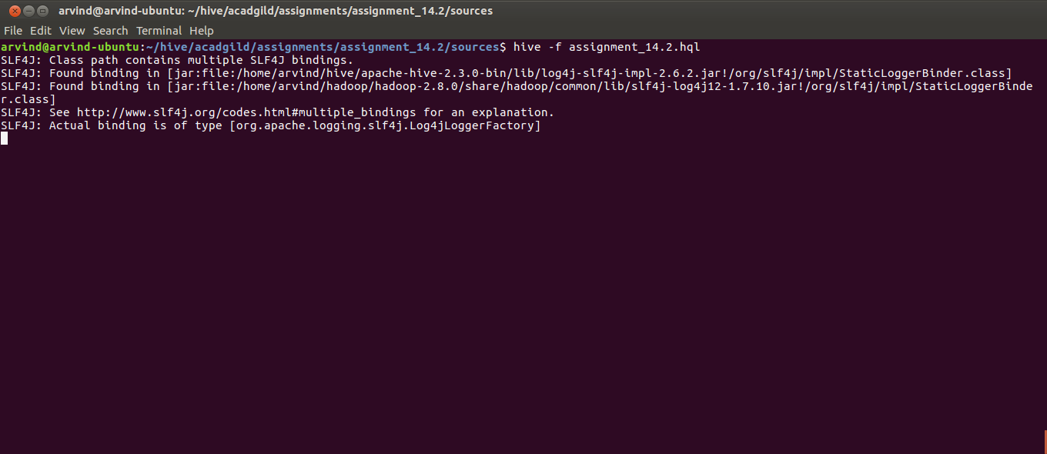

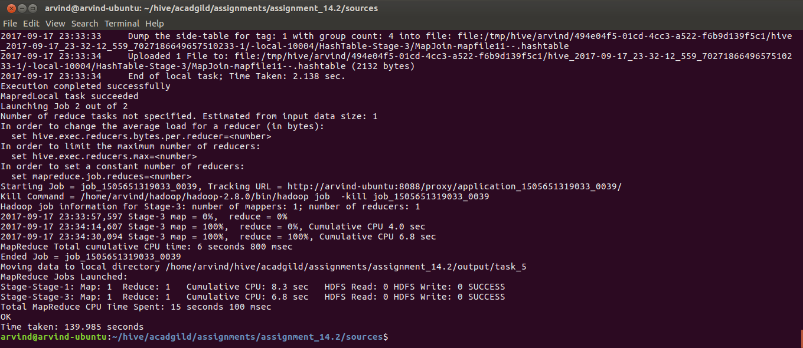
6. After successful execution of the hql script, navigate to the directory as configured in the property hive.metastore.warehouse.dir in hive-site.xml using the command:
cd /home/arvind/hive/warehouse/

7. Verify that a folder called assignment_14_2.db is present using the command:
ls -l | grep assignment_14_2.db

8. Navigate into the custom.db directory using the command:
cd assignment_14_2.db

9. Verify that a folder called temperature_data is present using the command:
ls -l | grep temperature_data

10. Navigate into that directory using the command:
cd temperature_data

11. List the files in the current directory using the command:
ls

12. Display the contents of the file using:
cat 000000_0

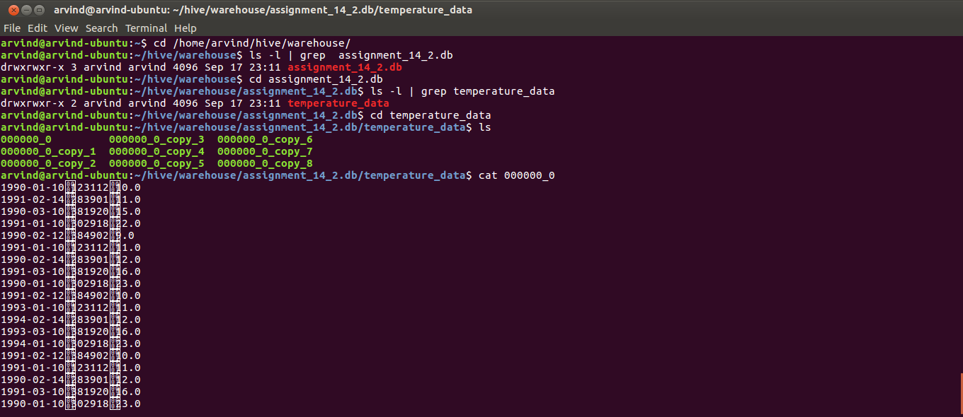
13. Navigate to the output folder of the assignment using the command:
cd /home/arvind/hive/acadgild/assignments/assignment_14.2/output

14. List out the contents of the output folder using the command:
ls

15. Verify the output contents by using the commands
cat task_1/000000_0
cat task_2/000000_0
cat task_3/000000_0
cat task_5/000000_0

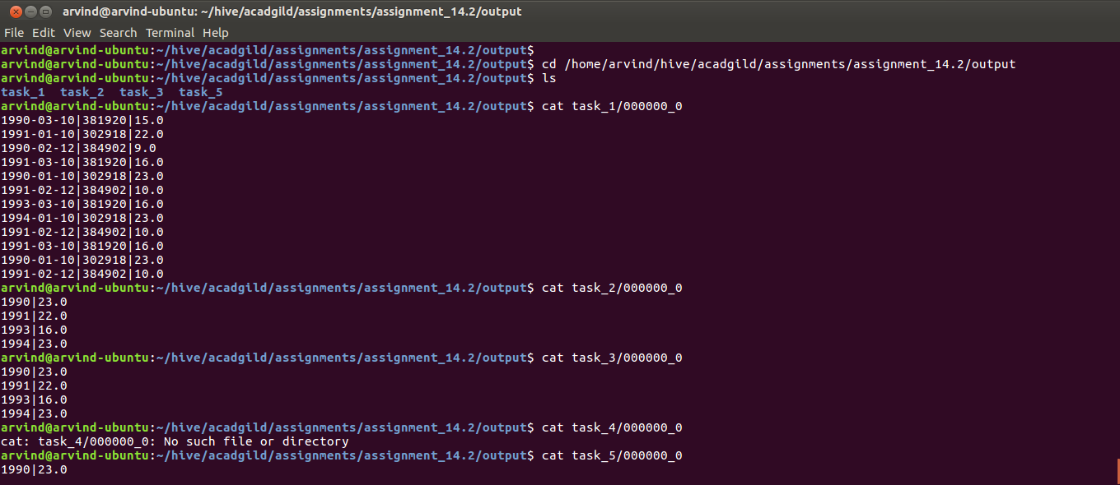
16. Start hive using the command:
hive

17. In the hive prompt run the hive command:
show databases;

And verify whether ‘assignment_14_2’ is listed as one of the databases

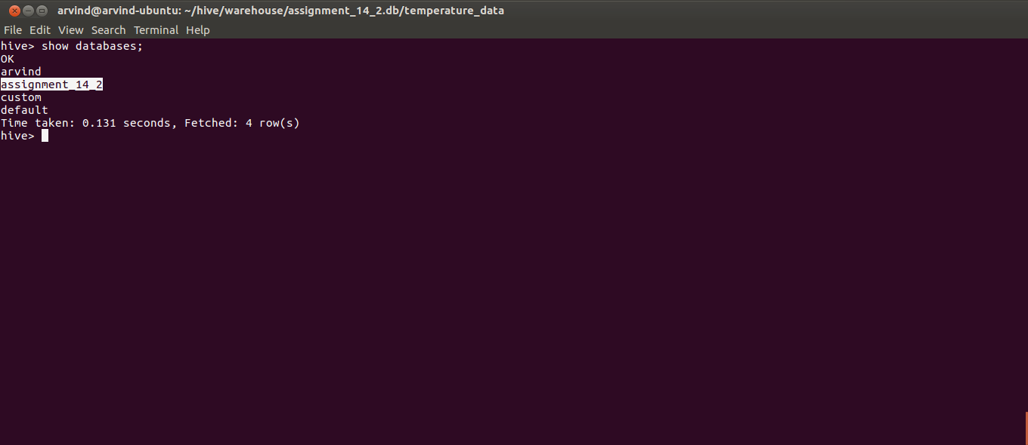

18. Switch to the assignment_14_2 database in the hive prompt using the hive command:
use assignment_14_2;

19. Verify you have switched to the custom database by using the hive command:
set hive.cli.print.current.db=true;

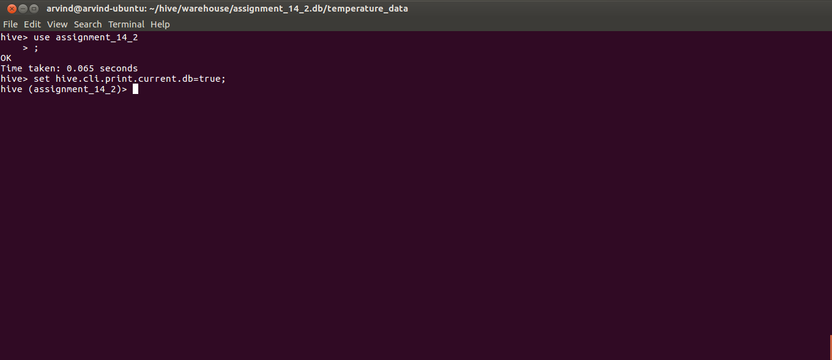
20. List the tables in the custom database using the hive command:
show tables;

And verify whether temperature_data and temperature_data_vw are listed in the list of tables

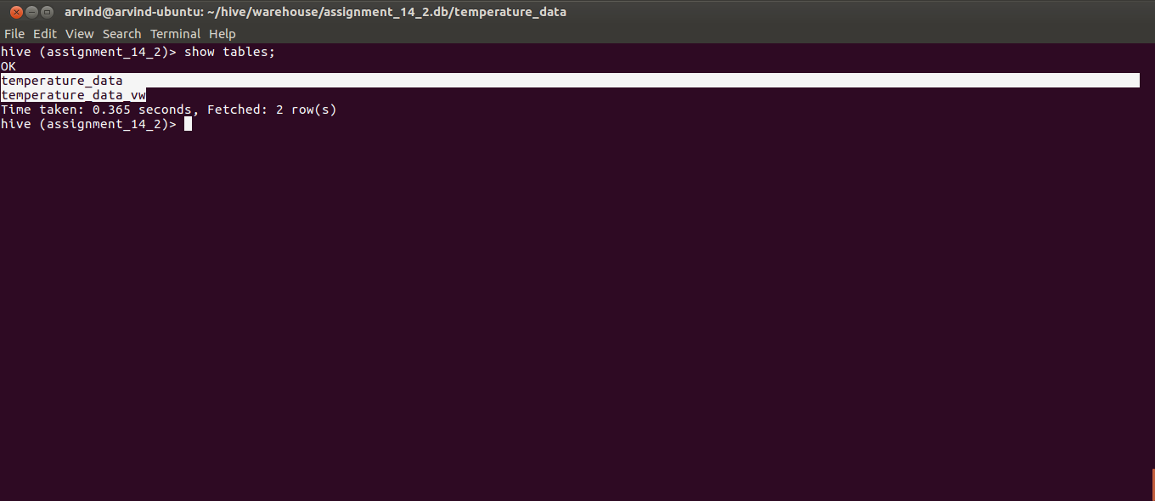
21. View the data in the temperature_data table and temperature_data_vw view using the hive commands:
select * from temperature_data;
select * from temperature_data_vw;

